NAME ……………………………………….…… ADM NO……….… DATE …….………
SCHOOL…………………………………………...……… SIGNATURE …………...……….
121
MATHEMATICS
FORM 4 PAPER 1
SEPTEMBER 2022
TIME: 2 ½ HOURS
OPENER EXAMINATION TERM 3, 2022
Kenya Certificate of Secondary Education 2022

INSTRUCTIONS TO CANDIDATES
- Write your name and admission number in the spaces provided at the top of this page.
- This paper consists of two sections: Section I and Section II.
- Answer all questions in section I and any five questions in Section II.
- Show all the steps in your calculations, giving your answers at each stage in the spaces below each question.
- Marks may be given for correct working even if the answer is wrong.
- KNEC Mathematical tables may be used.

For Examiner’s Use Only

1 | 2 | 3 | 4 | 5 | 6 | 7 | 8 | 9 | 10 | 11 | 12 | 13 | 14 | 15 | 16 | Total

17 | 18 | 19 | 20 | 21 | 22 | 23 | 24
Grand
Total

SECTION I 50 Marks
Answer all questions in the spaces provided in this section
- When a certain number x is divided by 30, 45 or 54, there is always a remainder of 21. Find the least value of the number x. (3 marks)

- Without using a calculator, evaluate (3 marks)
$$\frac{\left(2\frac{3}{7}-1\frac{5}{6}\right)÷\frac{5}{6}}{\frac{2}{3} of2\frac{1}{4}-1\frac{1}{7}}$$

- Find by construction the image of the triangle ABC when it is reflected in the mirror line M. (3 marks)
- Solve the following inequality and state the integral values (3 marks)
$$2x - 1 < 7 + x < 3x + 2$$

- The sum of interior angles of a triangle is given by $\left(10x-2y\right)°$ while that of a hexagon is given by $\left(30x+24y\right)°.$Calculate the values of $x$ and $y$ (3 marks)

- A bus left Mombasa at 7.00 a.m. travelling at an average speed of 80 km/hr towards Nairobi. After two hours, a car started and travelled in the same direction at 120 km/hr. Calculate how far from Mombasa the car caught up with the bus. (3 marks)

- Simplify the expression: (3 marks)
$$\frac{{3x}^{2}-4xy+y^{2}}{{9x}^{2}-y^{2}}$$

- Electricity bill comprises of a meter rent charge of Ksh. 250, a fixed charge of Ksh. 130, a charge of Ksh. 1.50 per unit and a fuel cost charge of 5% of the total charges. Melton, a domestic consumer of KPLC consumed 898 units in a certain month. Find the bill for that month. (3 marks)

- A translation maps triangle ABC onto $A'B'C'$ where $A(1,-1)$, $B(2, 2)$, $C(3, 1)$ and $C'(-1, 3)$. Find:
- Translation vector. (1 mark)

- Coordinates of $A'$ and $B^{'}.$ (2 marks)

- Using elimination method, solve the simultaneous equations. (3 marks)
$4x + 3y = 10$
$2x + 3y = 8$

- Given that x is an acute angle and that $\sin{(x-20°)-\cos\left(3x-50°\right)=0}$, find the value of x in degrees. (2 marks)

- (i) Using a ruler and pair of compass only, construct a parallelogram ABCD such that $AB=6 cm,$ $BC=4.8 cm$ and angle ABC = $150°$ (3 marks)

(ii) Drop a perpendicular from D to meet AB at M. Measure DM. (1 mark)

- Manzu and Halima started a journey to Nairobi from Kisumu at 8.30 a.m , after$1 hour$ Manzu stopped on the way for 35 minutes .If Halima arrived in Nairobi $6 hours$ earlier than Manzu, at what time did Manzu arrive in Nairobi. (3 marks)

- The figure below shows a right pyramid with sides AB = 13 cm, BC = 5 cm and CD = 7 cm.
Determine the volume of the solid. (3 marks)

- Find the possible values of x in the equation $9^{x^{2}}={27}^{2x+12}$ (4 marks)

- Find the equation of the tangent to the curve $y = 4x^{3} – 2x^{2} – 3x + 5$ at the point (2, 1) (4 marks)

SECTION II 50 Marks
Attempt any five questions ONLY this section
- In the following diagram, the gradient of the lines L₁ and L₂ area 1.2 and 2 respectively, and $x-$coordinates of points A and B are 2 and 4 respectively. The line L₃ passes through point B and the origin.
- Find the co-ordinates of A and B. (3 marks)

- Find the equation of L₁. (2 marks)

- Find the equation of line L₂ in the form $\frac{x}{a}+\frac{y}{b}=1$ (3 marks)

- Find the equation of the line L₃ in the form $ax+by=c$ (2 marks)

- The figure below represent a solid made up of a conical frustum and a hemispherical top. The slant height of the frustum is 8 cm and its base radius is 4.2 cm. Use $π=\frac{22}{7}$
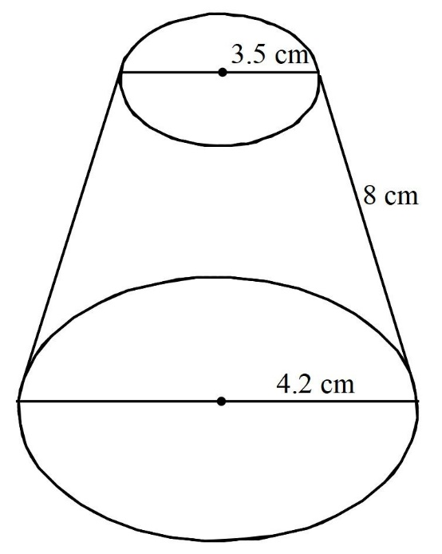
If the radius of the hemispherical top is 3.5 cm
- Find the area of:
- The circular base. (2 marks)

- The curved surface of the frustum. (4 marks)

- The hemispherical surface. (2 marks)

- A similar solid has a total surface area of $81.5 {cm}^{2}$. Determine the radius of the base. (2 marks)

- (a) Given the matrix $A=\left(\begin{matrix}3 & 4 \\ 2 & 3\end{matrix}\right)$, find the inverse of A. (2 marks)

(b) Two universities, TECK and KCT purchased beans and rice. TECK bought 90 bags of beans and 120 bags of rice for a total of sh 360, 000. KCT bought 200 bags of beans and 300 bags of rice for a total of sh 850,000. Use the matrix method to find the price of one bag of each item. (5 marks)

(c) The price of beans later decreased in the ratio $4 : 5$ while the price of rice increased by 20%. A businessman bought 20 bags of beans and 30 bags of rice. How much did he pay? (3 marks)

- In the quadrilateral ABCD below, AB = 7.4 cm, BC = 9.1 cm AD = 12 cm, angle $ABC = 133°$ and angle ACD = $48°$
- Calculate the size of angle ADC. Give your answer correct to 3 significant figures. (5 marks)

- Calculate the shortest distance from D to the line AC. (2 marks)

- Calculate the area of the quadrilateral ABCD. Give the answer correct to 2 significant figures. (3 marks)

- The football team in a school decided to raise Ksh. 3600 for a party. Each student was to contribute equal amount. However before the contributions were made, five members of the football team decided to transfer to other schools. This meant the remaining members had to pay Ksh. 24 more to meet the same target. Taking the original number of footballers to be x,
- Write an expression for the initial amount that each student should have contributed. (1 mark)

- Write an expression for the contribution by each student after the transfer. (1 mark)

- Form an equation hence find the number of members in the football team originally. (5 marks)

- Calculate the percentage increase in the contribution per student caused by the transfer. (3 marks)

- Triangle $OAB$ is such that $OA = a$ and $OB = b.$C lies on OB such that $OC:CB =1:1 .$ D lies on AB such that $AD:DB = 1:1$ and E lies on OA such that $OA:AE =3:1$. Find in terms of a and b
- $\vec{OC}$ (1 mark)

- $\vec{OD}$ (2 marks)

- $\vec{CD}$ (2 marks)

- $\vec{OE}$ (2 marks)

- $\vec{DE}$ (2 marks)

- $\vec{AB}$ (1 mark)

- The lengths, in cm, of 37 leaves of a certain tree were recorded as follows:
8.5 | 7.9 | 8.6 | 9.7 | 9.7 | 10.3 | 11.0 | 9.0 | 8.5
10.5 | 9.5 | 8.0 | 8.3 | 9.1 | 7.9 | 10.2 | 9.2 | 8.3
10.1 | 10.2 | 9.9 | 9.4 | 9.9 | 8.7 | 9.7 | 10.6 | 8.9
9.9 | 8.9 | 9.9 | 10.9 | 9.5 | 10.1 | 10.0 | 9.2 | 9.5
9.1
- Starting with 7.9 and using a class interval of 0.5 cm, prepare a frequency distribution table to represent the data. (2 marks)

- Use the table in (a) above to determine the estimate of:
- The mean (3 marks)

- The median (3 marks)

- Draw a frequency polygon to represent the data. (2 marks)

- The displacement S metres of a moving particle from a point O after t seconds is given by $S=t^{3}-5t^{2}+3t+10$.
- Find S when t = 2 seconds. (2 marks)

- Determine;
- The velocity of the particle when t = 5 seconds. (3 marks)

- The value of t when the particle is momentarily at rest. (3 marks)

- Find the time when the velocity of the particle is maximum. (2 marks)

THIS IS THE LAST PRINTED PAGE

