MATHEMATICS FORM THREE
MARKING SCHEME
NO | WORKING | MARKS | REMARKS
1 | Numerator  $$-24÷-8×5+30$$  $$3×5+30$$  $$15+30=45$$  Denominator  $$-16×4÷2+\left(-8\right)$$  $$-16×2-8$$  $$-32-8=-40$$  $$\frac{Num}{Den}=\frac{45}{-40}=-1\frac{1}{8}$$ | M 1  M 1  A 1
2 | $${3x}^{2}-3xy+xy-y^{2}$$  $$3x\left(x-y\right)+y\left(x-y\right)$$  $$(x-y)(3x+y)$$ | M1  M1  A1
3 | 100 500 dollars to shillings = $9.84×100 500$  $$=sh. 988 920$$  Balance after expenses = $Sh. 988 920-430 897$  $$=Sh. 558 023$$  Amount received in Japanese Yen = $\frac{558 023 ×100}{75.12}$  $$=742 842 Yen$$ | M 1  M 1  A 1
4 | NO Standard form Log  $$0.7432$$ $$80.23$$ $$7.432×{10}^{-1}$$ $$8.023×{10}^{1}$$ $$\overline{1}.8712$$ $$1.9049+$$  $$1.7756$$  $$4.125$$ $$4.125×{10}^{0}$$ $$0.6154×2$$ $$1.2308-$$  $$0.5448÷3$$  $$1.519$$ $$←0.1816×{10}^{0}$$ $$0.1816$$ | B 1  B1  B 1  A 1 | All logarithms  Addition and subtraction  Cube root  Correct answer
5 | Absolute error = 0.05  Actual Perimeter =$6.5+7.4+8.2=22.1cm$  Max perimeter = $6.55+7.45+8.25=22.25cm$  Min perimeter =$6.45+7.35+8.15=$21.95 cm  % error $=\frac{1}{2}\left(\frac{22.25-21.95}{22.1}\right)×100\%$  $$=\frac{0.3}{44.2}×100\%$$  $$=0.679\%$$ | B1  M1  A1
6 | Mid-point of AB = $\left(\frac{2+6}{2},\frac{-4 + \left(-8\right)}{2}\right)=\left(4, -6\right)$  $$m_{1}=\frac{-8-(-4)}{6-2}=\frac{-4}{4}=-1$$  $$m_{2}=1$$  Equation of $L_{2}⇒\frac{1}{1}=\frac{y -(-6)}{x - 4}$  $$x-4=y+6$$  $$x-y-10=0$$ | M 1  M 1  A 1 | Correct coordinates of mid-point  Gradient of line L₂  Equation of L₂
7 | - ${AB}^{2}=6^{2}+9^{2}-2\left(6×9\right)\cos{132°}$  $$=36+81-108\cos{132°}$$  $=\sqrt{189.266}$  = 13.76 cm  - Area = $πR^{2}$  $$=\frac{22}{7}×\left(\frac{13.76}{2\sin{132}}\right)×\left(\frac{13.76}{2\sin{132}}\right)$$  $$=\frac{22}{7}×9.26×9.26=269.49 {cm}^{2}$$ | M 1  A 1  M 1  A 1
8 | $$\log_{10}{25-\log_{10}{4+\log_{10}{1600}}}$$  $$\log_{10}\left(\frac{25×1600}{4}\right)$$  $$\log_{10}{10 000}$$  $$4$$ | M1  M1  A1
9 | $$\frac{3\left(2\sqrt{5}-\sqrt{2}\right)}{\left(2\sqrt{5}+\sqrt{2}\right)\left(2\sqrt{5}-\sqrt{2}\right)}$$  $$\frac{6\sqrt{5}-3\sqrt{2}}{20-2\sqrt{10}+2\sqrt{10}-2}$$  $$\frac{6\sqrt{5}-3\sqrt{2}}{20-2}$$  $$\frac{6\sqrt{5}-3\sqrt{2}}{18}⇒\frac{1}{3}\sqrt{5}-\frac{1}{6}\sqrt{2}$$ | M 1  M 1  A 1
10 | $${6a}^{2}-5a=4$$  $$a^{2}-\frac{5}{6}a=\frac{2}{3}$$  $$a^{2}-\frac{5}{6}a+\frac{25}{144}=\frac{2}{3}+\frac{25}{144}$$  $${\left(a-\frac{5}{12}\right)}^{2}=0.8403$$  $$a-\frac{5}{12}=\sqrt{0.8403}=±0.9167$$  $$a=0.9167+\frac{5}{12} OR-0.9167+\frac{5}{12}$$  $$a=1.333 OR-0.5$$ | M 1  M 1  A 1
11 | $HP =41400+\left(900×6\right)=9800/$ =  Cost price $\frac{100}{175}×9800=5600 /$ =  $$∴Cash price=\frac{125}{100}×5600$$  $=7000 /$= | M1  M1  A1 | expression
12

13 | $$A^{2}=\left[\begin{matrix}1 & 2 \\ 4 & 3\end{matrix}\right]\left[\begin{matrix}1 & 2 \\ 4 & 3\end{matrix}\right]=\left(\begin{matrix}9 & 8 \\ 16 & 17\end{matrix}\right)$$  $$\left(\begin{matrix}9 & 8 \\ 16 & 17\end{matrix}\right)=\left(\begin{matrix}1 & 2 \\ 4 & 3\end{matrix}\right)+\left(\begin{matrix}a & b \\ c & d\end{matrix}\right)$$  $$B=\left(\begin{matrix}8 & 6 \\ 12 & 14\end{matrix}\right)$$ | B 1  M 1  A 1
14 | $${\left(1+\frac{r}{100}\right)}^{n}=\frac{A}{P}$$  $$n\log\left(1+\frac{r}{100}\right)=\log{\frac{A}{P}}$$  $n=\frac{\log{\frac{A}{P}}}{\log\left(1+\frac{r}{100}\right)}$ | M1  M1  A1
15 | $$4x-3≤0.5\left(x+8\right)$$  $$4x-3≤0.5x+4$$  $$4x-0.5x≤4+3$$  $$3.5x≤7$$  $$x≤14$$  $$0.5\left(x+8\right)<x+5$$  $$0.5x+4<x+5$$  $$0.5x-x<5-4$$  $$x>-2$$  $$-2<x≤14$$ | M 1  A 1  B 1 | Both inequalities solved  Compound inequality  Number line
16 | $$a+5d=27$$  $$a+9d=43-$$  $-4d=-16$  $$d=4$$  $$a+20=27 ;a=7$$  16th term = $7+15\left(4\right)=60+7$  $=67$ | B 1  M 1  A 1
17 | - $(21,750 + 15,000 + 8,000 ) × 12$  =$Kshs 537,000$  - Calculation of tax due  1st slab = $116 160×10\%=Shs. 11 616$  2nd slab = $109 440×15\%=Shs. 16 416$  3rd slab = $109 440×20\%=Shs. 21 888$  4th slab = $109 440×25\%=Shs. 27 360$  5th slab = $92 520×30\%=Shs. 27 756$  Tax due = $11 616+16 416+21 888+27 360+27 756$  $=105 036$  Net tax = $105 036-12 672$  $$=Sh. 92 364$$  - Net income = $Gross income-total deductions$  $$=\left(21 750+15 000+8 000\right)-\left(\frac{92 364}{12}+200+4 500\right)$$  $$=44 750-12 397$$  $$=Shs. 32 353$$ | M1  A1  M1  M1  M1  A1  M1  A1  M1  A1

18. a)
$$x°$$ | $$-90$$ | $$-75$$ | $$-60$$ | $$-45$$ | $$-30$$ | $$-15$$ | $$0$$ | $$15$$ | $$30$$ | $$45$$ | $$60$$ | $$75$$ | $$90$$
$$3\cos{2x°}$$ | $$-3$$ | $$-2.6$$ | $$-1.5$$ | $$0$$ | $$1.5$$ | 2.6 | $$3$$ | $$2.6$$ | 1.5 | $$0$$ | $$-1.5$$ | $$-2.6$$ | $$-3$$
$$\sin\left(2x+30°\right)$$ | $$-0.5$$ | $$-0.87$$ | $$-1$$ | $$-0.87$$ | $$-0.5$$ | $$0$$ | $$0.5$$ | 0.87 | $$1$$ | 0.87 | $$0.5$$ | $$0$$ | $$-0.5$$

- (i) $x=-54°$ and $x=33°$

(ii)$6\cos{2x°}+5=0$
$3\cos{2x°=-\frac{5}{2}=-2.5}$
$$x=-75° and x=75°$$

19.
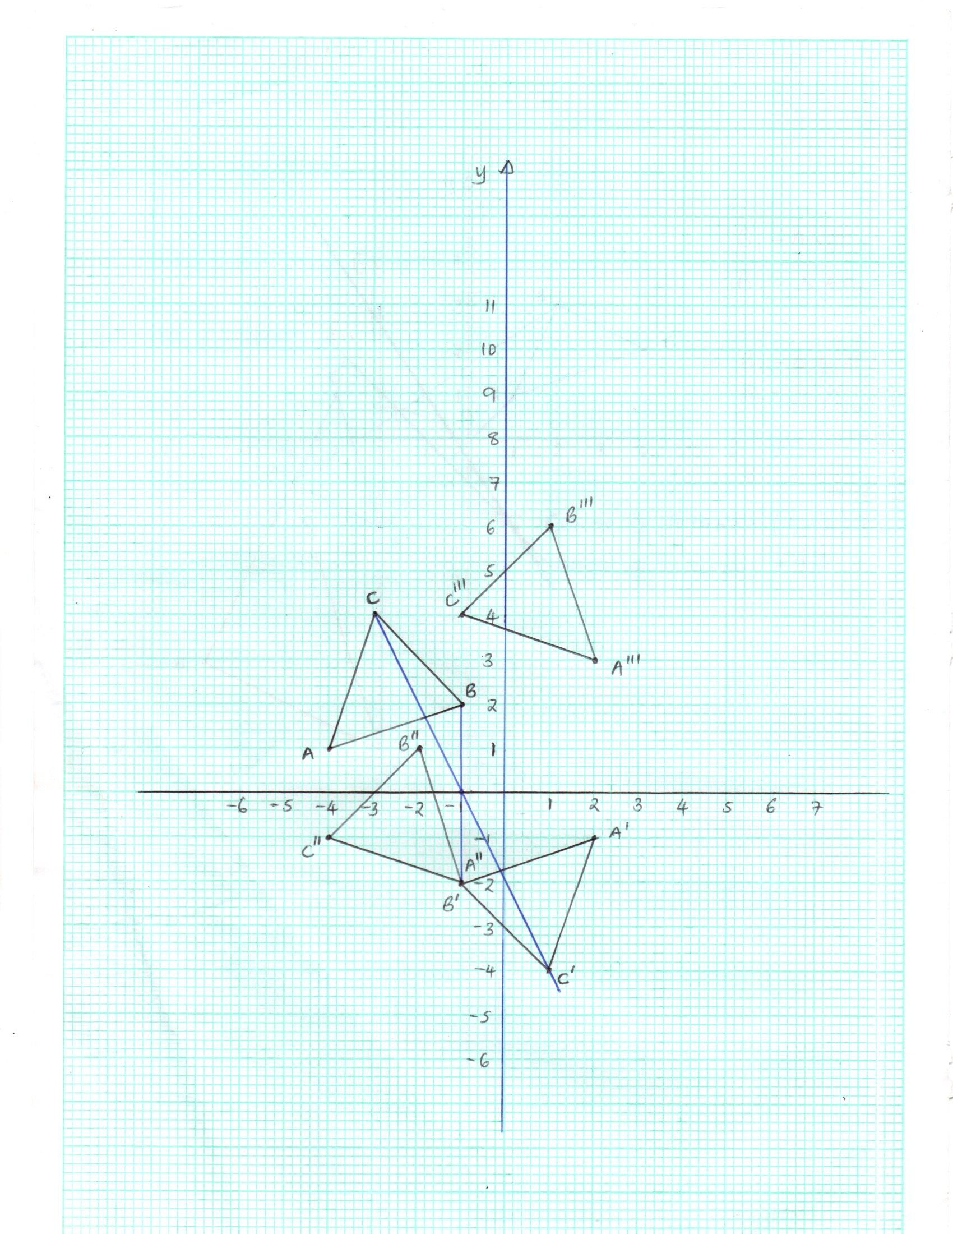
- B 1 Diagram
- B 1 Plotting
B 1 Diagram
B 1 Coordinates $A^{'}\left(2, -1\right) B^{'}\left(-1, -2\right) and C^{'}\left(1, -4\right)$
- B 1 plotting
B 1 Diagram
B 1 Coordinates $A^{''}\left(-1, -2\right) {B'}^{'}\left(-2, 1\right) and {C'}^{'}\left(-4, -1\right)$
- (i) $\left({2 \atop 3}\right)-\left({-1 \atop -2}\right)=\left({3 \atop 5}\right)$
$T=\left({3 \atop 5}\right)$ B 1

(ii) B 1 coordinates
$B^{'''}→\left({-2 \atop 1}\right)+\left({3 \atop 5}\right)=\left({1 \atop 6}\right)=(1, 6)$
$C^{'''}→\left({-4 \atop -1}\right)+\left({3 \atop 5}\right)=\left({-1 \atop 4}\right)=(-1, 4)$
$B 1$ Diagram
20 | - (i) $x-5$  (ii) $\left[x+(x-5)\right]×$2  $4x-10$  b) i) $\left(x+20\right)\left(x+15\right)=15(4x+10)$  $$x^{2}-25x+150=0$$  $$\left(x-10\right)\left(x-15\right)=0$$  $x=10 or x=15$  ii) $4×10-10 or 4×15-10$  $=30 or 50$  iii) $\left(10-5\right)+20 or \left(15-5 \right)+20$  $= 25 or 30$ | B1  B1  B1  M1  M1  A1  M1  A1  M1  A1 | Correct equation  solving

21 | - The completed table is shown below.  Mass in Kg Class mid-point $x$ Frequency $$f$$ $$fx$$  $$41-45$$ 43 5 215  $$46-50$$ 48 10 480  $$51-55$$ 53 14 742  $$56-60$$ 58 8 464  $$61-65$$ 63 3 189  ∑f = 40 ∑f $x=2090$  - (i) Mean mass $\overline{x}=\frac{∑f x}{∑f }$  $$=\frac{2090}{40}$$  $$=52.25 kg$$  (ii) Median = $50.5+\left(\frac{20 – 15}{14}\right)×5$  $$=50.5+\frac{25}{14}$$  $$=52.29 kg$$  - Frequency polygon on the attached graph. |  | B 1 – column for$x$  B 1 – column for $f$  B 1 – column for $fx$  B 1 - ∑f $x=2090$  M 1  A 1  M 1  A 1  B 1 all points plotted  B 1 polygon drawn
22 | - ${DC}^{2}={50}^{2}-3^{2}=2500-9=2491$  $DC=\sqrt{2491}=49.91 cm$  - $\cos{θ=\frac{3}{50}=0.06 θ=86.52×2=173.12°}$  $ϑ=360-173.12=186.88$  $$l=\frac{186.88}{360}×\frac{22}{7}×2×9=29.37 cm$$  - $\sin{β=\frac{3}{50}=0.06; β=3.4398}$  $γ=2(90+3.4398)=186.88$  $$360-186.88=173.12$$  $$l=\frac{173.12}{360}×2×\frac{22}{7}×6=18.14 cm$$  - Total length = $49.91+29.37+49.91+18.14$  $$=147.33 cm$$ | M 1  A 1  B 1  M 1 A 1  B 1  M1 A1  M 1  A 1
23 | - (i) Area of curved part $=\frac{22}{7}×4×4×0.5$  $$= 25.14 {cm}^{2}$$  Area of Rectangular part = $12×6=72{cm}^{2}$  Total Area of solid $=25.14+72$  $=97.14{cm}^{2}$  (ii) Curved length = $\frac{22}{7}×8$ =12.57  Total perimeter  $=12.57+2+6+12+6+2$  = 40.57cm  - Volume of solid $=97.14×900$  $=87.43 {cm}^{3}$  Density =$\frac{ 306×1000}{87.43} g/{cm}^{3}$= $3.499$  $$\sim 3.5{g/cm}^{3}$$ | M1  M1  A1  M1  M1 A 1  M1  A1  M1  A1
24 | - (I) $4.4×50=220±5 km$  (II) $180+18=198°$  - B 1 – angle of depression  B 1 - construction of perpendicular bisector of PQ from M.  B 1 - $6×50=300 km$ |  | B 1  B 1

