NAME ……………………………………….…… ADM NO……….… DATE …….………
SCHOOL…………………………………………...……… SIGNATURE …………...……….
121
MATHEMATICS
FORM 4 PAPER 2

TIME: 2 ½ HOURS
END OF TERM TWO EXAMINATION
Kenya Certificate of Secondary Education

INSTRUCTIONS TO CANDIDATES
- Write your name and admission number in the spaces provided at the top of this page.
- This paper consists of two sections: Section I and Section II.
- Answer all questions in section I and any five questions in Section II.
- Show all the steps in your calculations, giving your answers at each stage in the spaces below each question.
- Marks may be given for correct working even if the answer is wrong.
- KNEC Mathematical tables may be used.

For Examiner’s Use Only

1 | 2 | 3 | 4 | 5 | 6 | 7 | 8 | 9 | 10 | 11 | 12 | 13 | 14 | 15 | 16 | Total

17 | 18 | 19 | 20 | 21 | 22 | 23 | 24
Grand
Total

SECTION I (50 Marks)
- Simplify giving $\frac{4}{5+\sqrt{2}}-\frac{3}{5-\sqrt{2}}$ your answer in surd form with a rational denominator. (3 marks)

- A shopkeeper mixes 3kg of beans costing Sh. 120 per kg and 6 kg of maize costing Sh. 60 per kg. At what price must he sell the mixture so as to make profit of 30%? (3 marks)

- Three quantities Q, h and r are such that Q varies jointly with h and the square of r. When $h=15$ and $r= 3$, $Q =675$. Find
- An equation connecting Q, h and r (2 marks)

- The value of Q when $h=12$ and $r=4$ (1 mark)

- In the figure below, O is the centre of the circle. BOD is the diameter. AC = BC and angle $BAC=25°.$
Find the size of ∠AOD (2 marks)

- Solve the following simultaneous equations using substitution method (4 marks)
$$3x+4y=6$$
$$4x-6y=1$$

- In a certain firm there are 6 men and 4 women employees. Two employees are chosen at random to attend a seminar. Determine the probability that a man and a woman are chosen. (3 marks)

- Find the equation of the tangent to the curve $y=6x^{2}-x-4$ at the point A (1, 1). (3 marks)

- The figure below shows a sector of a circle.
If the area is $30.8 cm^{2}$, calculate the length of the arc AB. (2 marks)

- In a math’s test the scores of eight form four students in a certain school were as follows $43,48, 54, 55,56, 57, 62, 65$ .Calculate the standard deviation of the scores (4 marks)

- A triangle XYZ in which $XY=12.4 cm, YZ=15.6 cm and ∠XZY=60°$ is inscribed in a circle. Calculate the radius of the circle correct to 1 decimal place. (2 marks)

- The figure below shows a cuboid.
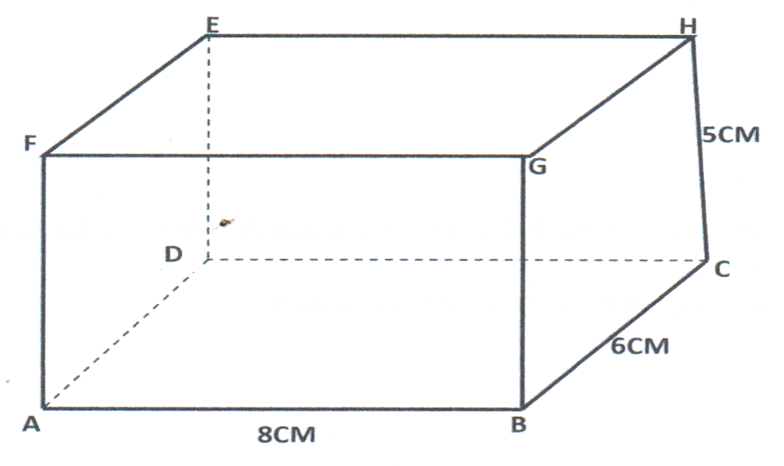

Calculate
- The length BE. (2 marks)

- The angle between BE and plane ABCD correct to (4 s.f) (2 marks)

- For the last 5 years the value of a car has been depreciating at a constant rate of 12 % per annum. The present value of the car is Ksh 316 640. Calculate the value of the car at the beginning of the 5 year period (3 marks)

- Find scalars m and n such that $m\left(\begin{matrix}4 \\ 3\end{matrix}\right)+n\left(\begin{matrix}-3 \\ 2\end{matrix}\right)=\left(\begin{matrix}5 \\ 8\end{matrix}\right)$ (3 marks)

- A transformation is represented by the matrix $\left[\begin{matrix}1 & 2 \\ 3 & 2\end{matrix}\right]$. This transformation maps a triangle ABC of the area $3 cm^{2}$ onto another triangle $’B’C’$ . Find the area of the triangle $A’B’C’$ (3 marks)

- Find the value of $x$ given that $2\log{15-\log{x}=\log{5+\log\left(x-4\right)}}$ (4 marks)

- A circle whose centre is at (1, 3) has the x – axis as its tangent. Determine the equation of the circle in the form $x^{2}+y^{2}+ax+by+c=0$ where a, b and c are integers. (4 marks)

SECTION II (50 Marks)
Instruction: Answer any five questions in this section.
- Three consecutive terms in a G.P are $3^{2x+1}$, $9^{x}$ and 81 respectively.
- Calculate the value of $x$ (2 marks)

- Find the common ratio of the series. (2 marks)

- Calculate the sum of the first 10 terms of the series. (3 marks)

- Given that the 5th and 7th terms of the G.P in (a) above form the first two consecutive terms of an A.P Calculate the sum of the 1st 20 terms of the A.P. (3 marks)

- The table below shows the income tax rate for a certain year
Taxable pay per month (KSh) | Tax rates (%)
$$1-9680$$ | 10
$$9681 – 18800$$ | 15
$$18801 - 27920$$ | 20
$$27921 - 37040$$ | 25
37041 and above | 30
That year Kazembe paid a net tax of Ksh 5212 per month. His total monthly taxable allowances amounted to Ksh 15,220 and he was entitled a monthly personal relief of K.sh 1,162 .Every month the following deductions were made
- NHIF - Ksh 320
- UNION DUES - Ksh 200
- CO-OPERATIVE SHARES - Ksh 7500
- Calculate Kazembe’s gross tax (1 mark)

- Calculate Kazembe’s monthly basic salary in K.sh (6 marks)

- Calculate his monthly net salary (3 marks)

- (a) Draw a circle centre O and radius 4 cm. (1 mark)

(b) From any point A on the circumference, draw two chords AB = 7 cm and AC = 7.5 cm on
the opposite sides of the centre. (2 marks)

(c) Join B to C and locate the orthocenter (H) of triangle ABC. Join OH and measure OH. (4 marks)

(d) Use the midpoint of OH as the centre to inscribe a circle to triangle ABC and measure its radius. (3 marks)
- The position of two towns X and Y are given to the nearest degrees as $X(45°N , 10°E)$ and $Y(45°N , 70°E$).
- Find the difference in longitude (1 mark)

- The distance between the towns in:
- Kilometers (take the radius of the earth = 6371km and $π=\frac{22}{7}$) (3 marks)

- Nautical miles ( take 1 nautical mile to 1.853 km) (2 marks)

c) The local time at X when the local time at Y is 2.00 pm (2 marks)

d) Calculate the speed of the aeroplane moving from X to Y in; (2 marks)
- Km/hr

- Knots

- A soda manufacturing company supplies two types of drinks, Fanta and Coke. The total number of crates must not be more than 400.The company must supply more crates of Fanta than Coke. However the number of crates of Fanta must not be more than 300 and the number of crates of coke must not be less than 80. Taking $x$to represent Fanta and $y$ to represent Coke,
- Write down all inequalities representing the given information (4 marks)

- Represent the inequalities on the grid provided (4 marks)
- The profit obtained was as follow
Fanta Sh. 300 per crate
Coke Sh. 200 per crate
- Use the graph to determine the number of crates of each type that should give maximum profit (1 mark)

- Calculate the maximum profit (1 mark)

- (a) Complete the table below for the functions $y=2\cos{x}$ and $y=\sin{2x}$ for $-180°≤x≤180°$ (2 marks)

$$x°$$ | $$-180°$$ | $$-150°$$ | $$-120°$$ | $$-90°$$ | $$-60°$$ | $$-30°$$ | $$0°$$ | $$30°$$ | $$60°$$ | $$90°$$ | $$120°$$ | $$150°$$ | $$180°$$
$$2x°$$ | $$-360°$$ | $$-300°$$ |  |  |  | $$-60°$$ |  |  | $$120°$$ |  |  | $$300°$$
$$2\cos{x}$$ |  |  | $$-1$$ |  | $$1$$ |  |  |  | $$1$$ |  |  |  | $$-2$$
$$\sin{2x}$$ | $$0$$ |  |  |  | $$-0.87$$ |  |  | $$0.87$$ |  |  | $$-0.87$$
(b) On the grid provided, on the same axis draw the graphs $y=2\cos{x}$ and $y=\sin{2x}$ for $-180°≤x≤180°$ (4 marks)

(c) Use the graphs in (b) above to find;
- The value of x such that for $2\cos{x}-\sin{2x=0}$ (1 mark)

- State the amplitude and period of the graph $y=2\cos{x}$ (2 marks)

- Find the difference in value of y when $x=-45°$. (1 mark)

- The diagram below shows triangle OAB in which N is the mid-point of AB and M is a point on OA such that $OM:MA = 2:1$.
Given that $\vec{OA}=\check{a}$ and $\vec{OB}=\check{b}$.
- Express in terms of $\check{a}$ and $\check{b}$.
- $\vec{AB}$ (1 mark)

- $\vec{ON}$ (2 marks)

- $\vec{BM}$ (1 mark)

- Lines ON and BM meet at X such that $OX=hON$ and $MX=kMB$ where h and k are constants.
- Express OX in terms of $\check{a}, \check{b}$ and $h$. (1 mark)

- Express OX in terms of $\check{a}, \check{b}$ and k. (1 mark)

- Hence find the value of h and k. (3 marks)

- Find the ratio $OX: XN$. (1 mark)

- A triangle with vertices at P(1,1) , Q(-3,2) and R (0,3) is transformed by a matrix $\left[\begin{matrix}3 & 0 \\ 1 & 2\end{matrix}\right]$ to triangle P’Q’R’.
- Determine the coordinates of the image (2 marks)

- On the grid provided draw the object and the image (2 marks)

- $P’Q’R’$ is then transformed by the transformation with the matrix $\left[\begin{matrix}\frac{2}{3} & 0 \\ -\frac{2}{3} & 2\end{matrix}\right]$ to $P’’Q’’R’’$ .Find the coordinates of $P’’Q’’R’’$ and draw $P’’Q’’R’’$ (3 marks)

- Find a single matrix which maps PQR onto P’’Q’’R’’ (3 marks)

