**MATHEMATICS PAPER 2 MARKING SCHEME**

|  |  |  |
| --- | --- | --- |
| **No** | **Working** | **Remarks** |
| 1 |  | M1  M1  A1 |
| 2 | Cost price  Taking profit as 30% | M1  M1  A1 |
| 3 |  | M1  A1  B1 |
| 4 |  | B1  B1 |
| 5 | , | M1  A1  M1  A1 |
| 6 | P(M and W) or P( W and M) | M1  M1  A1 |
| 7 | At A,  Gradient of tangent = 11 | M1  M1  A1 |
| 8 | Area of a sector  Length of an arc | M1  A1 |
| 9 | Mean   |  |  |  | | --- | --- | --- | |  |  |  | | 43 |  | 144 | | 48 |  | 49 | | 54 |  | 1 | | 55 |  | 0 | | 56 |  | 1 | | 57 | 2 | 4 | | 62 | 7 | 49 | | 65 | 10 | 100 | |  |  |  |     Standard dev = | B1  B1 for  M1 A1 |
| 10 |  | M1  A1 |
| 11 | 1. DB =   BE = = 11.18 cm | M1  A1  M1  A1 |
| 12 |  | M1  M1  A1 |
| 13 | .... (i)  ..... (ii)  From (i) | M1  M1  A1 for both values |
| 14 | Determinant =  Area of image = | M1  M1  A1 |
| 15 | Accept only | M1  M1  M1  A1 |
| 16 |  | M1  M1  M1  A1 |
| 17 | 1. Common ratio     S4 = 729  = 729  =  = 1080   1. For the A.P, | M1  A1  M1  A1  M1  M1  A1  B1  M1  A1 |
| 18 | 1. Tax due   1st band =  2nd band =  3rd band =  4th band =    Taxable income    Basic salary   1. Total deductions   Net salary | B1  M1  M1  M1  A1  M1  M1  A1 |

19. (a)

B1 for circle r = 4 cm

B2 for AC and AB

B1 for BC

B2 for perpendicular bisectors

B2 for circle touching points A,B and C only

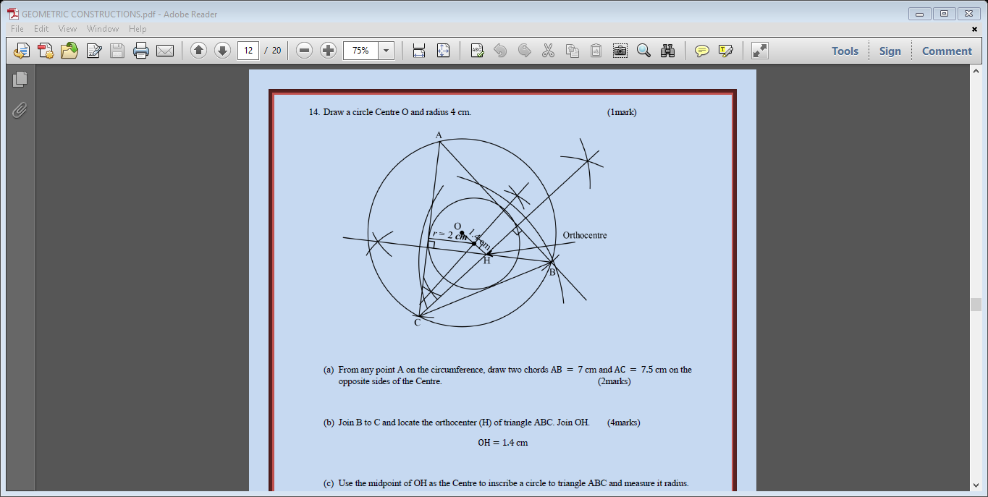

|  |  |  |
| --- | --- | --- |
| 19 | 1. OH = 1.4 cm 2. Radius = 2.0 cm | B1  B1 |
| 20 | 1. (i) Distance =       (ii)     1. Time difference =   2.00 p.m. + 4 hrs = 6.00 p.m   1. (i)   (ii) | B1  M1  M1  A1  M1  A1  B1  B1  B1  B1 |
| 21 | 1. (i) Fanta = 300 crates   Coke = 100 crates  (ii) | B1  B1  B1  B1  B1  B1 |

b) 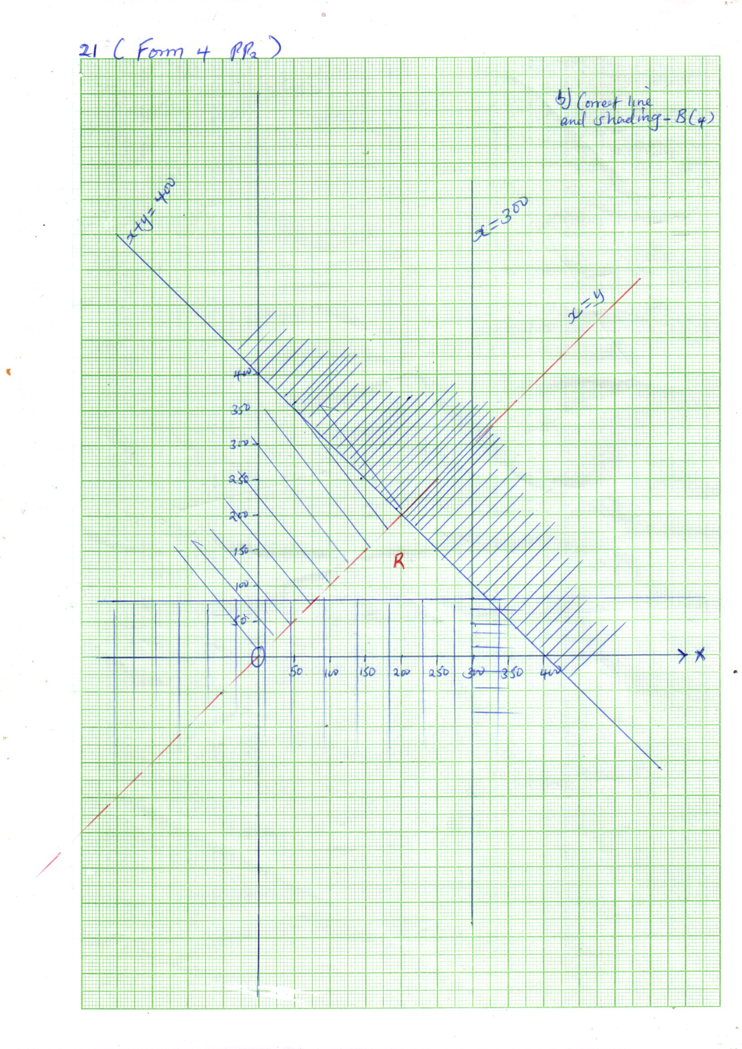

B1 for each of the inequalities total 4 marks

22 (a)

|  |  |  |  |  |  |  |  |  |  |  |  |  |  |
| --- | --- | --- | --- | --- | --- | --- | --- | --- | --- | --- | --- | --- | --- |
|  |  |  |  |  |  |  |  |  |  |  |  |  |  |
|  |  |  |  |  |  |  |  |  |  |  |  |  |  |
|  |  |  |  |  |  |  |  |  |  |  |  |  |  |
|  |  |  |  |  |  |  |  |  |  |  |  |  |  |

|  |  |  |
| --- | --- | --- |
| 22 | S & A =1  P = 2  C =1   1. (i) B1   (ii) Amplitude = 2 B1  Period = B1  (iii)    Difference in y B1 | |
| 23 | 1. (i)   (ii)    (iii)   1. (i)   (ii)    (iii)  ................ (i)  ..... (ii) | B1  M1  A1  B1  B1  B1  M1  M1  A1 for both h and k  B1 |
| 24 | 1. On the graph shown below         Matrix M = | M1  A1  M1 M1  A1  M1  M1 solving simultaneous equations  A1 |

24 (b)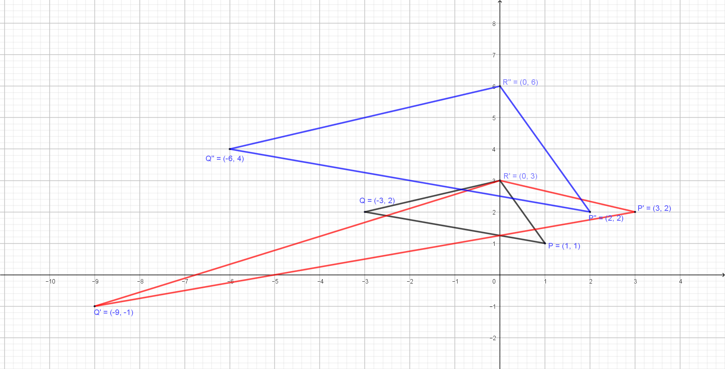

B1 for

B1 for

B1 for