**NAME** ……………………………………….…… **ADM NO**……….… **DATE** …….………

**SCHOOL**…………………………………………...……… **SIGNATURE** …………...……….

121

MATHEMATICS

FORM 4 PAPER 1

TIME: 2 ½ HOURS

**END OF TERM TWO EXAMINATION**

**Kenya Certificate of Secondary Education**

**INSTRUCTIONS TO CANDIDATES**

1. *Write your name and admission number in the spaces provided at the top of this page.*
2. *This paper consists of two sections:* **Section I and Section II.**
3. *Answer* ***al****l questions in* **section I** and any five questions in Section **II.**
4. *Show all the steps in your calculations, giving your answers at each stage in the spaces below each question.*
5. *Marks may be given for correct working even if the answer is wrong.*
6. ***KNEC*** *Mathematical tables may be used.*

**For Examiner’s Use Only**

|  |  |  |  |  |  |  |  |  |  |  |  |  |  |  |  |  |
| --- | --- | --- | --- | --- | --- | --- | --- | --- | --- | --- | --- | --- | --- | --- | --- | --- |
| **1** | **2** | **3** | **4** | **5** | **6** | **7** | **8** | **9** | **10** | **11** | **12** | **13** | **14** | **15** | **16** | **Total** |
|  |  |  |  |  |  |  |  |  |  |  |  |  |  |  |  |  |

|  |  |  |  |  |  |  |  |
| --- | --- | --- | --- | --- | --- | --- | --- |
| **17** | **18** | **19** | **20** | **21** | **22** | **23** | **24** |
|  |  |  |  |  |  |  |  |

**Grand**

**Total**

**SECTION I (50 Marks)**

**Answer all the questions in this section**

1. Evaluate without using mathematical tables or a calculator; (3 marks)

$\frac{0.0084×1.23×3.5}{2.87×0.056}$

1. Use the prime factors of 7056 and 74088 to evaluate (4 marks)
$$\frac{\sqrt[3]{74088}}{\sqrt{7056}}$$

2. A bus left Nairobi and travelled towards Busia at an average speed of 90 km/h. After $2\frac{2}{9}$ hours, a car left Nairobi and travelled along the same road at an average speed of 170 km/h. If the distance between Nairobi and Busia is 800 km, Determine the distance the car travelled to catch up with the bus. (3 marks)
3. Factorize $16a+12b-8a^{2}-6ab$ (2 marks)
4. Find the area of the triangle below correct to 4 .s.f (2 marks)

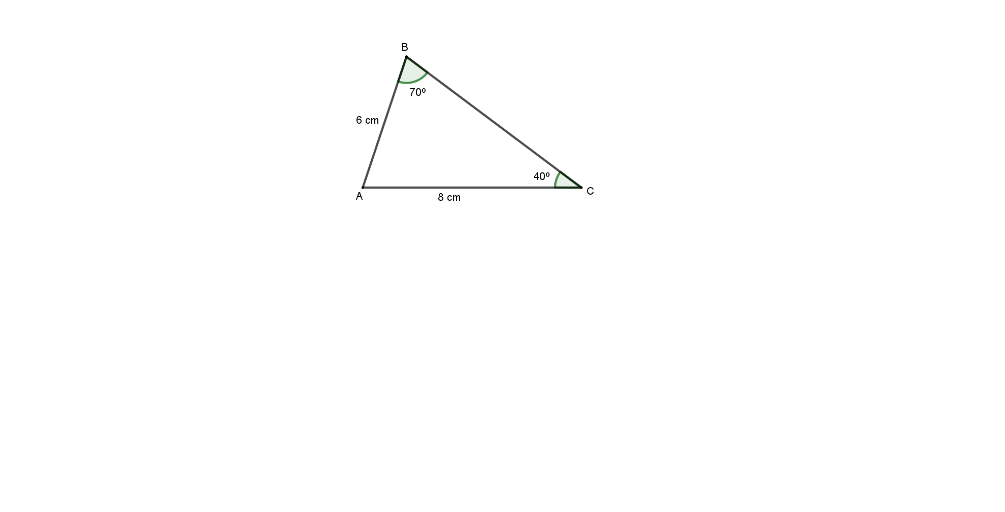

1. Without using mathematical tables or a calculator, solve for x in: (3 marks)
$$\frac{{81}^{x}}{9^{x+1}}=3\sqrt{3}$$

2. B is on a bearing of $N30°E$ from A and C is due East of B. The distance from A to B is 600km and the distance from B to C is 400km. Calculate the distance from A to C. (3 marks)
3. The length of three wires were 30m, 36m and 84m .pieces of wire of equal length were cut from the three wires. Calculate the least number of pieces obtained (3 marks)
4. Given that $\sin{x=\frac{4}{5}}$ where x is an acute angle, find the value of $\cos\left(180-x\right)°$ (3 marks)
5. A Kenyan bank buys and sells foreign currencies as shown below

|  |  |  |
| --- | --- | --- |
|  | Buying (Ksh) | Selling (Ksh) |
| 1 Hong Kong dollar | 9.74 | 9.77 |
| 1 South African rand | 12.03 | 12.11 |

A tourists arrived in Kenya with 105 000 Hong Kong dollars and changed the whole amount to Kenyan shillings. While in Kenya, she Spent Ksh. 403 897 and changed the balance to South African rand before leaving for South Africa. Calculate the amount, in South African rand that she received. (3 marks)

1. Given the column vectors $a=\left(\begin{matrix}-1 \\ 4\end{matrix}\right)$, $b=\left(\begin{matrix}-3 \\ -2\end{matrix}\right),c=\left(\begin{matrix}-2 \\ -1\end{matrix}\right)$ and that $\check{p}=2\check{a}-4\check{b}+3\check{c}$
2. Express P as a column vector (2 marks)
3. Hence find its magnitude (2 marks)
4. (a) Using a ruler and a pair of compass only construct triangle PQR such that PQ = 4 cm, QR = 6 cm and $∠PQR =60°$ (2 marks)

(b) Hence construct an escribed circle to triangle PQR touching line PR. (2 marks)

1. Solve the inequality sand state the integral values of $x$. (3 marks)

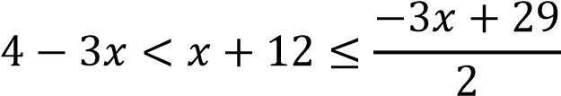

1. Determine the point of intersection of the lines $2x-3y=8$ and $x+2y=-3$ using matrix method. (3 marks)
2. Use graphical method to solve the pair of simultaneous equations (3 marks)



$$2x+y=3$$

$$5x+3y=7$$

1. Njoroge boarded a bus that took off at 9.45pm on a Sunday to visit his sister in Nairobi. The bus took 8 hours 20 minutes to arrive in Nairobi. After 10 minutes he took a taxi that took 42 minutes to arrive at his sister’s home. Find the day and time in 24hr system when Njoroge arrived at his sister’s home. (3 marks)

**SECTION II (50 Marks)**

**Answer any five questions only in this section**

1. The figure below ABCDEFGH is a frustum of a right pyramid .The altitude of the frustum is 2cm.

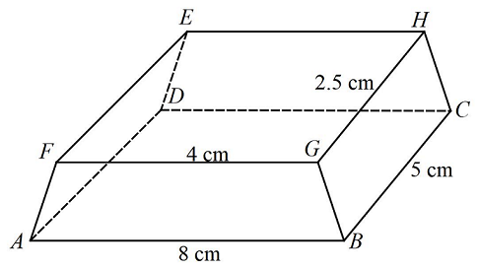

Calculate

1. The altitude of the pyramid (5 marks)
2. The volume of the frustum (5 marks)
3. A line **L1** with then equation $-mx+2y=3$ passes through the point $\left(-3, 1\right)$.

Calculate;

1. The value of **m**. (2 marks)

1. The angle the line makes with $x$– axis correct to 4 significant figures. (2 marks)
2. The equation of line **L2** parallel to **L1** and passes through ($2,6$). Leave your answer in the form $\frac{x}{a}+\frac{y}{b}=1$. (3 marks)
3. The equation of the line **L3** perpendicular to **L1** at ). Give your answer in the form $ax+by=c$ (3 marks)
4. The vertices of quadrilateral OPQR are $O (0,0), P(2, 0), Q(4, 2)$ and $R(0, 3).$ The vertices of its image under a rotation are $O’(1, -1), P'(1, -3) Q'(3, -5)$ and $R'(4, -1)$.
5. (i) On the grid provided, draw OPQR and its image $O'P'Q'R'$ (2 marks)

(ii) By construction, determine the centre and angle of rotation. (3 marks)

1. On the same grid as (a) (i) above, draw $O''P''Q''R''$, the image of $O'P'Q'R'$ under a reflection in the line $y = x$ (3 marks)
2. From the quadrilaterals drawn, state the pairs that are:
3. Directly congruent; (1 mark)
4. Oppositely congruent (1 mark)
5. Below is a cylinder of diameter 21m in which a hole in the shape of a cuboid has been drilled through the centre as shown below.

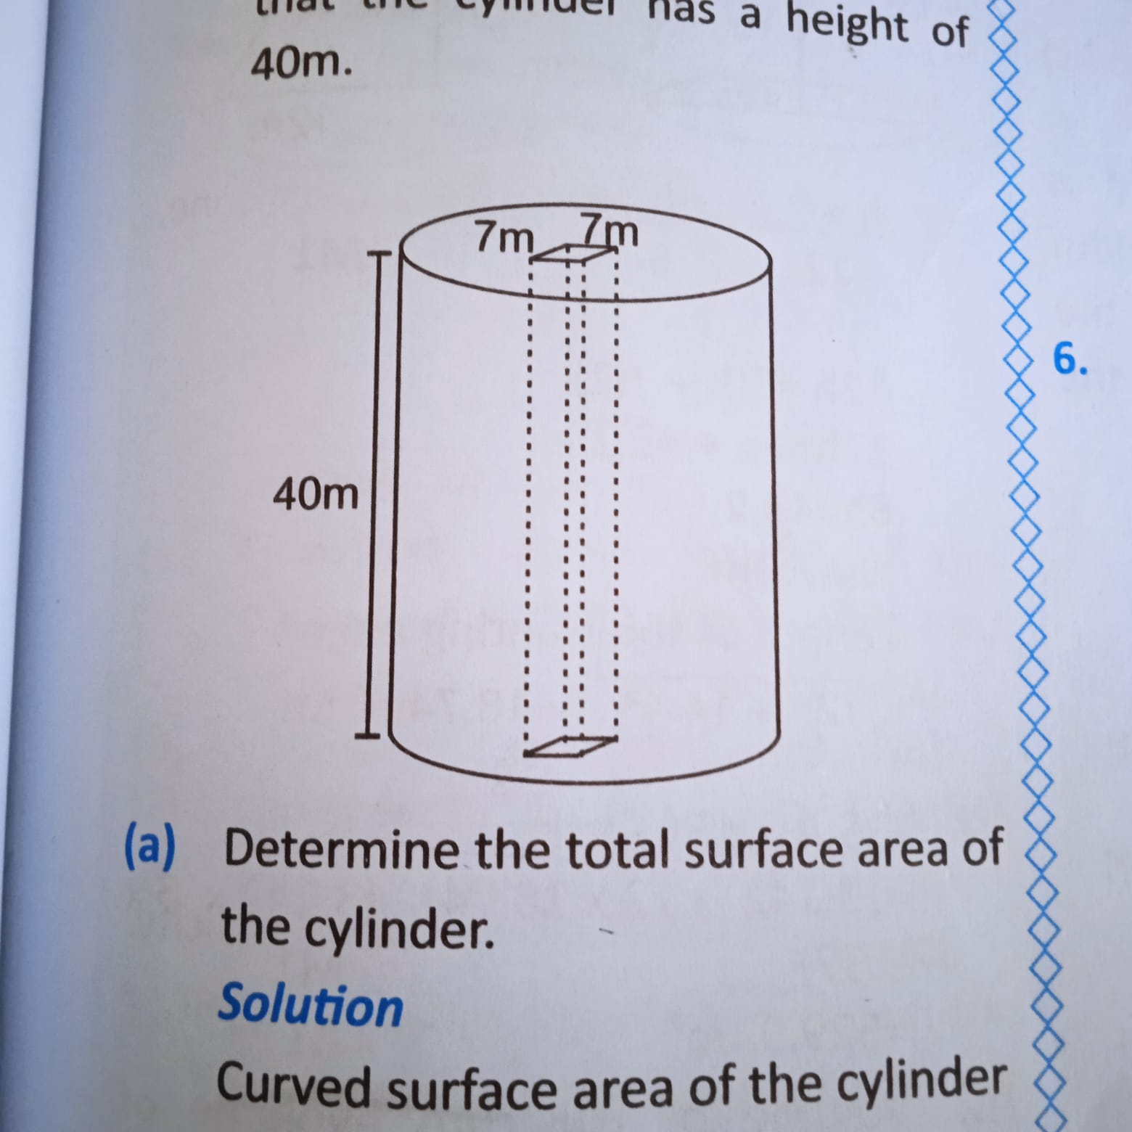

Given that the cylinder has a height of 40m

1. Determine the total surface area of the cylinder (7 marks)
2. Volume of the solid. (3 marks)
3. The table below shows the marks obtained by 40 students in an examination.

|  |  |  |  |  |  |
| --- | --- | --- | --- | --- | --- |
| Marks | $$5-14$$ | $$15-29$$ | $$30-34$$ | $$35-44$$ | $$45-49$$ |
| Frequency f | 2 | 2 | 7 | 15 | $$x$$ |

1. Find the value of $x.$ (2 marks)
2. On a grid, draw a histogram to represent the data. (5 marks)
3. By drawing a straight line on the graph, determine the median mark. (3 marks)
4. The figure below shows a triangular garden XZY. $XZ=6cm$, $XY=4cm$ and $angle XZY =40°$.

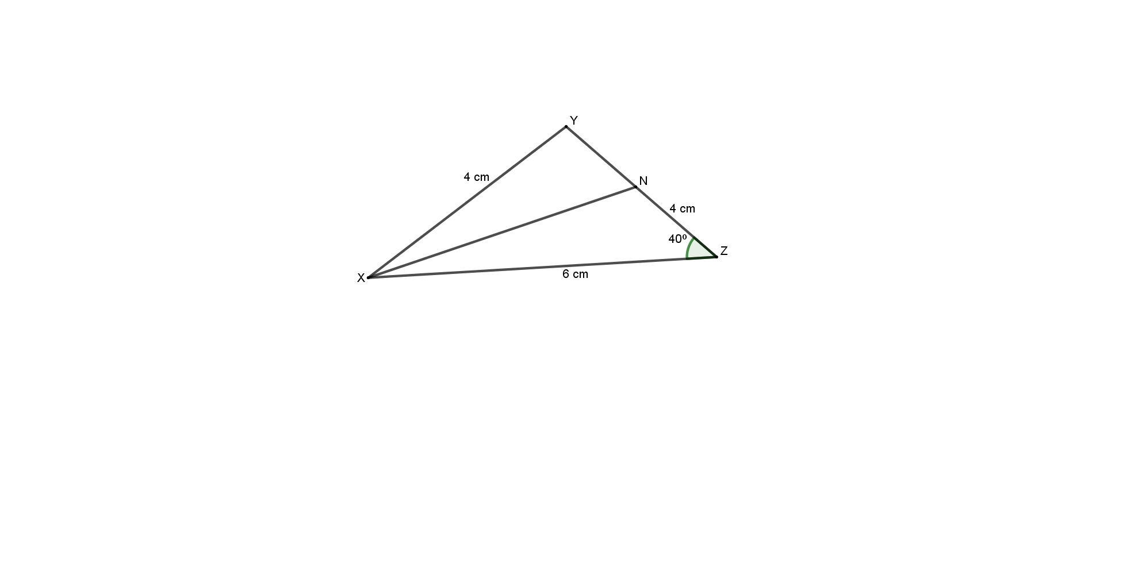

A point N lies on the line ZY such that $ZN = 4cm$. Find correct to 2 decimal places

1. $∠ZNX$ (3 marks)
2. Length of ZY (3 marks)
3. Length of NY (2 marks)

1. Area of the garden (2 marks)
2. (a) Draw the graph of the function $y=10+3x-x^{2}$ for $-2≤x≤5$ (4 marks)

|  |  |  |  |  |  |  |  |  |
| --- | --- | --- | --- | --- | --- | --- | --- | --- |
| $$x$$ | $$-2$$ | $$-1$$ | 0 | 1 | 2 | 3 | 4 | 5 |
| $$y$$ |  |  |  |  |  |  |  |  |

(b) Use trapezoidal rule with 5 strips to estimate the area of the curve from $x=-1$ to $x=4$ (2 marks)

(c) Use integration to find the actual area of the curve from $x= -1$ to $x=4$. (2 marks)

(d) Find the percentage error of the estimated area to the actual area of the region correct to 2 decimal places (2 marks)

1. The displacement of a particle after t seconds is given by $s=40t^{3}-t^{2}-3t+3$.

Find

1. Displacement of the particle when t = 2 (2 marks)
2. The values of t when the particle is momentarily at rest (3 marks)
3. The velocity when the particle is momentarily at rest (2 marks)
4. The acceleration when the particle is momentarily at rest (3 marks)