NAME ……………………………………….…… ADM NO……….… DATE …….………
SCHOOL…………………………………………...……… SIGNATURE …………...……….
121
MATHEMATICS
FORM 3

TIME: 2 ½ HOURS
END OF TERM TWO EXAMINATION
Kenya Certificate of Secondary Education

INSTRUCTIONS TO CANDIDATES
- Write your name and admission number in the spaces provided at the top of this page.
- This paper consists of two sections: Section I and Section II.
- Answer all questions in section I and any five questions in Section II.
- Show all the steps in your calculations, giving your answers at each stage in the spaces below each question.
- Marks may be given for correct working even if the answer is wrong.
- KNEC Mathematical tables may be used.

For Examiner’s Use Only

1 | 2 | 3 | 4 | 5 | 6 | 7 | 8 | 9 | 10 | 11 | 12 | 13 | 14 | 15 | 16 | Total

17 | 18 | 19 | 20 | 21 | 22 | 23 | 24
Grand
Total

SECTION I (50 marks)
- Without using a calculator evaluate (3 marks)
$\frac{2\frac{1}{3}-1\frac{2}{3}÷\frac{5}{9}}{\frac{4}{7}of2\frac{1}{3}-2\frac{2}{7}}$

- Simplify the expression. (3 marks)
$$\frac{18xy-18xr}{9xr-9xy}$$

- Solve the equation $\sin\left(\frac{5}{2}x\right)=-\frac{1}{2}$ for $0°≤x≤360°$ (3 marks)

- The sum of the interior angles of a regular polygon is $1800°$. Find the size of each exterior angle
(3 marks)

- In the figure below the shaded region is a segment of the circle with Centre O and radius r. $AB=8 cm$, $ON = 3 cm$, angle AOB =$106.3°$.
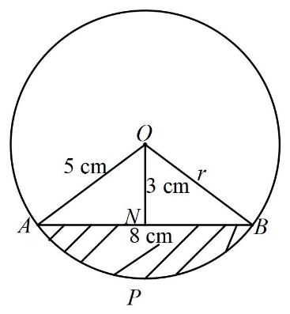
Find the area of the shaded part. (4 marks)

- Simplify the expression $\frac{\sqrt{48}}{\sqrt{5} + \sqrt{3}}$ leaving your answer in the form $a+b\sqrt{c}$ where a, b and c are integers. (3 marks)

- By use of a quadratic formula solve the equation (3 marks)
$$2P(P+1)=4$$

- Solve for $x$ in the equation (3 marks)
${32}^{(x-3)}÷8^{(x-4)}$=64$÷2^{x}$

- Use logarithms correct to 4 decimal places to evaluate; (4 marks)
$$\sqrt{\frac{83.46×0.0054}{{1.56}^{2}}}$$

- Make H the subject of the formula (3 marks)
$F=\sqrt{\frac{H-2WL}{3H}}$

- In the figure below angle BAC and ADC are equal. Angle ACD is a right angle. The ratio of the sides $AC:BC =4:3$. Given that area of triangle ABC is 24 cm², find the area of triangle ACD. (3 marks)
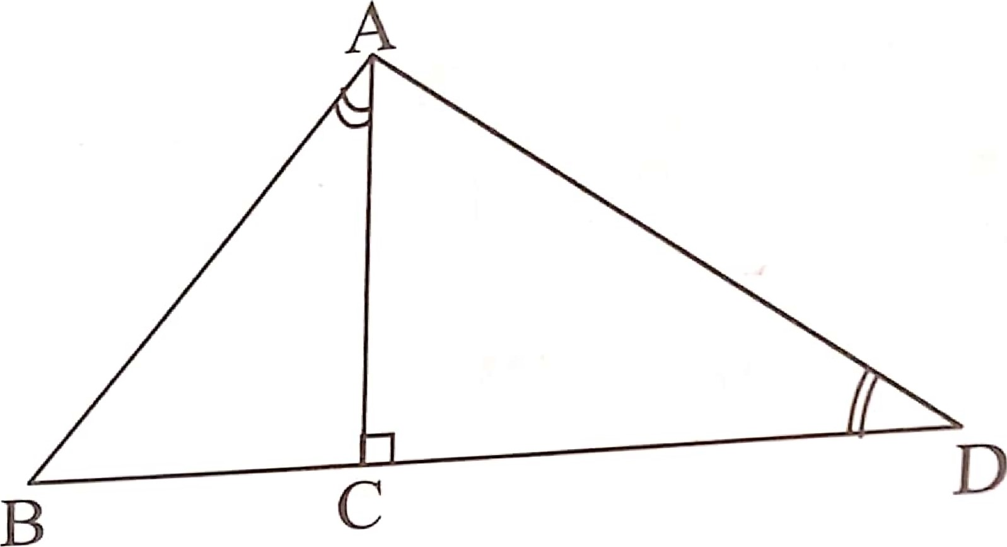

- Evaluate without using a calculator or a mathematical table, (3 marks) $\log\left(3x+8\right)-3log{2}=\log\left(x-4\right)$

- In the figure below O is the centre .Calculate the angles marked $x$ ,$y$ and $z$ (3 marks)

- The exchange rate in January 2000 was US $ 1 = Ksh 75.60 and UK £1 = Ksh 115.80.
A tourist came to Kenya with US $ 5000 and out of it spent ksh.189,000. He changed the balance in UK£. How many pounds did he receive? (3 marks)

- The length and width of a rectangle are given to the nearest 0.1 cm as 18.5 cm and 12.4 cm respectively. Calculate the percentage error in the area of the rectangle. (3 marks)

- Solve the following inequalities and hence state the integral values that satisfy the inequalities. (3 marks)
$x+1≤4x-5<3x+2$

SECTION II (50 Marks)

- (a) L₁ is a line which passes through $\left(2, 5\right)$, $\left(5, 16\right)$ and $\left(-4, h\right)$. Find the equation of the line and the value of h. (3 marks)

(b) Equation of L₂ is $3y + x =23$ and it intersects line L₁ at point A. Find the co-ordinates of A. (2 marks)

(c) B $\left(-1, p\right)$ is on line L₁. Find p hence find the length of AB. (2 marks)

(d) C$\left(t, 9\right)$ is on the line L₂. Find t. It is given that the line L₃ passes through C and parallel to L₁. Find the equation of L₃ (3 marks)

- The table below shows the rates of taxation in a certain year.
Income in K£ p.a | Rates in Ksh per K£
$$1-3900$$ | 2
$$3901-7800$$ | 3
$$7801-11700$$ | 4
$$11701-15600$$ | 5
$$15601-19500$$ | 7
$$19501 and above$$ | 9
In that year, Juma was earning a basic salary of Ksh. 41 000 per month. In addition he was entitled to a house allowance of Ksh. 13 000 p.m. and a personal relief of Ksh. 1056 p.m.
- Calculate Juma’s taxable income in K£ per annum. (2 marks)

- How much tax did he pay per month? (5 marks)

- His other deductions per month included: Sacco contribution of Ksh 4000 and loan repayment of Ksh 5 500. Calculate Juma’s net salary. (3 marks)

- The distance between towns A and B is 360km .A minibus left town A at 8.15a.m and travelled towards town B at an average speed of 90km/hr .A matatu left town B two and a third hours later on the same day and travelled towards town A at an average speed of 110km/hr.
- (i) At what time did the two vehicles meet (4 marks)

(ii) How far from town A did the two vehicles meet (2 marks)

- A motorist started from his home at 10.30 a.m. on the same day as the matatu and travelled at an average speed of 100km/hr .He arrived at B at the same time as the minibus .Calculate the distance from A to his house. (4 marks)

- A triangle ABC with vertices $A(-4,2),$ $B(-6,6)$ and $C(-6,2)$ undergoes enlargement scale factor $-1$ and centre $(-2,6)$ to produce triangle $A'B'C'$.
- On the grid provided draw triangle ABC and its image $A'B'C'$, state the co-ordinates of $∆A'B'C'$ (4 marks)

- Triangle $∆A'B'C'$ is the reflected in the line $y+x=0$ to give $∆A''B''C''$ . Draw triangle $∆A''B''C''$ and state the co-ordinates of its vertices. (3 marks)

- If triangle $A'B'C'$ is mapped onto a triangle whose co-ordinates are $'''(-4,-2)$ , $B'''(-6,-6)$ and $C'''(-6,-2)$ by a rotation, find the centre and angle of rotation. (3 marks)

- Three quantities R, S and T are such that R varies directly as S and inversely as the square root of T.
- R = 480 when S = 150 and T = 25.Write an equation connecting R, S and T. (4 marks)

- Find;
- The value of R when S = 360 and T = 2.25. (2 marks)

- The percentage change in R if S is increased by 5% and T decreased by 15.36%. (4 marks)

- The diagram below represents a lampshade in the form of an open-ended frustum of a cone. Its bottom and the top diameters are 14cm and 7cm respectively. Its height is 10cm. Use ($π=3.142$)
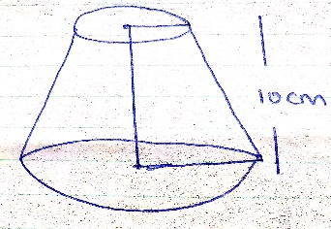
    - Find
- The height of the cone from which the frustum was cut. (2 marks)

- The area of the curved surface of the frustum (5 marks)

    - The material used for making the lampshade is sold at Shs.800 per square metre. Find the cost of 10 lampshades if a lampshade is sold at twice the cost of the material. (3 marks)

- The table below shows the mass of 60 women working in hotels
Mass (Kg) | $$60 – 64$$ | $$65 – 69$$ | $$70 – 74$$ | $$75 - 79$$ | $$80 – 84$$ | $$85 - 89$$
No. of women | 8 | 14 | 18 | 15 | 3 | 2
- State:
- The modal class (1 mark)

- The median class (1 mark)

- Estimate the mean mark (4 marks)

- Draw a histogram for the data (2 marks)

- Two vertical walls of height h and 2h respectively stand on a level ground and the walls are 100m apart. From a point P which is y m from the shorter wall, the angles of elevation of the top of the walls are $35°$ and $28°$ respectively. From another point Q, d metres from P, the angle of elevation of the top of the taller building is $75°$ as shown.
Calculate;
- The vertical heights of the two walls. (6 marks)

- The distance PQ in metres correct to 1 decimal place. (4 marks)

