**NAME** ……………………………………….…… **ADM NO**……….… **DATE** …….………

**SCHOOL**…………………………………………...……… **SIGNATURE** …………...……….

121

MATHEMATICS

FORM 2

TIME: 2 ½ HOURS

**END OF TERM TWO EXAMINATION**

**Kenya Certificate of Secondary Education**

**INSTRUCTIONS TO CANDIDATES**

1. *Write your name and admission number in the spaces provided at the top of this page.*
2. *This paper consists of two sections:* **Section I and Section II.**
3. *Answer* ***al****l questions in* **section I** and section **II.**
4. *Show all the steps in your calculations, giving your answers at each stage in the spaces below each question.*
5. *Marks may be given for correct working even if the answer is wrong.*
6. ***KNEC*** *Mathematical tables may be used.*

**For Examiner’s Use Only**

|  |  |  |  |  |  |  |  |  |  |  |  |  |  |  |  |  |
| --- | --- | --- | --- | --- | --- | --- | --- | --- | --- | --- | --- | --- | --- | --- | --- | --- |
| **1** | **2** | **3** | **4** | **5** | **6** | **7** | **8** | **9** | **10** | **11** | **12** | **13** | **14** | **15** | **16** | **Total** |
|  |  |  |  |  |  |  |  |  |  |  |  |  |  |  |  |  |

|  |  |  |  |  |
| --- | --- | --- | --- | --- |
| **17** | **18** | **19** | **20** | **21** |
|  |  |  |  |  |

**Grand**

**Total**

**SECTION I (50 marks)**

1. Wafula uses $\frac{1}{6}$ of his land for planting maize $\frac{1}{12}$ for beans and $\frac{4}{9}$ of the remainder for grazing. He still has 10 hectares of unused land. Find the size of Wafula’s land (3 marks)
2. In a right angle triangle, one shorter side is 6 cm and longer side is 10cm. Find :
3. Length of the other side (1 mark)
4. The area of the triangle (2 marks)
5. Wambua’s family is watching a movie. Wambua checked the watch and realized that the movie ended at 0110h. If the movie lasted 2.3 hours, what was the time on Wambua’s watch when the movie started? (2 marks)
6. Find the area of a triangular plot with side 85m,75m and 60m in hectares (3 marks)
7. When a certain number $x$ is divided by 30, 45 or 54, there is always a remainder of 21. Find the least value of the number $x$. (3 marks)
8. Solve for $x$ in the following equation: $Sin\left(\frac{1}{2} x-{10}^{0}\right)=Cos2x$ (3 marks)
9. Use logarithm table to evaluate (4 marks)

$\sqrt{\frac{0.246×142}{0.02×1.14}}$

1. (a) Using a ruler and compass only, construct triangle PQR in which $PQ=3.5 cm$, $QR = 7 cm$ and angle $PQR=30°$ (2 marks)

(b) Construct a circle passing through points P, Q and R (2 marks)

1. In the figure below points O, A and C represents the center of an arc of a circle. $OA=OC=AC=12 cm$

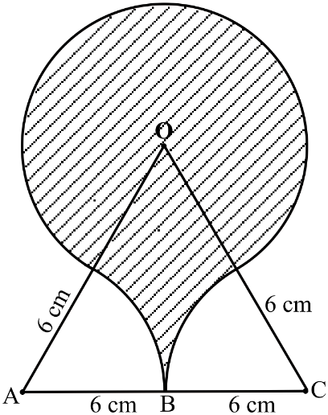

Calculate the area of the shaded region correct to 4 significant figures. (3 marks)

1. Express $\frac{x-y}{3}-\frac{2x-y}{2}$ as a single fraction (3 marks)
2. Find the equation of the line perpendicular to the line $4x-y = -5$ and passing through the point $(-3,-2).$ (3 marks)
3. Simplify; $\frac{4xy+{8y}^{2}-3x-6y}{8y-6}$ (3 marks)
4. Otieno is standing at a point P 300m away from a building. The angle of elevation from point P to the top of the building is $32°$. He then walks 200m towards the building to a point Q.
5. Find the height of the building correct to 2 d.p (1 mark)
6. Find the angle of elevation from point Q to the top of the building (2 marks)
7. The volume of two similar cylinders are $4 752 {cm}^{3}$ and $1 408 {cm}^{3}$.If the area of curved surface of the smaller one is $352 {cm}^{2}$, find the area of the curved surface of the larger cylinder . (3 marks)
8. 7500 ml of milk is poured into a cylindrical milk churn. Given that the height of the milk in the churn is 30 cm, determine the surface area in contact with the milk in the churn.(4 marks)
9. A minor arc of a circle subtends an angle of $105°$ at the centre of the circle. If the radius of the circle is 8.4 cm, find the length of the major arc (3 marks)

**SECTION II (50 marks)**

**Answer all the questions in the spaces provided.**

1. The exchange rate on March 17th 2000, was as follows: -

1 US$ = Kshs.74.75

1 French Franc (Fr) = Kshs.11.04

A Kenyan tourist had Ksh. $350,000$ and decided to proceed to America .

1. How much in dollars did he receive from his Ksh. $350, 000$ in 4 s.f? (3 marks)
2. The tourist spend ¼ of the amount in America and proceeded to France where he spend Fr 16,200. Calculate his balance in French Francs to 4 s.f (4 marks)
3. When he flies back to Kenya, the exchange rate for 1 Fr = Kshs.12.80. How much more in Kshs. does he receive for his balance than he would have got the day he left?(3 marks)
4. The figure below (not drawn to scale) shows two intersecting circles centres P and Q with radii 6 cm and 5 cm respectively. The common chord AB is 9.3 cm long.



Determine;

1. Angle APB. (2 marks)
2. Angle AQB. (2 marks)
3. The common area between the two circles. (Shaded region). (6 marks)
4. The diagram below shows a frustum which represents a bucket with an open end diameter of 30cm and bottom diameter 24cm.

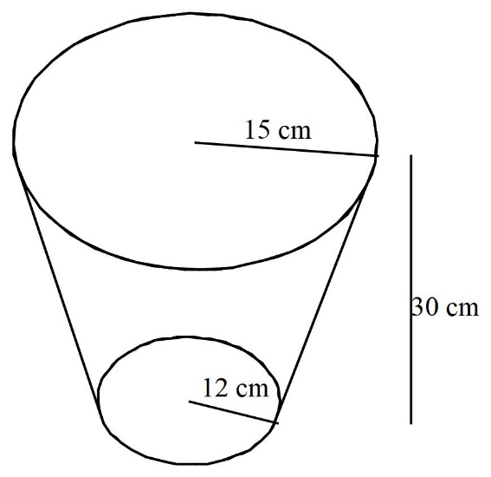

The bucket is 30cm deep. (Use $π=3.142$)

1. Calculate the capacity of the tank in litres (5 marks)
2. The bucket is used to fill an empty cylindrical tank of diameter 1.4m and height 1.2m
3. Calculate the capacity of the tank in litres (3 marks)
4. Determine the number of buckets that must be drawn in order to fill the tank. (2 marks)
5. A rectangle ABCD is such that A and C lie on the line $y = 3x$. The images of B and D under a reflection in the line $y = x$ are $B'(-1, -3)$ and $D'(1,3)$ respectively.
6. Draw on a cartesian plane, the line $y = x$ and mark points $B'$ and $D'$ (3 marks)

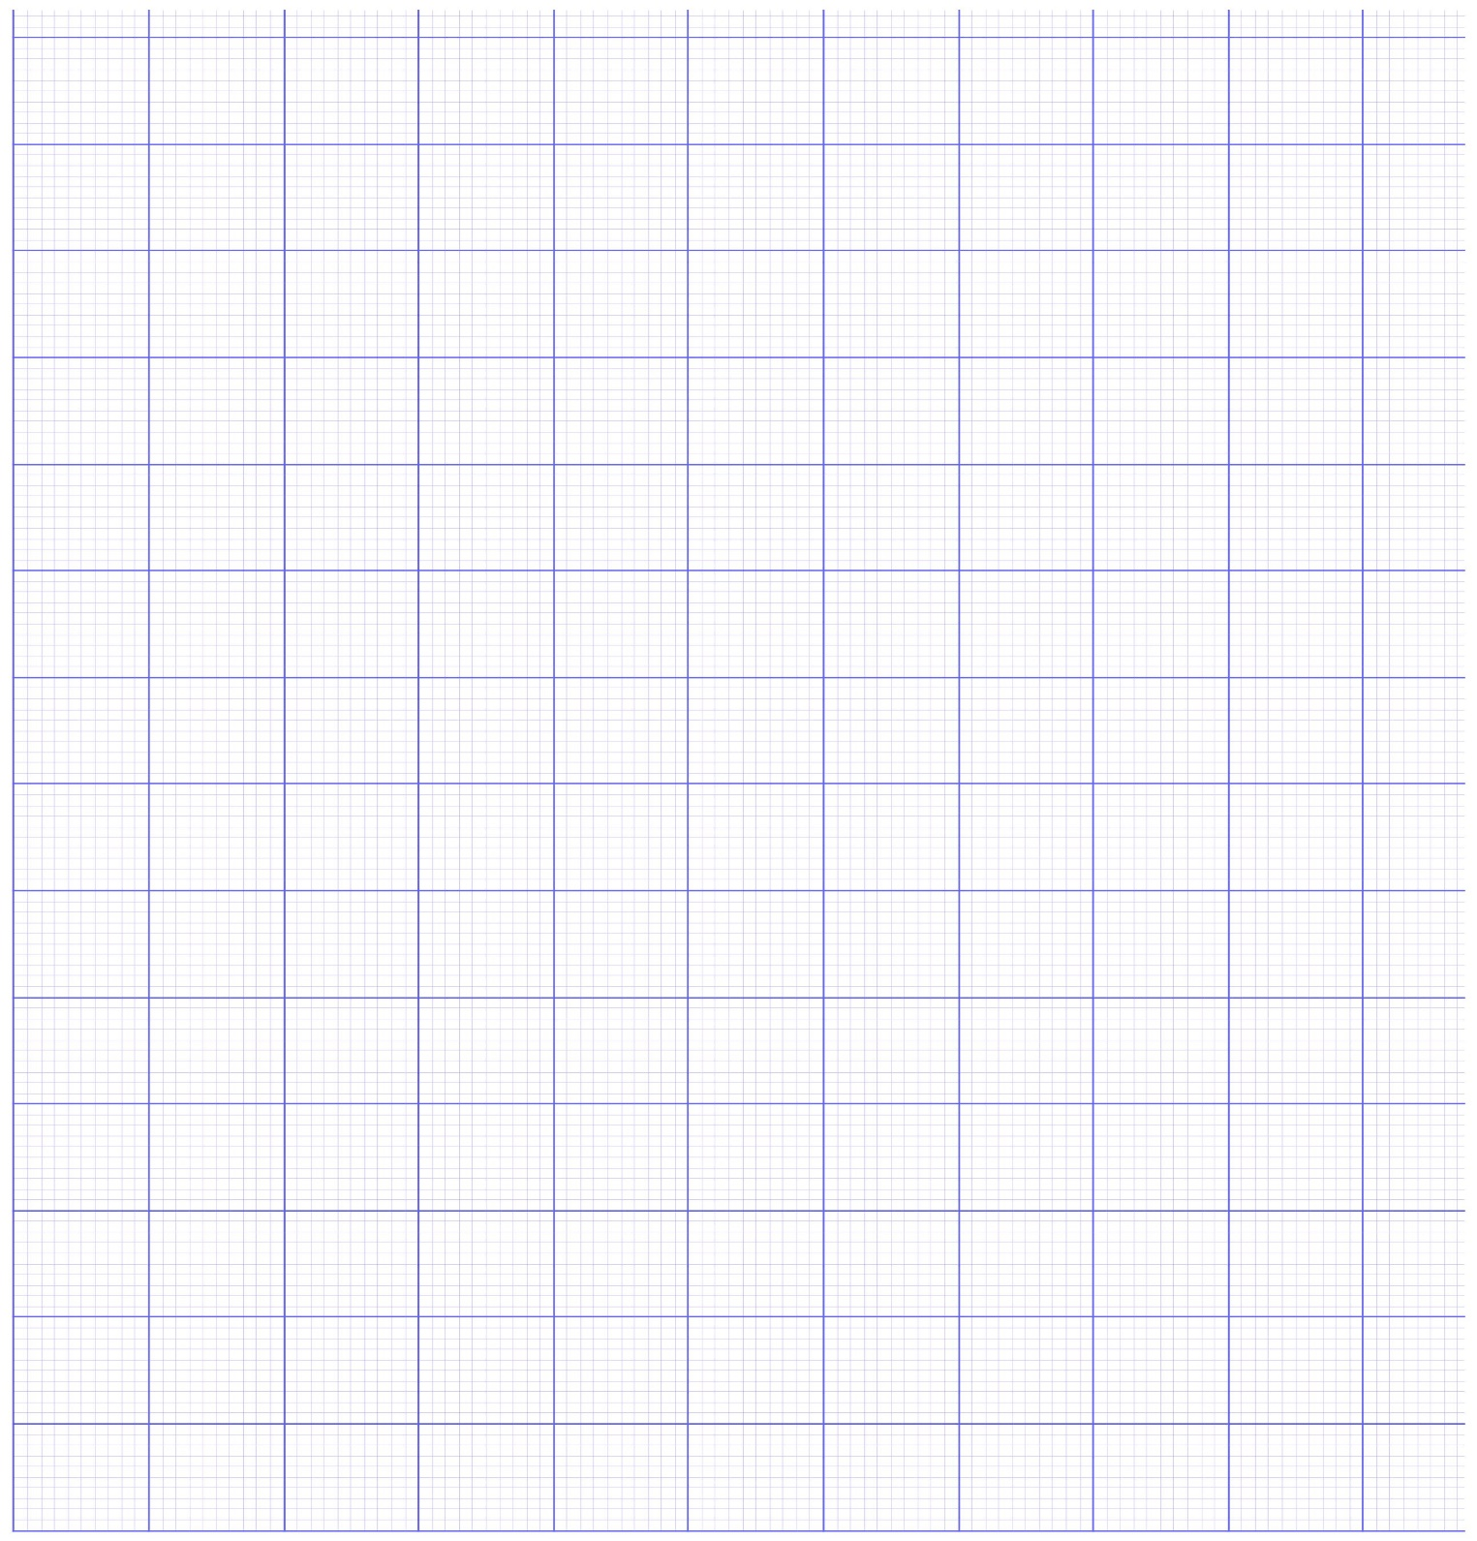

1. Mark the points B and D before reflection (2 marks)
2. Draw the line $y = 3x$ hence mark the points A and C to complete and draw the rectangle ABCD. State its co-ordinates, and these of $A'$ and $C'$. (3 marks)
3. Find the image of D under a rotation, through $- 90°$, center the origin. (2 marks)
4. A metallic solid which is cuboidal measuring 5m by 4.5m by 4m has a cylindrical hole of diameter 50cm drilled through the face measuring 4.5m by 4 as shown below.



Calculate, leaving your answer in term of π

1. The surface area of the solid. (5 marks)
2. The mass in kilograms of the cuboid if the density of the material used to make it is $2.43g/{cm}^{3}$ (5 marks)