FORM TWO END TERM 2 MATHEMATICS MARKING SCHEME
No | Working | Remarks
1 | $$\frac{1}{6}+\frac{1}{12}=\frac{3}{12}$$grazing land = $\frac{4}{9}×\frac{9}{12}=\frac{1}{3}$  Unused land = $1-\left(\frac{3}{12}+\frac{1}{3}\right)=\frac{5}{12}$  $$\frac{5}{12}of k=10 hac$$  $$k=\frac{10×12}{5}=24 ha$$ | M1  M1  A1
2 | - $\sqrt{{ {10}^{2}-6}^{2}}=8 cm$  - Area = $\frac{1}{2}×6×8$  $=24 cm^{2}$ | B1  M1 A1
3 | $2.3$hours = 2 hr 18 mins  $$0110h-2h 18 mins$$  $$=1052h$$ | B1  M1  A1
4 | $$S=\frac{1}{2}(75+85+60)=110$$  $$A=\sqrt{110(110-75)(110-85)(110-60)}$$  $$=\sqrt{4812500}$$  $=2193.74 m^{2}$  $$Area in hectares=\frac{2193.74}{10 000}=0.219374 ha$$ | M1  A1  B1
5 | LCM of 30, 45 and 54 = 270  Value of x = $270 +21$  $=291$ | B1  M1  A1
6 | $$\frac{1}{2}x-10+2x=90°$$  $$\frac{5}{2}x=90+10$$  $$x=\frac{2×100}{5}=40°$$ | M1  M1  A1
7 | No. Standard form Log  0.0246 $${2.46×10}^{-2}$$ $$\overline{2.}3909$$ $2.1523$ +  142 $${1.4210}^{2}$$  0.5432  0.02 $${2×10}^{-2}$$ $$\overline{2.}3010$$  1.14 $$1.14×{10}^{0}$$ $0.0569$ +  $$\overline{2.}3579$$  $$\frac{N}{D}$$ $$0.5432$$ $\overline{2.}3579-$ $2.1853$  Sq. root $$2.1853×\frac{1}{2}$$  12.38 $${10}^{0.9027}×10^{1}$$ $$1.0927$$ | B1... all correct logs  B1 Addition and subtraction  B1…sq. root  A1
8 |  | B2 for triangle  B1 for line bisectors  B1 for circle
9 | Area of triangle = $\frac{1}{2}×12×12×\sin{60=62.35 {cm}^{2}}$  Area of unshaded sectors = $2×\frac{60}{360}×3.142×36=37.71 {cm}^{2}$  Area of shaded sector = $\frac{300}{360}×3.142×36=94.26 cm^{2}$  Total area of shaded region = $94.26+\left(62.35-37.71\right)$  $=118.9 cm^{2}$ | M1  M1  A1
10 | $$\frac{2\left(x-y\right)-3(2x-y)}{6}$$  $$\frac{2x-2y-6x+3y}{6}$$  $$\frac{y-4x}{6}$$ | M1  M1  A1
11 | $$y=4x+5$$  $m_{1}=4$  $$m_{2}=-\frac{1}{4}$$  $$\frac{y+2}{x+3}=-\frac{1}{4}$$  $$4y+8=-x-3$$  $$y=-\frac{1}{4}x-\frac{11}{4}$$ | B1  M1  A1
12 | $$\frac{4xy+8y^{2}-3x-6y}{8y-6}=\frac{4y\left(x+2y\right)-3(x+2y)}{2(4y-3)}$$  $$=\frac{\left(4y-3\right)\left(x+2y\right)}{2(4y-3)}$$  $$=\frac{x+2y}{2}$$ | M1  M1  A1
13 | - $\tan{32°=\frac{h}{300}}$  $$h=187.46 m$$  b) $\tan{θ=\frac{187.46}{100}}$  $θ=\tan^{-1}\left(0.1875\right)=61.92°$ | M1  M1  A1
14 | $L.S.F=\sqrt[3]{\frac{4752}{1408}}$ = 1.5  A.S.F $={\left(1.5\right)}^{2}=2.25$  Area of larger $=2.25×352$  $=792 {cm}^{2}$ | M1  M1  A1
15 | $$7500=\frac{22}{7}×r^{2}×30$$  $$r=8.92 cm$$  Total surface area = $\left(\frac{22}{7}×8.92^{2}\right)+\left(\frac{22}{7}×8.92×30\right)$  $=$ $250.07+841.03$  $=1091.1 cm^{2}$ | M1  M1  M1  A1
16 | Angle subtended by major arc = $360-105 = 255°$  Length of an arc $=\frac{255}{360}×\frac{22}{7}×2×8.4$  $=37.4cm$ | B1  M1  A1
SECTION II
17 | - $Ksh→US\$$ = $\frac{350 000}{74.75}$  $=4682 dollars$  - Balance $=0.75×4682=3511.5 dollars$  US dollars $→Fr⟹\frac{3511.5×74.75}{11.04}=23 775≅23780$  Balance $=23 780-16 200=7 580$  - Value on arrival $= Ksh.7580×12.80$  $= Ksh.97,024$  Value on departure $= Kshs.7580 ×11.04$  $= Ksh.83 683.2$  Difference $= Kshs.97,024 - 83683.2$  $= Kshs.13,340.80$ | M1 M1  A1  B1  M1  M1 A1  B1  M1  A1
18 | $$\sin{P=\frac{4.65}{6}}$$  $$∠APB=2×\sin^{-1}\left(\frac{4.65}{6}\right)=101.6°$$  $$\sin{Q=\frac{4.65}{6}}$$  $$∠AQB=2×\sin^{-1}\left(\frac{4.65}{5}\right)=136.9°$$  Area of circle centre Q = $\frac{22}{7}×5×5=78.57 cm^{2}$  Area of segment centre P = $\left(\frac{101.6}{360}×\frac{22}{7}×36\right)-\left(0.5×36×\sin{101.6}\right)$  $=31.93-17.63$  $=14.3 cm^{2}$  Area of segment centre Q = $\left(\frac{136.9}{360}×\frac{22}{7}×25\right)-\left(0.5×25×\sin{139.6}\right)$  $$=29.88-8.54$$  $$=21.34 cm^{2}$$  Area of minor crescent k = $21.34-14.3=7.04 cm^{2}$  Area of shaded region = $78.57-7.04=71.53 cm^{2}$ | M1 A1  M1 A1  M1  M1  M1  A1  M1 A1
19 | - $\frac{h+30}{h}=\frac{15}{12}$  $$15h =12h+360$$  $$h=120,H=150$$  $$Volume=\left(\frac{1}{3}×3.142×15×15×150\right)-\left(\frac{1}{3}×3.142×12×12×120\right)$$  $=35347.5-18097.92$  $= 17249.58 cm^{3}$  $=\frac{17249.58}{1000}=17.250$ litres  - (i) $Volume= 3.142×0.7×0.7×1.2$  $=1.847496×1000$  $=1847.26 litres$  (ii) $\frac{1847.26}{17.250}=107.1≅108 buckets$ | M1  A1  M1  M1  A1  M1  M1  A1  M1 A1
20
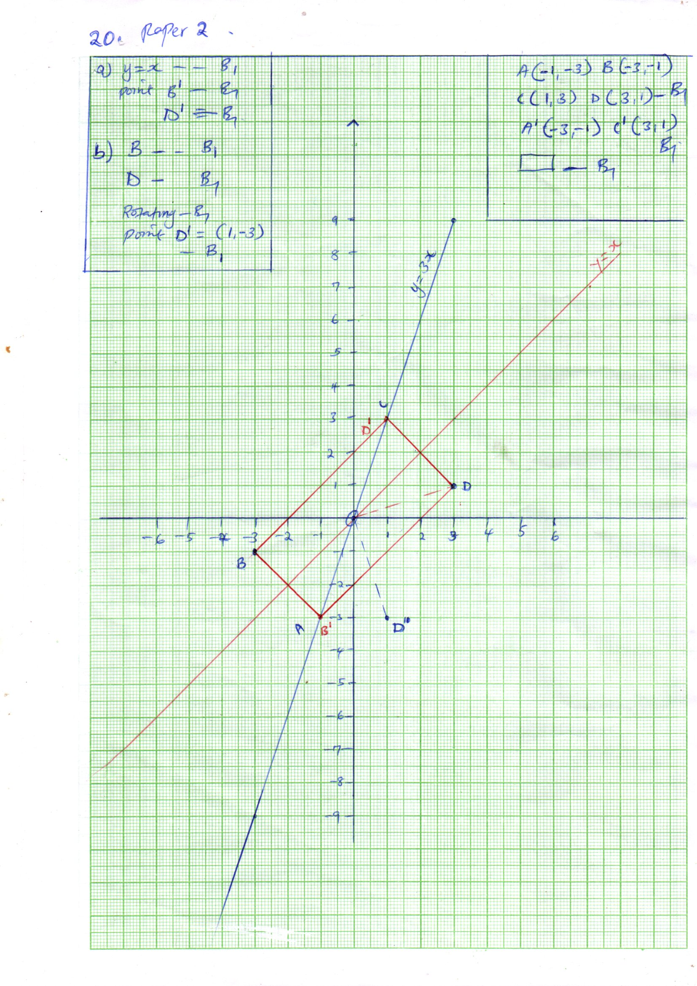
21 | - Area of rectangular faces = $\left(2×4×5\right)+\left(2×4.5×4\right)+\left(2×5×4.5\right)$  $=40+36+45$  $=121 m^{2}$  Surface area of drilled hole = $\left(π×0.25×2×5\right)$ + $\left(2×π×0.25×0.25\right)$  $=2.5π+0.125π$  $=2.625π m^{2}$  Total surface area = $\left(121-2.625π \right)m^{2}$  - Volume of the cuboid = $\left(5×4.5×4\right)-\left(π×0.25×0.25×5\right)$  $=(90-0.3125π) m^{3}$  Mass = $2430×\left(90-0.3125π\right)$  $=\left\lfloor 218 700-759.375π\right\rfloor kg$ | M1  A1  M1  M1  A1  M1  A1  M1 M1  A1

