NAME ……………………………………….…… ADM NO……….… DATE …….………
SCHOOL…………………………………………...……… SIGNATURE …………...……….
121
MATHEMATICS
FORM 1

TIME: 2 ½ HOURS
END OF TERM TWO EXAMINATION
Kenya Certificate of Secondary Education

INSTRUCTIONS TO CANDIDATES
- Write your name and admission number in the spaces provided at the top of this page.
- This paper consists of two sections: Section I and Section II.
- Answer all questions in section I and any five questions in Section II.
- Show all the steps in your calculations, giving your answers at each stage in the spaces below each question.
- Marks may be given for correct working even if the answer is wrong.
- KNEC Mathematical tables may be used.

For Examiner’s Use Only

1 | 2 | 3 | 4 | 5 | 6 | 7 | 8 | 9 | 10 | 11 | 12 | 13 | 14 | 15 | 16 | Total

17 | 18 | 19 | 20 | 21
Grand
Total

- (a) Write the odd numbers in descending order between 70 and 80. (1 mark)

(b) Find the total value of the sixth digit in the number formed in (a) above. (2 marks)

- A fruit vender bought oranges at Sh.150 per dozen and sold them at Sh. 15 each. Calculate his percentage profit (3 marks)

- Akinyi,Bundi, Cura and Diba invested some money in the ratio of 7:9:10:14 respectively. The business realized a profit of Sh. 46800. They shared 12% of the profit equally and the remainder in the ratio of their contributions. Calculate the total amount of money received by Diba. (4 marks)

- Expand and simplify $4\left(q+6\right)+7\left(q-3\right)$ (2 marks)

- Use prime factorization to find the square root of
- 324 (2 marks)

- 1764 (2 marks)

- Work out: (3 marks)
- $98 + 6734 + 348$

- $6349 + 259 -7954$

- $72-30+36$

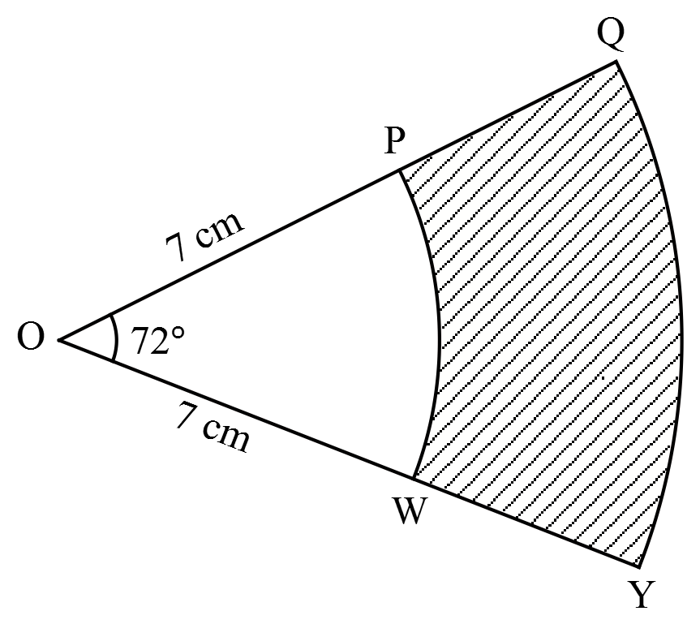
- In the figure below, $OPQ$ and $OWY$ subtend an angle of $72°$ at the centre of the circle. $OP=OW=7 cm$and $PQ=WY=5 cm$.

Calculate the area of the shaded region. $\left(Take π=\frac{22}{7}\right)$ (3 marks)

- A cylindrical glass has inner radius of 7.7cm and height of 14cm. Calculate its capacity in litres (Take $π=\frac{22}{7}$) (3 marks)

- A rectangular slab of glass measures 8 cm by 2 cm by 14 cm and has a mass of 610g. Calculate the density of the glass in kg/m³ (3 marks)

- Use mathematical table to evaluate (4 marks)
${2.543}^{2}+\sqrt{0.425}$

- Express 0.2$\dot{3}$ as a fraction in its lowest form (2 marks)

- Evaluate 15 ÷ $\frac{1}{4}$ 𝑜𝑓 12 + 15 ÷ ($\frac{1}{4}×$ 12) (3 marks)

- A business man makes a profit of 20% when he sells a carpet for Ksh.36000. In a trade fair he sold one such carpet for Ksh.33600. Calculate the percentage profit made on the sale of the carpet during the trade fair. (3 marks)

- Three pots can hold 500,400 and 300 litres of water respectively. Find the capacity of the largest container that can be used to fill each of the pots in full measures. (3 marks)

- Find the angle subtended at the Centre of a circle by an arc of length 11cm if the radius of the circle is 21cm. (use $π=\frac{22}{7}$ ) (3 marks)

- (a) The population of a certain town is estimated to be 2 105 000 000. Write this in standard form. (1 mark)

(b) Evaluate without using mathematical tables or calculators correct to 2 decimal places.
$\frac{0.36×4.2}{0.8×3×5}$ (3 marks)

SECTION II (50 marks)
Answer all the questions in the spaces provided.
- (a) Copy and complete the table (i) and (ii) below for the functions $y=7-3x$ and $y=2x-8$ respectively
- $y=7-3x$ (2 marks)
$$x$$ | $$-2$$ | $$-1$$ | 0 | 1 | 2 | 3 | 4 | 5
$$y$$ | 13 |  | 7 |  |  |  |  | -8

- $y=2x-8$ (2 marks)
$$x$$ | $$-4$$ | $$-2$$ | 0 | 2 | 4 | 6 | 8 | 10
$$y$$ | $$-16$$ |  | $$-8$$ |  |  | 4
(b) On the same grid draw the graphs of $y=7-3x$ and $y=2x-8$ (4 marks)

(c) Use the graph to solve the simultaneous equations (1 mark)
$3x+y=7$
$2x-y=8$

- The line $y=2x-8$ meet the $x$-axis at the point P .Write down the coordinates of P (1 mark)

- Two businessmen jointly bought a minibus which could ferry 25 paying passengers when full. The fare between two towns A and B was Kshs. 80 per passenger for one way. The minibus made three round trips between the two towns daily. The cost of fuel was Kshs 1500 per day. The driver and the conductor were paid daily allowances of Kshs 200 and Kshs 150 respectively. A further Kshs 4000 per day was set aside for maintenance.
- One day the minibus was full on every trip.
- How much money was collected from the passengers that day? (3 marks)

- How much was the net profit? (3 marks)

- On another day, the minibus was 80% on average for the 3 round trips. How much did each businessman get if the days profit was shared in the ratio 2:3? (4 marks)

- A bus left Nairobi on Thursday evening and travelled to Dar-es-Salam according to the travel time table below and arrived there on Saturday morning.
Nairobi | Dep: 2015h
Namanga | Arr: 2325h
Dep: 0310h
Arusha | Arr: 0640h
Dep: 0820h
Dodoma | Arr: 2100h
Dep: 2255h
Dar-es-Salam | Arr: 1015h

- Determine the total:
- Travelling time for the whole journey. (3 marks)

- Stoppage time in all the stations. (3 marks)

- Time taken for the whole journey. (2 marks)

- Given that the average speed of the bus for the whole journey is 60km/h, calculate the distance between Nairobi and Dar-es-Salaam. (2 marks)

- A room is 9m long 6.5m wide and 3m high
- i)The walls and the celling are to be covered with plywood. If one sheet of plywood is 2m long and 1.5m wide and the area occupied by doors and windows is 16.5m² .Find the number of plywood sheets required to cover the walls and ceiling (5marks)

ii) If the cost of one plywood is Shs 135 .Find the total cost of all plywoods required. (2 marks)

- A closed cylindrical container has a diameter of 14cm and height 10cm. Find the surface area of the cylinder in m² (use $π=\frac{22}{7})$ (3 marks)

- The cost of two skirts and three blouses is Sh. 600.If the cost of one skirt and two blouses of the same quality is Sh. 350.
- Make equations to represent the above information. (2 marks)

- Calculate the price of a skirt and a blouses (3 marks)

- Musau decided to buy 8 skirts and 5 blouses .Calculate the total amount he spend. (3 marks)

- If he had sold the 8 skirts and 5 blouses making a profit of 20%, calculate the selling price of the two commodities. (2 marks)

