KISWAHILI KIDATO CHA PILI
MTIHANI WA MUHULA WA MWISHO 2021
MUDA: SAA 2
JINA:……………………………………………………NAMBARI…………………………
DARASA……………………………………………….TAREHE………………………….
SEHEMU YA A: UFAHAMU
Soma taarifa ifuatayo kisha ujibu maswali
HAKI ZA WATOTO
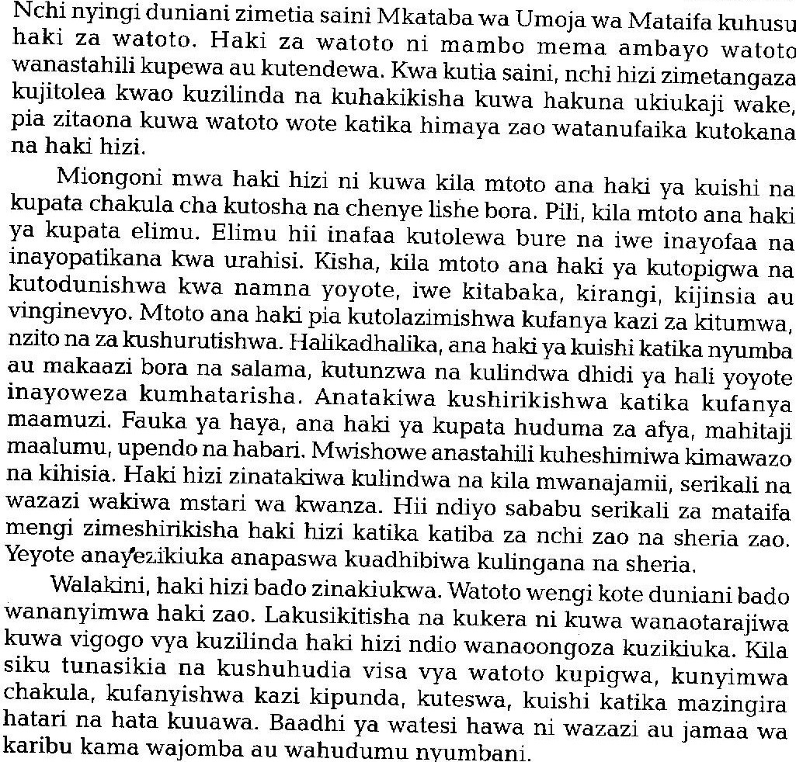
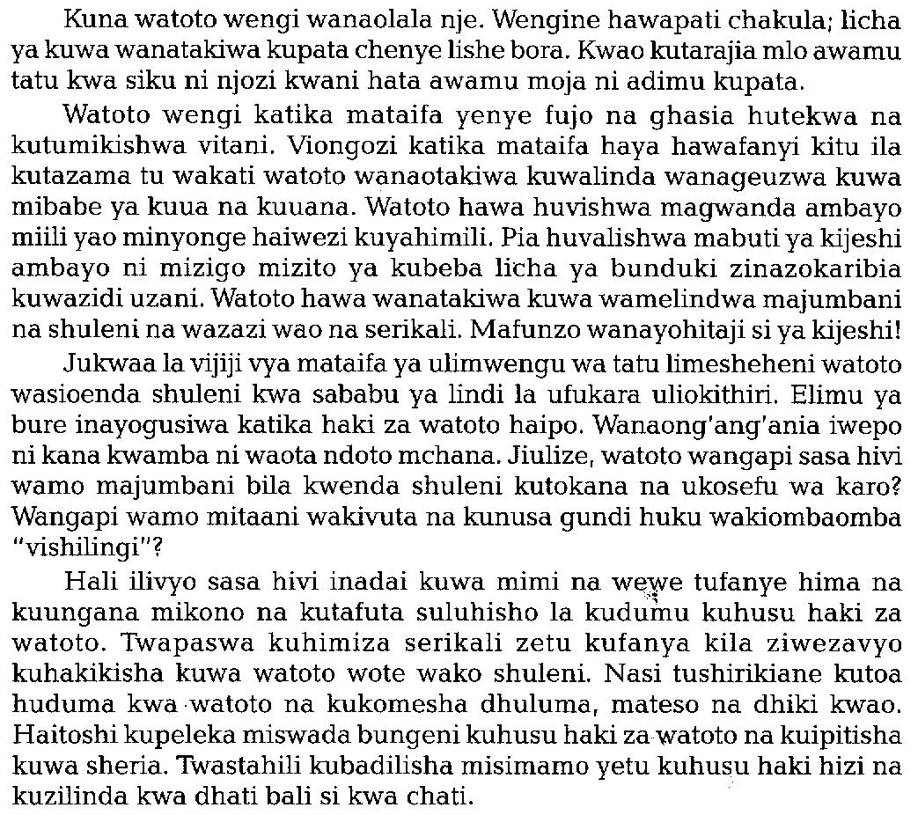
JIBU MASWALI YOTE
- Haki za watoto zina maana au umuhimu gani? (alama 2)
……………………………………………………………………………………………………………………………………………………………………………………………………………………………………………………………………………………………………………………….

- Taja haki tano ambaza mtoto anatakiwa kuwa nazo kulingana na kifungu. (alama5)
…………………………………………………………………………………………………………………………………………………………………………………………………………………………………………………………………………………………………………………………………………………………………………………………………………………………………………………………………….....................................................................................................
- Eleza mifano mitatu kuonyesha jinsi haki za watoto zinavyokiukwa. (alama 3 )
………………………………………………………………………………………………………………………………………………………………………………………………………………………………………………………………………………………………………………………..
- Unadhani ukiukaji wa haki za watoto unaweza kuepukwaje? (alama 2)
………………………………………………………………………………………………………………………………………………………………………………………………………………………………………………………………………………………………………………………..
- Eleza maana ya msamiati ufuatao kama ulivyotumika: (alama 3)
- Mkataba
………………………………………………………………………………………………………………………………………………………………………………………………................
- Ukiukaji
………………………………………………………………………………………………………………………………………………………………………………………………………………………………………………………………………………………………………………
- Lindi la ufukara
………………………………………………………………………………………………………………………………………………………………………………………………………………………………………………………………………………………………………………

SEHEMU YA B: SARUFI NA MATUMIZI YA LUGHA
- Taja aina mbili za sauti za Kiswahili. (alama 2)
………………………………………………………………………………………………………………………………………………………………………………………………………………
- Onyesha shadda katika maneno yafuatayo. (alama 2)
- Cherehani
………………………………………………………………………………………………..
- Kitabu
..................................................................................................................................................
- Ainisha viambishi katika neon lifuatalo. (alama 3)
Tutakayempelekea
………………………………………………………………………………………………………………………………………………………………………………………………………………………………………………………………………………………………………………………………………………………………………………………………………………………………..
- Kanusha sentensi zifuatazo. (alama 2)
- Ningesoma ningepita.
………………………………………………………………………………………………………………………………………………………………………………………………..
- Ningalikuwa na uwezo ningalimsaidia.
……………………………………………………………………………………………………………………………………………………………………………………………….
- Andika sentensi ifuatayo kwa udogo kisha katika wingi. (alama 2)
Mtoto mkaidi aliiba kitabu cha mwenzake.
…………………………………………………………………………………………………………………………………………………………………………………………………………….
- Onyesha viwakilishi katika sentensi zifuatazo, (alama 2)
- Yule na huyo wamemaliza kazi yao.
- Chenyewe kimekaliwa na wageni wake.
- Akifisha sentensi ifuatayo. (alama 3)
mama maria amenunua kabeji kitunguu mchicha sukumawiki na sufuria.
……………………………………………………………………………………………………………………………………………………………………………………………………………….
- Andika sentensi zifuatazo katika wakati ujao. (alama 2)
- Mama ameninunulia kalamu.
…………………………………………………………………………………………………………………………………………………………………………………………
- Wanafunzi wameenda nyumbani.
………………………………………………………………………………………………………………………………………………………………………………………………
- Nomino hizi zipo katika ngeli gani? (alama 2)
- Mwezi
………………………………………………………………………………………………
- Maji
………………………………………………………………………………………………..
- Andika sentensi ifuatayo katika usemi wa taarifa. (alama 2)
“Uhuru huu tunaojivunia ulipatikana kwa umwagikaji mwingi wa damu,” mwanasiasa alisema.
……………………………………………………………………………………………………………………………………………………………………………………………………………….
- Unda nomino kutokana na vitenzi vilivyo mabanoni ili kukamilisha sentensi zifuatazo. (alama 2)
- ………………………………………ilikuwa ya kuogofya mno. (ota)
- Jengo hili lilijengwa na …………………………………………..hodari. (jenga)
- Tunga sentensi sahihi ili kutofautisha maana ya vitate vifuatavyo. (alama 2)
Suka
…………………………………………………………………………………………………………………………………………………………………............................................................
Zuka

…………………………………………………………………………………………………

- Tumia kivumishi ‘-enyewe’ kukamilisha sentensi zifuatazo. (alama 2)
- Mimi nataka mikate ………………………………………………
- Manukato …………………………………yananukia.
- Bainisha maneno katika sentensi ifuatayo. (alama3 )
Yusufu na Ali wamekwenda wapi jamani?
……………………………………………………………………………………………………………………………………………………………………………………………………………….
………………………………………………………………………………………………………………………………………………………………………………………………………………………………………………………………………………………………………………………................................................................................................................................................................
- Neno ‘huyu’ limetumikaje katika sentensi hizi? (alama 2)
- Huyu amekujakwangu.
………………………………………………………………………………………………
- Mgeni huyu amekuja kwangu.
………………………………………………………………………………………………
- Onyesha vivumishi katika sentensi zifuatazo. (alama 4)
- Tunda kubwa limeanngukia mtoto mvivu.
- Shule maarufu husajili wanafunzi wengi.
- Taja aina tatu za nomino huku ukizitolea mifano. (alama 3)
……………………………………………………………………………………………………………………………………………………………………………………………………………………………………………………………………………………………………………………….
18. Andika kwa wingi.
Upepo wa kusini ulipeperusha mabati ya paa la nyumba na kuharibu kifaamuhimu. (alama 2)
………………………………………………………………………………………………………………………………………………………………………………………………………………………………

19. Tofautisha kati ya shadda na kiimbo. (alama 2)
………………………………………………………………………………………………………………………………………………………………………………………………………………………………
………………………………………………………………………………………………………………………………………………………………………………………………………………………………
20. Tunga sentensi yenye mpangilio ufuatao. (alama 2)
Nomino + Kivumishi + Kitenzi + Kielezi + Kielezi
………………………………………………………………………………………………………………………………………………………………………………………………………………………………
21. Taja na ueleze aina mbili za matamshi (alama 4)
Toa mifano kwa kila aina.
………………………………………………………………………………………………………………………………………………………………………………………………………………………………
………………………………………………………………………………………………………………………………………………………………………………………………………………………………
SEHEMU YA C: FASIHI SIMULIZI
- (a) Taja aina zozote tano za nyimbo. (alama 5)
……………………………………………………………………………………………………………………………………………………………………………………………………………………………………………………………………………………………………………………………………………………………………………………………………………………………………………………………………………………………………………………………………….
(b) Tofautisha kati ya fasihi simulizi na fasihi andishi (alama 10)
……………………………………………………………………………………………………………………………………………………………………………………………………………………………………………………………………………………………………………………………………………………………………………………………………………………………………………………………………………………………………………………………………….
…………………………………………………………………………………………………………………………………………………………………………………………………………………………………………………………………………………………………………………………………………………………………………………………………………………………………………………………………………………………………………………………………………………………………………………………………………………………………………………………………………………………………………………………………………………….

KILA LA HERI

