441/1
HOMESCIENCE THEORY
PAPER 1
Marking Scheme
DECEMBER 2021
ELDORET DIOCESE EXAM 2021
Kenya Certificate of Secondary Education (K.C.S.E.) TRAIL

SECTION A

- Methods of cooking using dry heat (Any 2X1=2 MARKS)
- Baking
- Roasting

- Types of tacking stitches. (2 marks)
- Even tacking
- Tailors tacking
- Long and short tacking
- Basting/ Diagonal tacking (Any 2X1=2 MARKS)

3. Types of hand sewing needles
- Betweens
- Crewels
- Darners
- Embroidery
- Sharps (Any 2X1=2 MARKS)

- Ways of enhancing personal health.
- Give body proper cleaning
- Take balanced diet
- Take proper rest
- Do enough exercises
- Dress well (Any 2X1=2 MARKS)

- Advantages of baking as a cooking method
- If temperature is properly set it does not require a lot of attention.
- Foods are light and easy to digest.
- Baking saves on fuel since several dishes can be cooked at the same time.
- Foods baked are attractive and appeasing. (Any 2 X1=2 MARKS)

- Methods of ventilation
- Adjacent method.
- Cross method. (Any 2 X 1=2 MARKS)

- Ways of reducing a bulk in a seam.
- Trimming
- Layering
- Pressing flat (Any 2X1=2 MARKS)

- Items in the house that can be recycled
- Plastic papers can be used for lining surfaces
- Old tins can be used as utensils
- Plastic containers can be washed then used to store ingredients
Carton box can be used keeping clothes, or some stuff in the house.
- Old clothes can be used as dusters, Any 2 X1=2 MARKS)

9. General functions of minerals in the body
- Building of bones and teeth
- Maintaining all cells in the body e.g. muscles, nerves, brain and blood cells
- Controlling body processes and enabling them to run smoothly (Any 2X1=2 MARKS)

10. Kitchen hygiene – refers to cleanliness of surfaces, equipment and proper disposal of refuse. (Any 2X1=2 MARKS)

11.Colour schemes that are used for interior decoration.
- Monochromatic colour schemes (one colour plan)
- Complementary scheme.
- Triad harmonies
- Analogous (Any 2X1=2 MARKS)

12. Functions of sebaceous glands in the skin.
- Production of sebum which keeps the skin supple.
- Produce sebum which makes the skin water proof.
- Produce sebum which destroys disease causing micro-organism.
(Any 2X1=2 MARKS)

13. Uses of a seam ripper
- Cutting button-holes
- For picking out stitches. (Any 2X1=2 MARKS)

14. Agents used in coating food during deep frying.
- Bread crumbs
- Egg white
- Thin batter (Any 2X1=2 MARKS)

15. Factors that determine size of a patch pocket.
- Purpose of the patch pocket
- Position of the pocket
- Size of the garment
- Age of the wearer. (Any 2X1=2 MARKS)

16. Points to be observed when washing articles with non-fast colour
- The garments should be washed using the kneading and squeezing method
- The garment should be hanged under shade
- Use moderate iron when ironing (Any 2X1=2 MARKS)

17. How to identify silk using burning test
- Burns with spluttering noise and is self extinguishing.
-Gives the smell of burnt feathers or hair. (Any 2X1=2 MARKS)

18. Ways of enriching leftover foods
- Adding vegetables
- Using species
- Serving together with vegetables / salads
- Garnishing
- Adding stock
- Coating some food (Any 2X1=2 MARKS)

19. Disadvantages of using candles for lighting
        - Get finished quickly
        - No sufficient light
        - Easily put off by wind
        - Can cause accidents easily (Any 2X1=2 MARKS)

20. Uses charcoal as fuel
- For cooling in a charcoal coder
- For cooking
- Ironing (Any 2X1=2 MARKS)
SECTION B (20 MARKS)
21.)
a) Description of washing a neglected aluminum pan
- Collect equipment and material needed ( ½ )
- Wash (½) in hot ½ soapy ½ water using scouring pad ½
- Rinse ½ severally ½ using hot ½ water.
- Wipe dry ½ with a kitchen cloth ½
- Clean equipment used (½ )
(any 8x1/2 = 4 marks)

b) Explanation of thorough cleaning an enamel plate.
- Collect equipment and material needed (½) to save on time (½ )
- Removal of loose dirt/dispose scrapes of food (½) to keep water clean (½)
- Use a sponge (½) and warm soapy (½) water to remove dirt and prevent scratches (½) and remove dirt (½)
- Rinse thoroughly in warm (½) water to remove dirt and soap (½)
- Final rinse in cold (½) water to freshen (½)
- Drip dry/upside down on a rack (½) to remove water (½).
- Store (½) in a clean cool dry place to maintain (½)
- Clean (½) equipment used to maintain (½) (any 14 x ½ = 7 marks)

c) Procedure of cleaning a hurricane lamp (omitting the glass)

- Collect equipment and materials (½) necessary for the work.
- Protect (½) the surface using old newspapers(½)
- Dismantle the lamp (½)and place the glass chimney on a clean dry place
- Empty the kerosene into a clean dry container (½)
- Put hot soapy water(½) inside the reservoir close the opening and shake the lamp (½)
- Rinse (½) thoroughly using warm (½) water
- Shake (½) off excess water
- Wipe off soot (½) using a newspaper especially the chimney
- Clean the frame chimney and handle using warm (½) soapy (½) water and a soft cloth/sponge(½)
- Rinse (½) thoroughly
- Drain off excess water by placing it upside down (½)on a clean surface
- Trim (½) the wick
- Reassemble (½) the lamp
- Refill (½) with kerosene
- Clean equipment and materials (½) used ( any 18 x ½ = 9 marks )

SECTION C (40 MARKS)
22 a) Points on conservation of energy in lighting.
- Lighting in various parts of the house should be designed to suit a particular area
- Use lightly colored surfaces as they reflect light and distribute it better than dark ones
- Daily light should be used as much as possible. Artificial light should be used only for dark hours
- Ensure that all light fittings e.g. shades, covers etc are clean and in working order
- Turn off lights when not in use even for short periods
- Avoid using bulbs with high voltage than really required (any 5 x 1 = 5 marks)

b) Suitable conditions for the growth of yeast.
(i) Food, this is provided by the sugar in the flour / Limited amounts should be used since too much of it will rupture the yeast cells retarding the fermentation process.
- Warmth , the working conditions must be warm 25°C / Hot temperatures will
kill the yeast and cold temperature will retard the growth of the yeast.
- Liquid , this is provided by the water or milk used in the mixture/ It is used for the formation of the solution in which fermentation process takes place.
- Time, this is provided by allowing yeast mixture to ferment and proof.
(any 3x2 = 6 marks)

c ) Preparation of a shaped round patch pocket and attachment.
- Neaten ½ the top edge ½ of the pocket
- Snip / notch ½ the turnings ½ of the curves (½),
- Fold ½ the allowance ( ½ ) along the SL ( ½ ) to the W.S ( ½ ) of the pocket.
- Pin ½ and tack ½ in place ½
- Stitch (½ ) the pocket along the S.L ½ and re enforce ½ the mouth .
- Trim ½ the corners ( ½ ) of the pocket ½ .
- Press ( ½ ) the pocket flat ½ .
(any 18 x ½ = 9 marks )

23 a ) Advantages of stewing as a method of cooking.
-Economical method of providing a meat dish from a cheap cut of meat through slow
prolonged cooking
-The gravy (liquid part) of the food is served with the food therefore the nutrients which are in the gravy are not lost
-Does not require close attention during cooking except for occasional stirring therefore other tasks can be performed while the stew is cooking
-With the long slow cooking, natural flavour of food are developed which make the food more enjoyable
-It does not require special cooking facilities therefore can be carried out successfully even on three stones
-The water soluble nutrients are conserved because the evaporation is minimized through the use of a pan with a lid
-Consumes little fuel therefore economical on fuel
-Prolonged slow cooking tenderizes tough foods (Any 4 pointsx2= 8 marks)

b ) Different symbols likely to be found on care labels of a woolen garment.

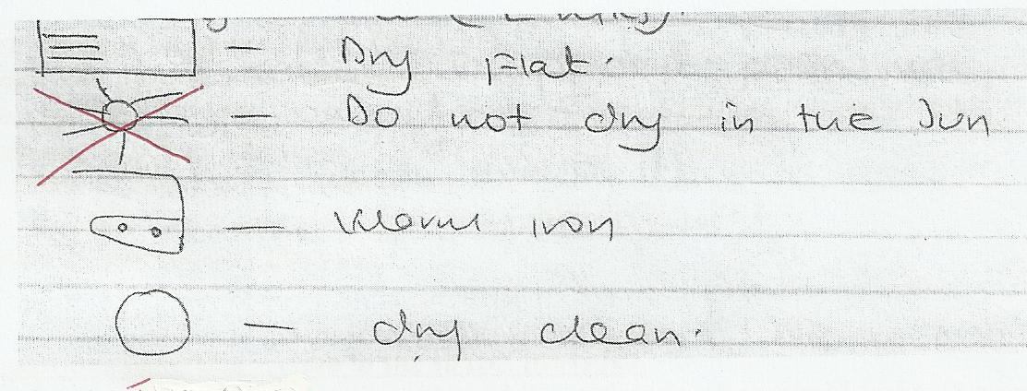

c ) Description of how to prepare a front and back facing using one well labeled diagram.
- Place the two ½ facings R.S ½ facing matching ½ the fitting line.
- Pin ½ and tack ½ along the fitting line ½
- Remove pins ½ and machine ½ stitch
- Remove tacking ½ and press ½ seam open ½
- Neaten ½ the free edge ½ .
(Description any 10 points x ½ = 5 marks and diagram 1 mark = 6 marks)

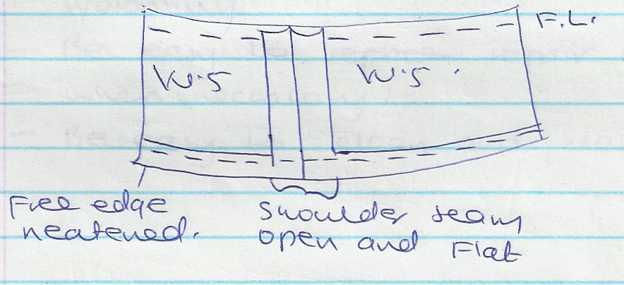

24 a) Reasons why hospitals would not use silk fabric for their bed sheets.
- Easily damaged by high temperatures, hospital bed sheets must be frequently sterilized.
- Easily damaged by alkalis and acids – hospital bed sheets are usually stained with medicines and other stains hence require strong fabrics.
- Weakened by long exposure to sunlight – hospital linens are exposed to the sunlight
for further sterilization.
- Silk is weak when wet-hospital linen require frequent washing which silk cannot stand ( any 4 x 2 = 8 marks)

b ) Precautions to observe when using a micro – wave oven.
(i) Do not overload
(ii) Do not use metal object to warm food
(iii) Follow manufactures instructions
(iv) Do not start micro – wave without food inside.
(v) Switch off when not in use.
(vi) Don’t let it get too dirty
(vii) Don’t keep the microwave near heating appliance (any 6 x 1 = 6 marks)

C) Good qualities of a kitchen plan.
- Working surfaces should be of comfortable height to avoid straining.
- Has sufficient working space for easy movement.
- Working surfaces should be close to each other to avoid too much movement.
- Should be well ventilated and to avoid fatigue.
- Should be well lit to avoid fatigue
- Work centers should allow work to flow from one surface to another to avoid retracing steps. (any 6 x 1 = 6 marks )

