LANJET EVALUATION TEST
441/1 HOMESCIENCE MARKING SCHEME.

SECTION A (40 MARKS)

1. Differentiate between wear and tear (2mks)
Wear is weakening or thinning of a part of garment or article due to continuous friction or rubbing
Tear is a hole on a particular section of a garment.

2. State two reasons for using fabric conditioner in laundry. (2mks)
- To get rid of static electricity
- To give clothes a good scent/ fragrance/ smell
- To soften toweling material, napkins etc.
- Minimize creasing

3. Mention two ways of meeting social needs of a pregnant woman (2mks)
- Family members should have a positive attitude towards her
- Children should be informed and mentally prepared of the expected arrival of the new baby
- Family members should help her with some duties

4. Explain giving an example, the meaning of a monochromatic colour scheme. (2mks)
- This is a colour plan that uses one colour as the key colour with its hints and shades or one
colour with its different intensities e.g red with pink and maroon/ blue with light blue and dark
blue

5. State two points to consider when choosing a laundry brush. (2mks)
- Bristles be firmly fixed onto the head
- Bristles be evenly distributed
- Bristles good quality – durable
- Handle be of convenient width and length
- Handle be light in weight and smooth

6. Give two conditions necessary for steam to act as a raising agent (2mks)
- Presence of enough moisture in the mixture
- Presence of high temperature which will convert the moisture quickly onto steam to
raise the moisture / enough hot oven

7. Identify three methods of finishing the edges of sleeves other than using a cuff (3mks)
- By use of a binding
- By use of a lace
- By use of a facing
- By use of hemming stitches
- By use of edge stitching
- By use of piping

8. Identify two ways of preventing umbilical cord infection at birth. (2mks)
- Use of clean equipment at birth
- TBA / nurse be clean & hands be clean
- Use of sterilized thread for tying the cord

9. State two reasons why foods are fortified (2mks)
- To reduce on malnutrition i.e swelling of the thyroid gland due to lack of iodine
- To increase the / improve the nutritive value of foods.

10. State two safety precautions to be exercised when handling calabashes (2mks)
- Do not sock them
- Avoid banging or knocking them for they will break
- Avoid harsh abrasives & soap

11. Give two reasons why a kitchen should be well lit. (2mks)
- To minimize accidents
- To avoid shadows on the working area which will reduce fatigue
- Keep off pests / - To enhance interior decoration

12. Outline three qualities of a well-made sleeve (3mks)
- It should have a good hang
- Cathers lease should be well distributed
- Side seam and under arm seam should meet
- Be appropriately neatened
- The cap should be smoothly rounded.
13. Give two reasons for an open and coarse texture in creamed cake mixtures. (2mks)
- Incorrect weighing of ingredients
- Insufficient creaming

14. What is the role of VCT in safe parenting. (2mks)
- Incase the mother is HIV positive she’s given antiretroviral drug to prevent mother to
child transmission of HIV/AIDS during delivery
- ARV drug is administered to baby on delivery to stop contracting the virus
- Parents know their HIV status so as to know how to take care of themselves.

15. Give three methods used to attach collars to the neck line. (3mks)
- Sandwiching between facing and reverse
- Use of crossway strip/bia binding
- Using the upper collar / self neatening

16. State the use of a water seal in a kitchen sink (1mk)
- To keep off bad smells from the drains

17. What is simmering? (1mk)
- To cool food gently at a point just below the boiling point

18. Give two reasons why plastics are becoming more popular in homes today. (1mk)
- Are cheap
- Come in different sizes, shapes and colours
- Light in weight
- Easy to clean

19. Name four improvised cleaning materials (2mks)
- Old cloths – for dusters
- Egg shells – for sausing
- Maize cob – for scrubbing
- Sisal fibre – ash or crushed charcoal can be applied omit & used to clean equipment
- Rough leaves – as an abrasive
- Sand – as an abrasive

20. Choose a suitable one course meal for an invalid. (2mks)
- Boiled rice/ potatoes mashed
- Steam fish/meat stew/Ndengu stew
- Boiled peas and carrots/ steamed spinach/cabbage

SECTION B (20 MARKS)
21. You have been asked to stay at home and carry out some household chores.
(a) Describe how you will thoroughly clean a hurricane lamp to be used in the
evening (9mks)
- Protect the worksurface with newspapers ½
- Remove all movable parts ½ empty the reservoir ½
- Clean the glass in warm soapy water gently ½ with a soft cloth ½ rinse in warm water ½
and drip dry on a safe protected surface ½
- Wipe the inside of the metal chimney ½ to remove soot
- Clean the vents ½ with a special brush ½ to open them up
- Wipe the burner ½ and other metal parts ½ using a cloth wrong out of warm soapy ½
- Rinse using a cloth wrong out of warm water ½
- Trim the wick ½ as the lamp is drying
- Refill the reservoir with oil ½
- Wipe off any spilt paraffin ½
- Replace the glass ½ and keep the lamp ready for use

(b) Describe how you will wash a nylon petticoat for your younger sister. (6mks)
- Shake the petticoat ½ remove hose dirt
- Turn inside out and wash RS & WS using luke warm soapy ½ water using kneading and
squeezing method. ½
- Rinse in luke warm ½ water to remove dirt and saop
- Finally rinse in cold water ½ into which a fabric conditioner has been added ½ to reduce
static electricity. ½
- Hang on a wireline ½ WS out ½ secured by pegs under a shade to dry ½
- Press using a cool iron ½ Air ½ to freshen. Fold and store well.

(c) Describe how you will thoroughly clean a chopping board. (5mks)
- Wash in warm water ½ to avoid fixing of stains ½
- Scrub ½ using a scrubbing ½ brush ½ along the grain ½
- Rinse in warm water ½
- Finally rinse in cold water ½
- Dry the board using a dry tea towel ½
- Dry the wood ½ under a shade ½ on a utensil rack

SECTION C (40 MARKS)
22. (a) give five importance of making a budget (5mks)
-budget guides consumer to buy wisely
-give psychological satisfaction to the individual
-enable consumers to prioritize their needs
--a consumer is able to live within their means.
- minimizes overspending
-enables a consumer to save money for future use

(b) Explain four factors that influence consumer buying. (8mks)
- Amount of money one has
- Price fluctuation
- Availability for one to shop
- Family composition and stage of development
- Customers traditions and festivals
- Ones status
- Goods and services available or in season
- Advertisement especially persuasive
(Any 4 – well explained 4 x 2 = 8)

(c) Discuss three reasons why the use of charcoal should be minimized.
- Tree cutting is a threat to the environment as it leads to desertification
- Charcoal burning causes air pollution due to smoke
- If not properly burnt it produces smoke which blackens the cooking utensils

(d) What is food fortification? (1mk)
- Is the addition of nutrients that are lacking/lost during processing or are less in
In order to improve food value.

23. (a) Suggest five sanitary practices that 2 to 5 year old child should be taught. (5mks)
- Wash hands before eating
- Wash hands after visiting a toilet/ latrine
- Eat well without soiling clothes
- Bath daily
- Put on clean cloths

(b) Explain five reasons for coating food before deep frying (10mks)
- To prevent over cooking
- Prevent absorption of much fat/ oil which may make the food soggy
- Prevent food from breaking
- To add nutritive value
- To prevent food from sticking on frying pan

(c) State five points to consider when preparing and cooking green vegetable (5mks)
- Cut just before cooking to prevent loss of Vit. C.
- Use a sharp knife when cutting
- Cook in a pan with a well fitting lid
- Avoid use of soda to prevent loss of vit. C
- Avoid overcooking
- Cook just before serving to avoid retreating
- Cook for a short time in a little amount of water

24. (a) List any five effects of moist yeast on starch (5mks)
- The starch grains absorb water
- They smell thus increasing in size
- It bursts out
- Increase in surface area thus if it is porridge it thickens
- Colour changes from white to grayish

(b) Give four limitations of complementary feeding (4mks)
- Requires a lot of time and energy to prepare
- May be costly
- The baby may not accept new foods easily
- The baby may develop allergies to new foods.

(c) Which five preparations will you carry out once fabric before cutting. (5mks)
- Grain to get straight grain
- Press to remove creases for accurate measurements
- Identify the nap – to match the RS & WS.
- Pre shrink to have the right measurements/ straightening edges.
(d) By use of three well labeled diagrams describe how you will make an overlaid
seam (7mks)
- Fold the overlay along the ½ stitching line towards the W.S ½ and press.
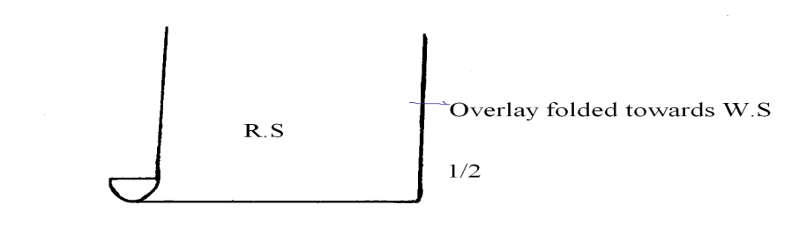
- Place the folded edge of the overlay on the underlay ½ matching the notches and
Stitching lines ½
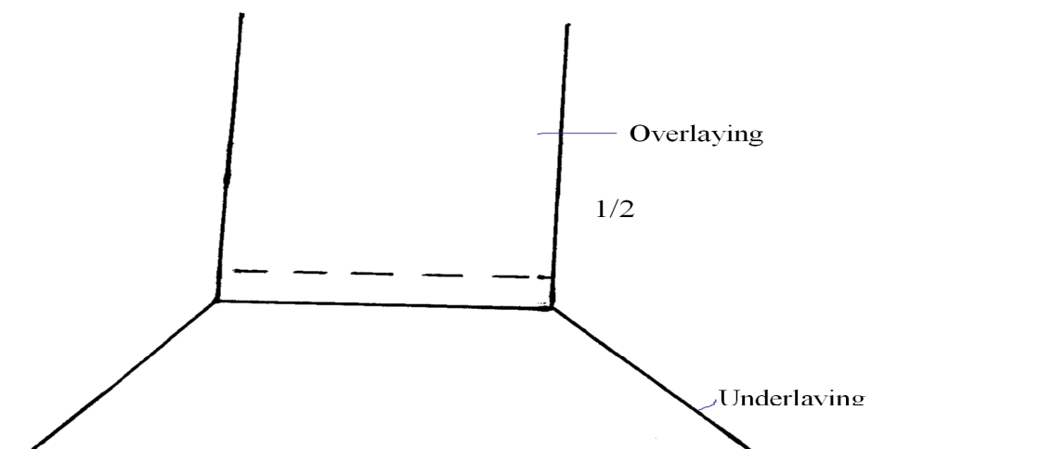

- Pin ½ tact ½ remove pins ½ machine stitch close ½ to the fold remove tacking stitches ½.
- Turn to W.S and trim the seam allowance to 0.8cm/8mm ½
- Neaten the raw edges using loop stitches ½ press the completed seam ½

