STEPHYJOY GIRLS HIGH SCHOOL
FORM ONE GEOGRAPHY ASSIGNMENT
1a. What is a weather station? 1mk
b. Give reasons why a Stevenson screen is:
- Painted white. 2mks
- Have louvers. 2mks
2a. What is temperature? 1Mk
b. State four factors affecting temperature. 4mks.
3a. Describe the following:
i) Mean daily temperature. 2mks
ii) Diurnal range of temperature. 2mks
iii) Mean monthly temperature. 2mks
b. Distinguish between fog and mist. 2mks.
4a. Describe how relief rainfall is formed. 5mks
b. Name four local winds. 4mks.
5a. State two factors that influence the wind direction and speed. 2mks
6a. Describe the passing star theory. 5mks.
b. State three weaknesses of the passing star theory. 3mks.
7a. What is a natural satellite? 1Mk.
b. What is a solstice and when does it occur? 2mks

8a.The diagram below shows the sun, the earth and the orbit of the moon round the earth. Study it and answer the questions that follow
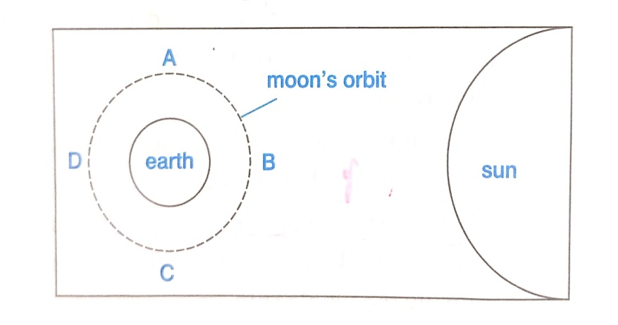
i) At what position is the moon likely to be for a solar eclipse to occur? 1mk
ii) At what position is the moon likely to be for a lunar eclipse to occur? 1mk
b. Giving an example, define a Great circle. 2mks
9a. Coal, petroleum and natural gas are not classified as minerals.
i) What are they? 1Mk
ii) What are they not considered minerals? 2mks.
10a. Explain how igneous rocks are formed? 3mks.
b. Describe the following types of rocks and give an example of each:
i) Calcareous rocks. 3mks
ii) Carbonaceous rocks. 3mks
11a. Explain why sedimentary rocks are widespread in the coastal plains of Kenya. 2mks.
b. State five factors that influence mineral exploitation. 5mks
12a. Name the minerals found in the following areas in East Africa.
i) Kariandusi. 1mk
ii) Kerio valley. 1mk
b. State three uses of diamond. 3mks.
13a. Give three by- products obtained when crude oil is refined. 3mks
b. State two methods used in mining 2mks
14a. Describe the stages involved in processing of diamond in South Africa. 5mks
b. Name two areas in South Africa where diamond is mined. 2mks.

