GEOGRAPHY PAPER TWO
312/2
NOVEMBER 2021

2 ¾ HOURS

ELDORET DIOCESE EXAM 2021

KENYA CERTIFICATE OF SECONDARY EDUCATION
GEOGRAPHY PAPER TWO – 312/2
2 ¾ HOURS

INSTRUCTIONS TO CANDIDATES
- This paper has two sections: A and B.
- Answer all the questions in SectionA.
- Answer question 6 and any other two questions from section B.
- All answers must be written in the answer booklet provided.
- Candidates should answer the questions in English.

SECTION A (25 MARKS)
- (a) define ecotourism (2 Marks)
(b) State two reasons why domestic tourism is encouraged in Kenya (2 Marks)
- (a) State three physical features that favoured the development of the seven forks hydro-electric power scheme. (3 Marks)
(b) State two human problems facing hydro-electric power projects development in Kenya. (2 Marks)
- Use the map of Eat Africa below to answer questions (a (i)
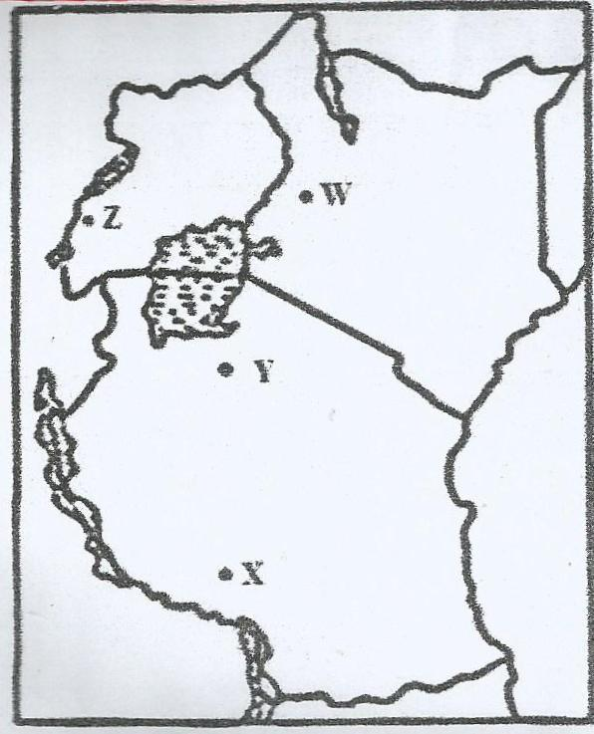

- Identify the minerals which are mined in the areas marked W, X, Y and Z. (4 Marks)
- State three problems facing gold mining in South Africa. (3 Marks)
- State two factors which influence the mode of occurrence of minerals. (2 Marks)
- (a) Give three features of the cottage industry in India. (3 Marks)
- Identify two human factors which influenced the development of the Iron and Steel industry in the Ruhr Region of Germany in the 19th century. (2 Marks.

- Below is a map of the Great Lakes of North America - St. Lawrence Seaway. Use it to answer question (a).
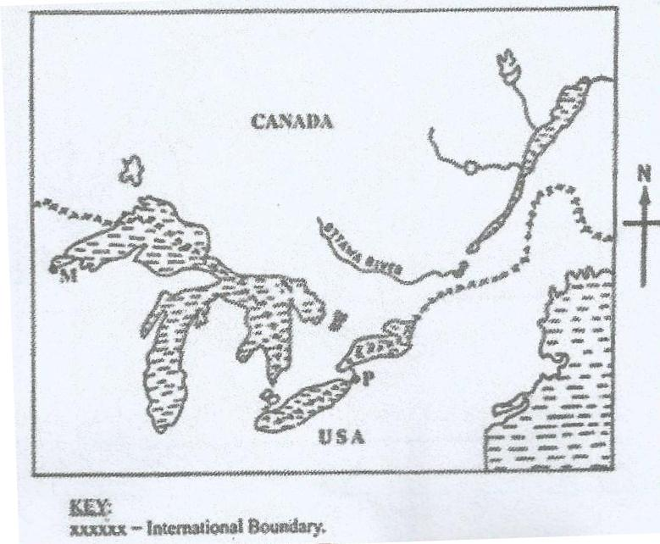

- Name:
- The Lake marked L (1 Mark)
- The waterfall marked M. (1 Mark)
- The port marked N. (1 Mark)
- Give two activities which were carried out by the St. Lawrence Seaway Project between 1954 and 1959. (2 Marks)
SECTION B (75 MARKS)
- The table below shows the population distribution within various sub counties of county T.
Sub - County | Population Size
K | 65,000
L | 55,000
M | 40,000
N | 35,000

- (i) Use the Base Map provided on page 7 to present the above population distribution data.
Use a scale of one (1) dot to represent 5000 people. (14 Marks)
(ii) State three disadvantages of Dot Maps in data presentation. (3 Marks).
- State four measures which the government of Kenya has taken to reduce infant mortality. (4 Marks)
- Statefour similarities between the population trends of Kenya and Sweden. (4 Marks)
- (a) (i) Differentiate land reclamation from land rehabilitation. (2 Marks)
(ii) Describe the stages of land reclamation from the sea in the Netherlands (6 Marks)
(b) Explain four ways in which the Zuyder Zee economically benefits the Netherlands.
(8 Marks)
(c) (i) State four ways in which land is reclaimed in Kenya excluding irrigation. (4 Marks)
(ii) State five problems facing the Perkerra Irrigation Scheme. (5 Marks)
- Use the map of the North-West Atlantic fishing ground below to answer questions (a)
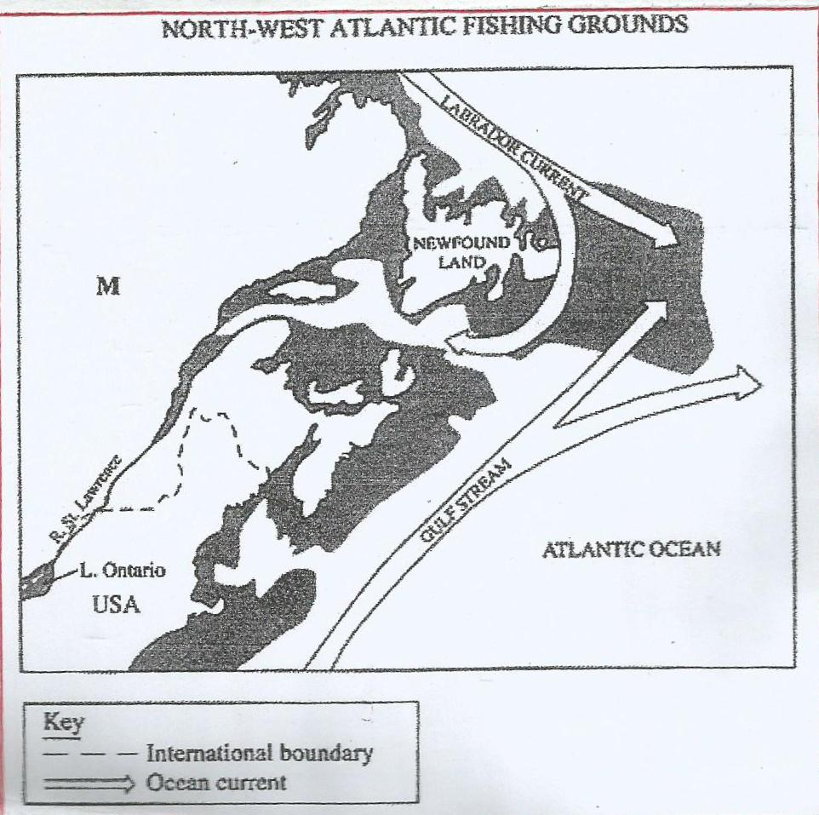
and (b)

- (i) Name the country marked M. (1 Mark)
(ii) Explain how the two ocean currents shown on the map influence fishing in the area. (4 Marks)
- Explain threefactors whichfavour commercial fishing in the area shaded on the map other than ocean currents. (6 Marks)
- Explain threehuman reasons why fresh water fishing is more developed than marine fishing in East Africa. (6 Marks)
- The diagram below shows a commercial fishing method.
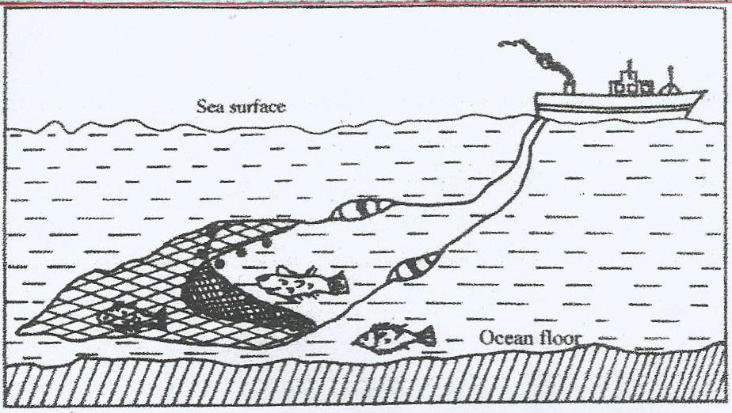

- Describe how the method is used in catching fish. (5 Marks)
- List three methods used to preserve fish (3 Marks)
- (a) State three physical conditions that favour coffee growing in the Central Highlands of Kenya. (3 Marks)
(b) Describe the stages involved in coffee production from picking to marketing. (8 Marks)
(c) Explain four problems facing coffee farming in Brazil. (8 Marks)
(d) Your Geography class carried out a field study on a coffee farm.
- State four methods the class may have used to collect data. (4 Marks)
- During the field study, the class collected data on the quantities of coffee produced from the farm in the last five years.
State two methods that the class may have used to present the data. (2 Marks)
- (a) (i) A part from water and air pollution, name two other types of pollution. (2 Marks)
(ii) Identify three ways in which water is polluted. (3 Marks)
- Explain three effects of air pollution on the environment. (6 Marks)
(b) (i) Explain three factors that lead to frequent flooding in the Lake Region of
Kenya. (6 Marks)
(ii) Explain two ways through which floods are controlled in the Lake Region of
Kenya. (4 Marks)
(c) State four negative effects of wind as an environmental hazard in Kenya. (4 Marks)

A BASE MAP FOR QUESTION 6 (a) (i)

__________________________________________________________________________________________________________________________________________________________________________________________________________________________________________

