ELDORET DIOCESE EXAM 2021
312/1 GEOGRAPHY MARKING SCHEME TERM 2
SECTION A
- a) Define the term climate. (2 marks)
- Average weather condition of an area recorded over along period of time usually 30-35 years
b) State three characteristics of the hot desert climate. (3 marks)
- High temperatures throughout the year./ Temperatures experienced are high often averaging 30°C.
- Night temperatures are extremely low.
- Low humidity.
- High temperature range.
- Occasional floods covered by sporadic rain/ Sudden torrential downpours often leads to temporary floods.
- Has low rainfall – less than 250mm p.a.
- Winds are strong and destructive / Strong winds experienced /desert sand storms/. Sandstorms are common.
- Cloudless skies often leads to low temperatures at night due to high terrestrial radiation and high during the day.
- Large daily temperature range i.e. 5°C - 20°C./ A large diurnal range
- Develops low pressure in summer and high pressure in winter
- High mean annual temperature
- High evaporation rates
2. (a) The diagram below represents planet earth.
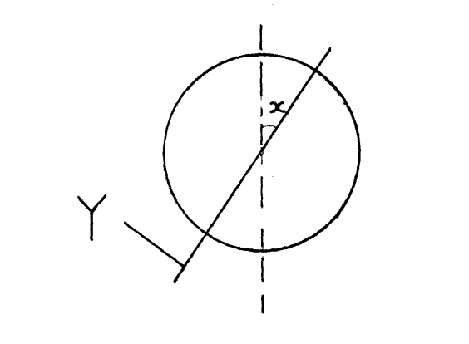

  - Name line Y. (1mark)
Axis
  - Give the measurement of angle X. (1mark)
23 1/2$°$
b) Give three reasons why the interior of the earth is still hot. (3marks)
- The interior of the earth cooled slowly after breaking away from the sun hence retained much of its original temperatures
- The weight of the overlying materials / layers exerts pressure on the core resulting in high temperatures
- Radioactivity taking place within the earth releases a lot of energy in form of heat
3 . (a) What are extrusive volcanic features? (2marks)

- These are features formed when hot molten magma from the interior of the earth are extruded onto the earth surface where they cool and solidifies .
(b) Apart from basic lava domes, name three other vent eruption volcanic features. (3marks)
- Composite cones
- Lava domes/basaltic lava dome /shield volcano
- Plug domes
- Spine / volcano plug
- Hot springs/steam jets and geysers
- Crater / caldera
- Ash and cinder cones.
- Fumaroles/ solfatara/ mofets
4. (a) Name two places in Kenya where karst scenery is relatively well developed.
Ramisi (2marks)
Shimoni
(b)State three ideal conditions for development of an artesian well/basin. (3marks)
- The aquifer must be sandwitched between impermeable rocks so that it can retain water.
- The aquifer must outcrop in a region which is a source of water.
- The aquifer must dip from a region of water intake and the rock layers must form a broad syncline or basin.
- The mouth of the well must be lower than the intake area to ensure water comes out of the well on its own
5. (a) Define soil. (2marks)
      - It is a naturally occurring thin layer of loose/unconsolidated materials which overlies the crustal rocks and on which plants grow OR
- It is any accumulation of the rock particles of minerals, organic matter and air found on the surface of the earth.OR
- A layer of weathered unconsolidated materials containing organic matter that support plant growth
(b)State three characteristics of laterite soils . (3 marks)
- They are red in colour
- They are rich in ion and aluminium oxides
- They have a low humus content
- They are acidic
- Are sticky.

SECTION B
Answer Question 6 and any other two questions from this section
6. Study the map of Kijabe 1:50,000 provided and answer questions that follow.
(a)(i) Identify what is grown in the plantation in the area covered by the map . (2 marks)
Trees/Forest
(ii) State the location of Kagwe Carbacid plant by use of latitude and longitude . (3 marks)
- (0 ⁰ 56’S,36 ⁰39’E)

(b )(i)Calculate the area covered by thickets in the area covered by the map. (2 marks)
- Incomplete Squares =2
- Complete Squares =16 x1/2 =8
= 2+8 =10 km ²

(ii) What is the general flow of river Wangenye. (1 mark)
southeastwards
(c )Using a vertical scale of 1cm rep 100m ,draw a cross section along northing 00 from Easting 30 to Easting 36 of the area covered by the map . (5marks)
(i) On it mark and label
- River
- Plantation
- All weather road loose surface

ACROSS SECTION ALONG NORTHING 00 FROM EASTING 30 TO EASTING 36 OF THE AREA IN THE MAP

(ii) Calculate the vertical exaggeration. (2 marks)
VE=VS/HS
=1/100 x100 ÷1/50,000 =5 Times
(d) Describe the relief of the area covered by the map (4 marks)
- The area covered by the map has conical hills eg Kijabe hill
- The area covered by the map has escarpment .
- The area covered by the map has valleys eg Ewaso Kedong Valley
- The area covered by the map has many river valleys .
- The highest point in the area covered by the map is 2660m and the lowest is 1720m
- The land is flat around the plantations in the northern part of the map
- The Eastern part of the area covered by the map is gently sloppy this is evidenced by wide spread contours
- The area has steep slopes on the north eastern part
(e )Explain three factors that has influenced the distribution of settlement in the area covered by the map. (6 marks)
Relief Kijabe hill has steep slopes on the western side thus no settlements.
Eastern slopes of Kijabe hill have few settlements due to gentle slopes.
The escarpment has no settlements due to steep slopes.
At the foot of the escarpment, there are many settlements due to gently sloping land
Regions within river valleys have very few or no settlements due to ruggedness.
Gently sloping areas immediately to the east of escarpment has many settlement as it is easy to construct houses/carry out farming .
steep land on the western side of the hill has no settlement as it is difficult to construct houses .
Transport –There are many settlements along roads and railway line due to accessibility
Vegetation-there are no settlement within the forest and thicket due to safety concerns and difficulty in clearance of forests for construction of house
Social amenities-there are many settlements close to schools for ease of access to Education.
Economic activities-There are many settlements around market centers and towns for ease of access to goods and services.
7. (a)(i) Differentiate between faulting and folding . (2 marks)
Faulting is breaking, fracturing or cracking of brittle crustal rocks due to the rocks being exposed to tectonic forces while Folding is the process of crustal distortion which causes the bending of the rocks of the earths crust due to compressional forces
(ii) State three causes of faulting . (3 marks)
- Faulting may be caused by earth movements which causes tension/STRAIN within the rocks
- It could also be caused by earth movements which cause compression within the rocks
- Faulting can occur when rocks shear
- Vertical movements in the rocks cause rocks to fracture
(b)The diagram below represents features produced by faulting. Use it to answer questions that follow
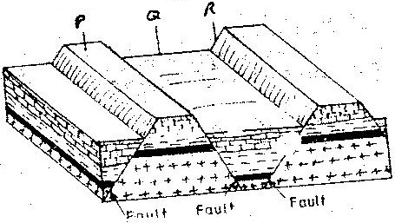

(i))Name the features marked P,Q, and R (3 marks)
P-Block mountain/Horst /fault block
Q-Rift valley /Graben
R-Fault scarp /Escarpment
(ii)Explain the formation of the part marked P (5marks)
- Layers of rocks of the earth’s crust are subjected to compressional forces.
- Parallel reversed faults develop
- The middle block is uplifted due compressional forces/are uplifted to the higher level by vertical forces forming a raised upland (bordered by fault scarps) known as fault block.

(c )State five main uses of rift valley of Kenya . (5 marks)
- The rift valley attracts tourists ,hence earning foreign exchange
- The escarpment eg mau have forests hence providing timber.
- Volcanic features eg steam jets are generating geothermal power
- The floor of the rift valley has fertile soils which encourage agriculture
- Soda ash is mined in lake magadi and exported earning foreign exchange
(d). Students from a school in Trans Nzoia County carried out a field study on a faulted landscape
(i) Give two reasons why there was need for a pre-visit of the area of study . (2 marks)
-To enable proper planning
- To identify problems they are likely to encounter
- To identify the methods they are likely to use for data collection
- To determine appropriate routes to be taken.
(ii) mention Two secondary source of information that they would use to collect data. (2 marks)
- Geography Text books/ Pamphlets/ Journals/ Magazines/ Periodicals/ Handouts.
- Geological maps/maps
- Photographs/pictures/video tapes/slides/films
- Tape recorded information.
(iii) Give three follow-up activities they are likely to have carried out after the study .
(3 marks)
- Presenting a lecture
- Holding a discussion
- Displaying photographs
- Writing a report
- Displaying diagrams
- Process the photographs
- Draw and display charts

8. a) (i) What are tides? (2 marks)
Tides are the periodic rise and fall on the level of water in large water bodies /oceans
(ii) Give three causes of ocean current (3 marks)
- Wind blowing over the surface of the ocean.
- Rotation of the earth .
- Shape of the land masses.
- Difference in temperatures of ocean waters.
(iii) Name the three ocean currents along the western coast of Africa. (3 marks)
- Cold benguela current
- Cold canary current
- Guinea current
(b) (i) State three characteristics of submerged lowland coasts. (3 marks)
- coasts have broad shallow indentation /estuaries
- coasts have several creeks
- coasts have extensive marshes
- coasts have broad continental shelf
(ii) Explain three factors that determine the rate of coastal erosion. (6 marks)
Nature of the load
- Hard rocks carried by waves increase the erosive power of the waves as they hit against the coast
- Heavy pieces of rocks carried by waves hit against the cliffs thus weakening the wall making it susceptible to wave erosion
nature of the coastal rocks
- A coast made of soft rocks wears away easily when subjected to sea waves
- Well jointed / fractured/ unconsolidated rock enhances erosion by waves along the line of weakness
- Where rocks are soluble or made of limestone/ chalk they are easily eroded through solution process
Gradient of the coast line
- Steep coast are eroded faster than gentle coasts
Strength of the waves
- Strong waves erodes faster than weak waves
(c )Explain four ways through which oceans and seas are of economic importance to human activities . (8 marks)
- Land breeze and sea breeze modifies the temperatures of the adjacent land making it suitable for human settlement
- Onshore winds from the oceans cause convectional rainfall in the surrounding areas making them suitable for agriculture.
- Ocean beds may have mineral deposits which may be mined and sild to earn income /form raw materials for other industry .
- Oceans and beaches provide recreational grounds and beautiful sceneries that attract tourist that earns foreign exchange .
- Powerful tides and waves can be used to produce energy for domestic and industrial use .
- Oceans provide cheap means of transporting heavy and bulky goods.
- Oceans provide sand and pebbles that are used for building and construction industry.
- Ocean water can be desalinized and used for irrigation and other domestic used
- Some continental shelves provide suitable conditions for fish breeding promoting the fishing industry

9.( a)(i)Name three desert surfaces . (3 marks)
- Sandy deserts/Koum/erg.
- Stony deserts/reg/seur.
- Rocky deserts/Hamada.
- Bad lands.
- Dust bolws
(ii) Name three features resulting from water deposition in a desert (3 marks)
- Bajadas
- Pediplains
- Alluvial fans
- pediments
- Playas /salina
Use the diagram below to answer question (b).
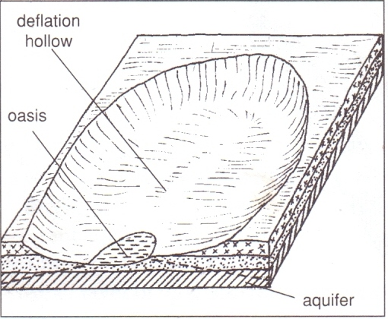
X
Layers of rocks
Prevailing wind
(b) (i) Name the wind marked X. (1 mark)
- Eddy currents
(ii) Name two processes that lead to the feature shown in the diagram. Deflation
Abrasion (2 marks )
(c) Explain three factors that influence wind deposition in desert areas. (6 marks)
- Presence of obstacles such as rocks, bushes and shrubs in the path of prevailing wind creates friction have wind drops some of its load.
- Wind carrying too many particles it may lead to some of the load to the deposited
- Sudden down pour experienced in deserts may lead to some practices carried by wind & suspended in the air may be washed down and have deposited.
- When the strength of wind slackens, there may be deposition of load.
- Occurrence of a water surface or a moist ground along a desert landscape leads to friction have deposition of materials
(d) With the aid of well labeled diagrams, describe the formation of the following Features formed in a desert:-
(i) Yardangs (5 marks)
- Rocks made up of vertical alternating layers of hard and soft rocks lie parallel to the prevailing winds in desert.
- Wind abrasion erodes the soft rocks and the particles are removed by deflation leading to formation of large furrows .the layers of hard resistant rocks are left standing as ridges.
- The ridges that are left standing in between furrows are called Yardangs.

(ii) Rock pedestals (5 marks)
- An exposed mass of rock with alternating layers of hard and soft rocks lies on the path of moving wind.
- The rock is acted on by abrasion and the soft layers are worn out more rapidly than the resistant ones.
- Resulting in an irregular mass of rock with protruding layers that alternate with hollows.
- Wind abrasion attacks the lower part of the rock more than the upper layers because the heavier and more effective particles are carried closer to the ground.
- Continued wind abrasion erodes the layer of soft rock making the hollows more pronounced and the hard layers protrude.

10.(a)Mention four types of glaciers . (4 marks)
- Avalanches
- Cirque glacier
- Piedmont glacier
- valley glacier / Alpine glacier
- ice bergs
- ice caps
- ice sheet
- continental glacier
(b)Give three ways through which glacier moves. (3 marks)
- Plastic flowage/freeze-thaw action
- Extrusion flow
- Basal slip
- Internal shearing
(c ) Describe how the following landforms have been formed .
(i)Hanging valley . (5marks)
- Initially there exists a V-Shaped river valley and a tributary valley.
- Both river and tributary valley were occupied by ice during glaciation.
- More ice accumulated in the main river valley than the smaller tributary valley.
- The two valleys were widened and deepened by plucking and abrasion.
- The main valley was eroded more thus became very deep and wider than the tributary valley.
- When ice melted, the tributary valley was left at a higher level than the main glacial trough thus called a hanging valley.
(ii)Eskers S(5marks)
- Ice flows through tunnels
- The flow is fast and the load is a lot
- The tunnel collapses when the ice melts
The streams flow down and most of the load deposited forming a long winding ridge of deposit known as eskers.

(C )Explain four ways in which glacial landforms Have affected human activities negatively .
(8 marks)
- A marshy landscape is created by the deposited clay due to poor drainage hence the land can not be fully utilized for agriculture
- Results to the formation of a rugged landscape which is difficult to settle, construct transport line and to cultivate
- Terminal moraine deposits may create numerous lakes which reduce the available land for cultivation and settlement/ e.g. in the Canadian shield
- The outwash plains may have infertile sand deposits which are not suitable for agriculture
- Glaciated mountain slopes may be too steep/bare/rugged for human habitation

This is the last printed page

