FORM 4 ENTRANCE EXAMS 2023

Kenya Certificate of Secondary Education (KCSE)
312/1
Paper 1
GEOGRAPHY
INSTRUCTIONS TO CANDIDATES
- This paper has two sections, A and B.
- Answer question 6 and any other TWO questions.

FOR EXAMINERS USE ONLY
SECTION | QUESTION | MARKS | SCORE
A | 1-5 | 25
B | 6 | 25
 | 7 | 25
 | 8 | 25
 | 9 | 25
 | 10 | 25
TOTAL MARKS |  | 100
TOTAL SCORE

SECTION A:
Answer all the questions in this section
- The diagram below shows the internal structure of the earth.
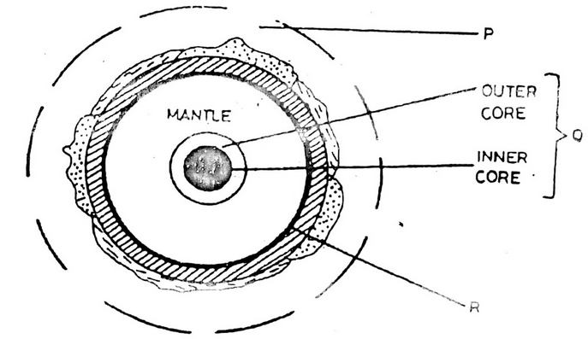
- Name the parts labelled P, Q and R. (3marks)
- State the characteristics of the inner core. (3marks)
- (a) Give two local winds that are found in Kenya. (3 marks)
(b) State three conditions that are necessary for formation of dew. (3 marks)
- Explain how the following factors influence climate.
- Oceans currents (2marks)
- Forests (2marks)
- (a) Define a lake (2marks)
(b) State three reasons why some rift valley lakes are fresh water. (2marks)
- (a) Give two main components of soils (2marks)
(b) List three factors that influence soil erosion (3marks)

SECTION B
Answer question 6 and any other two questions from this section.
- Study the map of Kijabe 1:50,000 (sheet 134/3) provided and answer the following questions.
- (i) Identify the type of map provided (1 mark)
(ii) Give the longitudinal extent of the area covered by the map. (2 marks)
(iii) Convert the scale of this map into statement scale. (2 marks)
- Draw a rectangle 10cm by 20cm to represent part of the area between the northings 90 and 00 and easting 25 and 30 on it mark and name: (6 marks)
- Kijabe
- Road A 104
- Power line
- Provincial boundary
- (i) Identify four types of natural vegetation in the area covered by the map. (4 marks)
(ii) Describe the drainage of the area covered by the map (5 marks)
- Identify five economic activities and their evidences in the areas covered by the map. (5 marks)
- (a) (i) Distinguish between minerals and rocks. (2 marks)
(ii) Describe the following characteristics of minerals:
- Colour. (2 marks)
- Tenacity. (2 marks)
- Hardness. (2 marks)
(b)(i) What are sedimentary rocks? (2 marks)
(ii) State three characteristics of sedimentary rocks. (3 marks)
(iii) Explain two reasons why sedimentary rocks are widespread in the coastal plain of Kenya. (4 marks)
(c) Describe how the following sedimentary rocks are formed.
- Mechanically formed. (4 marks)
- Organically formed. (4 marks)

- (a)(i) Name two types of earth movements. (2 marks)
(ii) State three causes of earth movement. (2 marks)
(iii) Describe the plate tectonics theory. (5 marks)
(b) (i) Define faulting. (2 marks)
(ii) State three factors that may influence faulting processes. (3 marks)
(iii) Name four types of faults. (4 marks)
(d) With the aid of well-labelled diagrams, describe the formation of rift Valley by compressional forces. (7 marks)

- (a)(i) Name two types of hot desert landscapes. (2 marks)
(ii) State two reasons why wind erosion is very effective in hot deserts. (2 marks)
(b)(i) A part from Yadangs, name three features that result from wind action in deserts. (3 marks)
(ii) Using well-labelled diagrams, describe how Yadangs are formed. (7 marks)
- Explain three ways in which winds transport in desert areas. (6 marks)
- State the significance of desert features to human environment. (5 marks)

- (a)(i) What is glacier? (2 marks)
(ii) Describe how glacier is formed. (4 marks)
(b) Describe two processes of ice erosion on a glaciated highland. (6 marks)
(c)(i) Apart from Crag and Tail, name two other features formed by ice erosion in lowlands. (2 marks)
(ii) Describe how a crag and tail is formed. (5 marks)
(d) Explain three positive effects of glaciation in the lowland areas. (6 marks)

