Name: __________________________________________Adm No: ____________________

School:__________________________________ Candidate’s Sign_____________________

Date: ______________________________

312/2
GEOGRAPHY
Paper 2

MARCH/APRIL, 2023.
Time: 2 ¾ Hours

ARISE AND SHINE TRIAL EXAMS
Kenya Certificate of Secondary Education (K.C.S.E)

Instructions to Candidates:
- This paper has two sections: A and B.
- Answer all questions in section A
- Answer question 6 and any two other questions from section B.
- This paper consist of 5 printed pages
- Candidates should check the question paper to ascertain that all the pages are printed as indicated and that no questions are missing
- Candidates should answer the questions in English

FOR EXAMINER’S USE ONLY
SECTION A
Question number | 1 | 2 | 3 | 4 | 5 | Sub total
Marks

Grand total
Question number | 6 | 7 | 8 | 9 | 10 | Sub total
Marks

SECTION A.
Answer All the Questions in the Section
- (a) Name two provinces in Canada where wheat is grown in large scales. (2 marks)
(b) List three economic factors that influence agriculture. (3 marks)

- (a) Name two horticultural crops grown in Kenya. (2 marks)
(b) State three reasons why horticulture is more developed in the Netherlands than in Kenya. (3 marks)

- (a) State three reasons why marine fisheries in Kenya are underdeveloped. (3 marks)
(b) State three ways through which fish farming contributes to the economy of Kenya. (3 marks)

- (a) Differentiate between transport and communication. (2 marks)
(b) State three modern means of communication used in Kenya besides cellphones. (3 marks)

- The table below represents information on population change in Kenya by region between years 2000 and 2005.
Region | Population in Millions
 | Years
 | 2000 | 2005
Nairobi | 2.229 | 2.751
Central | 3.882 | 4.038
Coast | 2.662 | 2.927
Eastern | 4.840 | 5.120
North-Eastern | 1.054 | 1.438
Nyanza | 4.598 | 4.916
Rift-Valley | 7.386 | 8.366
Western | 5.532 | 3.885
Total | 30.183 | 33.441
(a) Which region had the highest change in population between 2000 and 2005? (2 marks)
(b) Calculate the percentage increase in population in Kenya between 2000 and 2005. (2 marks)

SECTION B
Answer Question 6 and any other two questions from this section.
- Study the photograph below and use it to answer question (a).
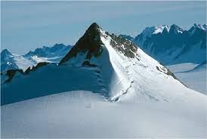
- (i) Name the type of photograph shown. (1 mark)
(ii) Draw a rectangle measuring 15cm by 10cm to represent the area of the photograph. (1 mark)
(iii) On the rectangle, draw a sketch of the photograph and label three physical features. (3 marks)
(iv) Explain two physical conditions that would discourage setting up of a game park in the area shown on the photograph. (4 marks)

- Apart from national parks, outline four other ways in which wildlife is conserved in Kenya. (4 marks)
- Give four reasons why domestic tourism is being encouraged in Kenya. (4 marks)
- Explain four factors which make switzerland receive more tourists than Kenya. (8 marks)
- (a) (i) What is forestry? (2 marks)
(ii) Explain three factors that favour the growth of natural forests on the slopes of Mt. Kenya. (6 marks)
(iii) State five factors that have led to the reduction of the area under forest on the slopes of Mt. Kenya. (5 marks)

- Explain four measures that the govrnment of Kenya is taking to conserve forests in the country. (8 marks)
- Give the differences in the exploitation of softwood forests in Kenya and Canada under the following sub-headings:
- Period of harvesting (2 marks)
- Transportation (2 marks)

- (a) The map below shows some major tea growing areas in Kenya.
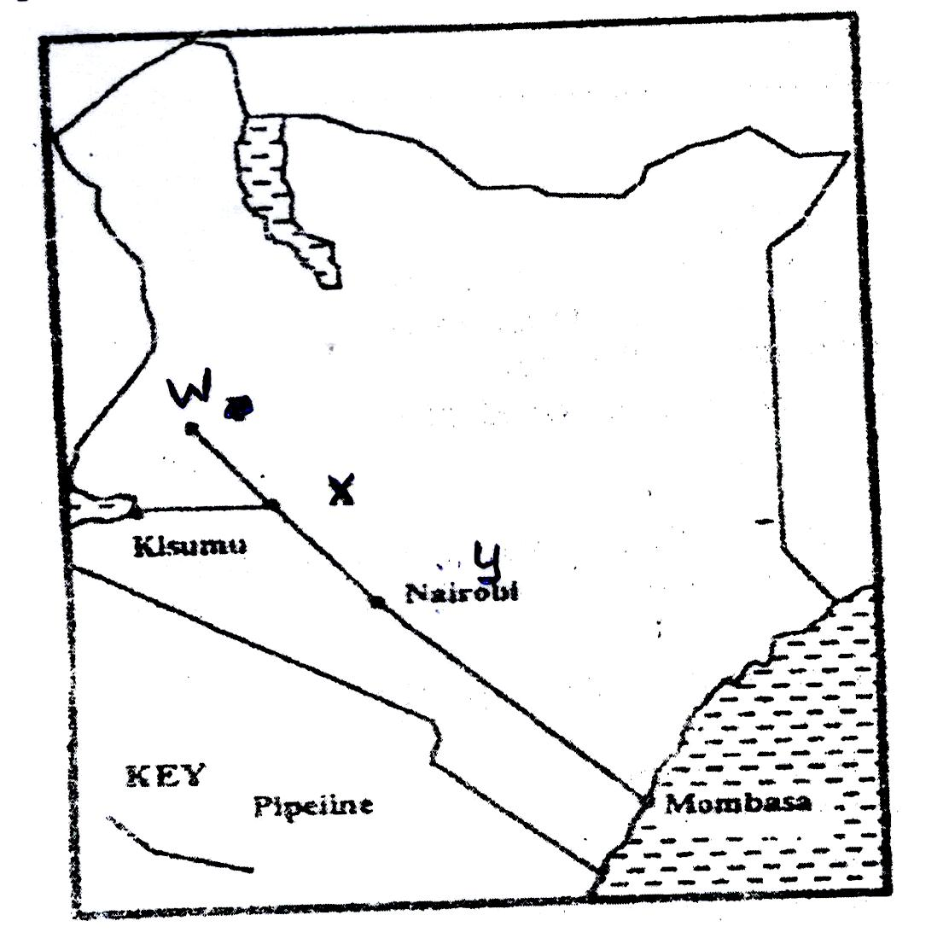

- Name the areas marked W, X and Y. (3 marks)
- State four physical conditions that favour tea growing in Kenya. (4 marks)

(b) The table below shows tea production in Kenya for two years.
Years | Tea Produced (in tonnes)
1975  1985 | 56,000  137,000

- Calculate the percentage increase in tea production over the ten years period between 1975 and 1985. (2 marks)
- Give two reasons why there was such an increase in tea production over the given period. (2 marks)

(c) Describe the stages through which tea is processed from picking to the time its ready for marketing. (6 marks)
(d) Explain four problems experienced in small scale farming in Kenya. (8 marks)

- A map of East Africa showing minerals distribution.
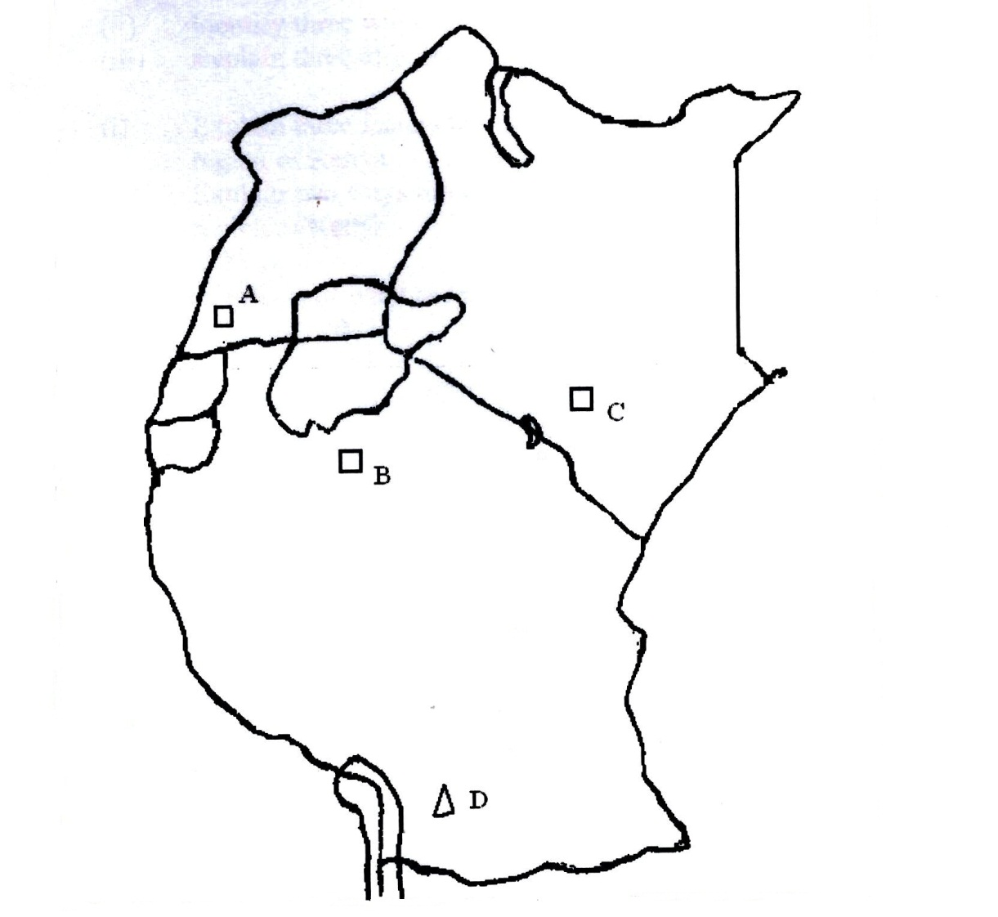
Use the map of East Africa above to answer question (a).
- (i) Name the mineral mined at points A, B, C, D. (4 marks)
(ii) Give three by products obtained when crude oil is refined. (3 marks)

- (i) Explain how trona is processed after reaching the factory. (7 marks)
(ii) List three uses of soda ash. (3 marks)

- Explain four effects of the rising prices of crude oil in the economy of Kenya. (8 marks)

- (a) (i) Apart from water and air pollution, name two other types of pollution. (2 marks)
(ii) Identify three ways through which water is polluted (3 marks)
(iii) Explain three effects of air pollution on the environment. (6 marks)

(b) (i) Explain three factors that lead to frequent flooding in the lake region of Kenya. (6 marks)
(ii) Explain two ways through which floods are controlled in the lake region of Kenya. (4 marks)
(c) State four effects of wind as an environmental hazard in Kenya. (4 marks)

