Name: ______________________________________Index No: ________________________

School:______________________________ Adm.No:_____________________________

Candidate’s Sign___________________ Date: ____________________________

312/1
GEOGRAPHY
Paper 1

APRIL 2023
Time: 2 ¾ Hours

ARISE AND SHINE
FORM 4 TRIAL1 EXAMINATION - 2023
Kenya Certificate of Secondary Education (K.C.S.E)

Instructions to Candidates:
- Write your name and admission number on the spaces provided above.
- This paper has two sections: A and B.
- Answer all questions in section A.
- In section B, answer question6 and any other two questions.

FOR EXAMINERS USE ONLY

SECTION A
Question number | 1 | 2 | 3 | 4 | 5 | Sub Total
Marks
Grand total

SECTION B
Question number | 6 | 7 | 8 | 9 | 10 | Sub Total
Marks

SECTION A
Answer ALL Questions in this Section

- The diagram below shows the angles of the sun’s rays at different latitudes when the sun is at the equator.
Use it to answer questions (a) (b).

- Name the parts of the earth’s surface marked J and K. (2 marks)
- Giver two reasons why the intensity of the insolation is higher at M than at N. (2 marks)

- (a) What is weathering? (2 marks)
(b) Give three factors that influence the rate of weathering. (3 marks)

3 The diagram below shows a composite volcano.
- Name the features marked P, Q and R. (3 marks)
- How is a parasitic cone formed? (3 marks)

4. (a). What is land breeze? (2 marks)
(b). Give two ways in which sea breezes influence the adjacent land. (2 marks)

5.
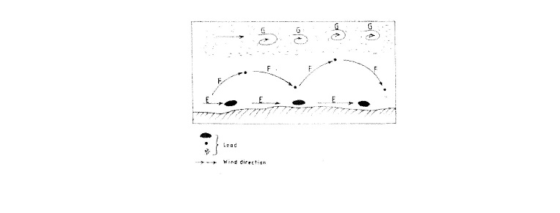
(a). Name the three ways labelled E,F and G. (3 marks)
(b). Name three features produced by wind abrasion in arid areas. (3 marks)

SECTION B
Answer Question 6 and Any Other Two Questions from this Section.

- Study the map of KISUMU EAST 1:50,000provided and answer the following questions.

(a) i) Convert the ratio scale into statement scale. (2 marks)
ii) Identify two methods that have been used to represent relief on the map. (2 marks)
iii) Name three physical features found in grid square 0298. (3 marks)

- i) Give the six figure grid reference of the Air Photo Principal point to the East of
Obumba School. (2 marks)
(c) Describe the drainage of the area covered by the map. (4 marks)
(d) i) Citing evidence, name three social services offered in the area covered by the map.
(6 marks)
ii) Explain three factors that may have influenced the distribution of settlements in the area.
(6 marks)
- (a) Describe the following characteristics of minerals
(i) Colour (2 marks)
(ii) Cleavage (2 marks)
(iii) Hardness (2 marks)
(b) (i) Give two types of igneous rocks. (2 marks)
(ii) Explain three conditions necessary for the growth of coral polyps. (6 marks)
(c)State four uses of rocks. (4 marks)
(d). You are planning to carry out a field study on the rocks within your school environment
(i) Give two secondary source of information you would use to prepare for the field study.
(2 marks)
(ii) State why you would need the following items during the field study:
- A fork jembe (1 mark)
- A polythene bag (1 mark)
(iii). Suppose during the field study you collected: Marble, sandstone and granite, classify
each of these samples according to its mode of formation. (3 marks)

- The map below shows the location of some mountain ranges.
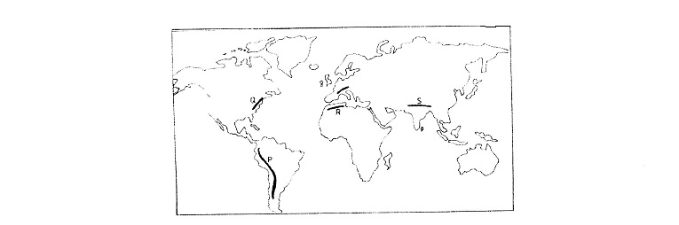

(a). Name the ranges marked P , Q, R and S. (4 marks)
(b). (i) Apart from fold mountains, name three other features resulting from folding. (3 marks)
(ii). With the aid of labelled diagrams, describe how fold mountains are formed. (10 marks)
- Explain the significance of fold mountains to human activities (8 marks)

9. (a) (i) What are tides? (2 marks)
(ii). Give three causes of ocean currents (3 marks)
(iii) Name the three ocean currents along the western coast of Africa (3 marks)
(b). (i) State three characteristics of submerged lowland coasts. (3 marks)
(ii) Explain three factors that determine the rate of coastal erosion. (6 marks)
(c). With the aid of labelled diagrams, describe the process through which a stack is formed.
- marks)
10. The diagram below represents an artesian basin. Use it to answer question (a)
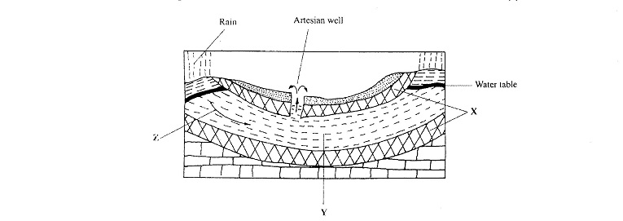
- Identify:
(i) The layers marked X and Y (2 marks)
(ii) The process marked Z (1 mark)
- Explain how the following factors influence the amount of underground water in limestone areas:
(i) Rainfall (4marks)
(ii) Vegetation cover (4 marks)
(c)
(i) Apart from stalagmites, name three other underground features formed in limestone areas.
(3 marks)
(ii) With the aid of a diagram, describe how a stalagmite is formed (8 marks)
(d) Give three reasons why there are few settlements in kartst landscapes. (3 marks)

