NAME: ____________________________________ CLASS: ____________ADM NO: ___________
312/2
GEOGRAPHY
PAPER 312/2
PAPER TWO
END OF TERM TWO
FORM 4 EXAM
Time: 2 ¾ hours
INSTRUCTIONS TO CANDIDATES
- This paper consists of two sections A and B answer all questions in section A
- In section B answer question 6 and any other two questions.
- All questions must be written in the answer booklet provided.
For examiner’s use only
Section A | 1 – 5
Section B | 6
 | 7
 | 8
 | 9
 | 10
TOTAL

SECTION A: ANSWER ALL QUESTIONS IN THE ANSWER BOOKLET PROVIDED.
1a) Apart from draining swamp, state two other methods used in reclaiming land in Kenya. 2mks
b) State three benefits that resulted from the reclamation of the Yala swamp. (3mks)
2. a) Define ecotourism (2mks)
b) Give three tourist attractions found in Turkana County. (3mks)
3a) State three problems facing hydro-electric power projects in Kenya. (3mks)
b) State two ways in which Kenya has benefited from the development of geothermal power. (2mks)
4a) State three physical conditions that favour large scale maize cultivation in Trans-Nzoia district in Kenya (3mks)
b) State three problems facing maize farming in Kenya (3mks)
5a) Why is it necessary to conserve water? (2mks)
b) How does terracing help in water conservation (2mks)

SECTION B: Answer question 6 and any two other questions from this section
6. The photograph provided shows means of railway transport used in Kenya. Use it to answer questions a & b.

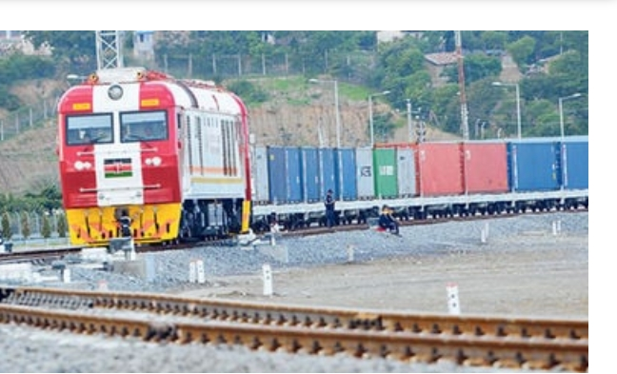

a i) What evidence in the photograph shows that it is a ground general view type of
photograph (3mks)
ii) Draw a rectangle measuring 15cm by 10cm to represent the area of the photograph (1mk)
iii) On it sketch and label four main features (4mks)
b) Explain four reason why there are few rail links among African countries (8mks)
ii) Explain three measures which should be taken to improve inland water transport in
Africa. (6mks)
iii) State three advantages of containenzation. (3mks)

7a i) Give three documents from where information on population data is obtained (3mks)

ii) The pyramid below represent population structure in Sweden.

Describe the characteristics of population represented by the pyramid (3mks)
b (i) Explain four positive effects of low population growth rate in a country. (8mks)
ii) Give three reasons it is necessary for the government of Kenya to carry out population census. (3mks)
c. Explain four causes of rural urban migration in Kenya (8mks)

8 a i) Name three manufacturing industries found in Thika town. (3mks)
ii) State three reasons why paper milling industries are located near rivers (3mks)
b (i) Explain four causes of the decline in the textile industry in Kenya. (8mks)
ii) Outline five reasons why the County government of Murang’a should encourage foreign investors to establish Juakali industries in the county. (5mks)
c) Explain three problems arising from industrialization in Kenya. (6mks)

9 a i) Define the term fisheries (2mks)
ii) Name three fresh water lake in Uganda where fishing takes place (3mks)
b) Explain how the following factors favour fishing along the coast of North West
Atlantic fishing ground.
(i) Indented coastline (2mks)
(ii) Ocean Currents (2mks)
c i) Explain four reasons why in East Africa, fresh water fishing is more developed than marine fishing. (8 Marks)
ii) Outline four similarities between fishing in Kenya and Japan (8mks)
10.a) The diagram below shows the occurrence of petroleum in the earth’s crust. Use it to answer question a (i)

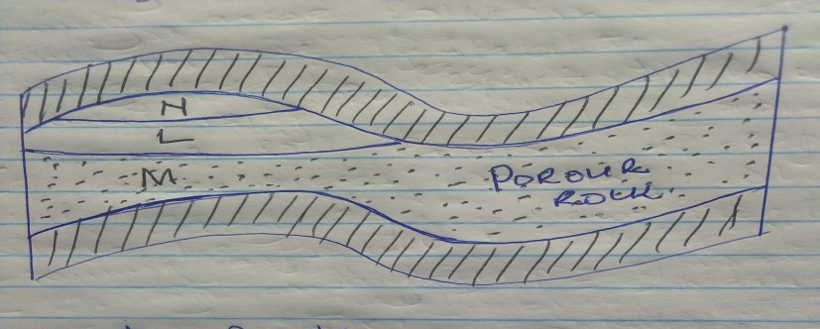

i) Name the substance in the area, labeled L,M and N. (3mks)
ii) Give three by products obtained when crude oil is refined (3mks)
b) State five negative effects of open cast mining on the environment (4mks)
c (i) Describe the stage involved in the processing of trona from lake Magadi. (7mks)
ii) Explain four ways in which Kenya has benefited from mining of trona on lake Magadi. (8mks)

