321/1
GEOGRAPHY PAPER 1
FORM FOUR
2 ¾ HOURS
KENYA CERTIFICATE OF SECONDARY EDUCATION
GEOGRAPHY PAPER 1

MARKING SCHEME
- a) Name two planets without satellites. (2mks)
- mercury
- venus (2×1=2mks)
b) State three characteristics of the inner core. (3mks)
- it is made up of iron
- it has very high temperatures estimated to be between 4500ºC
- it has average density of between 16-17gm/cc/has very high density
- it is solid in nature (any 3×1mk=3mks)

- a) Give two local winds that are found in Kenya. (2mks)
- anabatic winds
- katabatic winds
- sea breeze
- land breeze (Any 2×1mk=2mks)
b) State three conditions necessary for formation of dew. (3mks)
- day time should be warm to facilitate evaporation
- the air should be calm
- the temperatures should be low below dew point
- the sky should be clear/cloudless at night. (Any 3×1mk=3mks)

- a) Define a lake. (2mks)
- It is a body of water which occupies a basin, depression or hollow on the earth’s surface. (1×2=2mks)
b) State three reasons why some rift valley lakes have fresh water. (3mks)
- They have surface and subterranean outlets through which excess salts deposits are carried away.
- They have regular inflow of fresh water from rivers which dilute the salts, keeping the water fresh.
- They are situated in areas of high rainfall, which keep this water fresh
- They are isolated in areas of low temperatures, resulting in low rates of evaporation, therefore low salt concentration. (Any 3×1=3mks)

- a) Give two main components of soil. (2mks)
- inorganic matter
- organic matter
- soil water/moisture
- soil/air (Any 2×1=2mks)
b) State three factors that favour soil erosion.
- Steep slope
- Fine textured soil e.g. volcanic ash
- Absence of vegetation cover
- High rainfall (Any 3×1=3mks)

- The diagram below shows a river and its tributaries. Use it to answer question 5(a)

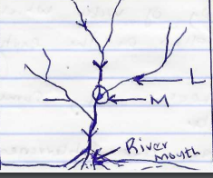

- Name the parts marked L and M. (2mks)
L – Tributary
M – Confluence (2×1mk=2mks)

- State three factors that influence river deposition. (3mks)
- Reduction/reduced gradient/velocity
- Decrease in river volume
- Nature and amount of load
- Presence of obstacles in the river channel
- Widening of the river channel
- River entering into a calm water body/lake/sea
- Freezing of river water. (Any 3×1mk=3mks)
SECTION B
Answer question 6 and any other two in this section
- Study the map of Kijabe provided (1:50,000) and use it to answer the questions that follow.
- i) State one method of representing relief used in the map extract.
- Contours
- Trigonometrical station and spot height. (1×1mk=1mk)
ii) Give the six figure grid reference of the cattle dip near Kenton. (2mks)
- 279014 (1×2mks=2mks)
iii) Give the longitudinal extent of the map extract. (2mks)
- From 36º 30ºE to 36º 45¹E (1×2mks=2mks)
- i) Calculate the area to the south of the power line giving your answer in Km² (2mks)
- Full squares =16
- Half squares =28 =28/2=14 full squares.
Total area =16+14=30km² (⁺0.5km²) (1×2mks=2mks)
ii) Describe the settlement distribution in the area covered by the map extract.
(5mks)
- There are no settlements within the Ewaso Kadong valley
- There are nucleated settlements in the markets/shopping centres/villages
- Some areas with steep slopes/ridges/river valleys/kijabe hill have fewer or no settlement
- There are fewer settlement within the forest
- Kinale/Kinari forest station has dense settlement.
- There are no settlements within the plantations
- There are few settlements to the west of Naivasha-Narok road.
- The area covered by the map is generally sparsely settled.
- There are linear settlements along some roads.
(Any 5×1mk=5mks)
- Explain three factors favouring cattle rearing in the area covered by the map. (6mks)
- The presence of scrub and scattered trees show that there is natural pasture for cattle.
- The presence of many rivers/sources of water show that there is adequate water for cattle.
- The area has high attitude/above 1000m which provide cool conditions suitable for cattle rearing.
- The many cattle dips for controlling ticks/parasites which attack cattle show that there is access to veterinary services.
- There are large tracks of land with few settlements ensuring extensive areas available for grazing.
- Availability of transport as evidenced by roads/railway line for movement of cattle/cattle products.
- Dense settlements in some areas provide market for cattle/cattle products
(Any 3×2mks=6mks)
- Draw a cross section from grid reference 270900 to 300960. On your cross section label and name
- Tarmac rod
- Power line
- River Tongitongi
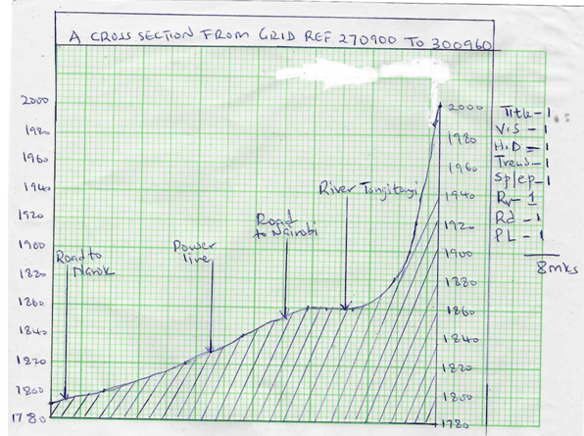
T- Title ,V.S- vertical scale, H.D- Horizontal distance, ST/EP- Starting point(1780- 1800m) And End point ( 2000m), Rv- River, Rd- road( Any road), PL- Power line

- a) i) Differentiate between weathering and mass wasting. (2mks)
- Weathering is the mechanical breakdown or chemical decay of rocks in situ while mass wasting is the movement of weather rock materials down a slope under the influence of gravity. (2mks)
ii) Name two types of landslides. (2mks)
- slump
- debris slide
- debris fall
- rock fall
- rock slide (Any 2×1mk=2mks)

iii) Other than water, identify three other weathering agents. (3mks)
- heat
- dissolved substances
- plants
- animals
- people
- gases eg. Co₂, O₂ (Any 3×1mk=3mks)
b) i) Explain how the following process of weathering take place.
- Exfoliation
- During the day, the rock surface is heated more than the inner layers because rocks are bad conductor of heat. The surface expands more than inner layers creating a strain between the two layers.
- At night the surface cools faster than the inner layers.
- With time the outer layer develops cracks and later frees off and pieces of rock fall down by gravity. (3mks)
-Carbonation
- Rain water mixes with carbon dioxide in the atmosphere to form a weak carbonic acid.
- The carbonic acid reacts with calcium carbonate in calcareous rocks (limestone, dolomite, chalk) to form calcium bicarbonate.
- Calcium carbonate is soluble and it is removed from the rock in solution. (3mks)
ii) Explain how the following factors influence mass wasting.
- Climate
- Heavy rain or alternate freeze and thaw periods encourage movement of materials
- Areas with high rainfall records have wet materials which are easily moved under gravity. (any 2×1mk=2mks)
- Slope
- There is faster movement of materials on steep slopes compared to gentle slope/low lying plain. (1×2mks=2mks)

- i) Describe the process of solifluction. (3mks)
- it occurs in mountaneous and cold climate areas
- in cold seasons, the soil water get frozen. When the warm season sets in frozen water in the top soil thaws and subsoil remains frozen.
- The top soil gets saturated with water, making it slide over the frozen subsoil. This movement is called solifluction. (1×3mks=3mks)
ii) State two causes of soil creep. (2mks)
- Ploughing downhill cause soil to shift down slope.
- Earthquakes shakes the crustal rocks causing soil particles to move downwards
- Temperature changes makes soil particles to expand and contract
- Trampling and burrowing of animals. (any 2×1mk=2mks)

- Students of Makuyu Boys carried out a field study on weathering in a limestone area.
- Name two surface features they may have identified. (2mks)
- Grikes
- Clints
- Dolines
- Swallow holes/sink holes
- Uvala
- Polje
- Dry river valley. (Any 2×1mk=2mks)

- State one effect of weathering on human activities (1mk)
- It leads to formation of soils useful for agriculture.
- It may break rocks which contain minerals which man can exploit
- It produces clay and bauxite which can be used in pottery and manufacture of aluminium
- It weaken rocks which moltens quarrying easier ( 1MK)

- a) i) What is a piedmont glacier. (2mks)
- This is a glacier formed when several valley glaciers flow and coalesce downhill to the lowland to form a large mass of ice. (2mks)

ii) State two conditions favouring the formation of glaciers
- existence of very low temperatures below 0ºC which allow formation of ice and snow
- Abundant and constant supply of snow fall that exceeds snow melting. (2×1mk=2mks)
b) Explain the following ways of ice movement. (2mks)
i) Basal slip
- this is where a glacier slides/slips over the overlying rocks due to gravity
- Melt water at the base of the glacier resulting from pressure exerted by the glacier at the base acts as a lubricant between the ice and at the underlying rock. (2×1-2mks)

ii) Plastic flowage (2mks)
- This is the flow of ice as a viscous liquid resulting from thawing of ice in the lower layers caused by the weight of the overlying layers of ice. (1×2=2mks)
c) i) State two processes of glacier erosion. (2mks)
- Plucking
- Abrasion (2×1=2mks)
ii) Using a well labeled diagram describe the formation of crag and tail. (7mks)
- A resistant rock (crag) lib on the path of a glacier
- A glacier passes over and around the rock
- The glacier is only able to slightly erode the rock
- The materials that are carried by the glacier are deposited on the lee side of the resistant rock (downstream side)
- The upstream side of the resistant rock is eroded slightly forming the crag and the downstream side when there is deposition forms the tail

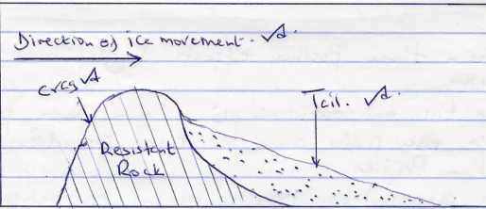
(Explanation 4mks diagram 3Mrks= 7Mks)
- Apart from crag and tail state two glacial depositional featutes. (2mks)
- Terminal moraine
- Drumlins
- Kame
- Outwash plain
- Esker
- Eratics
- Till/boulder clay
- Boulder train (Any 2x1mk=2mks)

d) Explain three positive effects of glaciations to human activities.
- Some till and outwash plains form part of the world’s fertile areas for crops production eg the Canadian prairies.
- Some glacial lakes provide natural transportation routes eg the Great lakes of North America
- Waterfalls from hanging valleys can be used to produce hydroelectric power (HEP). The power can be used to run machines industries.
- Erosion by continental ice sheets expose minerals such as iron and gold in the Canadian Shield, for easier exploitation.
- Melt water from glaciers gives rise to rivers that provide water for irrigation, domestic/industrial use, products on of HEP
- Glaciated highlands especially mountains are attraction sites for tourists. Winter sports such as skiing are major attractions on the Alps in Switzerland.
- Sand for building and construction is excavated from outwash plains, eskers and kames. (any 3x2mks=6mks)

- a) i) Differentiate between orogenic and epeirogenic earth movement. (2mks)
- orogenic earth movements are the horizontal/lateral displacements occurring within the crustal rocks due to tectonic forces while epeirogenic earth movements are the vertical displacements occurring within the crystal rocks due to tectonic movements. (1x2mks=2mks)

ii) Describe the origin of continents according to the theory of plate tectonics. (4mks)
- the earth lithosphere/crust is divided into several rigid blocks called tectonic plates.
- The plates float on semi molten mantle that lies beneath
- The plates move horizontally due to convectional currents within the mantle in three ways; towards one another, away from one another or side by side parallel to each other
- The plates form distinct boundaries along the plates margins. Each continent sits on a tectonic plate. (4x1mk=4mks)

b) i) Apart from an over thrust fold, name three other types of folds.
- Simple fold/symmetrical fold
- Asymmetrical fold
- Over fold
- Isoclinals fold
- Recumbent fold
- Over thrust fold/nape fold
- Anticlinorium and synclinorium complex fold.
( 3 x 1 = 3Marks)
ii) Using well labeled diagrams, describe how Fold Mountains are formed.
(8mks)
- Compressional force lead to the formation of a large depression called a geosynclines
- Water collects in the geosynclines to form a sea.
- Prolonged and extensive erosion occurs on the surrounding higher lands and the sediments are deposited in geosynclines forming a thick deposit
- The weight of the sediments causes subsidence of the geosyncline leading to accumulation of more sediments to great thickness.
- Further subsidence of the geosyncline triggers off compressional forces which cause the sediments to fold.
- The folded layers of sediments in the geosyncline are thrust upwards to form Fold Mountains along the edges of the geosynclines.
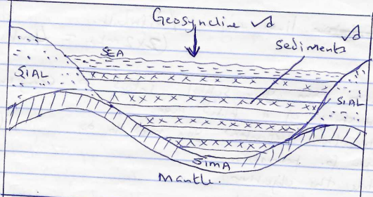

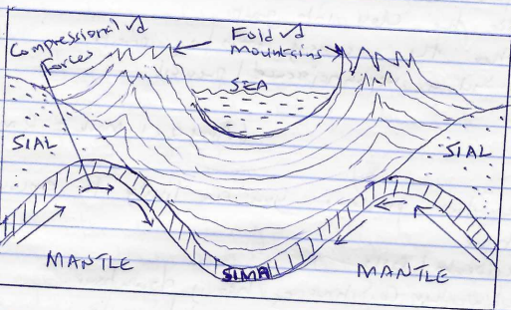

Text – 4
Diagrams – 4 = 8mks
c) Explain two negative effects of folding to human activities.
- Leeward slopes of fold mountains receive little or no rainfall/experience dry conditions which discourage settlement/crops farming.
- The rugged nature of folded landscape discourage settlement
- Fold mountains are barrier to transport/make construction of transport lines expensive/difficult. (Any 2x2=4mks)
d) Students from your school intend to carry out a field study of a folded area.
i) State two preparations you need to do. (2mks)
- Seek for permission
- State the objectives
- Formulate the hypothesis
- Prepare a working schedule
- Divide the class into groups
- Gather the necessary tools/equipment
- Conduct a reconnaissance/previsit (any 2x1=2mks)

ii) State two problems you are likely to encounter. (2mks)
- Fatigue
- Accidents/falls
- Bad weather conditions eg heavy downpour
- Attack by dangerous animals/insects
- Uncomperative respondents.
- Difficulties in climbing activities. (any 2x1mk=2mks)

- a) i) Apart from stalagmite Identify two underground features in a Karst scenery. (2mks)
- Limestone pillars
- Cave
- Stalagmite
- Stalactite (any 2x1mk=2mks)
ii) State three conditions necessary for the formation of a Karst landscape. (3mks)
- The surface rock should be thick limestone, chalk or dolomite to allow solubility of water.
- The rock should be hard, well jointed to allow rainwater to percolate through the lines of weaknesses
- The place should be hot and humid to facilitate chemical weathering/carbonating/solution to take place.
- The water table should be far below the surface to allow formation of features
(Any 3x1mk=3mks)
iii) Describe the formation of a stalagmite. (5mks)
- Rainwater dissolves/absorbs carbon dioxide (Co₂) in the atmosphere to form weak carbonic acid. (H₂CO₂)√
- Carbonic acid falls on a jointed limestone rock below which is a cave√.
- The carbonic acid percolates through the joints reacting with calcium carbonate in the limestone rock forming calcium bicarbonate/calcium hydrogen carbonate which is soluble.√
- The solution drips to the floor of the cave from the roof.√
- Some of the water evaporates and CO₂ is released leaving behind deposits of calcium carbonate which grows upwards from the floor of the cave.√
- With time, the calcium carbonate accumulate and eventually lead to the formation of fingerlike projections on the floor of the cave called stalagmites.√
(5mks) NB Sequence must be followed.
(At the last point must be mentioned to score max points)
b) i) Name two water erosional features on a desert. (2mks)
- Landscape
- Mesas/buttes
- Gorges/canyons
- Wadins
- Dry river valleys/laghas
- Inselbergs (any 2x1mk=2mks)
ii) Describe the formation of a rock presestal. (5mks)
- A rock with alternating hard and soft layers lies on the path of wind.
- Wind abrasion attacks the rock eroding the softer layers faster than the hard layers.
- Abrasion is greater near the ground due to the heavier materials transported by wind
- The softer layers are eroded to form hollows and the hard layers are left as protrusions
- This leads to the formation of an irregular rock pillar with a narrow base called a rock pedestal.
c) Explain four significance of desert land forms to human activities. (8mks)
- Desert features eg Zeugen, yardangs, rockpedestals, are tourist attraction sites. Tourists bring in foreign exchange.
- Deflation hollows may contain water used for domestic us, irrigation/watering livestock.
- Loess resulting from wind depositions forms fertile soils for crops farming.
- Seasonal streams in the deserts may be dammed to provide water for irrigation during dry seasons
- Desert landscape/areas are ideal sites for testing militants weapons and military training.
- Sand dunes may cover roads making transport difficult
- The wadis/bad lands make transport facilities difficult and expensive to construct.
- The desert has high solar isolation which can be harness for solar energy production. This can be used to light homes and run industries.
- Desert scenery provide good site for shooting films
- Flash floods in the desert areas cause deaths when people are carried away by water that furiously flow through the wadis
- Rocky deserts surfaces discourage settlements. (any 4x2mks=8mks)

