NAME………………………………………………ADM……………….CLASS………….
PAPER 312/2
GEOGRAPHY PAPER 2
FORM FOUR
TIME : 2HRS 45 MIN
MULTILATERAL EXAMINATION
SEP/OCT 2022
OPENER EXAMINATION TERM 3, 2022
SECTION A: ANSWER ALL QUESTIONS FROM THIS SECTION
1.a) Differentiate renewable and non-renewable source of energy. ( 2mks)
b) State three problems experienced due to over-dependence on petroleum oil(3mks)
2.a) Name two types of manufacturing industries in Kenya. ( 2 mks)
b) State three problems facing jua-kali industries in Kenya (3mks)
3.a) Give the relationship between Geography and Economics. (2 marks)
b) State three reasons for studying Geography in secondary schools. (3 marks)
4a). State two reasons why wildlife conservation is encouraged in Kenya (2mks)
b) Measures the Kenyan government take to attract more tourists. (3mks)
5 (a ). Name three counties in Western highlands where tea is grown. (3 marks)
b) State two physical conditions that favour tea growing in the Kenya highlands.(2 marks )

SECTION B:
Answer question 6 and any other TWO questions from this section.

6. Study the photograph below and use it to answer question (a).
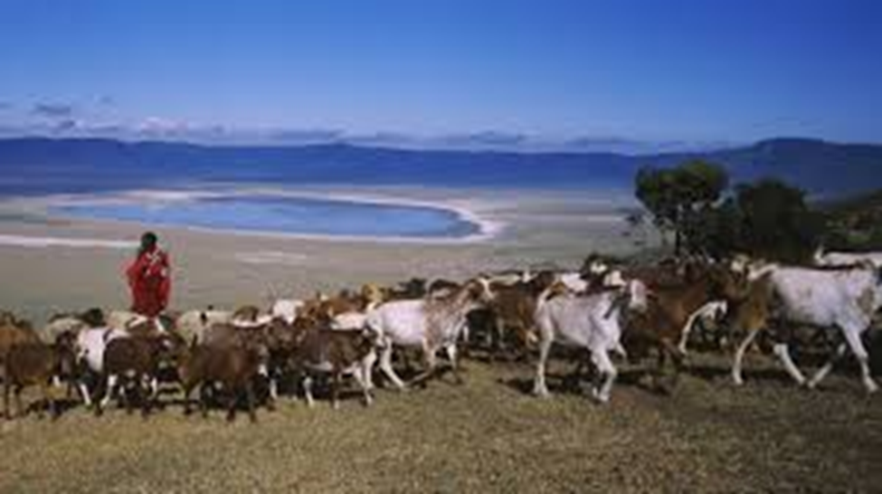
(a) (i) Identify the type of photograph shown above. (1 mark)
(ii) Using evidence from the photograph, give two indicators to show that the area is experiencing semi-arid conditions. (2 marks)
(iii) Describe the features shown on the photograph. (3 marks)
(iv) Draw a rectangle measuring 15 cm by 10 cm to represent the area covered by the photograph. (1 mark)
- On the rectangle, sketch and label four main features shown on the photograph. (4 marks)
(b) (i) Name two pastoral communities in East Africa. (2 marks)
(ii)Outline three physical factors that favour pastoral farming in Kenya.(3marks)

(c) State three problems facing pastoralists in Kenya. (3 marks)
(d.) Explain three ways in which the government of Kenya assists nomadic pastoralists to improve the quality of their livestock. (6 marks)

7. The table below shows the quantity of mineral produced in Kenya in tones between years 2001 and 2005.
Use it to answer questions a(i) and (ii).
Mineral / Years | 2001 | 2002 | 2003 | 2004 | 2005
Soda ash | 297780 | 304110 | 352560 | 353835 | 360161
Fluorspar | 11885 | 85015 | 80201 | 117986 | 109594
Salt | 5664 | 18848 | 21199 | 31139 | 26595
Others | 6093 | 7000 | 4971 | 6315 | 8972
Source: Economic Survey, 2006.
- Calculate the average production of soda ash over five year period. (2 Marks)
- Calculate the total mineral production for the year 2003. (1 Mark)
- Give three uses of soda ash. (3 Marks)
b) i)Name the main places in Kenya where the following minerals are mined: -
a) Flour spar-
b) Titanium-
c) Gold-. (3 Marks)
ii) State two problems associated with shaft mining. (2 Marks)
c) Explain four ways in which gold mining has contributed to the economy of South Africa. (8 Marks)
- Explain three negative effects of mining on the environment. (6 Marks)

8.a)i) Name four exotic softwood tree species planted in Kenya (4 marks)
(ii) State five factors favoring the development of softwood forests in Kenya (5 marks)
b) Explain four measures that the government of Kenya is taking to conserve forests in the country (8 marks)
c)i) Give reasons why forests are more wide spread in Canada than Kenya.(4 marks)
ii)Compare forestry in Canada and Kenya under the following sub-headings;
- Tree species (2 marks)
- Transportation (2 marks)
9.) a.) Differentiate between land reclamation and land rehabilitation (2 marks)
b.) Identify three methods of land reclamation in Kenya (3 marks)
c.) i.) State four physical factors that influenced the location of Mwea Tabere
irrigation scheme (4 marks)
ii.) Explain four problems facing Mwea Tabere irrigation scheme (8 marks)
d.) i.) Outline the stages that were involved in reclamation of land from the sea in Netherlands (5 marks)
ii.) State three benefits of irrigation farming in Kenya (3 marks)
10 a) (i) Name two types of fishing. (2mks)
(ii) State three physical factors that influencing fishing. (3mks)
b) Explain three reasons why the North East Atlantic fishing ground is extensively and highly developed. (6mks)
c) (i) What is fish farming? (2mks)
(ii) Describe harpooning as a method of fishing. (4mks)
d) (i) State two problems facing fishing in Japan. (4mks)
(ii) Explain two similarities between fishing in Kenya and Japan. (4mks)

