PAPER 312/2
GEOGRAPHY
FORM FOUR
AUGUST 2022
MARKING SCHEME
SECTION A: ANSWER ALL QUESTIONS FROM THIS SECTION
1. a) Differentiate renewable and non-renewable source of energy.
Renewable sources of energy are those that can be regenerated and used for a very long time while non- renewable source of energy are those once used they became exhausted. ( 2 Marks)
b) State three problems experienced due to over-dependence on petroleum oil (3mks)
- Importation of oil drains off foreign exchange leading to unfavorable balance of trade
- High cost of transportation when there are crisis
- Closure of some industries which depend on petroleum and petroleum product as a raw material Leads to high cost of production which increases the prices of manufactured goods. ( any 3 ×1= 3mks

2. a) Name two types of manufacturing industries in Kenya.
- Agricultural food processing industries
- Agricultural non-food processing industries
- Non-agricultural processing industries. (any 2 ×1 =2mks)
b) State three problems facing jua-kali industries in Kenya
- Competition from well-established factory manufactured goods hence reduced sales
- Inadequate capital to invest
- Discrimination of goods due to negative attitude on the products leading to low demand.
- A rise in cost of materials resulting in increase in the prices of goods limiting the growth of industries
- Exploitation by middle men who offer low prices.
( Any 3×1=3mks)

3.a) Give the relationship between Geography and Economics.
- Geography uses the information from economics to study exploitation of natural resources, the methods of production, trade, tourism, and factors influencing such economic activities.
- Economics uses geography to show where economic activities are carried out, factors of production and consumption of goods and services.
(2 MARKS)
b) State reasons for studying Geography in secondary schools.(3 marks)
- Provides knowledge/understanding the environment
- Helps students to manage time well.
- Prepares students for career opportunities
- Promotes the development of practical skills and critical thinking.
- Creates awareness on social values
- Promotes awareness on the proper use of natural resources.
(Any 3 x 1 =3Marks

4a).Reasons why wildlife conservation is encouraged in Kenya.
- To protect/regenerate endangered animals/plants species.
- To promote tourism.
- To generate foreign exchange/revenue.
- To keep them for posterity/for future generation.
- To sustain raw materials for supply of drugs/medicinal value.
- For education/research purposes.
- For aesthetic value/beauty/recreation purposes.
(Any2x1=2mks)
b) Measures the Kenyan government take to attract more tourists.
- Improve infrastructure/roads/airports/communication to all
tourists sites.
- Improve security for safety of tourists.
- Guard against terrorism that scare away tourists/maintain peace in
the country.
- Improve the image of the country abroad/market Kenya’s tourism
more aggressive.
- Establish a diversity of tourism attraction/stop depending on
traditional attractions.
- Promote ecotourism for conservation and for developing new
attractions.
- Establish modern tourist facilities in areas of high potential.
- Intensity domestic marketing/promote domestic tourism to avoid
overreliance on foreign tourists.
- Improve and train more personnel to serve tourists better.
- Sensitize citizens on the need to be hospitable to tourists.
( Any 3x1=3Marks )
- (a ). Name three counties in Western highlands where tea is grown.
- marks)
Narok - Bomet - Kericho
- Nyamira - Kisii - Nandi
- Bungoma - Kakamega - West Pokot (Any 3 x 1 =3Marks)

b) State four physical conditions that favour tea growing in the Kenya
highlands. (4 marks )
- High rainfall annually/1000mm-2000mm annually.
- Well distributed rainfall throughout the year.
- Cool to warm conditions/moderate temperature/15° to 20°C
- Frost free conditions annually
- Deep, well drained soils/red volcanic soils
- Gentle/ sloping land
- Slightly acidic soils/volcanic
- High altitude/1500m-2400m above sea level.
( Any 4 x 1 = 4 marks)

SECTION B:
Answer question 6 and any other TWO questions from this section.

6. Study the photograph below and use it to answer question (a).
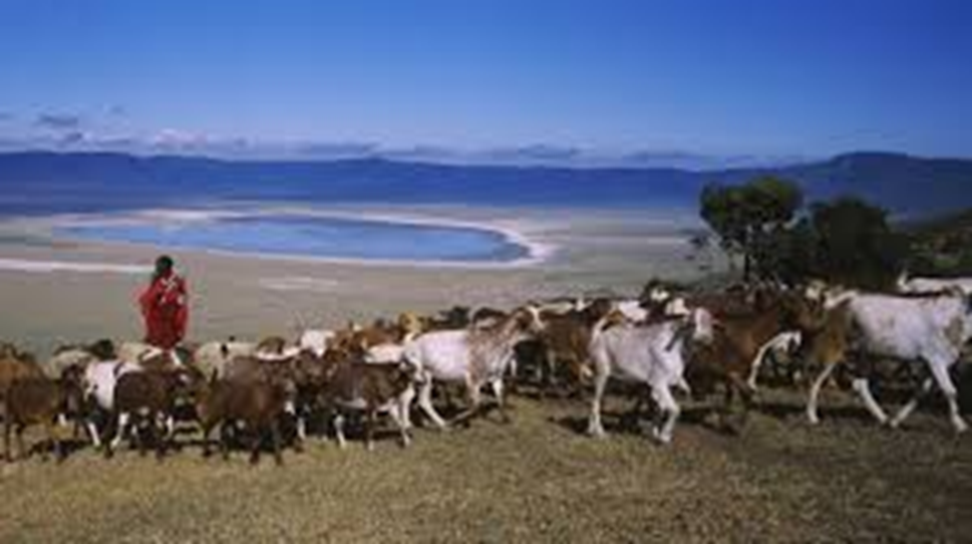
(a) (i) Identify the type of photograph shown above. (1 mark)
Ground general view
(ii) Using evidence from the photograph, give two indicators to show that the area is experiencing semi-arid conditions. (2 marks)
- There are patches of bareground in the foreground/middle ground
- There are few short/stunted trees /plants
- There is an oasis/playa in the middle ground
- The grass is short and dry/brown on the photograph.
( Any 2 x 1 = 2marks )
(iii) Describe the features shown on the photograph. (3 marks)
- On the foreground there is a bare ground, a herdsman herding and the goats browsing/grazing.
- There is a playa/oasis in the middle ground.
- There are scattered clouds in the background.
- There are hills in the middle ground.

(iv) Draw a rectangle measuring 15 cm by 10 cm to represent the area covered by the photograph. (1 mark)
- On the rectangle, sketch and label four main features shown on the photograph. (4 marks)
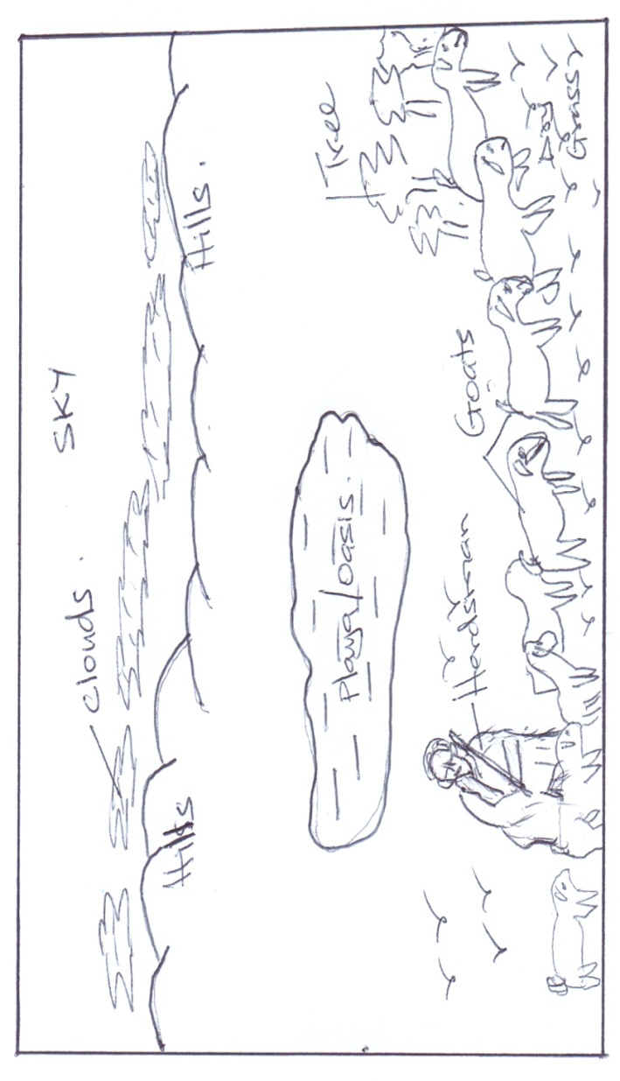

(b) (i) Name two pastoral communities in East Africa. (2 marks)
- Maasai
- Rendile
- Samburu
- Somali
- Borana
- Turkana
- Pokot

(ii)Outline three physical factors that favour pastoral farming in Kenya.
- The grazing areas are free from tsetse fly due to dry and hot conditions.
- Large tracts of land due to sparse population in the Northern and North Eastern regions.
- Availability of natural pasture in the Wooded Savannah lands.
- The gentle sloping landscape enable easy movement of livestock from one place to another.
(Any 3 x 1 = 3 marks)

(c) State three problems facing pastoralists in Kenya. (3 marks)
      - Prolonged drought which leads to shortage of water and pasture.
      - Low quality/less nutritious natural pasture.
      - Overstocking which leads to overgrazing hence poor pasture.
      - Pests e.g. ticks
      - Diseases e.g. Rinder pest/East coast fever/foot and mouth.
      - Low quality local breeds/Zebu/Boran which yields little milk/provide low quality meat.
      - Inadequate extension services.
      - Frequent livestock raids/cattle rustling.
      - Competition for range pastures with wildlife.
      - Poor transport connection hinders accessibility to potential markets.
      - Fire outbreaks destroy huge tracts of the grassland hindering their regeneration.
(Any 3 x 1 = 3 marks)

(d.) Explain three ways in which the government of Kenya assists nomadic pastoralists to improve the quality of their livestock. (6 marks)

- Establish demonstration ranches to sensitize pastoralists on better methods of animal husbandry.
- Cattle dips have been constructed to control pests.
- The government is encouraging group ranching to enable the pastoralist to view livestock keeping as a commercial undertaking.
- Boreholes have been sunk to provide water for livestock.
- Encouraging crossbreeding of indigenous breed with hybrid breeds to improve quality of livestock.
- Improvement of transport system in the areas for faster transportation of their livestock.
- Revival of Kenya Meat Commission to guarantee market for livestock.
- Establishment of anti-stock theft police to curb cattle raids.
- Research centres have been established for pest and disease control.
- Veterinary services have been provided to treat their animals.
- Extension services are being offered to educate/advice farmers.

(Any 3 x 2 = 6 marks)

7. The table below shows the quantity of mineral produced in Kenya in tones between years 2001 and 2005.
Use it to answer questions a(i) and (ii).
Mineral / Years | 2001 | 2002 | 2003 | 2004 | 2005
Soda ash | 297780 | 304110 | 352560 | 353835 | 360161
Fluorspar | 11885 | 85015 | 80201 | 117986 | 109594
Salt | 5664 | 18848 | 21199 | 31139 | 26595
Others | 6093 | 7000 | 4971 | 6315 | 8972
Source: Economic Survey, 2006.
- Calculate the average production of soda ash over five year period. (2 Marks)
297780+304110+352560+353835+360161=1,400,436√
1,400,436/5=280,087.2 tonnes√

- Calculate the total mineral production for the year 2003. (1 Mark)
352560+80201+21199+4971=458,931tonnes

- Give three uses of soda ash. (3 Marks)
- Used in manufacture of soap
- Used in manufacture of glass
- Used in manufacture of detergents
- Used in paper and pulp industry
- Used in oil refining
- Used in textile industry ( any 3×1=3mks)
b) i) Name the main places in Kenya where the following minerals are mined: -
a) Flour spar-Kerio valley
b) Titanium- Kwale county
c) Gold- Migori or Kakamega. (3 Marks)
ii) State two problems associated with shaft mining. (2 Marks)
- Sometimes mines are flooded with water causing waterborne diseases
- The dust produced causes respiratory diseases
- Emission of poisonous gases causes death/ respiratory diseases
- Collapse of mines leading to death of miners
( Any 2×1= 2mks)
c) Explain four ways in which gold mining has contributed to the economy of South Africa. (8 Marks)
- When exported earns the country foreign exchange
- Gold has been used as a unit of exchange for paying international debt
- Has led to development of social amenties
- Has led to urbanization of towns such as witwatersland
- Has led to industrialization hence larger market for the goods
- Has created employment opportunities raising the standard of livings
- Has led to development of transport network.
( any 4 ×2 = 8 mks)
- Explain three negative effects of mining on the environment. (6 Marks)
- Dumping of rock waste has led to loss of biodiversity
- Has led to land dereliction leading to wastage of of agricultural land
- Open pits that are left behind are breeding grounds for mosquitoes
- Causes environmental pollution e.g harmful gases released contaminates the air./mineral waste dumped into the rivers leading to death of aquatic life.
- Mining disrupts the water table leading to shortage of water
- Bare surfaces left due to clearing of the vegetation the land becomes prone to soil erosion. ( Any 3×2=6 mks)

8.a)i) Name four exotic softwood tree species planted in Kenya (4 marks)
- Cypress
- Pines
- Grevillea
- Fir
- K-apple
- Wattle
- Jacaranda (Any 4x1=4mks)

- State five factors favoring the development of softwood forests in
Kenya (5 marks)
- Cool climate experienced in the Kenya highland
- Heavy rainfall
- Rugged and steep landscape experienced in some parts of the Kenya highlands discourage settlement/agriculture leaving the forests to flourish.
- High demand for timber and wood products in the country
- Volcanic soils
- Government’s efforts to create forests through implementation of afforestation and re-afforestation programmes.

(Any 5 x 1 = 5 marks)

b) Explain four measures that the government of Kenya is taking to conserve forests in the country (8 marks)
- The government is registering/recognizing the efforts of NGOs like the green belt movement which have mounted campaigns on planting of trees
- It’s also gazetting forested areas to reduce encroachment of the public
- Creating public awareness through mass media/baraza’s on the importance of conserving forest resources.
- Enacting laws to prohibit the cutting of trees without a license protecting indigenous tree species.
- Employing forest guards to protect forests from fires/other illegal human activities.
- Encouraging people to practice agro-forestry so as to avoid cutting tress from the forests.
- Enactment of laws e.g. that are meant to effectively manage the forests e.g. The Forest Bill 2000
- Carrying out research through KEFRI and ICRAF in order to come up with ways of controlling diseases/develop species suitable for different ecological regions.

(Any 4 x 2 = 8 marks)

c)i) Give reasons why forests are more wide spread in Canada than Kenya.
(4 marks)
- The cool to cold climate, which prevails across Canada, favours the growth of coniferous but discourage settlement and agriculture leaving large area under forest.
- Population in Canada is very low (3 persons per squae km) hence a lot of land is available for the establishment of forests unlike Kenya.
- In Kenya a lot of land has been converted to agriculture and settlement reducing areas under forest unlike in Canada.
- Unregulated human activities such as charcoal production is rampant in Kenya unlike in Canada which destroyed a large area under forest.
- Large tract of land is rugged and with thin soils discouraging agriculture leaving forest to thrive.

(Any 4 x 1 = 4 marks)

ii) Compare forestry in Canada and Kenya under the following sub-headings;
- Tree species (2 marks)
- In Kenya there are both exotic and indigenous softwoods while in Canada main trees are indigenous.
- Harvesting (2 marks)
- In Kenya harvesting is done throughout the year while in Canada it is done in winter and early spring.
- In Kenya harvesting is done selectively while in Canada clear cutting of trees is done. (2 MARKS)
- Transportation (2 marks)
- In Kenya transportation of logs is done by road while in Canada logs are transported using meltwater/rivers, mobile steel bars/skidded along ice covered ground.
- In Kenya, transportation is expensive while in Canada it is cheap. (2MARKS)

9.) a.) i.) Differentiate between land reclamation and land rehabilitation (2 marks)
- Land reclamation is the process of converting wasteland into farm land for growing of crops and keeping of animals while land rehabilitation is the process of restoring land to its former productive state. ( 2 MARKS)
b.) Identify three methods of land reclamation in Kenya (3 marks)
- Irrigation
- Drainage of Swamps
- Control of Pests
c.) i.) State four physical factors that influenced the location of Mwea Tabere
irrigation scheme (4 marks)
- Availability of extensive land which made created room for future expansion.
- Black cotton soils with high water retention capacities suitable for rice growing.
- Well drained clay loamy soils suitable for growing of other cash and food crops.
- Gently sloping land which allows use of tractors and allows water to flow by gravity reducing the cost of pumping it to the fields.
- Availability of plenty of water from permanent rivers Thiba and Nyamindi draining the area.
- Experiences warm climate/conditions during the second part of the year suitable for rice growing.
(Any 4 x 1 = 4 marks)

ii.) Explain four problems facing Mwea Tabere irrigation scheme (8 marks)
- Stagnant water has become a breeding ground for mosquitoes and snails which transmit malaria and Bilharzia respectively
- Shortage of water due to excessive droughts and diversion of water into ‘Jua Kali’ rice farms.
- Pests and diseases e.g. case warm and leaf miner which attack crops lowering the yields and Quelea birds which feed on rice leading to a major loss of the crop.
- Inadequate capital on the part of farmers since the co-operatives collapse making them unable to acquire inputs forcing them to lease out all or part of their farms.
- Shortage of labour during the planting and harvesting season which forces the farmers to hire labour from outside at a high cost.
(Any 4 x 2 = 8 marks)

d.) i.) Outline the stages that were involved in reclamation of land from the sea in Netherlands (5 marks)
- Dykes were constructed to protect the land from getting flooded during high tide.
- Ring canals were constructed to carry water from the area to be reclaimed into the sea.
- Pumps were installed to pump out water from the area enclosed by dykes.
- Reeds were sowed to use up excess water.
- Drainage pipes were laid in ditches to drain water from the water table.
- The soil was treated with chemicals to lower salinity.
- Drained land was flushed with fresh water to remove salt from the soil.
(5 x 1 = 5Marks)
ii.) State three benefits of irrigation farming in Kenya (3 marks)
- Resettlement of landless people e.g. in Mwea.
- It has made barren land reproductive.
- Enables farmers to earn an income when they sell farm produce.
- Provision of employment opportunities which has alleviated poverty and improved the standard of living.
- Creation of settlement for landless.
- Earning of foreign exchange by the country after exportation chillies, flowers, peas, fruits, etc.
- Promoted industrial development through providing raw materials e.g. rice mills, pineapple processing, sugarcane factories, etc.
- Has assisted in the control of environmental hazards such as droughts and floods.
- Has enhanced food security in the country by encouraging growing of food crops such as maize, beans, rice, etc
(ANY 3 X 1 = 3MARKS)
10 a) (i) Name two types of fishing. (2mks)
  - -Pelagic fishing.
  - . Demersal fishing.
  - . Anadromous fishing.
  - . Inshore fishing.
  - . Fresh water fishing
(Any 2 X 1 = 2Marks

(ii) State three physical factors that influencing fishing. (3mks)
- -Presence of planktons.
- Nature of the coastline.
- Climate conditions of the region.
- Relief of the adjacent land.
- - Meeting of cold and warm ocean currents. ( 3 x 1 = 3Marks)

b) Explain three reasons why the North East Atlantic fishing ground is extensively and highly developed. (6mks)
- The coast has numerous inlets/bays estuaries that provide shelter for fish breeding/anchoring of fishing vessels/fishing villages.
- The adjacent landscape is highly rugged hence unfavourable for agriculture making fishing an alternative economic activity.
- The Warm Atlantic drift current raises the ocean temperature providing ideal condition for plankton growth / the coast remain ice free making fishing possible throughout the year.
- Presence of shallow, extensive continental shelf which is suitable for plankton growth attracting large shoals of fish.
- Presence of land derived minerals brought by icebergs from the land providing nutrients for planktons to thrive on.
- High capital outlay by countries like Norway,Britain,Germany which is used to purchase modern equipment's to carry out deep sea fishing/highly developed technology allowing fishing throughout the year.
- Presence of high, affluent/wealthy population among western European countries providing a ready market for fish.
(ANY 3 X 3 = 6MARKS

c) (i) What is fish farming? (2mks)
Fish farming is the rearing of fish in ponds and reservoirs

(ii) Describe harpooning as a method of fishing. (4mks)
- A harpoon is a sharpened spear/arrow/stick utilised to strike a fish by spearing it
- A sharpened spear/arrow/stick is used.
- Its used in very clear waters.
- The fisherman strikes the fish in water and extract it out.
- N.B can only catch one fish at a time.

d) (i) State two problems facing fishing in Japan. (4mks)
- High pollution of Japanese waters by industrial effluent sand oil spillage which has interfered with aquatic life.
- Overfishing along coastal waters as a result of increase in the fishing fleet which has resulted into depletion of some fish species.
- Restriction of Japanese fleet from other nations territories e.g. to the west where they are kept away by the Korean government

(ii) Explain two similarities between fishing in Kenya and Japan. (4mks)

- Both countries carry out inland and marine fishing activities.
- There is overexploitation of fish resources in both countries.
- There is fish farming in both countries to supplement natural fisheries.
- Both countries experience the problem of pollution whereby in Kenya it’s by industrial effluents and agricultural chemicals and in Japan by industries dumping mercury into the sea.
- Modern methods of preserving and processing fish such as refrigerated vessels and fish filleting are used in both countries.
- Fish is consumed locally and exported in both countries.
- In both countries fishermen have organised themselves into co-operatives.
- In both countries fishing faces the problem of restriction e.g. in japan by Korean Government while in Kenya they are restricted from Ugandan and Tanzanian waters
(Any 2 X 2 = 4Marks)

