NAME………………………………………….ADM NO…………CLASS……………
312
GEOGRAPHY
FORM THREE
TIME:2. 30HRS
END OF TERM II
INSRTUCTIONS
ANSWER ALL QUESTIONS IN SECTION A IN THE SPACES PROVIDED
IN SECTION B ANSWER QUESTION SIX(6) AND ANY OTHER TWO QUESTIONS
SECTION A: (25MARKS)
ANSWER ALL QUESTIONS IN THIS SECTION IN THE SPACES PROVIDED
1(a) Give two reasons why hardwood tress species in Keya are in danger of extinction (2mks)
- High demand for hardwood has led to over exploitation
- Population pressure on land has led to increased cutting of trees to provide land for farming & settlement
- The time taken for the hardwood trees to mature does not match the rate at which they are being exploited ( Any 2x1=2marks)
(b) State three ways in which softwood forest in Kenya differ from those of Canada (3mks)
- Softwood forest in Kenya are mainly planted while those in Canada are mainly natural
- Softwood forests in Canada are more extensive than those in Kenya
- Softwood trees species in Kenya are exotic while those in Canada are indigenous
- There is a wider variety of softwood tree species in Canada than is in Kenya
(Any 3x1=3 Marks )
2. (a) Name two conditions that are necessary for the formation of petroleum (2mks)
- Presence of sedimentary rocks
- Presence of non-porous roc/ cap rock
-Presence of pressure to compress organic materials
-Presence of porous rocks
(Any 2x1=2Marks )

(b) List three ways in which open cast mining affects the environment (3mks)
- It leaves behind open ugly craters/ dereliction
- It cause air water pollution & noise pollution
- Water collects in the open craters forming breeding ground for mosquitoes/ pests
- Destruction of biodiversity (plants &animals
( Any 3x1=3marks )
3. (a) Name three types of soil according to texture
- Loam /loamy
-clay/clayey
- Sandy (3x1=3mks)
(b) List any two methods used is soil erosion control
- Construction of gabions
- Construction of check dams
- A fforestation/ re-a fforestation
- filling gullies
- Construction of cut -off drains
- Terracing
- Practices appropriate methods of farming planting cover crops/ mulching contour ploughing/ strip cropping /crop rotation
(Any 2x1=2mks)
4.(a) Differentiate between weather and climate (2mks)
- Weather is the atmospheric conditions of a place over a short period of the time usually 24hrs while climate is the average conditions of a given place over a long period of time, usually 30-35 yrs (1x2=2mks)
(b) List any three characteristics of modified equatorial climate (3mks)
- Rainfall throughout the year
-Rainfall total between 100mm-1600mm heavy/ high rainfall
-Rainfall mainly in the afternoon
-Rain is accompanied by thunder
-Temperature range between 20⁰-26⁰/ moderate temperatures
- There is high humidity
- Double maximum rainfall
(Any 31x=3mks)
5. (a) What is meant by the term environment (2mks)
- Refer to external conditions that surround living things (1x2=2mks)
(b) State three effects of the rotation of the earth (3mks)
- Causes day and night
- Causes difference of one hour between meridians 15⁰ a part
- It causes deflection of wind and ocean tides (3x1-3mks)
SECTION B (75 MARKS
ANSWER QUESTION SIX (6) AND ANY OTHER TWO QUESTIONS
SECTION B
Answer question 6 and any other two from this section
6. a) The table below shows the quantity of minerals produced in Kenya in tones between years 2001 and 2003. Use it to answer questions (a) (i) and (ii)
i)
Mineral | 2001 | 2002 | 2003
Soda ash | 297789 | 304110 | 352560
Flousphar | 11885 | 85015 | 80201
Salt | 5664 | 18848 | 21199
Others | 6093 | 7000 | 4971
Totals | 321431 | 407973 | 458931

- Using the square root method, draw proportional circles to represent the above information. (7mks)

Use the scale 1cm rep 250

- Square roots
2001 = $\frac{\sqrt{321431}}{}$ = 566.95
2002 = $\frac{\sqrt{407973}}{}$ =638.73
2003 = $\frac{\sqrt{458931}}{}$ = 677.44 (1mk for all the sqr roots)

- Scale: 1cm represents 250
- Radius:
2001 = 2.3cm
2002 = 2.6cm
2003 = 2.7cm (2mks for all radii)
Proportional circles showing quantities of minerals produced in Kenya in tones between 2001-2003 (1 mk for the title)

- Each circle with radius indicated 3x1mk=3mks. Total = 7mks

- Calculate the average annual production of soda ash over the 3 years period. (2mks)
297789+304110+352560
3
=318,153 tonnes (1x2mks=2mks)
- Calculate the total mineral production for the year 2003
- 352560+80201+21199+4971 = 458931 (1x1mk=1mk)

- Make two conclusions from your proportional circles. (2mks)
- Year 2003 had the highest minerals production during the 3 years period.
- Year 2001 had the lowest minerals production during the 3 years period.
- Soda ash was the highest mineral produced in the three years.
- Other minerals accounted for the last amount of minerals production in the three years period. (Any 2x1mk=2mks)
b) Explain three ways in which gold mining has contributed to the economy of South Africa. (6mks)
- It earns foreign exchange when exported the other countries. Foreign exchange is used to clear foreign debts.
- It offers employment to many South African people raising their standards of living.
- It has led to widespread urbanization contributing to formation of witwaters rand conurbation (*an urban area in South Africa must be mentioned to score)
- It has formed a broad market for other industries e.g. engineering, fost wear, electrical and construction industries.
- It has led to improvement of infrastructure and social amenities e.g. roads, schools, hospitals, railways
- It has led to development of agriculture. People living in the urban areas need to be fed hence more food production. (Any 3x2mks=6mks)
c) State three negative effects of mining on the environment. (3mks)
- Leads to land dereliction due to open pits left on land and heaps of rock waste litter dumped on land.
- Leads to environment pollution – air, water, land and noise.
- Leads to biodiversity due to destruction of vegetation
- It causes soil degradation by loosening the soil which makes it vulnerable to agents of erosion. (any 3x1mk=3mks)
d) Students from Nyati Secondary school carried out a field study on a quarry near their school.
i) State two objectives of the study. (2mks)
- To find out the types of rocks in the query
- To find out the uses of the stones extracted from the quarry.
- To find out the effects of quarrying in the environment.
- To find out the problems experienced by the workers in the quarry.
- To find out how the stores extracted from the quarry are transported from the quarry to the users. (any 2x1mk=2mks)

ii) State two problems they may have encountered. (2mks)
- Fatigue
- Accidents e.g. falls
- Bad weather e.g. heavy downpour
- Difficulty in walking on rocky surfaces.
- Attack by dangerous animals e.g. snakes (any 2x1mk=2mks)

7. (a)(i) What is vulcanicity? (2mks)
- It is the process through which gaseous liquid/ molten rock/ solid r materials are forced into the earth’s crust or are ejected onto the surface (1x2=2mks)
(ii) Name three intrusive volcanic features (3mks)
-Dykes
-Loccolith
- Batholith
-lapolith
-Phacolith
-sill (Any3x1-3mks )
(ii) Describe how the hot spring is formed
- Rainfall enters the crustal rocks through cracks/ fissures
- The water reaches a zone of hot igneous rocks
- The water is super heated
- The supper heated water changes into vapour
- The vapour under high pressure forces its way up heating the ground water
- This water flows out continuously to form hot springs (Any 5x1=5mks)
(b)(i ) Name the fold mountains found in the following continents
- Africa- Atlas
- Cape ranges
- Asia- Himalayas
-North America- Rock/ Appalachian
-South America- Andes (Any 4x1=4mks)
(ii) Explain the formation of an over thrust fold (5mks)
- Layers of rocks of the earth’s crust are subjected to compressional forces
- Intense folding result in the formation of over fold
- With increase pressure the over fold results to the formation of recumbent fold
- When pressure is very great, a fracture occurs along the axis in the recumbent fold producing a thrust plane
- The upper part of the recumbent fold slides forward over the lower part along the plane resulting to the formation of an over thrust fold
(Any 5x1=5mks)

(c) (i)What are earth quakes? (2mks)
- Sudden earth movements which cause vibrations within the crust (1x2=2mks)
(ii) Name two types of earthquakes (2mks)
- Primary /push waves/P-waves
- Secondary/shear waves/ S-waves
- Longitudinal waves/L-waves (Any 2x1=2mks)
(iii) State any two ways in which the earth’s crust is affected by earthquakes (2mks)
- Earth quakes cause lateral vertical displacement of rocks
- They cause raising and lowering uplifting and warping of parts of the sea floor
- They cause raising/ lowering of land
- They cause landslides/ stumps
- They lead to faulting of the crust
- They lead to volcanic eruptions
(Any 2x1=2mks)
8. (a)Name three types of coast (3mks)
- Coral coast
-submerged coast
-Emerged coast ( 3x1=3mks)
(b) Using well labeled diagrams, Describe the formation of stump in the sea (6mks)
- Caves develop on both sides of headland due to wave erosion
- Two caves meet and opening occurs
- The head land becomes an oral
-Continuous erosion collapses the root to arch leaving a pillar standing called stacks
- The stack is further eroded to a low remnant called stump which under the water
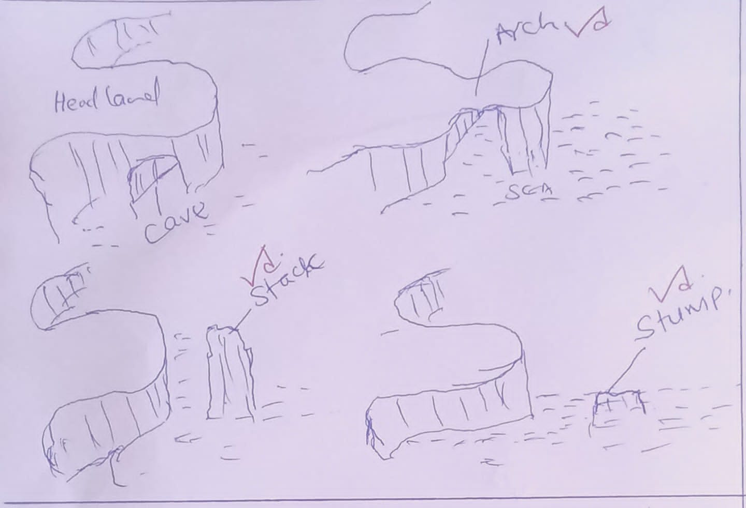
Text – 3Marks Diagram 3 Marks = 6 Marks

(c) (i) Outline for conditions favouring coral growth (4mks)
- Plenty supply of planktons
- Temperature ranging 20⁰-29⁰/ warm
- clear salty water
- Shallow water with a depth of less than 60m
-submerged conditions even at low tides
- Clear & well oxygenated water (Any 4x1=4mks)
(ii) Explain three ways in which coral contributes to the economic development of Kenya (6mks)
- Source of raw material for cement industry
- Marine life boost tourism industry which earn country foreign exchange
- Coral reef prevent sharks country to the beach making the beaches save
- Provide stones which are used in building industry
- Coral stones are extracted and sold as ornaments
( Any 3x2=6mks )
(d) (i) Give three causes of ocean currents (3mks)
- Difference in ocean water density/ salinity
- Difference in ocean water temperature
- winds blowing over the ocean
- Shape of coastal land mass
- Rotational of the earth ( Any 3x1=3mks )

(ii) Name three types of tides
- Perigean
- Apogean
- Neap
- Spring
( Any 3x1=3mks )

9. a) i) What is a desert. (2mks)
- It is an area of land which receives little rainfall (less 250mm per annum) and has scanty or no vegetation. (1x2=2mks)

ii) Name two types of desert surfaces. (2mks)
- Stony desert/reg/serir
- Sandy desert/evg/koum
- Rocky desert/Hamada (Any 2x1mk=2mks)
b) Explain three factors that influence the development of deserts. (6mks)
- Increased temperature which is accompanied by excessive evaporation.
- Prolonged drought or very low rainfall
- Existence of low ocean currents which makes the onshore winds dry.
- Presence of high mountain which block rain bearing winds causing a rain shadow effect.
- Remoteness of land in the interior of the continent far away from the direct influence of the sea (contintavity)
- Location of an area in the region of anticyclones where the prevailing winds are descending and diverging
- Human activities e.g. deforestation, overgrazing and overdrawing of underground water resources. (any 3x2mks=6mks)
c) i) Apart from zengen, name two other features formed by wind erosion. (2mks)
- Mushroom block
- Ventifacts
- Yardangs
- Deflation hollows
- Rock pedestal
- Millet seeds (any 2x1mk=2mks)

ii) With the aid of well labeled diagrams, describe the formation of zeugen.
- The landscape is made up of horizontal alternating layers of hard and soft rocks.
- Weathering opens joints and cracks on the top resistant layer.
- Wind abrasion erodes the opened joints while deflation removes the eroded materials.
- The processes continues until the soft layer is reached leading to the formation of a ridge and furrow landscape. The ridges formed from the hard resistance rock are the zeugen.
(must be mention to score maximum points)
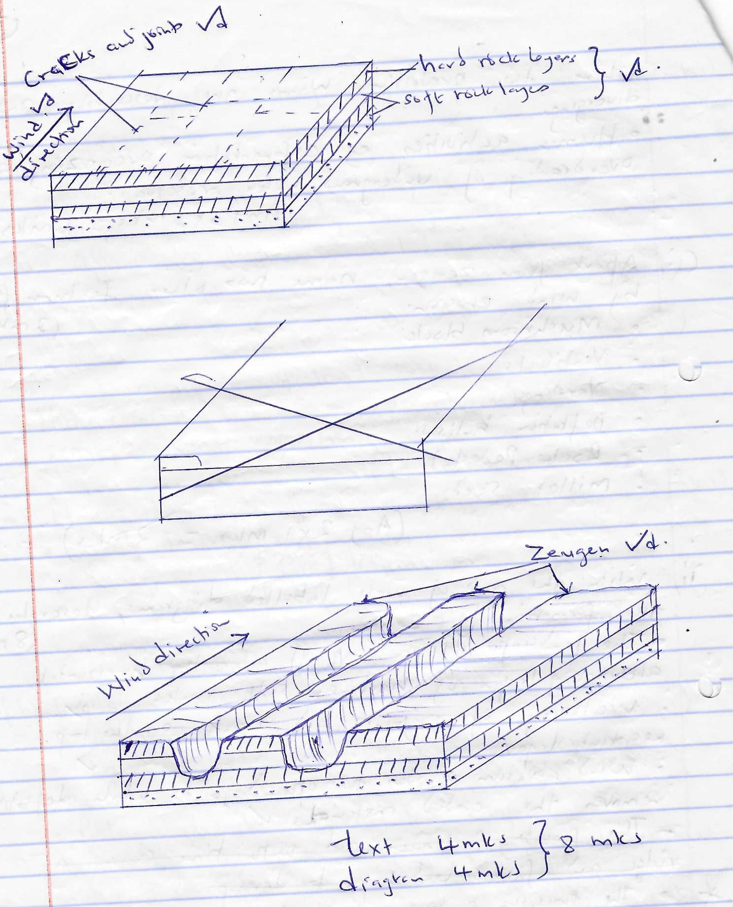
iii) State three processes of wind transportation in the deserts. (3mks)
- Suspension
- Saltation
- Surface creep (3x1=3mks)
d) State two factors influencing wind deposition in the deserts. (2mks)
- Nature of the desert surface
- Presence of obstacles
- Strength and the direction of the wind
- Variation in weather conditions
- The amount of load carried. (any 2x1=2mks)

10. a) i) Define underground water. (2mks)
- This is the water stored in rocks (aquifer) between the earth surface. (1x2=2mks)

ii) State three sources of underground water. (3mks)
- Rain
- Melt water
- Surface water storages
- Magmatic water/plutonic water. (any 3x1=3mks)
iii) State three levels of saturation of ground water. (3mks)
- Zone of non-saturation
- Zone of intermittent saturation
- Zone of permanent saturation (3x1=3mks)

b) i) What is an artesian basin. (2mks)
- It is a source shaped depression consisting of a layer of permeable rock sandwiched between two impermeable rocks and the whole system forms a syncline. (1x2mks=2mks)

ii) Describe three ways in which springs are formed. (6mks)
- Hill side spring
- Formed where a permeable rock lies above an impermeable one on a hill and water comes out at the junction the two rock layers.
- Dyke spring
- Formed where an igneous dyke cuts across a layer of permeable rock. Ground water on the upslope side is trapped causing water table to rise making it exposed to the surface leading to a spring.
- Vauclusian spring
- Formed on a hill or escarpment where limestone rock overlies an impermeable layer. Limestone rock becomes saturated with water and a spring emerges where the limestone rock meets the impermeable layer on the hillside.
- Valley spring
- Formed where water table intersects the surface along the side of the valley. (type 3mks, explanation 3mks total = 6mks)
c) i) What is a Karst scenery
- This is a limestone region with unique features formed as a result of action of water. (1x2mks=2mks)

ii) State two factors which influence the development of a Karst scenery. (2mks)
- The surface rock and the rock below should be hard and well jointed e.g. limestone, chalk or dolomite
- The climate should be hot and humid to facilitate chemical weathering.
- The water table should be far below the surface to allow underground features to form. (any 2x1mk=2mks)

iii) The diagram below shows underground features in a Karst scenery. Use it to answer he question that follows.
Name the features labeled A, B, C (3mks)
A – Cave/egverm
B – Stalagmite
C- Stalactite (3x1=3mks)
d) State two significance of Karst scenery. (2mks)
- Features in a karst scenery e.g. caves, attract tourists
- Limestone rock is used in the manufacture of cement.
- Limestone blocks are used for building
- Limestone regions are very good for grazing especially sheep
- Large villages called line settlements form at the line of vauclusian springs.
- Limestone landscape discourage settlements due to the ruggedness of the surface caused by clints and grikes.
- Limestone landscape lacks surface water due to presence of swallow holes. This discourages settlements. (any 2x1mk=2mks)

