OPENER EXAMINATION TERM 3, 2022
GEOGRAPHY FORM THREE
TIME: 2³/₄ HOURS
MARKIG SCHEME

SECTION A
1a) a) What is a solstice
Solstice is when the sun’s overhead position is over the tropic of Cancer and Capricorn
(2 Marks)
b) State three effects of the revolution of the earth
- Causes seasons i.e. spring, summer, autumn & winter
- Varying lengths of day and night at different times of the year
- Changes in the position of the midday sun at different times of the year
- Changes in the position of the midday sun at different times of the year
(Any3 x 1 = 3Marks)
2 a) What is an air mass?
It is large volume of air/ wind with similar/ uniform temperature humidity and covers
over a large area and flows over along distance
( 2 Marks)

b) Study the diagram below and name the air masses marked A, B , C and D
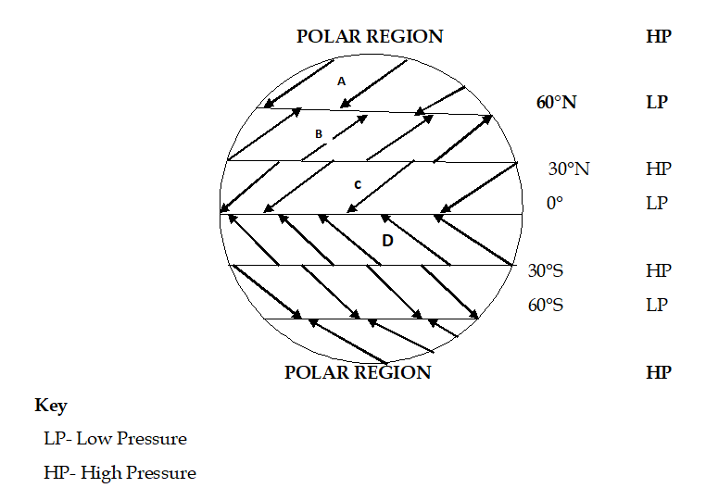

A- North East polar winds
B- South West westerlies/ S. West winds
C - North east trade winds
D - South East trade winds ( 4 x 1 = 4 Marks)

3 a) ] Give two ways through which rocks may be metamorphosed.
-due to pressure changes/dynamic metamorphism
-due to intense heat/thermal metamorphism
-due to a combination of heat and pressure/thermal-dynamic metamorphism
(Any 2 x 1 = 2Marks)

b) Name two examples of plutonic rocks
-Granite
-Diorite
-Peridotite
-Gabbro
-Syenite (Any 2 x 1 = 2Marks)

4 a) Differentiate between veins and lodes
A vein is a small crack containing minerals deposited in crystalline form wile a lode
is a large crack containing minerals in crystalline form (2Marks)
b) State three effects of land dereliction
- waste of Agricultural land
- Waste of industrial land
- Lightness where land has lost its beauty
- Health and accident hazards
(Any 2 x 1 = 2Marks)

5 a) (a) Give any two natural causes of earthquakes
-Isostatic adjustments
-Gravitation pressure
-Tectonic movement
-Magma movement (volcanic activities)
-Energy release in upper mantle
(Any 2 x 1 = 2Marks)

b] Name three characteristics of the rift valley lakes of Kenya
- Some lakes lacks outlets
-Some lakes are located I areas which are hot ad dry
-Some lakes do not have enough fresh water rivers emptying into them
- Some lakes are fed with water from the under ground
(Any 3 x 1 = 3marks)

SECTION B
Instructions; Answer question 6 and any other two questions from this section

Study the map of Nyeri 1:50000 (sheet 12014) provided and answer the following questions.
- i) Give the longitudinal extent of the area covered by the map.

6) a) i) 36⁰45¹E-37⁰00¹E (2Marks)

ii) What is the magnetic declination as at January 1975 of the map.
1⁰31¹
(2Marks)

b) i) Calculate the bearing of trigonometrical station in grid square 7546 from the forest guard station in grid square 6155.
120⁰ (2Marks)

ii) Identify two types of vegetation found in Abedare forest.
- forest
-Bamboo (2Marks)

d) Describe the drainage of the area covered by the map.
-there are rivers
-the rivers are permanent
- The main river is river Chanya
- Most of the rivers flow from western part of the area to eastern part.
- The main river form dendritic pattern with it tributaries
- There are some water holes
- There are many dams (7 x 1 = 7 Marks)

e) With evidence from the map given four social function of Nyeri town.
Social function Evidence
- Administrative -PC,DC
- Education –schools
- Recreation –clubs, golf course
- Communication - P.O
(Any 4 x 2= 8Marks)

f) Explain two factors favoring trade in Nyeri town
- Availability of market evidence by many settlements.
Good means of transport which facilitate movement of goods.
(Any 2 x 2 = 4Marks)
7 .The diagram below shows a simple fold
(a) (i) Name the part marked A, B and C
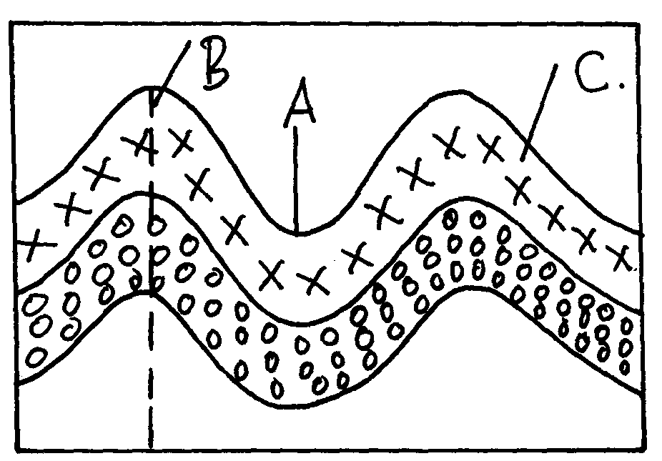

(a) i) A-axis B-syncline C-limb of a fold (3Marks)

ii) Name two fold mountains outside Africa

- The rockets
Andes (2 Marks)

iii) Give thee landform associated with folded regions
- fold mountain
cuesta
escarpment
plateus
basins (Any 3 x 1 = 3Marks)

b) With the aid of well labeled diagram describe the process of formation of Fold Mountain
- Geosynclines are formed on the earths surface
- prolonged and extensive erosion occurs on the surrounding higher grounds
- sediments are deposited in the geosyncline forming thick layers
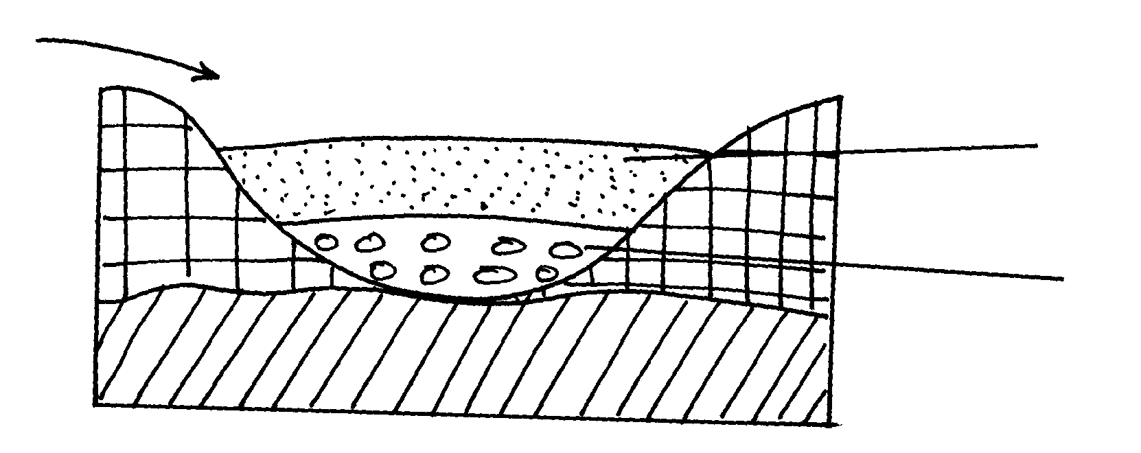
Layers of sediments deposited by rivers
Geosyncine/ basin
River from higher ground

- the weight of the sediments causes subsistence of the geosyncline leading to
accumulation of more sediments
- further subsidence of the geosyncline triggers off compressional forces which draw the
higher grounds closet forming fold mountains

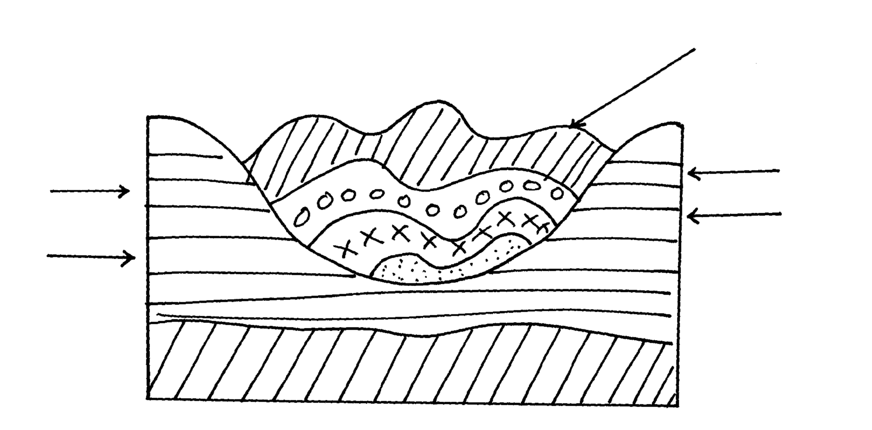
Compression
Forces on the geosyncline

( NB: TEXT 5 DIAGRAM 3 MARKS= 8marks)
c) Explain four ways in which folding influences human activities
- Fold Mountains are water catchments area. They brap rainfall which rivers which that provide water for domestics use - fold mountains are often forested and provide valuable timber used in construction and building industry(due to high rainfall)
- some fold mountains have valuable mineral deposits such as coal and petroleum for mining
- fold mountains influence transport system enter as barriers or as passed
(Any 4 x 2 = 8Marks)

8 a)i) What is chemical weathering
- Chemical weathering- is the breakdown or disintegration of rocks as a result of
chemical reaction or changes that cause decay of rocks
(2 Marks)

ii) State five factors that affect the rate of chemical weathering in equatorial regions
- Chemical composition of rocks
Presence of moisture/ water
Presence of gases
Temperature changes
Rock permeability
Vegetative matter (Any 5 x 1 = 5Marks)

b) Explain the following chemical weathering process
i) Carbonation
Water in air combines with carbon to form a weak carbonic acid
Carbonic acid reacts with calcium carbonate to form soluble calcium
bicarbonate
Solution is washed away causing weathering to take place
(2 Marks)
ii) Hydrolysis
- Water enters the rocks
Water breaks down into ions which combine with minerals
Rocks break down to form completely new compounds e.g. fluorspar with clay
(2 Marks)

c) Explain four economic importance of weathering to physical and human environments
- Produces clay that is vital in brick making
Weakens rocks making them easier to exploit i.e. mining
Important in soil formation
Weathered rocks provide scenery for tourist attraction
May break down large rocks hence leveling the landscape for settlement
(Any 4 x 2 = 8Marks)
d) Give three factors which influence mass-wasting
. - Climate.
- Topography
- Nature of the rocks.
- Plants and animals.
- Time factor.
(Any 3 x 1 = 3Marks)
9 . a) Explain three reasons for over-exploitation of hardwoods in Africa. - High demand for hardwoods
- Population pressure which has led to increased deforestation in creation of room for farming and settlement
- Hardwoods take too long to mature and this doesn’t match the rate of felling
- (Any 3 x 2 = 6Marks)
b) State four measures taken to conserve forests in Kenya.
- Agro forestry programme
- Public awareness and education through mass media
- Creation of forest reserve
- Recycling of waste papers to make newsprint
- Enacting law governing forest conservation
- Forest research stations to conduct research on new tree species
- Establishment of government tea zones at the edge of forests to act as buffer zones
(Any 4 x 1 = 4Marks)

c i) Name two major lumbering provinces in Eastern Canada.
- New found land
- Nova Scotia
- Prince Edward Island
- New Bruswick (Any 2 x 1 = 2Marks)

ii) Explain five factors that have favored forestry in Canada. [10marks]
- The landscape is rugged hence does not favour agriculture
- High rainfall thoughout the year favours forest growth
- Coastal location favour establishment of ports for timber exportation
- Constant supply of H.E.P for industrial use due to many rivers with water falls
- Plenty/abundant water supply for processing purposes e.g. bleaching of pulp
- Ready market in Canada and U.S.A for forest products
- Cheap means of transport or rivers like Ottawa, Fraser e.t.c
- Low temperatures in the highlands discourage settlement hence forestry is the main use of land (Any 5 x 2 = 10 Marks)
d) ) Explain three differences between softwoods in Kenya and Canada.
- In Canada they grow naturally while in Kenya they are planted
- In Canada they cover extensive areas while in Kenya they cover small areas
- In Canada they exist in a wide variety while in Kenya the species are limited
- In Canada they are indigenous while in Kenya they are mainly exotic
(Any 3 x 2 = 6 Marks)
10] a i] State two ways in which wind erodes the surface of the earth. [2marks]
-Deflation
-Abrasion ( 2Marks)
ii) Explain three ways thorough which wind transports its load.
– Suspension -fine particles are lifted, cleared off the ground and carried air borne
saltation -larger fragments of sand particles are lifted from the ground by
eddy action
-The sand particles are moved in a series of hops/jumps within the wind current
surface creep√/traction
-The heavy materials /small stones/pebbles are tracked along the ground.
-these materials are rolled for short distance in a process called surface creep
(Any 3 x 2 = 6 Marks)
b i), Describe how the following desert features are formed:-
(i) Zeugen
-Zeugen are formed in desert areas where alternating horizontal layers of hard
and soft rock occur, -the top layer of hard rock is jointed/has cracks√
-weathering opens up the joints and wind abrasion deepens and widens them to reach the soft layer of rocks√
-Deflation blows away the loose broken materials√
-furrows formed and gradually widen as abrasion continuous in to the soft rocks√
-the hard rock form ridges separating furrows√
-this process creates a ridge and furrows landscape. The ridges are called Zeugen√. (5Marks)
ii) Rock pedestal
-an outcrop rock is eroded by wind from all sides
-the rock has alternating horizontal hard and soft layers
-hard layers eroded at a lower rate while soft layers are eroded faster
-continual erosion through abrasion make hard layer left outstanding
-near the ground more erosion narrows the base
-the protruding layer are the bands resistance rock while the hallows are the areas
where the soft layer were positioned (5Marks)

c i) Give the name given to rocky desert in the Sahara
Hamada (1MK)
ii) Explain three positive effects of desert features to both human and physical environment.
Loss region have very fertile alluvial soils which are used for agriculture√√
-desert features such as rock pedestals yardages and sand dunes are tourist attraction√√
-salty fats are economically used for salt production especially in north Africa√√
-extensive and bare desert are used as testing grounds for car and jets engines√√
-desert landscape provides good site for testing military weapons e.g. nuclear bombs
( Any 3 x 2 = 6 Marks)

