Name:……………………………………………………………..Class:…………….Adm No:…….
ANESTAR SCHOOLS
FORM 3 – 2022
GEOGRAPHY PAPER 2

INSTRUCTIONS.
Answer all the questions in the spaces provided.
- a) Name three mining methods. (3mks)

b) State three conditions that are necessary for the formation of petroleum. (3mks)

- a) List two factors that determine the distribution of forests in Kenya. (2mks)

b) Give three economic uses of mangrove forest. (3mks)

- The diagram below shows the occurrence of petroleum in the earth’s crust. Use it to answer question (a).

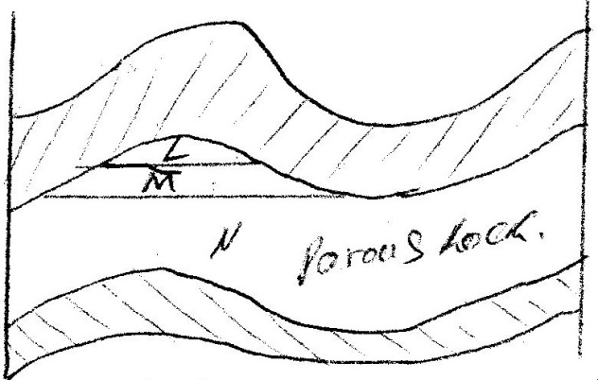

- Name the substance in the area labeled L, M and N. (3mks)

- Give two by products obtained when crude oil is refined. (2mks)

- Name five uses of soda ash. (5mks)

- State five factors that have led to the reduction of the area under forest on the slopes of Mt. Kenya. (5mks)

- Study the photograph below and use it to answer question (a)

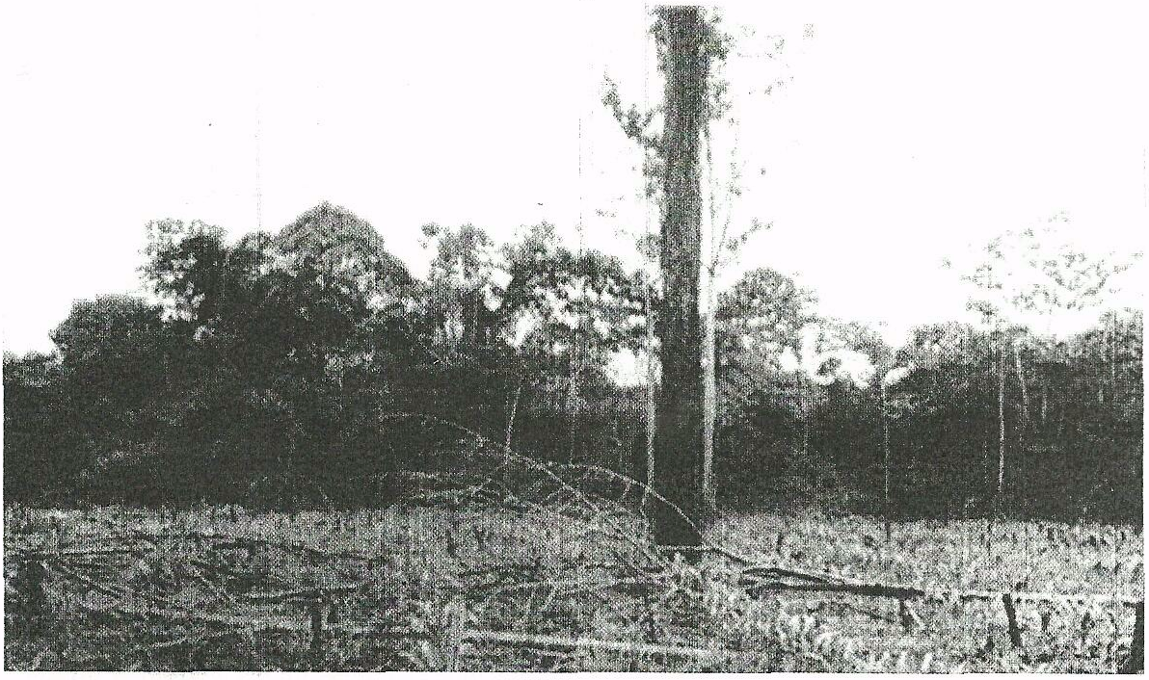
- What evidence shows that this is a ground general – view photograph? (2mks)

- Draw a rectangle measuring 12cm by 8 cm. (1mk)

- On the rectangle sketch and label the following features shown on the photographs. (5mks)
- Planted crops
- Tree stumps
- Forest
- Felled trees
- The sky
- Describe the characteristics of the forest shown on the photograph. (5mks)

b) Explain four measures being taken by the government of Kenya to control
human encroachment on forested areas. (8mks)

c) Give the differences between softwood forests in Kenya and Canada under
the following sub-headings.
- Tree harvesting (2mks)

- Marketing of forest products. (2mks)

d) Explain four problems facing forestry in Kenya. (8mks)

e) What is Agro forestry? (2mks)

ii) Give four reasons why Agro forestry is encouraged in Kenya. (4mks)

iii) Use the map of Kenya below to answer questions.
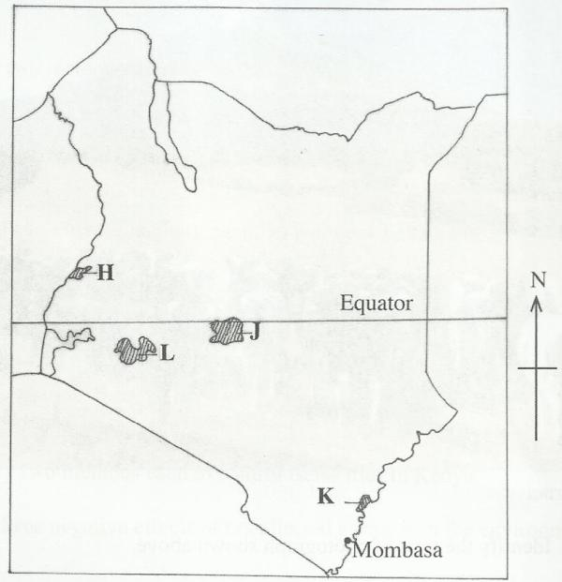

- Name the forest reserves marked H, J and K. (3mks)

- Explain four factors that favour the growth of natural forest in the area marked L. (8mks)

iv) Explain two benefits of petroleum mining to economies of Middle East
countries. (2mks)

- The table below shows the quantities of minerals produced in Kenya in tones between year 2001 and 2005. Use it to answer questions a(i) and (II)
Source economic survey 2006
Mineral/Year | 2001 | 2002 | 2003 | 2004 | 2005
Soda ash | 297,789 | 304, 110 | 352, 560 | 353, 835 | 360, 161
Fluorspar | 11,885 | 85,015 | 80, 201 | 117, 986 | 26, 595
Salt | 5,664 | 18,848 | 21,199 | 31,139 | 26,595
Others | 6,093 | 7,000 | 4,971 | 6,315 | 8,972

- Calculate the average annual production of soda ash over the 5 years period. (1 mk)

- Calculate the total mineral production for the year 2003. (1mk)

b) The diagram below shows shaft mining.
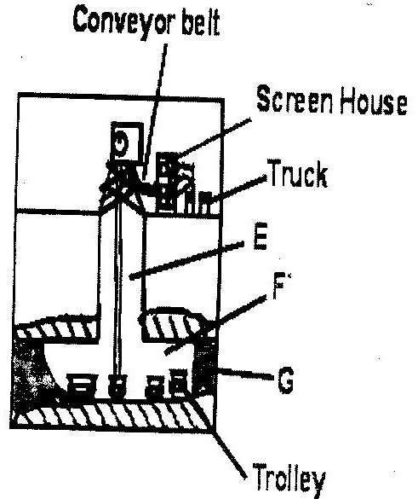

- Name the part marked E, F, G. (3mks)

- State three problems associated with shaft mining. (3mks)

- Explain four ways in which gold mining has contributed to the economy of South Africa. (8mks)

- Explain three negative effects of mining on the environment.(6mks)

