NAME: ______________________________________CLASS: ____________ADM NO: ___________
312/2
GEOGRAPHY
PAPER 312
MULTILATERAL EXAM
END OF TERM TWO
FORM 2 EXAM
Time: 2HOURS
INSTRUCTIONS TO CANDIDATES
Answer All question in the spaces provided
All Answers must be written in English
SECTION A | 1
 | 2
 | 3
 | 4
 | 5
 | 6
 | 7
 | 8
SECTION B | 9
 | 10
 | 11
ANSWER ALL QUESTIONS IN SECTION A IN THE SPACES PROVIDED

SECTION A: (40 MARKS)
ANSWER ALL QUESTIONS IN THIS SECTION IN THE SPACES PROVIDED:
- (a) what is a Stevenson screen ( 2mks)

(b) Name three instruments that are placed in Stevenson screen (3mks)

2. State three effects of the rotation of the earth (3mks)

3. (a) State four proofs that the earth is spherical (4mks)

4. Name the layers of the atmosphere (4mks

5. (a) Name two scales used to measure the intensity of an earthquake (2mks)

(b) List five causes of earthquake (5mks)

6. (a) Outline any four uses of maps (4mks)

(b) Give any three marginal information found in topographical map (3mks)

7. (a) Give three forces that are responsible for lateral earth movement (3mks)
(b) Name two types of tectonic plate boundaries (2mks)

8. (a) What is folding (2mks)

(b) Use the diagram below to answer the questions that follow

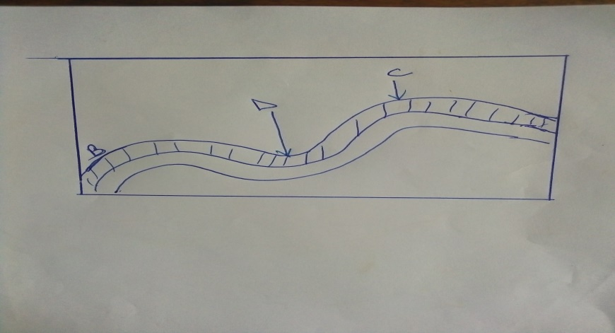

Name the part labeled
B-
C-
D-
SECTION B :60 marks : Answer all questions in this section
9.(a) Give 2 factors that are considered when classifying clouds (2mks)

(b) Give four reasons why weather forecasting is important (4mks)

(c) Suppose you visited a weather station a field study on weather
(i) Give four methods you would use to record data (4mks)

(ii) State five advantages of studying weather through field work (5mk)

(d) State five factors that influences climate (5mks)

10(a). (i) What is a mineral (2mks)

(ii) Give four characteristics of minerals (4mks)

(b) (ii)What is metamorphic rocks (2mks)

(ii) State 4 characteristics of igneous rock (4mks)

(c) Outline the significance of rocks to the economy of Kenya (8mks)

11. (a) Name four active volcanoes in Kenya (4mks)

(b) Describe the formative of a composite volcano (4mks)

(c) Explain six ways in which volcanic feature influence human activities (12mks)

