GEOGRAPHY FORM 2
END OF TERM 2 EXAMINATION

MARKING SCHEME
- (a) what is a Stevenson screen
- Is a white wooden box in which metrological instruments are kept in a weather station (1x2= 2 marks)
(b) Name three instruments that are placed in Stevenson screen
- Maximum thermometer
-Minimum thermometer
-Six’s thermometer
- Hydrometer
(Any 3 x1=3 marks )
2. State three effects of the rotation of the earth
- Causes day & night
- causes differences of one hour between
- It causes deflection of winds ocean tides
( 3 x 1= 3 marks )
- (a) State four proofs that the earth is spherical
- Circumnavigation of the earth along a straight path leads one of starting point
- The gradual appearance of the ship approaching the shock
- The difference times during which sun rises and sets in different parts of the world
- The circular shadow cast by the earth during a lunar eclipse
- All other planets are circular
( Any 4 x1=4 marks )
4. Name the layers of the atmosphere
- Troposphere
- Stratosphere
-Mesosphere
-Thermosphere/ Ioriosphere
- Exosphere ( Any 4 x1=4 marks )
5. (a) Name two scales used to measure the intensity of an earthquake
- The Rossi-sorrel scale
- The mercelli scale ( 2 x 1 =2marks )
(b) List five causes of earthquake
- Gravitational pressure
- Collision of tectonic plates
- Energy release in the mantle
- Isotonic adjustment
- Violent volcanic emption
-Nuclear explosions
- Adjustment along fault lines
- building reservoirs
- Magma movement within the crust ( Any 5x1=5marks )
6. (a) Outline any four uses of maps
- To locate places/landforms on the earth’s surface
- To determine the size of a particular location
- To provide different information about places eg. Climate vegetation
- used by travelers to find direction to a particular place
- used to summarize information quickly for future reference ( Any 4x1=4marks )
(b) Give any three marginal information found in topographical map
- map series
-sheet index number
- Sheet name/ title
- The scale
-Edition
- Copyright & publisher
- The key
- Grid system numbers
- Latitudes & longitudes
- Compass direction
- Index to adjusting sheets
- Administrations boundaries ( Any 3 x 1=3 marks )

7. (a) Give three forces that are responsible for lateral earth movement
- Tension force
- Compression
- tear/ shear force ( 3x1=3 Marks )
(b) Name two types of tectonic plate boundaries
-Divergence/ extension/ constructive
- converging/ compression/ destructive
- Transform/ conservative ( 2x1= 2marks)
8. (a) What is folding
-Process in which crustal rocks are distorted by compressional forces causing them to bend upwards and downwards ( 2Marks)

(b) Use the diagram below to answer the questions that follow
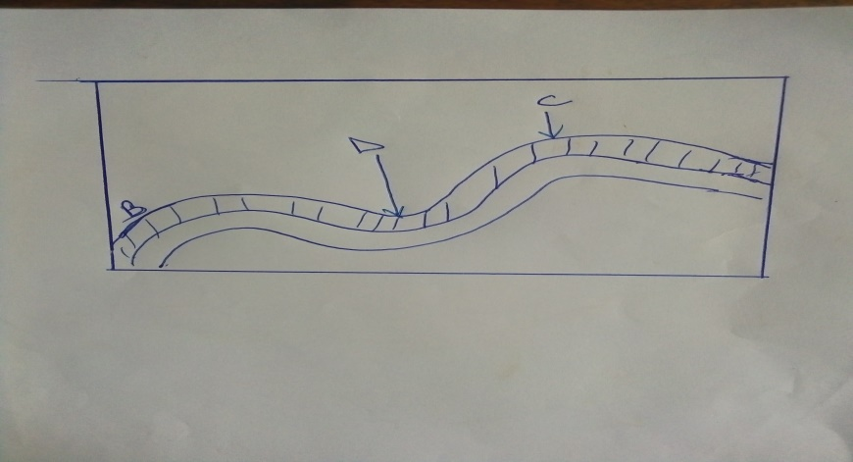

Name the part labeled
B- Limb
C-Anticline
D- Syncline ( 3 x 1=3 marks )
SECTION B : 60 marks
9. (a) Give 2 factors that are considered when classifying clouds
- Height
-Shape/form
- Appearance
( Any 2 x 1= 2Marks )
(b) Give four reasons why weather forecasting is important
- Help the farmer to plan their farming activities
- It influence design of houses guides in the timing of sporting tourism activities
- It guides in landing & taking it of aircrafts
- it guides fishing activities
-It guide sporting activities (Any4 x 1 = 4mks)
(c) Suppose you visited a weather station a field study on weather
(i) Give four methods you would use to record data
- Filming/ video tapping/ taking photographs
- Observation
-interviewing
- Reading from secondary sources
- Administering questionnaires
- Taking measurements
- Reading instruments (Any 4 x 1 = 4 Mks)
(ii) State five advantages of studying weather through field work
- It enables students to collect first hand information
- It enables learner to learn how to use weather instruments
- It enables students to apply the knowledge learned in the classroom
- It make learning real
- It provides detailed/broad learning
- It enhances visual memory learning
( Any 5 x 1= 5marks )
(d) State five factors that influences climate
- Altitude
- Configuration of coastline in relation to prevailing wind
- Aspect
-Latitude
- Distance from the ocean
- Ocean currents
- Wind & air massing
- Human activities
( Any 5 x1=5 Marks )
10(a). (i) what is a mineral It is an inorganic substance with definite chemical composition at or on beneath the earth surface (2 Marks)
(ii) Give four characteristics of minerals
- Have different degree of hardness
- Can be opaque, transparent translucent
- Minerals have tenacity ability to with stand tearing
- Minerals have different texture
(b) (ii) What is metamorphic rocks - Rock formed when original igneous/ sedimentary rock is subjected intense heat or pressure
(2mks)
(ii) State four characteristics of igneous rock
- Rock form no crystals
- Fined grained
- Form on the earth’s surface
- They form from cooling & solidification of lava
( 4 x 1=4 Marks)
(c) Outline the significance of rocks to the economy of Kenya
- Some rocks unique features that attract tourist
-Some sedimentary rocks contain fossils fuel which is a source of energy
- Some rock act a storage for water which can be supplied for domestic & industrial use
- Rocks are exploited to earn income eg in quarries
- Some rocks contain minerals which exploited for income
(Any 4 x 2=8 Marks)
11. (a) Name four active volcanoes in Kenya
- Logonot
- Teleki
-Likaiyu
- Suswa
- Menengai
-Homahills
( Any 4x1=4mks )
(b) Describe the formative of a composite volcano
- It is made up of alternative layers of pyroclasts and lava
- It is formed when successive vent eruptions occur. The volcano begins with each eruption with great violence forming layers of ash
-Lava pass through the main pipe and exits through the crater
- a parasitic cone may develop on the side of the volcano composite
- Volcano has steep slopes ( Any 4x1= 4 Marks)
(c) Explain Six ways in which volcanic feature influence human activities
-Volcanic highlands/ mountain are sources of rivers which provide water for domestic & agriculture/ industrial use
- Volcanic rocks weather to form fertile volcanic soils which support agriculture
- Volcanic rocks are important building materials in the construction industry
- Volcanic features are tourist attractions which promote tourist industry
-Volcanic features such as steam jets and geysers are harnessed to provide geothermal power
- Volcanic mountains/ highlands have forests which provide valuable timber used in building & construction industries
- Volcanic highlands/ mountains modify temperature making them attractive to human settlements
( Any 6 x 2= 12mks )

