NAME………………………………………….CLASS………ADM NO. …………..

OPENER EXAMINATION TERM 3, 2022
FORM TWO GEOGRAPHY
TIME 2 ⅟₂ Hrs
Answer all the questions in the spaces provided
1. Define the term ‛habitat’. 2mks

2. Give two types of environments. 2mks

3. State the relationships between:
i. Geography and Mathematics. 2mks

ii. Geography and History. 2mks

4. a) Describe the origin of the earth as proposed by the passing star theory. (5mks)

b) State two weakness of the passing star theory. (2mks)

5. Name two instruments that are kept in Stevenson Screen. (2mks)

6. List two factors that influence atmospheric pressure. (2mks)

7. State three characteristics of Inter Tropical Convergence Zone (ITCZ. (3mks)

9. State three methods of statistical data collection (3mks)

10. Given the following set of data: 26,30,25,34,18,19 Calculate the median. 2mks

11. a) What is marginal information? 2mks

b) Mention three common marginal information in a map sheet. 3mks

12. a) Define hypothesis. 2mks

b) Name and explain two main types of hypotheses. 4mks

c) Identify four possible problems likely to be encountered during field work.(4mks)

13. a) Differentiate between a mineral and a rock. (2mks)

b) Explain two ways in which metamorphic rocks are formed. (4mks)

14. a) Give two ways in which minerals occur. (2mks)

b) Explain two negative effects of open –cast mining. (4mks)

c) Explain two factors influencing exploitation of trona in L.Magadi. (4mks)

15. a) Define the term ‛earth movement’. (2mks)

b) Identify two types of earth movement. (2mks)

c) Explain the continental drift theory. (4mks)

16. The diagram below represents parts of the earth’s crust which has been subjected to tensional force. Use the diagram to answer questions that follow.
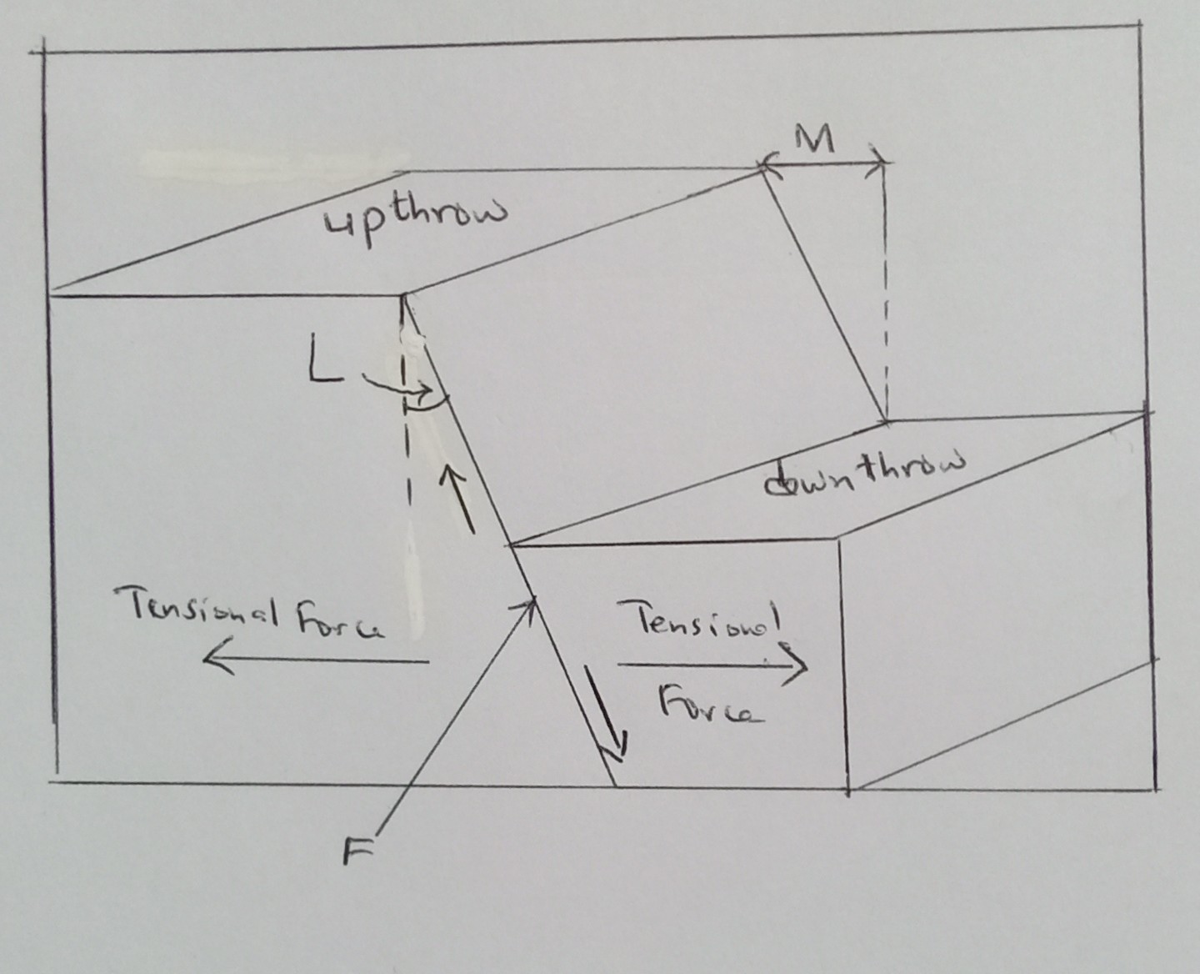
a). Identify the type of fault F. (1mk)

b). State two other types of faults apart from the one mentioned in (a) above. (2mks)

c. Name the angle L. (1mk)

d. Name the distance M. (1mk)

e. Mention two features resulting from faulting. (2mks)

17. Differentiate between:
a) Magnitude and intensity of earthquakes. (2mks)

b. Seismic and aseismic zones. (2mks)

c. State four effects of earthquakes? (4mk)

18. a) Define the term ‛bearing’ as used in Geography. (2mks)

b) Explain the following methods of representing relief on topographical maps.
i. Pictorial representation. (2mks)

ii. Hachures. (2mks)

19. Identify the three types of ground photographs. (3mks)

20. The table below represents sugar cane production in five major factories in Kenya. Use it to answer the following questions:
Factory Production in ‛000’ tones
Sony 50
Nzoia 100
Chemilil 200
Muhoroni 250
Mumias 400
a. Using the data above, draw a divided rectangle 15cm length. (7mks)
Use the graph paper provided

b. Give the difference in tonnage between sugar produced in Muhoroni and Nzoia factory.
(1mk)

21. a) Differentiate between weather and climate. (2mks)

b) State two factors influencing climate? (2mks)

