MARKING SCHEME
OPENER EXAMINATION TERM 3, 2022
FORM TWO GEORAPHY TIME 2⅟₂ Hrs
Answer all the questions in the spaces provided
1. Define the term ‛habitat’. 2mks
- It is a home of an organism that provides all the necessities for its survival
2. Give two types of environments. 2mks
- Physical environment
- Human environment
3. State the relationships between:
i. Geography and Mathematics. 2mks
- Mathematical techniques are used in drawing graphs and pie charts.
- Mathematical formulae are used in geography to calculate distances, areas, population densities, time etc.
ii. Geography and History. 2mks
- History uses geographical tools like maps, charts and graphs to show where past events took place e.g. the movement of people in the past.
4. a) Describe the origin of the earth as proposed by the passing star theory. (5mks)
- A star with a greater gravitational pull passed near the sun
- It attracted large quantities of hot gaseous materials from the sun
- The materials split, cooled and condensed to form planets and other members of the solar system
- The planets were set in their orbits by the passing star
- The earth being one of the planets was formed that way
b) State two weakness of the passing star theory. (2mks)
- Doesn’t explain the origin of the sun and star.
- Minimal chance of a star approaching another
- Materials would have dispersed rather than condense due to the prevailing high temperatures
- If the planets were set in their orbits by the passing star the effect would have been reduced when the star disappeared (Any 2x1mk = 2mks)

5. Name two instruments that are kept in Stevenson Screen. (2mks)
- Maximum thermometer
- Minimum thermometer
- Hygrometer
- Six’s thermometer (Any 2x1mk = 2mks)
6. List two factors that influence atmospheric pressure. (2mks)
- Altitude.
- Temperature.
- Rotation of the earth (Any 2x1 = 2mks)

7. State three characteristics of Inter Tropical Convergence Zone (ITCZ. (3mks)
- Found between 23 ½ °N and 23⅟₂ °S / found between the tropic of Cancer and the tropic of Capricorn
- Experiences high temperatures.
- A zone of low pressure and doldrums (light and intermediate winds).
- Zone where S.E and N.E Trade Winds converge.
- Associated with convectional rain and thunderstorms.
- Migrates to the north and to the south of the equator with the apparent movement of the overhead sun. (Any 3x1mk = 3mks)
9. State three methods of statistical data collection (3mks)
- Observation
- interviewing
- Administering questionnaires
- Content analysis
- Measuring
- Collecting Samples
- Counting/census taking
- Photographing
- Digging
- Feeling and touching
- sampling
- Experimentation (Any 3x1mk = 3mks)
10. Given the following set of data: 26,30,25,34,18,19 Calculate the median. 2mks
- Arrange in ascending order; 18,19,25,26,30,34
- Median = (25+26)/2 = 25.5
11. a) What is marginal information? 2mks
- These are facts and figures given at the edge of the map. They give more details about the map.

b) Mention three common marginal information in a map sheet. 3mks
- Map title/ map name
- Sheet number/ sheet index number
- Map edition
- Map series
- Publisher and copyright
- The key
- Scale
- Compass direction and magnetic declination
- Conversion table
- Administrative boundaries
- Index to adjoining sheets
- Latitudes and longitudes
- Grid co-ordinates (Any 3x1 = 3mks)

12. a) Define hypothesis. 2mks
- Assumption set before field work whose validity or acceptance is to be proved.

b) Name and explain two main types of hypotheses. 4mks
- Null Hypothesis (Ho)
- -One stated in negative form e.g. ‘There is no relationship between rainfall and crop yield’.
- Alternative/Substantive hypothesis (H1)
- -One stated positively e.g. ‘most foodstuffs sold in the neighbourhood come from the immediate neighbourhood’.
c) Identify four possible problems likely to be encountered during field work. (4mks)
- Dishonest Respondents
- Bad Weather eg. Raining heavily.
- Accidents in the Field
- Attacks by dangerous wild Animals
- Inaccessibility of the areas of study
- fatigue

13. a) Differentiate between a mineral and a rock. (2mks)
- A rock is a naturally occurring aggregate of one or more mineral particles forming part of the earth’s crust while a mineral is any naturally occurring, crystalline inorganic substance with definite chemical composition and physical properties.
b) Explain two ways in which metamorphic rocks are formed. (4mks)
May be formed through;
- Regional (thermo-dynamic) metamorphism
- Contact (thermal) metamorphism
- Dynamic metamorphism (Any 2x1mk = 2mks)
14. a) Give two ways in which minerals occur. (2mks)
- Veins and Lodes
- Reefs
- Seams/Layers/Beds
- Alluvial Deposits
- Weathering Products
- Oil pools/Wells
b) Explain two negative effects of open –cast mining. (4mks)
- it leads to loss of biodiversity
- it can lead to soil erosion and landslides
- it leads to environmental pollution – water, air, land, and land pollution
- it leads to creation of derelict land which makes the land look ugly
- it leads to creation of empty pits which when filled with water are breeding sites for mosquitoes which spread malaria. (Any 2x2mks = 4mks)

c) Explain two factors influencing exploitation of trona in L.Magadi. (4mks)
- Large mineral deposits-there is a large deposit of trona in the lake which is economically viable.
- Availability of market- trona is exported in large quantities to countries like Japan, and Philippines and it is also used locally in industries like detergents making industries.
- Availability of labour- the surrounding Maasai community and other Kenyans supply labour to the factory.
- Availability of transport-there is a direct railway line from the factory to Mombasa through Konza for easier transportation. There is also Nairobi – Magadi tarmac road. (Any 2x2mks = 4mks)
15. a) Define the term ‛earth movement’. (2mks)
- This is the displacement of crustal rocks due to tectonic forces

b) Identify two types of earth movement. (2mks)
- Horizontal/lateral/orogenic movements
- Vertical/epeirogenic movements

c) Explain the continental drift theory. (4mks)
It states:
- The earth was a single sialic land mass called Pangaea surrounded by a huge ocean called Panthalassa whose floor was a mass of sima.
- Pangaea broke into two parts called Laurasia (N. Hemisphere) which lay around equator and Gondwanaland (S. Hemisphere) which lay around south pole which were separated by a narrow ocean called Tethys (the present Mediterranean Sea).
- Laurasia broke into Laurentian Shield and Fennoscandia (Europe, Asia and N. America) and moved northwards to their present positions.
- Gondwanaland broke into Africa, Australia, S. America and Antarctica and India subcontinent. Africa and India drifted northwards
.
16. The diagram below represents parts of the earth’s crust which has been subjected to tensional force. Use the diagram to answer questions that follow.
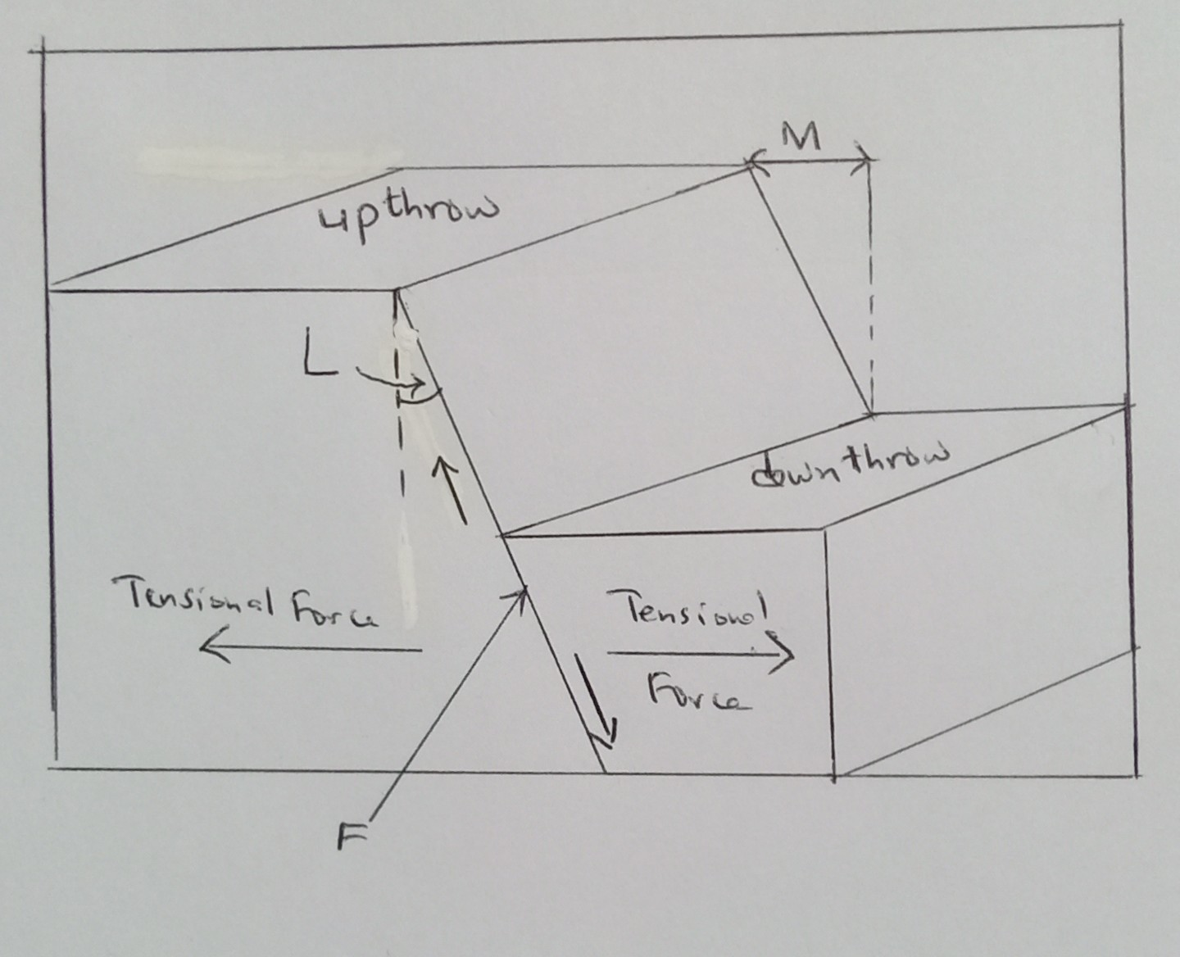
a). Identify the type of fault. (1mk)
- normal fault
b). State two other types of faults apart from the one mentioned in (a) above. (2mks)
- reverse fault
- shear/ tear/ transform fault
- anticlinal fault
- Thrust fault (Any 2x1mk = 2mks)

c. Name the angle L. (1mk)
- Hade
d. Name the distance M. (1mk)
- Heave
e. Mention two features resulting from faulting. (2mks)
- Rift valleys
- Tilt blocks
- Block mountains/ horsts
- Fault steps
- Depressions (Any 2x1mk =2mks)
17. Differentiate between:
a) Magnitude and intensity of earthquakes. (2mks)
- Magnitude is a measure of the amount of energy released by an earthquake while intensity is a measure of how hard an earthquake shakes the ground
b. Seismic and aseismic zones. (2mks)
- seismic zones are the areas where earthquakes occur frequently while aseismic zones are areas which are not prone to earthquakes
c. State four effects of earthquakes? (4mk)
- Can cause loss of life and property when buildings collapse burying people.
- Disrupt transport and communication by vertically and laterally displacing land which disconnects pipelines, electricity lines, roads and railways.
- Causes landslides which also cause loss of life and property and disrupts communication.
- Causes raising and lowering of the sea floor and the coastal regions.
- Cause huge sea waves called Tsunami which may flood the neighbouring coastal areas.
- Trigger folding, Vulcanicity and fires.
- Give off a lot of explosive energy more than an atomic bomb.
- Cause fear and panic.
- Hinder settlement as it is restricted to aseismic areas.
- Cause violent motions of the earth’s surface. (Any 4x1mk = 4mks)

18. a) Define the term ‛bearing’ as used in Geography. (2mks)
- Expression of direction in degrees of an angle.

b) Explain the following methods of representing relief on topographical maps.
i. Pictorial representation. (2mks)
- Showing relief by drawing landforms at approximate positions where they are found e.g. mountains, hills, valleys, etc.

ii. Hachures. (2mks)
- Short lines drawn to represent direction of slope.
- On steep land they are thick and close together.
- On gentle slopes they are thin and wide apart.

19. Identify the three types of ground photographs. (3mks)
- Ground close-up
- Ground general view
- Ground oblique
20. The table below represents sugar cane production in five major factories in Kenya. Use it to answer the following questions:
Factory Production in ‛000’ tones
Sony 50
Nzoia 100
Chemilil 200
Muhoroni 250
Mumias 400
a. Using the data above, draw a divided rectangle 15cm length. (7mks)
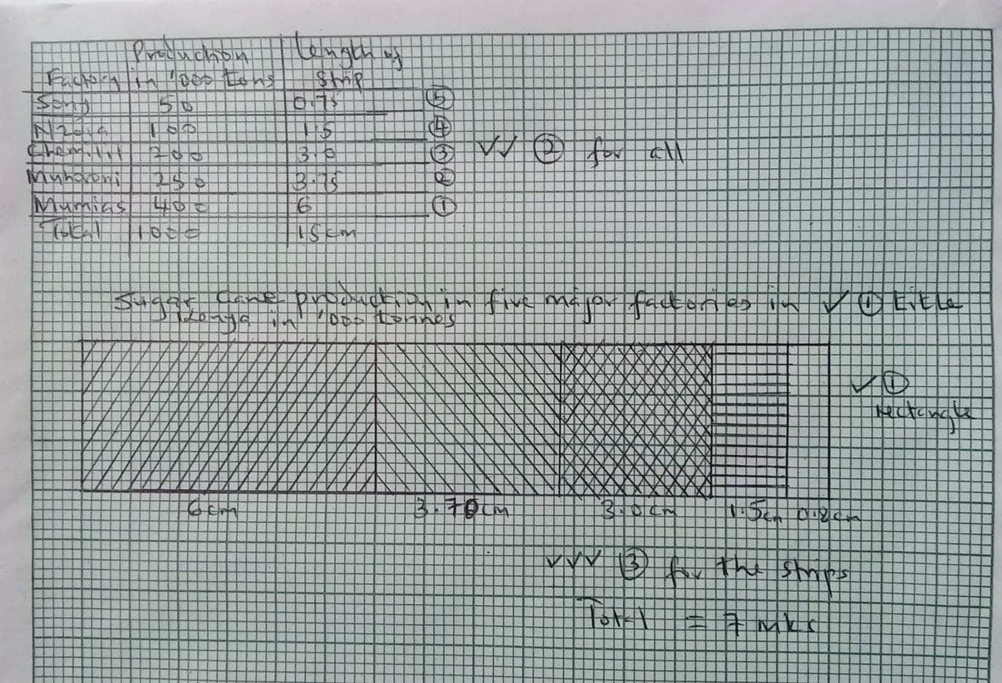

b. Give the difference in tonnage between sugar produced in Muhoroni and Nzoia factory. (1mk)
- 250000-100000=150000 tonnes
21. a) Differentiate between weather and climate. (2mks)
- Weather is the atmospheric conditions of a place at a specific time while climate is the average weather conditions of a place observed over a long period of time preferably 30-35 years.
b) State two factors influencing climate? (2mks)
latitude
altitude
continentality/ nearness to large water bodies
configuration of the coastline
ITCZ
Aspect
Ocean currents
Forests
Human activities (Any2x1mk = 2mks)

