GEOGRAPHY F1
PAPER 312
SEP/OCT 2022
TERM 3 OPENER EXAM
MARKING SCHEME
- (a) Name two subdivisions of human geography.
- Historical geography
- Political geography
- Medical geography
- Economic geography
- Population geography
- Industrial geography
- Agricultural geography
- Transport geography
(Any 2 × 1 = 2 marks)
( b) Define the following terms ).
(i). Geomorphology: The study of landforming processes (2Marks)

(ii). Climatology: the study of climate ( 2Marks)
c i) Draw a diagram of the internal structure of the Earth. (1mk)
On it label the following parts :- Sima. (1mk)
-Hydrosphere. (1mk)
- Asthenosphere. (1mk)
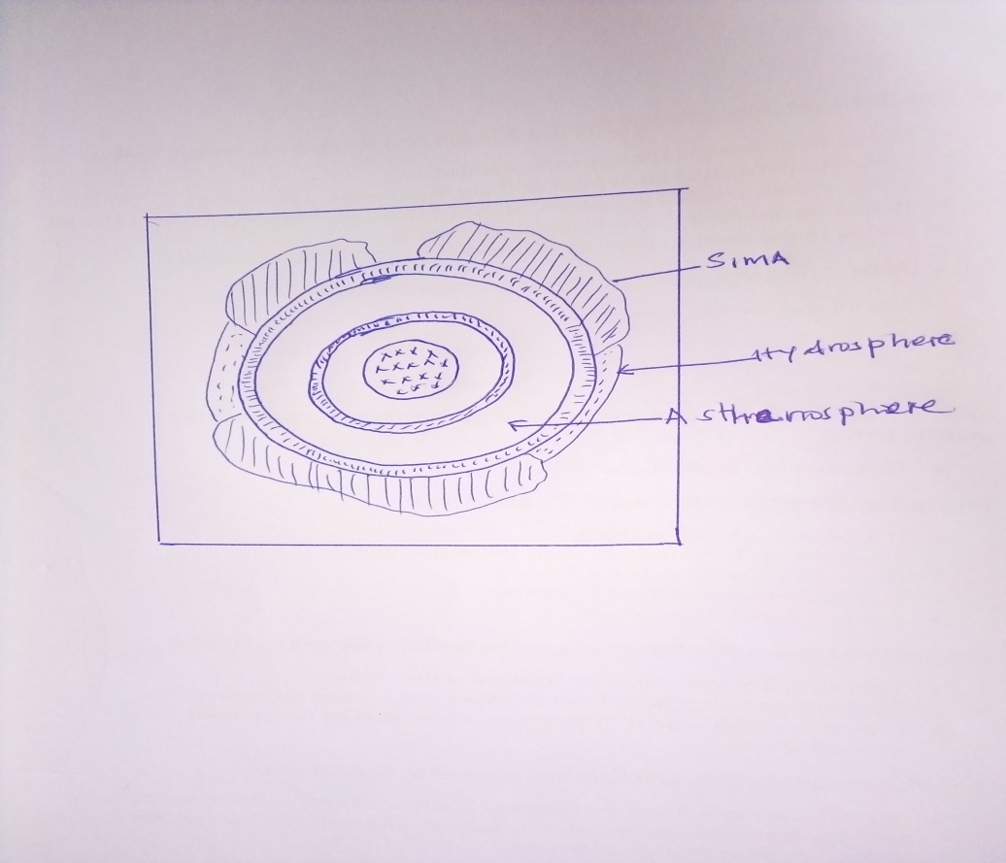

ii) Name the zone of discontinuity that occurs between the crust and the mantle.(1mk)
- Mohorovisic/Moho discontinuity .( 1mk)
iii) Outline three characteristics of the Sial. (3mks)
- It forms the continental rock.
- Comprises of two minerals, silica and aluminium.
- It’s usually less dense than sima.
- Has an average density of 2.7gms/cc.
- The rocks are mainly granitic.
iv) Give two reasons why the interior of the Earth is still very hot.(2mks)
- The original heat is still being retained at the centre.
- The crustal rock applies a lot of pressure to the centre generating heat.
- Presence of radioactivity at the centre where nuclear fission takes place generating heat.
2(a) What is a Land Breeze (2mks)
Refers to a mass of cool air blowing from the land to the sea during the night (2mks)
(b) Give three ways in which sea breeze influence the adjacent land.
- It lowers the temperature of the adjacent land.
- It may increase rainfall
- It may increase relative humidity
- It moderates diurnal range of temperature
- It may lead to convectional rainfall. ( Any 3x1 = 3 marks)
(c)i. what is a Stevenson screen
- Is a white wooden box in which metrological instruments are kept in a weather station (1x2= 2 marks)
(ii) Name three instruments that are placed in Stevenson screen
- Maximum thermometer
-Minimum thermometer
-Six’s thermometer
- Hydrometer (Any 3 x1=3 marks )
3 (a). State three effects of the rotation of the earth
- Causes day & night
- causes differences of one hour between
- It causes deflection of winds ocean tides
( 3 x 1= 3 marks )
(b) State four proofs that the earth is spherical
- Circumnavigation of the earth along a straight path leads one of starting point
- The gradual appearance of the ship approaching the shock
- The difference times during which sun rises and sets in different parts of the world
- The circular shadow cast by the earth during a lunar eclipse
- All other planets are circular
( Any 4 x1=4 marks )
4. (a)Name the layers of the atmosphere
- Troposphere
- Stratosphere
-Mesosphere
-Thermosphere/ Ioriosphere
- Exosphere ( Any 4 x1=4 marks )
(b) Give two local winds that are found in Kenya
- Anabatic winds
- Katabatic winds
- Sea breeze
- Land breeze
(2 x 1 = 2marks)
(c) State three conditions necessary for formation of dew.
- Daytime should be warm.
- The air should be calm
- Low temperature below dew point
- Cloudless nights. (Any3 x 1 = 3marks)
5) a)i) What is a map?
- It is a representation of a part of the whole of the earth surface on a flat surface usually drawn to scale. (2marks)
ii) State three uses of a map.
- Sketch maps are used to summarize information for easy reference
- They can be used for locating other countries.
- They can be used for comparing sizes of countries.
- Used for locating climatic regions of differently parts of the world.
- Give distribution of vegetation on the earth surface.
- Help travellers to find their way.
- Used to calculate distance and area of a certain place.
- Used to locate physical features like land forms. (Any 3 x 1= 3marks)
b) State three types of scale.
- Statement scale
- Linear scale
- Ratio scale R/F ( 3 x 1= 3marks)
( c)i). Convert the following scale into a statement scale.(2mks)
- 1/250,000
250,000 cm x 1 km = 2.5 km.
100,000 cm
1cm to 2.5km. (2Marks)
6 a) List the three types of North on a topographic map.
- True North
- Magnetic North
- Grid North ( 3 x 1= 3marks)
b) State three examples of marginal information on a map.
- map name
- Sheet title
- Grid system numbers
- Latitude and longitude
- Compass direction/ magnetic variation
- Scales
- Publisher and copy right
- Map series
- Sheet number or sheet index. (Any 3 x 1= 3marks)
c)i) . State three methods used to calculate area of an irregular feature in a map.
- Use of rectangles and triangle.
- Use of strips
Use of grid squares (Any 3 x 1= 3marks)

(ii) State two Forces that influenced the oblate spheroid of the earth
-Centripetal force
-Centrifugal force
-Gravitational force (2x1=2mks)
(iii) If the local time in Kampala ,Uganda 30ºE is 9.00pm ,what will be the time inAccra Ghana 0º (2mks)
Difference in degrees 30º – 0° = 30º
Time difference 30 x 4 = 120hour ÷ 60 = 2 hrs
Time in Accra 9.00 pm -2hrs =7.00pm (2x1=2mks)

7a) What is fieldwork? (2mks)
- Fieldwork is an activity that involves seeing and using the surrounding environment as a laboratory for teaching and learning geography.
(2 x 1= 2mks.)
b) List three main types of fieldwork.(3mks)
- Field study
- Field excursion
- Fieldwork research. (3 x 1 = 3mks)
c) Outline four methods of collecting data during field study.
- Direct observation.
- Interviewing the respondent.
- Administering questionnaires.
- Collecting samples.
- Counting.
- Taking photographs.
- Carrying out experiments.
- Extracting from secondary sources. ( Any 4 x1 =4 Marks)
b) Give four characteristics of a good sketch map. (4mks)
- It should have a title.
- It should have a key.
- It should have a compass direction.
- It should be enclosed in a frame.
- It should be neat and clear. (Any 4 x 1 = 4 Marks)

8 a) Differentiate between primary and secondary data.
- Primary data include all the facts and figures collected as first hand from the field while secondary data refers to facts and figures collected and recorded in textbooks/other written materials. ( 2Marks)
b) List two sources of secondary data.
- Textbooks.
- Statistical abstracts.
- Newspapers/Magazines.
- Census report.
- Geological reports.
(Any 2 x 1 =2Marks)
c) A student from your class picked the following numbers at random:
27,40,41,21,92,75,21,41,20,41,23.
i) Calculate the mean of the data. (2mks)
- 27 + 40+41+21+92+75+21+41+20+41+23 = 442 =40.18 (2 Marks)
11 11
ii) Determine the median value of the data. (2mks)
- 20,21,21,23,27,40,41,41,41,75,92.
Median is 40. ( 2mks)
iii) Determine the modal value of the data.(2mks)
20,21,21,23,27,40,41,41,41,75,92.
Modal value is 41. ( 2mks.)
9. a. Apart from planets give four other heavenly bodies
Asteroid
Meteors
Meteorites
Comets
Satellites ( Any 4 x 1 = 4marks)
b. Give three advantages of simple bar graph
- It is easy to draw
- It is easy to interpolate and read
- It gives a good clear vision
- It is easy to compare different quantities ( Any 3 x 1 = 3Marks)

c. State three methods of collecting data
- Administering questionnaire
- Direct observation
- Taking interview
- Taking photographs ( Any 3 x 1 = 3Marks)

