GEOGRAPHY MARKING SCHEME PP2 (MOMALICHE) CYCLE 10
SECTION A
- a) Environment refers to external conditions that surround a plant or an animal and have influence on their activities
b) -Geography as a subject helps learners to develop skills of observing, reading analyzing and interpreting maps, photographs, charts etc.
- One may develop a career in Geography
- Through the study of field work, Geography teaches one how to manage time properly
- It creates awareness in the people on the significance of management and conservation of environment
-It enables one to learn and explain the origin of the earth, the solar system and internal structure of the earth.
- (a) (i) U- Masinga
V- Kindaruma
(b) -Presence of catchment areas which provides a continuous water supply to turn turbines.
- Presence of hard basement rocks which provide firm foundation for construction of dams
- Presence of deep narrow valley to hold the reservoir and save cost of construction of a dam.

- (a) Fresian, Ayshire, Guernsey, Jersey, Alderney
(b) The landscape is gentle suitable for grazing
- The climate has warm temperature that allow outdoor grazing
- Cool climate suitable for pasture growing
- Moderate rainfall that support growth of grass
- Presence of fertile clay soil that support high pasture
- a) (i) north west pacific fishing ground
(ii) Salmon, mackerel, tuna, sardine, cod
b) – the broad shallow continental shelve favors the growth of planktons leading to more fish.
- indented coastline and island which favors fish breeding.
- The landscape of japan hinders the development of agriculture therefore forms an alternative form of economic activity
- Convergence of warm and cold ocean currents which provide a suitable habitat for planktons on which fish feed

- – protective dykes are constructed enclosing the part of the sea to be reclaimed
- Rings canals are constructed
- Pumping station are installed to pump out sea water from the area enclosed by the dyke
- Water is pumped out of the area enclosed by the dyke
- Drainage ditches and more pumping stations are made on the land being reclaimed.
- Drainage pipes are laid below the soil
- The area is divided into rectangular portions using inner dykes and ring canals
- The drained land is flushed with fresh water top remove salt from the soil.
- Soil are treated with chemicals to remove salinity.
- Pumping water from the polders is a continuous process to prevent water from accumulating in the reclaimed land.
- Reclaimed land is subdivided ready for settlement and agriculture

Section B
- a) (i)Graph paper
Cumulative table √¹
Crop | 1991 |  | 1992 |  | 1993 |  | 1994
Tea | 35 | 35 | 31 | 31 | 32 | 32 | 29 | 29
Coffee | 32 | 67 | 29 | 60 | 31 | 63 | 28 | 57
Sugarcane | 28 | 95 | 24 | 84 | 26 | 89 | 25 | 82
Wheat | 25 | 120 | 20 | 104 | 23 | 112 | 18 | 100

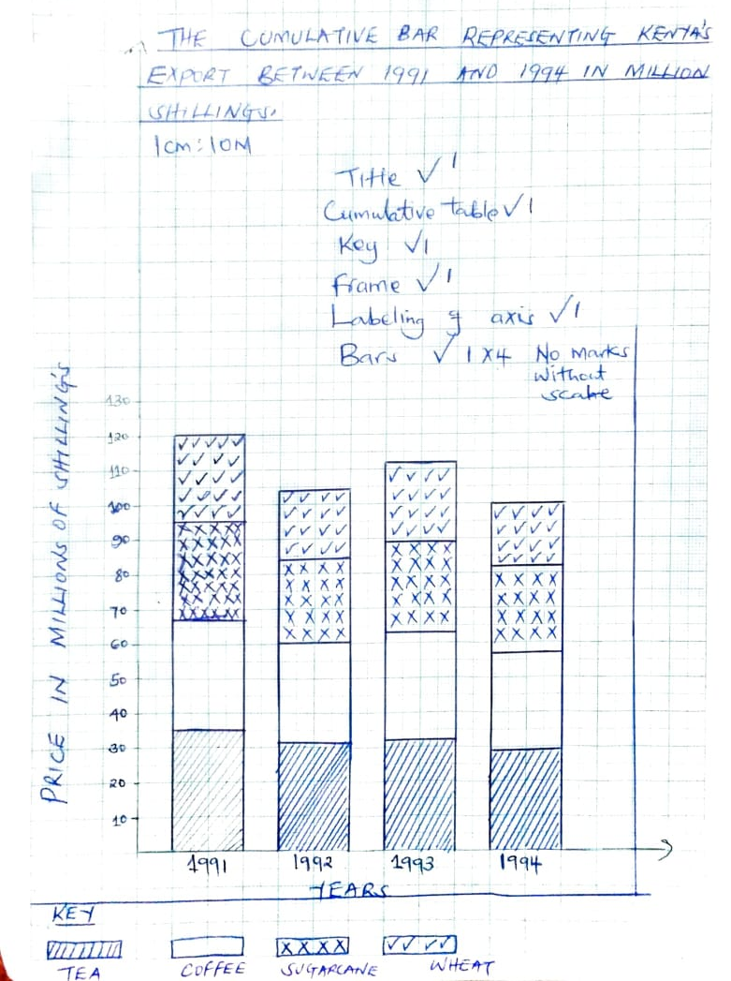

(ii)- Different variables can be represented on one bar
- Totals of components for individual years are clearly brought out
- They present a clear comparison of production of quantities within a given year
(b) - mismanagement of sugar industries lead to their collapse and hence need to supplement local supplies
- Pests such as rodents and diseases such as ranted stunt the amount of commodities produced hence need for importation.
- Kenya is not self-sufficient in these commodities because of high population hence need for importation.
- Subdivision/land fragmentation of former large scale farms due to land pressure has led to a reduction in production.
- Prolonged drought reduce the quantities produced
-unreliable rainfall lead to shortage necessitating importation to supplement the locally produced wheat.

(c) –Weighing at the factory
- Leaves are withered using warm air
- Leaves are passed through a set of rollers
-Leaves are fermented- they are rosted in drier until they turn black
- Leaves are sieved
- Processed tea is graded, tasted and packed for market, domestic or export.
- (a)(i) Ecotourism is the visiting of place of interest while conserving the environment WHILE domestic tourism is the visit of citizens of a country to places of interest within the country
(ii) -creation of national parks to protect wildlife
- Training vetinary personnel to treat sick animals
- Laws has been enacted to protect wildlife e.g against poaching
- Creation of animals’ orphanages home where sick wildlife can be taken care of.
(b) (i)- the varieties of languages e.g French, Germany and English facilitate the development of tourism
- Cottage industry especially handcraft is part of Swiss people’s tradition and attract tourist
- The traditional dances such as Scottish, polka and waltz attract tourists
- The traditional dresses such as ‘dirnd’
(ii) -advertisement of tourist attraction site and scenario abroad.
- Expansion and maintenance of facilities like transport and hotels
- Efficient banking and policy of neutrality attract financiers e.g France and Germany
- Maintenance of transport and communication facilities e.g excellent roads
(c)(i) – Importation of luxury goods drains country of its foreign exchange
- Tourist facilities are developed at the expense of other development projects like roads, airstrip, health facilities, etc
- Presence of tourist can lead to moral degradation
- Most tourists pay for their upkeep abroad causing the country to lose some of the profit
- Some tourists could be agent to spread some diseases such as HIV/AIDS
(ii) – flamingos
- Rhinos
- Pelicans
- (a)(i) W- Fluorspar
X- Gold
Y- Diamond
Z- Copper
(ii) Dredging
- Open cast
- Shaft
- Solution
(iii) –Mombasa
- Dar es salaam
(b) Mode of occurrence
- Quality of the ore
- Level of technology
- Availability of market
- Availability of transport facilities
- Government policy
(c) Soda ash is exported to earn foreign exchange which is used in the economic development of the country
- It creates employment opportunities to Kenyans hence improving living standards.
- Provides raw materials to the manufacturing industries leading to industrialization e.g glass manufacturing
- It has led to the development of social amenities in the area and has led to the growth of magadi town
- It has led to the growth of local and foreign tourism
- It provide revenue to the government through taxes
(d) -Planting trees
- Creating a park to attract tourists
- Refiling the holes with soil
- Landscaping for settlements or farming
- Introducing aqua culture

- (a) (i) Forestry is the science of planting, caring and using trees/ forests and their resources
(ii) The area receive high rainfall throughout the year which encourages continuous growth of trees
- The area has deep fertile soil that allow the roots to penetrate deep into the ground to support the trees
- The area has well drained soil thus there is no water logging which can chock plants and interfere with their growth
- The area ha moderate cool climate ideal for the growth of a variety of trees
- The area is gazeted forest reserve, settlement and cultivation are prohibited hence allowing forest to grow without interference
(b) – The government is enacting laws to prohibit the cutting of trees without a license
- There is establishment of NEMA to coordinate environmental management and conservation activities
- The government has set aside national tree planting day to encourage people to plant more trees
- The government is advising people to practice agroforestry so as to avoid cutting trees from the forest
- The government is employing forest guard to protect forest from fire
(c) (i) Period of havesting is done throughout the year in Kenya while in Canada havesting is in winter and early spring
(ii) Transportation in Kenya, logs are transported by road while in Canada transport is mainly by water
- (a) (i) agriculture refers to cultivation of crops and domestication of animals
(ii)- alberta
- Manitoba
- Saskatchewan
(b) (i) – Weighing
-wheat is ground into tiny particles. This is done in flour mills
- Tiny particles are sieved out
- The yellow flour is bleached
- bleaching gives white color to wheat flour
- Grading, packing ready for sell
(ii)- Wheat is sold on local
- Producer sell wheat or millers e.g unga
© - the plant do not suffer effects of excessive rainfall, hailstone and strong winds
- The plants will not be affected by drought because they are constantly watered
- The spread of pests and diseases is easily controlled
- It is easier to control the amount of moisture that flower require
- Uniform and constant climatic condition for plants are created
- The flowers are grown throughout the year
(d) (i) Hereford, Galloway, red angus, charolais
(ii)-gently sloppy land enables easy movement of animals
- Presence of warm temperature which is ideal for growth of pasture
- Fertile soil washed from foothills of Andes by rain and river eastwards to the dry areas. The fertile soils have given rise to good natural pasture
- Well distributed rainfall throughout the year favors the growth of good pasture as well as ensuring regular supply of water for cattle

