312/1

GEOGRAPHY
PAPER 1
PRE-MOCK I – JULY/AUGUST 2021
TIME: 2 HOURS 45 MINUTES

Name:………………………………………………………….Index Number:………………..

Class:……………… Adm No:……………………. Signature:……………………………..

INSTRUCTIONS TO CANDIDATES

1. The paper comprises two sections A and B.
2. Attempt all the questions in section A in the spaces provided.
3. Answer Questions 6 and any other two questions from Section B using separate answer sheets.
4. Candidates should check to ascertain that the question paper has all the questions.

SECTION A
QTN 6
QTN 7
QTN 8
QTN 9
QTN 10
TOTAL

SECTION A
Answer ALL the Questions in this section.
1.a) Name two forces that are responsible for the geoid shape of the earth. (2marks)
………………………………………………………………………………………………………………………………………………………………………………………………………………………………………………………………………………………………………………………
b) Give three reasons why the intensity of solar insolation is higher at the equator than at the poles. (3marks)
………………………………………………………………………………………………………………………………………………………………………………………………………………………………………………………………………………………………………………………………………………………………………………………………………………………………………………………………………………………………………………………………………………………………………………………………………………………………………………………………………………………………………………………………………………………………………………………………………………………………………………………………………………………………………………………………………………………………………

2. The map below below shows the world’s seismic zones. Use it to answer questions (a)
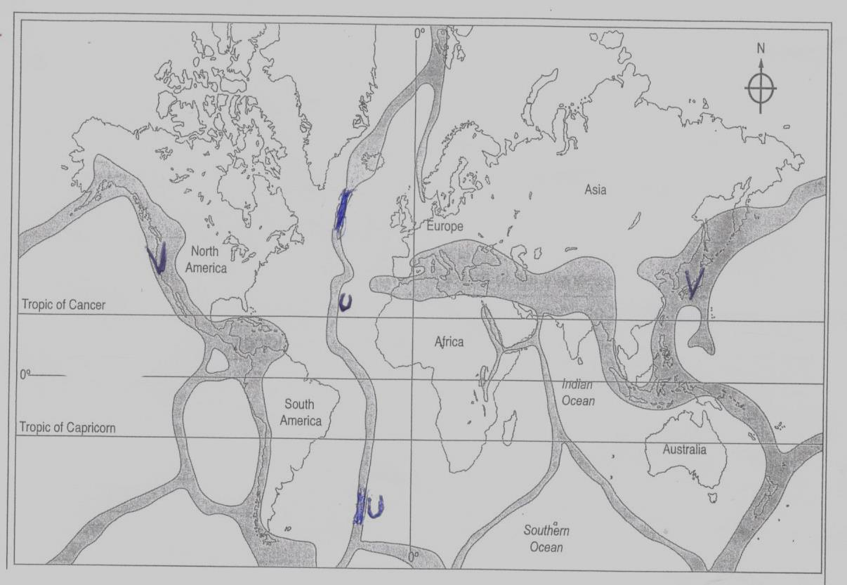
- Name the seismic zones marked U and V (2marks)
U ……………………………………..
V ……………………………………..
- State three natural causes of earthquakes. (3marks)
………………………………………………………………………………………………………………………………………………………………………………………………………………………………………………………………………………………………
3. a) Give two flowage movements of materials. (2marks)
………………………………………………………………………………………………………………………………………………………………………………………………
- State three causes of soil creep (3marks)
………………………………………………………………………………………………………………………………………………………………………………………………………………………………………………………………………………………………………………………………………………………………………………………………………………………………………………………………………………………………………………………………………………………………………………………………
4. The diagram below show a river and its tributaries. Use it to answer the questions (a)
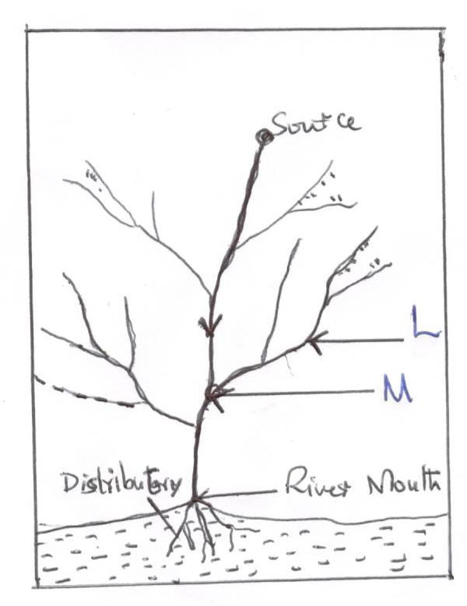
- Name the parts marked L and M (2marks)
L …………………………………………
M …………………………………………
b) State three factors that influence river deposition. (3marks)
………………………………………………………………………………………………………………………………………………………………………………………………………………………………………………………………………………………………………………………………………………………………………………………………………………………………………………………………………………………………
5. a) Identify two types of desert landscape. (2marks)
………………………………………………………………………………………………………………………………………………………………………………………………
- Describe how wind erode the desert surface by deflation. (3marks)
………………………………………………………………………………………………………………………………………………………………………………………………………………………………………………………………………………………………………………………………………………………………………………………………………………………………………………………………………………………………
SECTION B
Answer Questions 6 and any other two from this section.
6. Study the map of North Tinderet (1:50,000) provided and answer the following questions.
a.(i) What is the position of the North Eastern corner of the map by Latitude and
Longitude. (2marks)
(ii) Calculate the area of North Ainabkoi bounded by Ainabkoi feeder road and Uganda Coast road with municipality boundary. (2marks)
(iii) Name two types of planted vegetation in the area covered by the map. (2marks)

b. (i) Measure the distance of the power transmission line from the trigonometrical station 103S12 (in the South West) towards the West. Give your answer in meters. (2 marks)
(ii) What is the bearing of Senghalo sawmill site from the waterhole at grid 7417 (2marks)

c. Draw a cross section along northing 24 from Eastings 51 to Easting 58 (Use 1cm represent 40m). On it mark and name the following features. (2marks)
i) Season swamp (1mark)
ii) Lessos shops (1mark)
iii) District boundary (1mark)
iv) River Kirobi (1mk)
d. (i) Describe the relief of the area covered by the map. (5mks)
(ii) Explain how drainage has influenced the distribution of settlements in the area covered by the map. (4marks)

7a. (i) What is Vulcanicity? (2marks)
(ii) Name two dome shaped intrusive volcanic features. (2marks)
b. (i) Name two volcanic features found in the Riftvalley of Kenya. (2marks)
(ii) Describe how a basic lava dome is formed. (5marks)
(iii) Give three characteristic of a parasitic cone. (3marks)
c. Explain three negative effects of volcanic features to human activities. (6marks)
d. Supposed you carried out a field study on volcanic rocks near your school:
(i) Give three reasons why students collected rock samples. (3marks)
(ii) Give two disadvantages of using direct observation method in collecting data during the field study. (2marks)

8a.(i) Distinguish between Weather and Climate. (2marks)
(ii) Describe a suitable site you would locate a Weather Station in your school. (3marks)
b. (i) Identify the type of rainfall experienced in the Lake Region of Kenya and describe how that type of rainfall is formed. (4marks)
(ii) State the characteristics of the climatic conditions experienced in the Kenyan
Highlands. (4marks)
c. Explain how the following factors influence climate.
(i) Distance from the sea. (2marks)
(ii) Aspect (2marks)
d. (i) Account for three characteristics of the Equatorial climate. (6marks)
(ii) Give two measures that can be taken to control the effects of climate change.(2marks)

9a. (i) Name two sources of underground water. (2marks)
(ii) What is a spring? (2marks)
(iii) State three factors which influence the occurrence of springs. (3marks)
b. (i) State four conditions necessary for the formation of an artesian well. (4marks)
(ii) Explain three ways in which underground water influences human activities. (6marks)
c. Apart from a barchan, name two features formed by wind deposition in
arid areas. (2marks)
(ii) Using a well labelled diagram, describe how a barchan is formed. (6marks)

10a. (i) Distinguish between moraine and till. (2marks)
(ii) Name two areas in the world where ice sheets exist today. (2marks)
b. The diagram below shows an erosional feature in a glaciated lowland. Use it to answer question (i) and (ii).

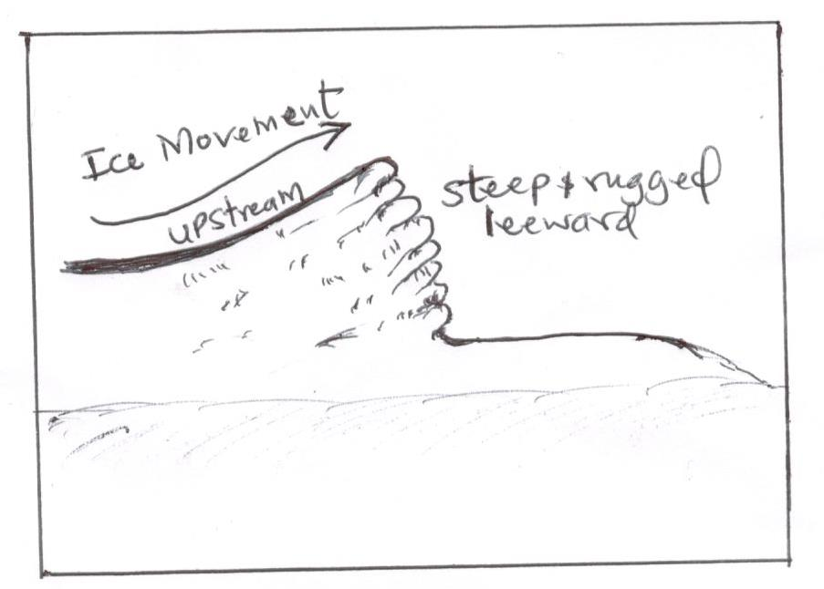
(i) Identify the features in the diagram. (1mark)
(ii) Describe how the feature shown is formed (3marks)
(iii) Describe how an outwash plain is formed. (4marks)
c. Explain three ways in which glaciation influence human environment. (6marks)
d. You carried out a field study on glacial erosion on Mt Kenya.
(i) Give two erosional highland features you identified. (2marks)
(ii) State three challenges you faced during the field study. (3marks)
(iii) Give two reasons why you needed a route map. (2marks)

