End of term I 2021
Geography paper 312/2
Form IV
Time 2^{3/}₄ hours
Kenya certificate secondary education (KCSE)

Name ------------------------------------------ Index No. --------------------

Date ---------------------------------- Signature -----------------------

This paper consists of two sections A and B. Answer all questions in section A. In section B, answer question 6 and any other two.

1.a) Name two conditions that are necessary for the formation of petroleum. (2 marks)
------------------------------------------------------------------------------------------------------------------------------------------------------------------------------------------------------------------------
b) List three ways in which opencast mining affects the environment. (3 marks)
------------------------------------------------------------------------------------------------------------------------------------------------------------------------------------------------------------------------

2. (a) What is soil conservation 2 marks

------------------------------------------------------------------------------------------------------------------------------------------------------------------------------------------------------------------------

(b) State three farming methods that assist in soil conservation. (3 marks.)
------------------------------------------------------------------------------------------------------------------------------------------------------------------------------------------------------------------------------------------------------------------------------------------------------------------------------------------------------------------------------------------------------------------------------------------------
3.(a) Define the term transhumance. (2 marks)
------------------------------------------------------------------------------------------------------------------------------------------------------------------------------------------------------------------------

(b). State three areas in Temperate world where transhumance is practiced. (3 marks)
------------------------------------------------------------------------------------------------------------------------------------------------------------------------------------------------------------------------------------------------------------------------------------------------------------------------------------------------------------------------------------------------------------------------------------------------
4.(a) State five characteristics of softwood forest in Canada. (5 marks)
------------------------------------------------------------------------------------------------------------------------------------------------------------------------------------------------------------------------------------------------------------------------------------------------------------------------------------------------------------------------------------------------------------------------------------------------------------------------------------------------------------------------------------------------------------------------------------------------------------------------------------------------------------------------------------------------------------------------------------------------------------------------------------------------------------------------------------------------------------------------------------------------
5. The table below represents information on population change in Kenya by province between years 2000 and 2005.

Province | Population in Millions
 | Years
 | 2000 | 2005
Nairobi | 2.229 | 2.751
Central | 3.882 | 4.038
Coast | 2.662 | 2.927
Eastern | 4.840 | 5.120
North- Eastern | 1.054 | 1.438
Nyanza | 4.598 | 4.916
Rift valley | 7.386 | 8.366
Western | 5.532 | 3.885
Total | 30.183 | 33.441

(a) Which province had the highest change in population between 2000 and
2005? (2marks)
------------------------------------------------------------------------------------------------------------------------------------------------------------------------------------------------------------------------
(b) Calculate the percentage increase in population in Kenya between 2000
and 2005. (3marks)
------------------------------------------------------------------------------------------------------------------------------------------------------------------------------------------------------------------------

Q.6Anwer question six and any other two.

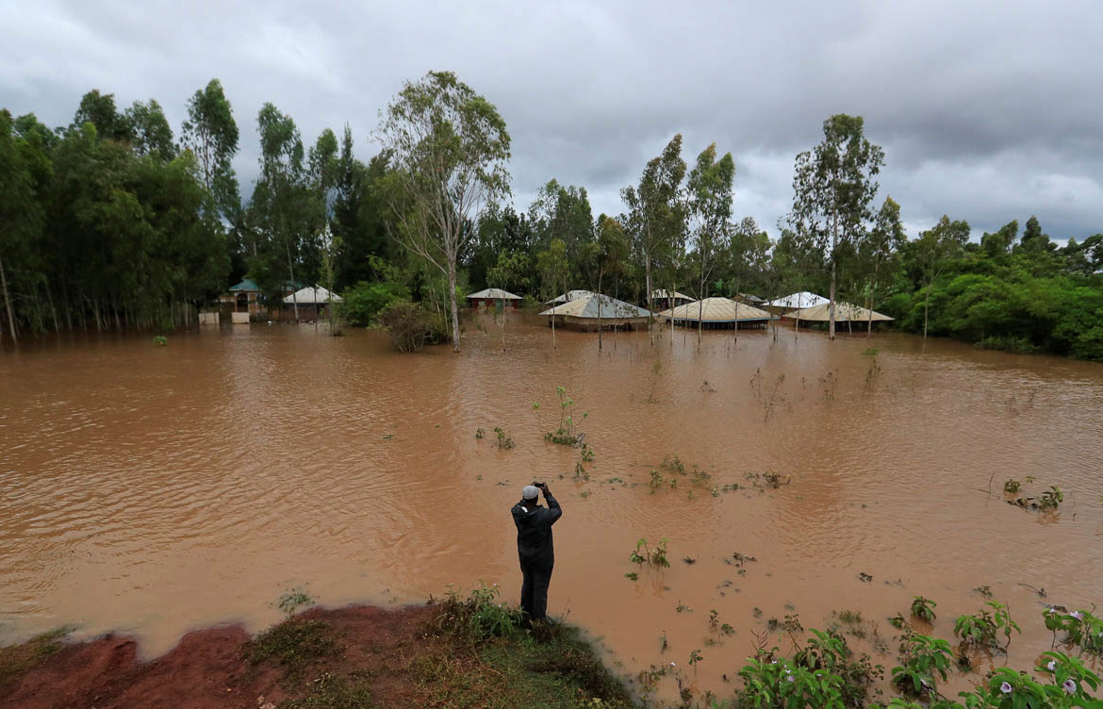

(a)(i). Identify the type of photograph shown above. (2 marks)
------------------------------------------------------------------------------------------------------------------------------------------------------------------------------------------------------------------------

(ii). State three physical factors that may have caused the phenomenon shown in the photograph. (3 marks)
------------------------------------------------------------------------------------------------------------------------------------------------------------------------------------------------------------------------------------------------------------------------------------------------------------------------------------------------------------------------------------------------------------------------------------------------
(iii). Identify the natural phenomenon taking place in the photograph. (1 marks)
------------------------------------------------------------------------------------------------------------------------------------------------------------------------------------------------------------------------
(iv). Name three areas in Kenya prone to the disaster shown in the photograph. (3 marks)
------------------------------------------------------------------------------------------------------------------------------------------------------------------------------------------------------------------------------------------------------------------------------------------------------------------------------------------------------------------------------------------------------------------------------------------------
b). (i) Draw a rectangle 15 cm by 12cm to represent the photograph above. (2 mark)
(ii). In the sketch, mark and name human being,
(iii) settlements.
(iv) Flooded areas
(v) Ripples.
( vi). clouds
5) marks

c). State three methods that can be used to minimize the occurrence of the phenomenon represented by the photograph. (3 marks)
------------------------------------------------------------------------------------------------------------------------------------------------------------------------------------------------------------------------------------------------------------------------------------------------------------------------------------------------------------------------------------------------------------------------------------------------
d.(i) Differentiate between land reclamation and land rehabilitation. (2 marks)
------------------------------------------------------------------------------------------------------------------------------------------------------------------------------------------------------------------------
(ii). State two ways in which each of the following problems experienced in Mwea irrigation scheme can be solved.
- Low prices of rice. (2 marks)
------------------------------------------------------------------------------------------------------------------------------------------------------------------------------------------------------------------------------------------------------------------------------------------------------------------------------------------------------------------------------------------------------------------------------------------------
- Fluctuating water levels in the irrigation canals. (2 marks)
------------------------------------------------------------------------------------------------------------------------------------------------------------------------------------------------------------------------------------------------------------------------------------------------------------------------------------------------------------------------------------------------------------------------------------------------

7. (a) What is mining. (2 marks).
------------------------------------------------------------------------------------------------------------------------------------------------------------------------------------------------------------------------
b). Explain how the following factors influence occurrence of minerals.
(i) Evaporation. (2 marks)
------------------------------------------------------------------------------------------------------------------------------------------------------------------------------------------------------------------------
(ii). Vulcanicity. (2 marks)
------------------------------------------------------------------------------------------------------------------------------------------------------------------------------------------------------------------------

(iii). Metamorphism. (2 marks)
-----------------------------------------------------------------------------------------------------------------------------------------------------------------------------------------------------------------------

(b) (i) Apart from deep shaft mining, name three other mining methods. (3marks)
------------------------------------------------------------------------------------------------------------------------------------------------------------------------------------------------------------------------------------------------------------------------------------------------------------------------------------------------------------------------------------------------------------------------------------------------
(ii) Describe how shaft mining is carried out. (6marks)
------------------------------------------------------------------------------------------------------------------------------------------------------------------------------------------------------------------------------------------------------------------------------------------------------------------------------------------------------------------------------------------------------------------------------------------------
------------------------------------------------------------------------------------------------------------------------------------------------------------------------------------------------------------------------

(c) Explain four ways in which mining contributes to the economy of Kenya. (8marks)
------------------------------------------------------------------------------------------------------------------------------------------------------------------------------------------------------------------------------------------------------------------------------------------------------------------------------------------------------------------------------------------------------------------------------------------------------------------------------------------------------------------------------------------------------------------------------------------------------------------------------------------------------------------------------------------------------------------------------------------------------------------------------------------------------------------------------------------------------------------------------------------------
------------------------------------------------------------------------------------------------------------------------------------------------------------------------------------------------------------------------------------------------------------------------------------------------------------------------------------------------------------------------------------------------------------------------------------------------
8. (a)(i). What is mixed farming. (2 marks)
------------------------------------------------------------------------------------------------------------------------------------------------------------------------------------------------------------------------
(ii). Draw a sketch map of Kenya, and on it mark and name three areas where coffee is grown. (4 marks).

(b)(i) State three physical conditions that favour coffee growing in the areas you have shaded.
(3 marks)
------------------------------------------------------------------------------------------------------------------------------------------------------------------------------------------------------------------------------------------------------------------------------------------------------------------------------------------------------------------------------------------------------------------------------------------------
(ii). Name two new varieties of coffee grown in Kenya. (2 marks)
------------------------------------------------------------------------------------------------------------------------------------------------------------------------------------------------------------------------------------------------------------------------------------------------------------------------------------
(c). Explain four ways in which the government of Kenya assist the small-scale
coffee farmers. (8 marks).
------------------------------------------------------------------------------------------------------------------------------------------------------------------------------------------------------------------------------------------------------------------------------------------------------------------------------------------------------------------------------------------------------------------------------------------------
------------------------------------------------------------------------------------------------------------------------------------------------------------------------------------------------------------------------------------------------------------------------------------------------------------------------------------------------------------------------------------------------------------------------------------------------
------------------------------------------------------------------------------------------------------------------------------------------------------------------------------------------------------------------------------------------------------------------------------------------------------------------------------------------------------------------------------------------------------------------------------------------------

d). Your geography class carried out field study in a coffee farm near the school.
i) State four methods the class may have used to collect data. 4 marks
------------------------------------------------------------------------------------------------------------------------------------------------------------------------------------------------------------------------------------------------------------------------------------------------------------------------------------------------------------------------------------------------------------------------------------------------------------------------------------------------------------------------------------------------------------------------------------------------------------------------------------------------------------------------------------------------------------------------------------------------------------------------------------------------------------------------------------------------------------------------------------------------
ii) During the field study the class collected data on quantities of coffee produced in the farm in the last five years. State two methods the class may have used to present the data. (2 marks).
------------------------------------------------------------------------------------------------------------------------------------------------------------------------------------------------------------------------------------------------------------------------------------------------------------------------------------------------------------------------------------------------------------------------------------------------

9. (a). Study the map of the world provided to answer the questions that follow. The world maps
indicate the major fishing ground.

(i). Name the ocean current marked X and Y. (2marks)
X---------------------------------------------------------------------------------------------------------Y---------------------------------------------------------------------------------------------------------

(ii). Name the continents marked L and N. (2 marks).
L-------------------------------------------------------------------------------------------

N-------------------------------------------------------------------------------------------

(iii). Name the Countries marked P and Q. (2 marks).
P-------------------------------------------------------------------------------------------

Q-------------------------------------------------------------------------------------------

b). Apart from the ocean currents explain four other factors that influence fishing where two current meets. (8 marks). ------------------------------------------------------------------------------------------------------------------------------------------------------------------------------------------------------------------------------------------------------------------------------------------------------------------------------------------------------------------------------------------------------------------------------------------------------------------------------------------------------------------------------------------------------------------------------------------------------------------------------------------------------------------------------------------------------------------------------------------------------------------------------------------------------------------------------------------------------------------------------------------------

c) Explain why in East Africa, fresh water fishing water in the area shaded on the map other than ocean currents. (6marks)
-----------------------------------------------------------------------------------------------------------------------------------------------------------------------------------------------------------------------------------------------------------------------------------------------------------------------------------------------------------------------------------------------------------------------------------------------------------------------------------------------------------------------------------------------------------------------------------------------------------------------------------------------------------------------------------------------------------------------------------------------------------------------------------------------------------------------------------------------------------------------------------------------------------------------------------------------------------------------------------------------------------------------------------------------------------------------------------------------------------------------------------------------------------------------------------------------------------------------------------
d). (i). State two measures taken by Kenya government to conserve fisheries in Kenya. (2 marks)
------------------------------------------------------------------------------------------------------------------------------------------------------------------------------------------------------------------------------------------------------------------------------------------------------------------------------------------------------------------------------------------------------------------------------------------------

ii) List three methods used to preserve fish. (3marks)
------------------------------------------------------------------------------------------------------------------------------------------------------------------------------------------------------------------------------------------------------------------------------------------------------------------------------------------------------------------------------------------------------------------------------------------------

10. (a)(i). What is energy crisis? (2 marks)
------------------------------------------------------------------------------------------------------------------------------------------------------------------------------------------------------------------------------------------------------------------------------------------------------------------------------------
(ii)Apart from water, give two renewable sources of industrial energy. (2 marks)
------------------------------------------------------------------------------------------------------------------------------------------------------------------------------------------------------------------------

The diagram below shows the occurrence of petroleum in the earths’ crust Use it to answer question (a iii).

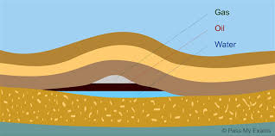
A
B
C
Non-porous rock

Porous Rock

(iii). Name the substances labelled A, B, C. (3 marks)
A-----------------------------------

B-----------------------------------

C------------------------------------

(b) Explain four benefits emanating. from rural electrification in Kenya. (8 marks)
------------------------------------------------------------------------------------------------------------------------------------------------------------------------------------------------------------------------------------------------------------------------------------------------------------------------------------------------------------------------------------------------------------------------------------------------------------------------------------------------------------------------------------------------------------------------------------------------------------------------------------------------------------------------------------------------------------------------------------------------------------------------------------------------------------------------------------------------------------------------------------------------------------------------------------------------------------------------------------------------------------------------------------------------------------------------------------------------------------------------------------------------------------------------------------------------------------------------------------------------------------------------------------------------------------------------------------------------------------------------------------------------------------------------------------------------------------
(c) (ii) Explain three effects that the increase in oil prices had on the economies of oil – importing countries of Africa. (6 marks)
------------------------------------------------------------------------------------------------------------------------------------------------------------------------------------------------------------------------------------------------------------------------------------------------------------------------------------------------------------------------------------------------------------------------------------------------------------------------------------------------------------------------------------------------------------------------------------------------------------------------------------------------------------------------------------------------------------------------------------------------------------------------------------------------------------------------------------------------------------------------------------------------

(ii). State four ways in which Kenya can reduce the use of petroleum as a source of energy.
(4 marks)
------------------------------------------------------------------------------------------------------------------------------------------------------------------------------------------------------------------------------------------------------------------------------------------------------------------------------------------------------------------------------------------------------------------------------------------------------------------------------------------------------------------------------------------------------------------------------------------------------------------------------------------------------------------------------------------------------------------------------------------------------------------------------------------------------------------------------------------------------------------------------------------------------------------------------------------------------------------------------------------------------------------------------------------------------------------------------------------------------------------------------------------------------------------------------------------------------------------------------------

©This is the last printed page. Sep/2021

