312/2
GEOGRAPHY
PAPER 2.
FORM 3
TIME: 2 ¾ HRS 2022
END OF TERM 3 EXAMINATIONS 2022

Name:……………………………………………………….Class:…………..Adm No:……….

Instructions.
This paper contain TWO section A and B. ANSWER ALL questions in Both sections.
In a separate booklet provided.

SECTION A.

- a. What is mining? (2mks)

b. State three factors influencing the occurrence of minerals. (3mks)

- a. Name two indigenous softwood trees species. (2mks)

b. Give three factors that favour the growth of Natural forests on the slopes of Mt. Kenya. (3mks)
- a. What is sampling? (2mks)

b. Give three main types of sampling techniques. (3mks)

- a. List two open cast methods of mining. (2mks)

b. What are the effects of dereliction of land during mining? (3mks)

- a. A student was requested to pick out fourteen numbers randomly from a set of numbers. She picked 20, 37, 1, 66, 42, 12, 6, 15, 12, 42, 100, 3, 82, and 42. Calculate:
i. The mean of the data. (2mks)

ii. The mode of the data. (1mk)

iii. The median of data. (2mks)

SECTION B.

- a. The table below shows hypothetical data of minerals production in Tanzania in tones. Use it to construct proportional divided circles.
 | Quantity in tonnes
Minerals | 1998 | 1999 | 2000
Graphites | 200 | 490 | 930
Fluorspar | 30 | 255 | 450
Soda ash | 270 | 300 | 350
Diamond | 500 | 870 | 1270
Total | 1000 | 1915 | 3000

b. State three advantage of proportional divided circles. (3mks)

- a. State four factors influencing exploitation of minerals. (4mks)

c. The map below show location of mineral in East Africa, use it to answer questions c (i) diagram

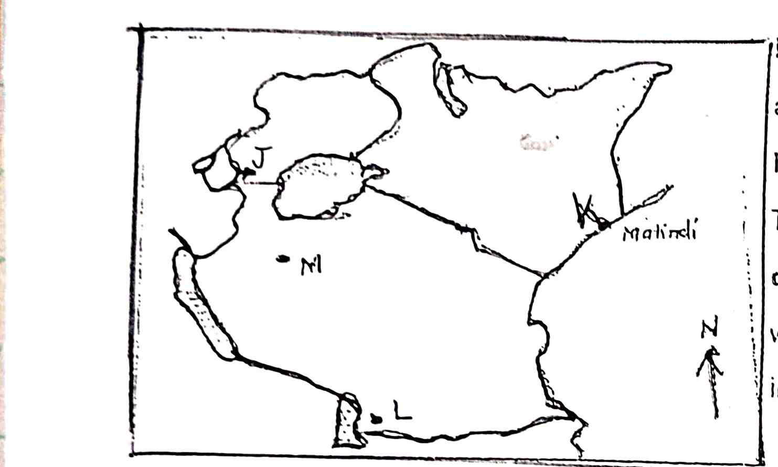
i. Name the minerals found in areas marked J, K, L and M. (4mks)

ii. Describe the process of Trona in Lake magadi. (4mks)

d. Your class intend to carry out a field study of mining of Trona in Lake Magadi.

i. State four reasons why it is important to conduct a reconnaissance. (4mks)

ii. Give three items to be included in the working schedule for the study . (3mks)

e. State three benefits of Trona to the economy of Kenya. (3mks)

- a. What is forestry? (2mks)

ii. Apart from tropical hardwood forest name two other types of natural forest. (2mks)

iii. State the problems experienced in exploitation of tropical hardwood forest. (5mks)

b. List the characteristics of planted forests in Kenya. (5mks)

c. Explain three factors that favour forestry in Canada. (6mks)

d. Give five measures that the government has taken to conserve and manage forests in Kenya. (5mks)

e. Form four students in your school carried out a field study on the forestry within the county.

i. Give reasons they had to prepare a working schedule. (3mks)

ii. What are the problems likely to be encountered during the field study? (2mks)

