CASPA JOINT EVALUATION
Kenya Certificate of Secondary Education
Geography (312/2)
Paper Two
Form 4
Marking Scheme
SECTION A (25 marks)
Answer All the Questions in this Section
1.a) Define the term mining. (2 marks)
✓ Mining is the process of extracting mineral substance from the earth crust for commercial purposes
b) State three forms in which minerals occur. (3 marks)
✓ Beds and seams/layers
✓ Veins and Lodes
✓ Weathering products
✓ Alluvial deposits
2.a) Distinguish between forest and forestry. (2 marks)
✓ A forest is a large tract of land covered by trees while Forestry is the science of developing and managing forests including cultivating them
b) Show three factors that influence the distribution of forests. (3 marks)
✓ High temperature causes fast growth of trees while low temperature causes slow growth.
✓ Dense forests are found on windward slopes of mountains because they are wetter than leeward slopes and they start at a lower level than on the leeward slopes.
✓ In temperate region slopes facing equator have dense forests because they are warmer
✓ There are dense forest where there is heavy precipitation while there is less forest cover consisting of stunted trees in areas with little precipitation.
✓ Deep soils support luxuriant growth of trees while shallow and infertile soils have stunted trees.
3.a) What is horticulture? (2 marks)
✓ is intensive cultivation of fruits, vegetables and flowers for sale
b) Give three economic factors that influence agricultural activities. (3 marks)
✓ availability of capital
✓ market prices of products
✓ availability of accessible transport facilities
✓ Competition from other world producers
✓ Government subsidies on cost of inputs
✓ Government taxation policy

4.a) Name two places where limestone are found in Kenya. (2 marks)
✓ Bamburi in Mombasa county
✓ Athi River in Kajiado county
✓ Some parts of West Pokot county
✓ Some parts of Wajir county
✓ Some parts of Homabay county

b) List three uses of soda ash. (3 marks)
✓ Raw material in the manufacture of glasses and bottles
✓ Manufacture of soap and detergents ✓ Refining of petroleum
✓ Water softener and treatment works
✓ De-sulphurizing steel
✓ Paper making industries
✓ Textile industries

5.a) What is a dead ground? (2 marks)
✓ Is the area/part of a photograph hidden from the view of a camera by an object

b) Mention three uses of a photograph. (3 marks)
✓ To show actual objects as they appear in real life
✓ Vertical aerial photographs are used in drawing maps
✓ To study physical features and their distribution in an area
✓ To deduce huma activities, climate and vegetation
✓ Provides important information on land use and geography of an area
✓ To ‘bring’ unfamiliar and distant landscapes in a classroom.
✓ To create awareness and understanding on geographical phenomena

SECTION B (75 marks)
Answer question 6 and any other two questions
6. Study the photograph below and use it to answer question (a).

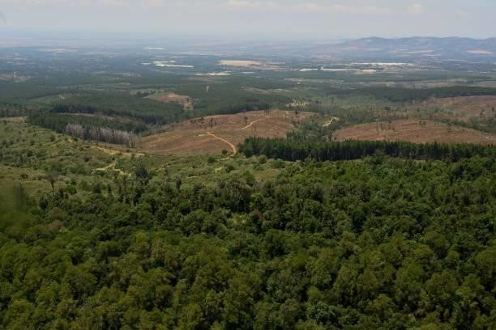

(a)(i) Identify the type of photograph shown above. (1 mark)
✓ Ground oblique photograph
(ii)Describe the characteristics of the forest shown on the photograph. (4 marks)
✓ The forest has mixed species of trees.
✓ The forest in the foreground is dense/trees are close to each other.
✓ The forest in the foreground is natural.
✓ The forest has some shrubs/undergrowth.
✓ Trees are of different height.
✓ Some part of the forest has been cleared.

(iii)Draw a rectangle measuring 15 cm by 10 cm to represent the area by the
photograph. On it sketch and label the main features shown on the photograph.
(5 marks)
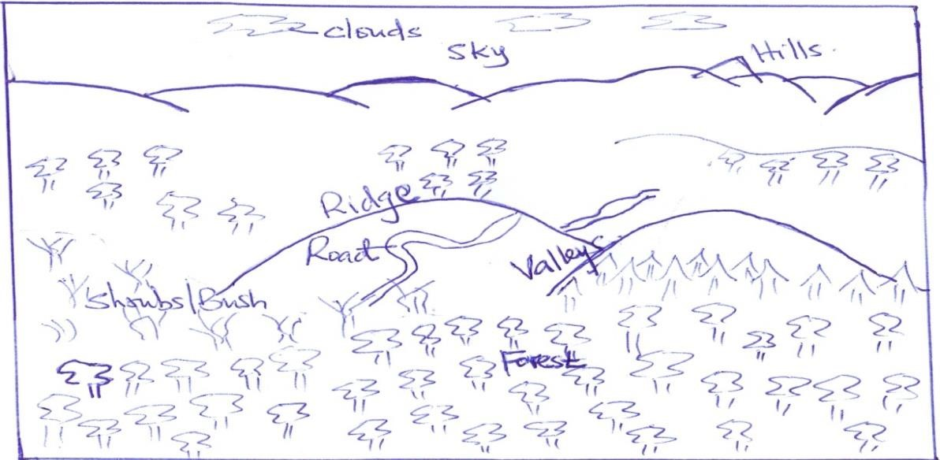

(b)(i) Name two indigenous softwood tree species in Kenya. (2 marks)
✓ Podo
✓ Cedar/Juniper
✓ African pencil

(ii)Explain three problems facing forestry in Kenya. (6 marks)
✓Rapid population increase has led to encroachment into the forested areas for settlement/agriculture leading to reduction of land under forest cover.
✓Illegal logging by unlicensed timber merchants have led to depletion of indigenous tree species leading to their extinction.
✓Prolonged drought have led to death of some tree species.
✓Attack by pests/diseases have caused the destruction of valuable tree species.
✓Occurrence of forest fires have led to destruction of large areas under forest cover.
✓Excision of forest land by the government for settlement/human activities have led to reduction of land under forest cover.

(iii)State three factors favouring the development of softwood forests in Canada. (3 marks)
✓ The cool/cold climate/low temperature.
✓ Rugged/steep landscape in British Columbia
✓ Low population density
✓ Heavy rainfall on the windward slopes of the mountain ranges of British Columbia. ✓ Extensive land in Canada is available for the forest to grow.

(c)Give four differences between softwood forests in Kenya and Canada. (4 marks)
✓ In Kenya harvesting of trees is done throughout the year while in Canada harvesting is done in winter and early spring.
✓In Kenya harvesting is done selectively while in Canada clear/indiscriminate cutting of trees is done.
✓In Kenya forest products are mainly sold locally while in Canada are mainly for export.
✓Species: Most Kenyan softwoods are exotic while in Canada softwoods are indigenous.
✓Areas where they are found: Most softwood forests are found mainly in the highlands while in Canada they are found both in the highlands and lowlands
✓Maturity: Softwoods in Kenya grow faster due to the warm tropical climate while softwoods take longer to reach maturity due to the cool temperate climate.

7. Study the table below and answer the questions that follow
a) i) Draw a simple pie chart to represent the information above. (6 marks)
Agriculture 4/100 x 360o = 14.4o Aviation 21/100 x 360o = 75.6o
Commerce and industry 22/100 x 360o = 79.2o Power 7/100 x 360o = 25.2o
Rail 6/100 x 360o = 21.6o Road 30/100 x 360o = 108o
Shipping 6/100 x 360o = 21.6o Others 4/100 x 360o = 14.4o

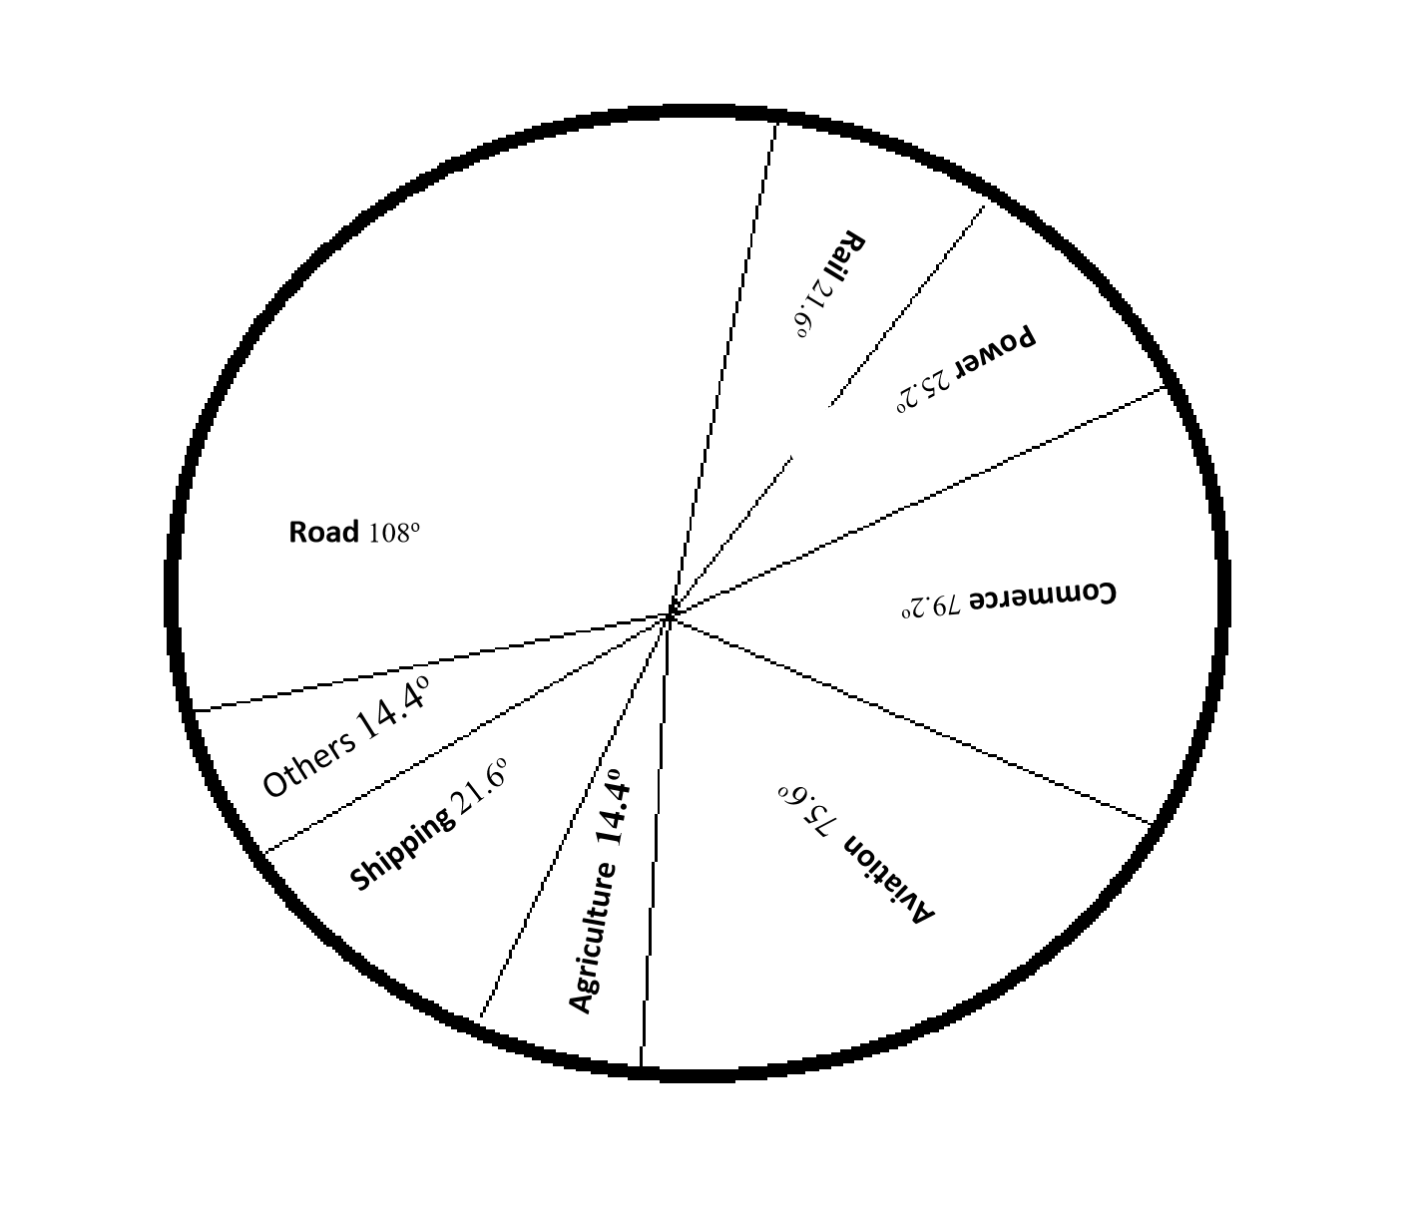

ii)What is the percentage of oil used in transport in the year 2010? (2 marks)
Transport sector = aviation + rail + road + Shipping
21 + 6 +30 + 6 = 63%
iii)Mention two demerits of using the method above to represent data. (2 marks)
✓ Difficult to interpret if segments are many.
✓ Tedious due to a lot of mathematical calculations and marking out of angles involved.
✓ Can’t be used to show trend/change over a certain period.
✓ Small quantities or decimals may not be easily represented.

b) i) List three countries where oil is produced in the Middle East. (3 marks)
✓ Saudi Arabia
✓ Iraq
✓ United Arab Emirates
✓ Syria
✓ Kuwait
✓ Iran
ii) Explain three contributions of oil in the economy of the countries in the Middle East (6 marks)
✓ It generates a lot of revenue through export and also from royal1es
✓ It creates employment with high income hence raising the standards of living
✓ It s1mulates growth and development of urban centers
✓ It create very rich communi1es such as sheikdoms improving their living standards
c) Describe how petroleum oil is formed. (6 marks)
✓ Organic materials are transported to lowland and deposited in layers
✓ With time the layers accumulate to form sedimentary rocks
✓ Great heat and pressure is exerted on the rocks changing into petroleum
✓ Eventually petroleum is squeezed out through porous rocks
✓ Oil is then trapped in places between the rocks water and gas may also be trapped in rock layers
8. a) Name two wheat growing counties in Kenya (2 marks)
✓ Uasin Gishu
✓ Nakuru
✓ Narok
✓ Laikipia
✓ Trans Nzoia
✓ Nyandarua

b) State five conditions favouring wheat farming in Kenya. (5 marks)
✓Warm temperatures in growing areas of 15-20◦c at least for three months which promotes growth of wheat and protects it against frost.
✓Moderate rainfall of 1800-1270mm which promotes growth of wheat.
✓High altitude of growing areas of 1500-2900m which reduces incidences by high humidity.
✓ Deep fertile volcanic soils which lead to high production.
✓ Gently or fairly level land for proper drainage and to allow mechanisation.
✓ Adequate labour for planting, weeding, application of fertilizers etc.
✓ Availability of transport facilities such as lorries and tractors to transport grains from the fields to the store and then to buying centres.
c)Describe wheat farming from planting to harvesting stage. (8 marks)
✓ Land is prepared by ploughing using tractor driven ploughs.
✓ It’s then hallowed several times to allow weeds and stray wheat grains to be killed in the next harrowing.
✓ Manure and phosphate fertilizers are applied after the last harrow before sowing.
✓ Sowing is done using drills that are pulled by tractors or hands.
✓ Weeding is done by spraying or pulling using hands.
✓ The crop is regularly inspected for pests and diseases. Harvesting
✓ Wheat is harvested by cutting heads using sharp knifes for small scale farms or combined harvesters for large scale farms which also threshes the grain.
✓ The grain is pumped into trucks or tractors which move alongside the harvesters.
✓ It’s taken to farm stores where it’s passed through driers before it’s packed for sale.

d) Give two selling points of wheat in Kenya. (2 marks)
✓ National Cereal and Produce Board
✓ Wheat millers
✓ Alcohol breweries
✓ Bakeries

e) Compare wheat farming in Kenya and Canada. (8 marks)
✓ There is mechanization in both countries.
✓ There are extensive farms in both countries.
✓ There is a dry sunny spell in both countries.
✓ Both countries experience the problem of pests and diseases.
✓ Wheat in both countries is grown in areas with gently sloping terrain. ✓ Wheat growing in both countries is affected by climatic hazards.
✓ In Kenya wheat is grown in highlands while in Canada it’s grown in lowlands.
✓ In Kenya wheat is consumed locally while in Canada most of it is for export.
✓ Kenya experiences wheat shortage while Canada experiences overproduction.
✓ Canadian farmers specialize while Kenyan farmers carry out mixed farming.
✓ In Canada all work is mechanized while in Kenya there is usage of human labour.
✓ Kenya has no incentives such as subsidies such as in Canada.
✓ In Kenya farming is all year round but Canada experiences winters. ✓ In Kenya farming is carried out on plateaus while in Canada it’s on plains.
✓ Canada produces more wheat grain than Kenya.
✓ Kenya grows spring wheat while Canada grows both spring and winter wheat.

9. a) Discuss nomadic pastoralism in Kenya under the following sub-headings
i) The cattle breeds kept (2 marks)
✓ The cattle breeds kept the pastoralists are mainly indigenous breeds such as Zebu and Boran.
ii) The pattern of movement (2 marks)
✓ Their movement is seasonal
✓ During the dry season the pastoralist migrate with the livestock to the highlands where there is pasture and water.
✓ During the wet season they move to the plains since pasture is available
iii) Marketing of the animals (3 marks) ✓ Some cattle are sold to slaughter houses/to individuals.
✓ Some pastoralists sell their livestock through community groups.
✓ Some livestock are sold to the livestock Marketing Department.
✓ Some pastoralists sell their animals to Kenya Meat Commission.

b)i) Give three reasons why nomadic pastoralists keep large heads of animals. (3 marks)
✓ It is a form of insurance against natural calamities such as diseases and drought.
✓ Animals are kept as a sign of wealth/prestige/social status.
✓ Animals are kept for use to pay dowry.
✓ Animals are used as a source of food/milk meat and blood.
ii) Explain four measures taken by the government of Kenya to improve beef cattle farming. (8 marks)
✓ It encourages the cross-breeding of traditional cattle breeds with exotic ones. This improves the quality of the animals/cross breeds are more resistant to diseases than
pure exotic breeds.
✓ It strengthens community education to teach beef cattle farmers better livestock management.
✓ It sets up demonstration ranches for farmers to learn new trends in livestock management.
✓ It has constructed roads to make services accessible to farmers/make transportation of animals to markets easier.
✓ It encourages the replacement of the coarse grass with nutritious pasture to improve the quality of animals.
✓ It has sunk bore holes/dug wells/constructed dams to provide water for the animals.
✓ It has revived the Kenya Meat Commission (KMC), a government parastatal that buys animas from farmers for slaughter.

c) Give four challenges facing nomadic pastoralism in Kenya (4 marks)
✓ Shortage of water and pasture due to long dry spell.
✓ Pests and diseases which weaken animals
✓ Overstocking causing overgrazing leading to severe erosion.
✓ Lack of extension and veterinary services due to insecurity and constant movement.
✓ Low levels of education and culture leading to keeping pastures and poor quality animals.
✓ Poor pastures resulting from poor soils with most areas consisting of tuft grasses and bare land.
✓ Cattle rustling which causes loss of live and destruction of property.
✓ Inaccessibility of pastoral areas due to poor roads making the farmers unable to get their animals to the market.
✓ They rear indigenous cattle such as zebu and boran which mature slowly, yield little milk and have poor quality beef.
✓ Exploitation by middlemen due to lack of market information.
✓ Small local market due to sparse population.
✓ Competition from national parks leading to conflicts.
d) Name three indigenous breeds of dairy cattle reared in Kenya. (3 marks)
✓ Zebu
✓ Boran
✓ Sahiwal

