END OF TERM 3 EXAMINATIONS 2022

FORM 3
GEOGRAPHY PAPER TWO.
MARKING SCHEME

Instructions.
This paper contain TWO section A and B. answer all questions in Both sections.
In a separate booklet provided.

SECTION A.

- a. What is mining? (2mks)
- Mining refers to all attempts to extract valuable minerals either solid, liquid or gases from the earth surface.
b. State three factors influencing the occurrence of minerals. (3mks)
- Veins and lodes
- Beds and seam
- Weathering products
- Alluvial or place deposits
- a. Name two indigenous softwood trees species. (2mks)
- Podo
- Cede/ Juniper
- Africa pencil
b. Give three factors that favour the growth of Natural forests on the slopes of Mt. Kenya. (3mks)
- The area receives heavy rainfall over 1000mm.
- The area has deep fertile volcanic soils.
- The steep slopes discourage human activities.
- The area is gazette forest reserve hence settlement is prohibited.
- a. What is sampling? (2mks)
- Sampling is the process by which a representative portion of the phenomena under research is selected for analysis.
b. Give three main types of sampling techniques. (3mks)
- Random sampling
- Systematic sampling
- Stratified sampling.
- a. List two open cast methods of mining. (2mks)
- Stripping
- His slope boring
b. What are the effects of dereliction of land during mining? (3mks)
- Waste of agricultural land
- Ugliness of the land
- Heath and accident hazards.
- a. A student was requested to pick out fourteen numbers randomly from a set of numbers. She picked 20, 37, 1, 66, 42, 12, 6, 15, 12, 42, 100, 3, 82, and 42. Calculate:
i. The mean of the data. (2mks)
= 20 + 37 + 1 + 66 + 42 + 12 + 6 15 + 12 + 42 + 100 +3 + 82 + 42
= 480
14
Mean = 34.3
ii. The mode of the data. (1mk)
42 occur thrice
iii. The median of data. (2mks)
= 1 , 3, 6 ,12, 12, 15, 20, 37, 42, 42, 42, 66, 82, 100
Median = 20 + 37
2
= 57
2
= 28.5

SECTION B.
- a. The table below shows hypothetical data of minerals production in Tanzania in tones. Use it to construct proportional divided circles.
 | Quantity in tonnes
Minerals | 1998 | 1999 | 2000
Graphites | 200 | 490 | 930
Fluorspar | 30 | 255 | 450
Soda ash | 270 | 300 | 350
Diamond | 500 | 870 | 1270
Total | 1000 | 1915 | 3000

Square root. scale
1998 1cm rep 10 tonnes
Total √1000 =31.6 radius
32 1998 = 3.2 cm
1999 1999 = 4.4 cm
Total √1915 = 43.76 2000= 5.5cm
44
2000
Total √3000 = 54.8
55
Calculations of percentages and angles.
Years 1998
Graphite = 200 x 100 = 20% = 20 x 360 =72^{O}
1000 100
Floursper = 30 x 100 = 3% = 3 x 360 = 10.8^{O}
1000 100

Soda ash = 270 x 100 = 27% = 27 x 360 = 97.2^{O}
1000 100
Diamond = 500 x 100 = 50% = 50 x 360= 180^{O}
1000 100

Year 1999
Graphite = 490 x 100 = 25.6 = 25.6 x 360 = 92.2^{O}
1915 100
Floursper 255 x 100 = 13.3% = 13.3x 360= 47.9^{O}
1915 100
Soda ash = 300 x 100 = 15.7% = 15.7 x 360= 56.5^{O}
1915 100
Diamond = 870 x 100 = 45.4% = 45.4 x 360 = 16.34^{O}
1915 100

Year 2000
Graphite = 930 x 100 = 31% = 31 x 360 = 111^{O}
3000 100
Floursper = 450 x 100 = 15% = 15 x 360 = 54^{O}
3000 100
Soda ash = 350 x 100 = 11.7% = 11.7 x 360 = 42.1^{O}
3000 100
Diamond = 1270 x 100 = 42.3% = 42.3 x 360 = 152.3^{O}
3000 100
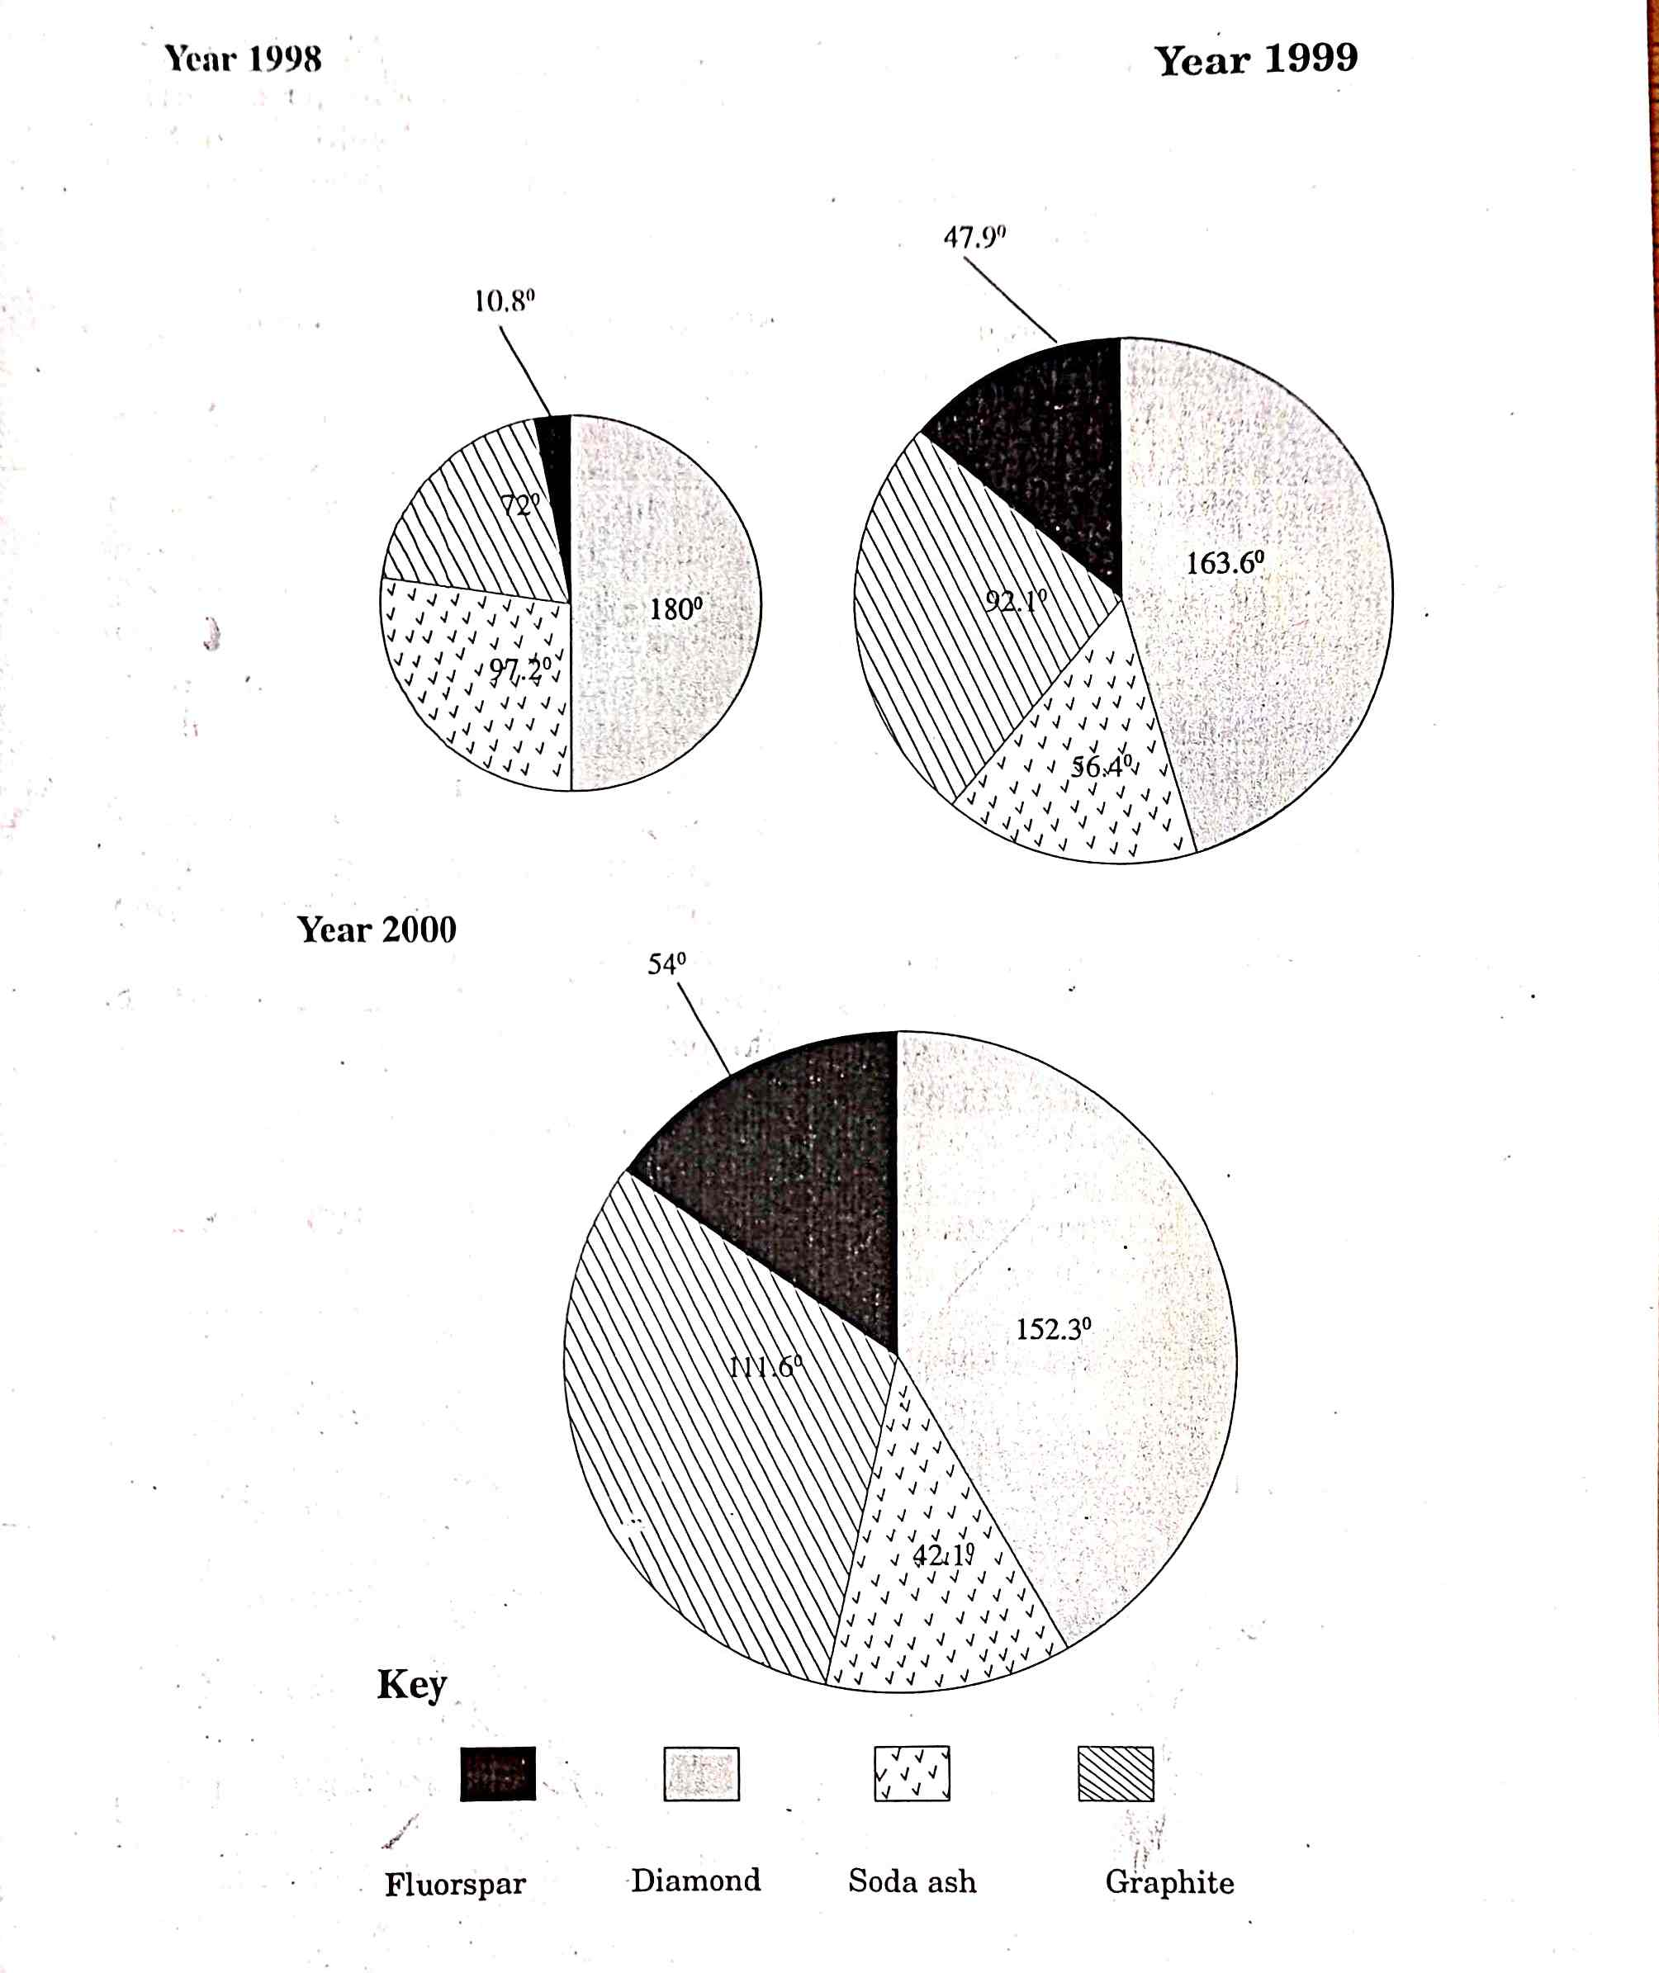
b. State three advantages of proportional divided circles. (3mks)
- Individual contributions made by each component in the circles can be made at glance.
- Components of the same circle can be compared easily.
- They can be used to show many commodities.
- They create a good visual impression.
- a. State four factors influencing exploitation of minerals. (4mks)
- value of the minerals
- size of the mineral deposits
- the quality of ore
- methods of mining
- technology
- capital
- market
- transport cost
b. Describe how drilling method occur in mining. (3mks)
- Drilling is commonly used in exploiting petroleum and natural gas.
- Here boring wells are used to reach mineral deposits.
- Petroleum is then brought to the surface either under its own pressure or by pumping.
c. The map below show location of mineral in East Africa, use it to answer questions c (i) diagram.
i. Name the minerals found in areas marked J, K, L and M. (4mks)
- J – Tin
- K – Salt/ limestone
- L – Coal
- M - Diamond
ii. Describe the process of Trona in Lake magadi. (4mks)
- Trona is separated from water by being put on large sieves like trays.
- Trona is washed to remove mud and salt.
- After drying Trona is heated in big cylinder and it breaks into small particles of sodium carbonate.
- Soda ash is allowed to cool.
- It is then ground weight and packed into paper bags.
d. Your class intend to carry out a field study of mining of Trona in Lake Magadi.
i. State four reasons why it is important to conduct a reconnaissance. (4mks)
- To familiarize the researcher with area of study.
- It introduces the researcher to the authority and responded.
- Help the researcher to identify methods of data collection.
- It enables the researcher to determine the suitability of the area of study.
- Help to identify any problem.
ii. Give three items to be included in the working schedule for the study . (3mks)
- Time for departure
- Time to spend in the study
- Time for lunch
- Time to end the study.
e. State three benefits of Trona to the economy of Kenya. (3mks)
- Led to the growth of Madagi town
- Led to the development of social amenities.
- Has stimulated the development of infrastructure.
- The company has provided employment to many
- a. What is forestry? (2mks)
- Forestry is the science of developing or cultivating forests.
ii. Apart from tropical hardwood forest name two other types of natural forest. (2mks)
- Temperate hardwood forests
- Coniferous forest
iii. State the problems experienced in exploitation of tropical hardwood forest. (5mks)
- Trees take long time to mature
- Different tree species are clustered in one area.
- Trees mature at different times.
- Trees trunks are huge.
- Trees are heavy bulky.
b. List the characteristics of planted forests in Kenya. (5mks)
- Trees appears in rows.
- Trees have same species.
- Trees are mainly softwoods.
- They have little or no undergrowth.
- They take time to mature.
- Mainly located in highlands areas.
c. Explain three factors that favour forestry in Canada. (6mks)
- The bottoms valley along the coast form a a suitable sites for location of paper mills clay for smoothening paper surface.
- There are many rivers with waterfalls suitable for generation of H.EP for use in the industries.
- Low temperature in the highland discourages settlement leaving forestry as the only land use.
- The land is rugged with thin soil that discourages agriculture.
- High precipitation favour growth of forests.
d. Give five measures that the government has taken to conserve and manage forests in Kenya. (5mks)
- It has inacted laws to prohibit the cutting of trees without licence.
- It has established forests research stations to conduct research on their species.
- It encourage people to use alternative sources of energy.
- Tree planting programmes drawn during rainy seasons.
- Forests are protected by establishing forests guards.
e. Form four students in your school carried out a field study on the forestry within the county.
i. Give reasons they had to prepare a working schedule. (3mks)
- It gives ample time to each activity.
- It reduces tendency to time wastage.
- It provide estimate of the time required for the study.
- It provides a basis for evaluating field work.
- It provide a framework that guides the reasercher.
ii. What the problems likely to be encountered during the field study. (2mks)
- The researcher may fall sick.
- The respondents may become uncooperative.
- Language barrier between the researcher and the responded.
- Transport problems
- Environmental constraint e.g. heavy rainfall.

