LANJET CLUSTER EXAMINATION
GEOGRAPHY Paper 2 (312/2).
DECEMBER, 2021
MARKING SCHEME

SECTION A

- a. Name two branches of Geography. (2mks)
- Physical geography
- Human geography

b. Outline three ways in which a student benefits from learning geography. (3mks)
- Provide international awareness
- Help learners acquire skills of observation.
- Promote understanding of origin of the earth and the solar system.
- Enhance national unity through studying other regions and people.
- Help learners to appreciate environmental conservations.
- Teach on how to manage time properly.
- It is a career subject

- a. Define the term mining. (2mks)
- Mining refers to all attempts to extract valuable minerals, either solid , liquid or gas from the earth crust.

b. Describe Hydraulic mining as a method of mining. (3mks)
- When alluvial deposits occur on a valley side or form thick terrace deposits.
- A powerful jet water under high pressure is directed at the hill or terrace side.
- Then gravels and mineral collects in the valley floor where mineral grains are recovred and washed out.

- a. List two factors that determine the distribution of forest in Kenya (2mks)
- Climate/rainfall/temperature
- Altitudes
- Reliefs
- Soils
- Human activities.

b. Give three economic uses of mangrove forests. (3mks)
- Provide poles for construction
- Source of fuel
- For export/earn foreign exchange/income
- The back of source of tannis

- a. Outline two biotic factors influencing agriculture. (2mks)
- Weeds and parasitic plants – complete with crop nutrients.
- Insectspest, fungi and diseases which are both harmful and benefictial in the farm.

b. State three physical conditions that favour cocoa farming in Ghana. (3mks)
- High rainfall/rainfall of between 1200-1500mm per year.
- High temperature/temperature of between 24^{O}-30^{.o}throughtout the year.
- Deep soils, loamy soils.
- Undecilating lowland/ 0 to 750m above sea level.
- Shelter from strong wind
- High relative humidity throughout the year.

- a. Differentiate between management and conservation of the environment. (2mks)
- Environmental management is the planning and implementation of the plan to ensure effective and proper utilization of the available resource in the environmentto achieve set objectives, while environmental conservation involves the protection, perseverations and proper utilization of resources in the environment to continue benefiting the present generation and future generation.

b. Outline three measures being taken by people to reduce the impact of floods. (3mks)
- Avoiding flood prone areas
- Land use zoning – government may evacuate people in flood prone areas.
- Building of dams.
- Dredging the river channel to remove deposited silt to widen river channel.
- Building of dykes
- Building of levees.

SECTION B

- Use the table below and answer the questions that follow in Narok County.
Name of divisions | No. of veterinary officers
Mayasho | 300
Gukaro | 150
Zachocho | 200
Mayayo | 160
Kakasho | 110
Ndikakho | 80
Totals | 1000
- Calculate the percentage of number of officers in Kakasho division. (2mks)
110 x 100
1000
=11%

- Draw a divided rectangle of 10cm long to represent the number of vetinary officer per division in Narok County. (10mks)
Divided rectangle of 10cm long will be:
Mayasho = 300 x 10 = 3.00cm
1000

Gakaro = 150 x 10 = 1.50cm
1000
Zachocho = 200 x 10 = 2.0cm
1000

Mayayo = 160 x 10 = 1.6cm
1000

Kakasho = 160 x 10 = 1.1cm
1000
Ndikasho = 80 x 10 = 0.8cm
1000
Simple divided rectangle showing the number of voluntary officer per division in Narok county.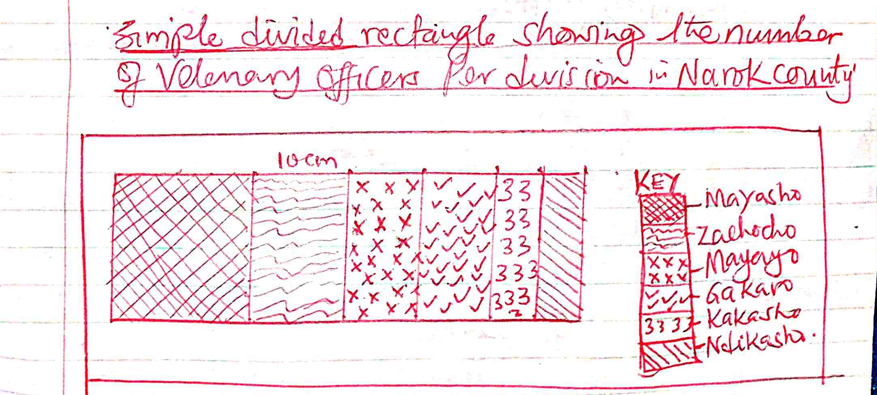

b. i. Give the four main Beef cattle breeds kept in Kenya. (4mks)
- Aberdean Angus
- Red Angus
- Hereford
- Short horn
- Gallaway
- Charollais

ii. State three physical factors encouraging beef farming. (3mks)
- Presence of extensive gentle sloping land with rich grass.
- Moderate rainfall to ensure growth of grass.
- Availability of water to feed the annual throughout the year.

c. Outline six effort taken by Kenya government its support beef cattle farming. (6mks)
- Revival of Kenya meet commission which buys animals from farmers.
- Sunk boreholes, wells and dams to ensure constant supply of water.
- Encourage farmers to grow nutritional pastures.
- Encourage research into cross breeding.
- Organize agricultural shows to demand rates.
- Below is a sketch map of the RMhr Industrial Region. Use it to answer questions. (i) (a)

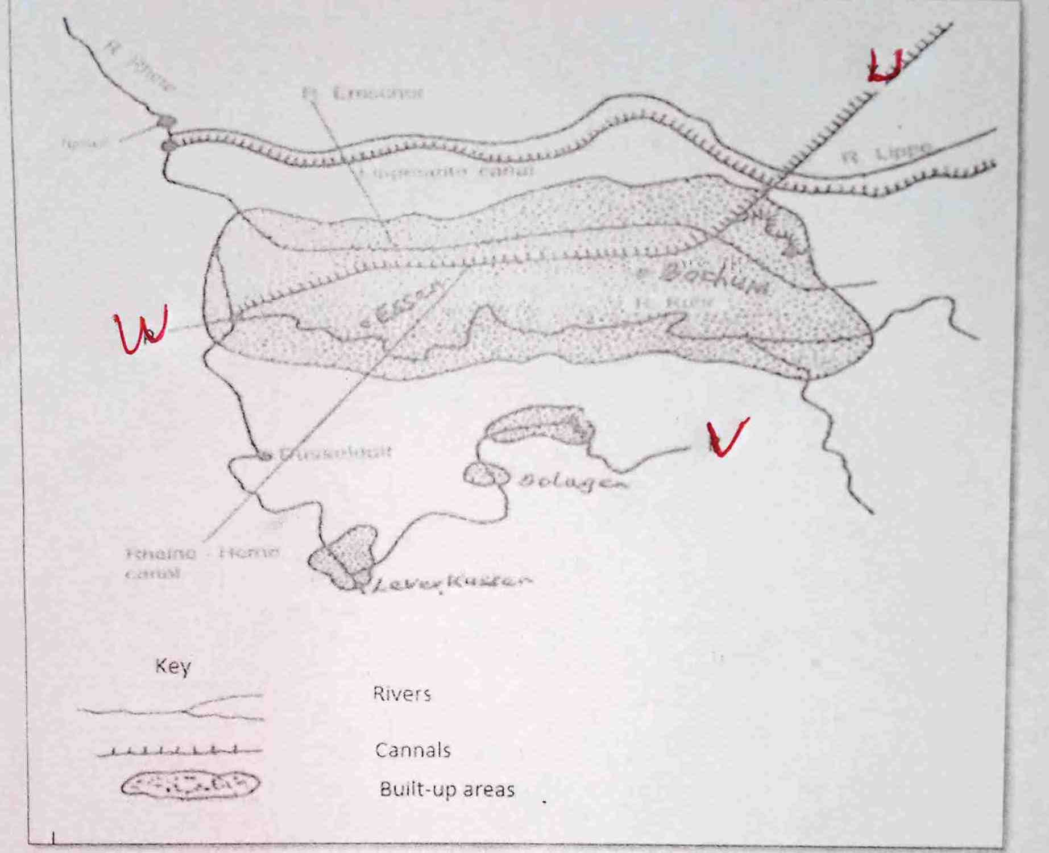

- a. Name the canal marked U. (1mk)
- Dortmound
- Name river marked V. (1mk)
- Wupper
- Name the town marked W. (1mk)
- Duisburg
b. i. What is Industrialization? (2mks)
- Is the process and the pace at which a country or community set to establish industries.
ii. Name the towns in Kenya where each of the following industries are located.
Oil refining. (1mk)
- Mombasa
Paper manufacturing (1mk)
- Webuye
Motor vehicle assembly. (1mk)
- Thika
c. i. Explain three factors which influenced the location in iron and steel industry in the rural region in Germany. (6mks)
- Availability of coal/limestone/iron ore which are the main raw material from river rhine valley needed in the industry.
- Availability of water from River Rhine and its tributance for the colloing of the machine in industries.
- Presence of navigable rivers and cannels providing cheap transport for bulky raw materials.
- A large population having acquired skills in iron working provided local labour.
- Dense population in central and western Europe and German provided ready market for products.

ii. Explain three factors which have favoured the development of car manufacturing industry in Japan. (6mks)
- Advanced/high skilled labour increasing efficiency for mass production of quality cars.
- Highly developed energy sources providing power to run manufactures in car manufacturing.
- Large external market encouraging more production of cars.
- Availability of large capital to expand car manufacturing industries.
- High population providing a large local market for manufactured
car.
d. You intend to carry out a field study of furniture making in the local (i)state three reasons why it would be necessary for you to visit the area of study in advance. (3mks)
- To be used to proper a route map.
- To determine the suitability of the area for the study.
- To be able to formulate appropriate objective for the study.
- To seek permission for the visit.

ii. For your field study you have prepared a working schedule. State three items you would include in the schedule. (3mks)
- Time for departure
- Time to spend for study
- Time for lunch
- Time to end the study.

- Define the term Eco-tourism. (2mks)
- It is a concepts that combines the promotion of tourism activities and conservation of the eco-system and culture of the host communication..

b. (i) Explain five reasons why Domestic tourism should be encouraged in Kenya. (10mks)
- It allows culture and social interaction among Kenyans thus bringing understanding and exchange of value.
- It earns government revenue which is used to improve other section of economy.
- It leads to conservation and wildlife for future generation.
- It encourages Kenyans to learn more about their country and appreciate the aesthelic value.
- It exposes many Kenyans to a wider variety of recreational activities thus reducing their involvement in negative activities such as crime.
- It encourages the use of accommodation facilities during low tourist seasons this ensures that hotel owners earn some income.

ii. State three problems facing tourism in Kenya. (3mks)
- Inadequate capital to provide adequate facilities.
- Inefficient transport facilities
- Inadequate accommodation facilities
- Terrorist attack which scare away tourist
- Death of aquatic plants and animal by water pollution.
c. Explain how the following factors influence tourism in Switzerland.
i. Climate (2mks)
- Switzerland experience summer, winter spring and autum which offersavariety of tourist.
- There is also sun bathing swimming and sport.
ii. Geographical location (2mks)
- Switzerland is centrally located in Europe hence easily accessible from neighbouring countries.
- The country is well linked with other countries by air, road and railway.
iii. Linguistic and plurality. (2mks)
- Swiss speaks four main language which include French, German,Italian and Rornanism.
- Major several language in Europe is spoken making it easy for tourist to get excellent services in the country.
d. Explain two reasons why Switzerland receive more tourists than Kenya. (4mks)
- Switzerland is centrally located in Europe which makes it easily accessible to tourist.
- Some tourist attraction are found in both Kenya hence tourist in Europe prefer visiting Switzerland which is nearer.
- Switzerland has efficient well developed transport and communication networkwhich provide easy access to the tourist site.
- a (i) Define balance of payment. (2mks)
- It is the difference in value between export of both visible and invisible trade and value of both visible and invisible imports.
ii. Identify three major exports from Kenya to European countries. (3mks)
- Vegetable
- Fruit
- Flowers
- Coffee
- Tea
- Soda ash
- Flouspar
b. Outline reasons why trade between Kenya and other African countries is not well developed. (4mks)
- Most of the African countries Produce similar goods/commodities.
- Africa has poorly developed transport network
- African countries largely import manufactured goods.
- Lack of common language.
c. Explain four reasons why a country should impose trade barriers. (8mks)
- To protect the local infant individuals against unfair compositions from other developed countries.
- To help raise revenue to the government from taxes levied or imports.
- Encourage growth of import substitution industries.
- Restrict flow of foreign exchange.
- Ensure that internally produced goods do not fluctuate in prices due to the floods of the market with cheap imports.
d. You intend to carry out field study in Nakuru Top Market.
i. Formulate the work schedule that you can use for the study. (4mks)
Time | Activities
8.00am – 8.40am | Depart school to Nakuru market
8.40am – 8.45am | Arrive at area of study
8.45am – 9.00am | Report to relevant authorities.
9.00am – 1.00pm | Embark of data collection
1.00pm-2.00pm | Regroup for lunch
2.00pm – 3.00pm | Depart back to school

ii. State the follow up activities you are likely to undertake after the study. (4mks)
- Displaying photographs
- Groups present their findings.
- Calculation of percentage mean, medium
- Discuss finding from the field.
- Display samples
- List three electric devices garget that relay through sound and pictures through the satellites. (3mks)
- Electric device
- Fax machine
- Radio
- Mobile phone
- Computers
- Films
- Televisions
- Internet
b. Explain two advantages of using the mobile phones. (4mks)
- Are potable thus convenience to the user.
- One can access to many activities on advance mobile phone at higher convenience e.g. paying of bills, money transfer, withdrawing of cash from ATM,mpesa news update.
c. Outline four problems facing the mobile users. (4mks)
- It has increased anti-social behavior.
- It is costly because of airtime
- It produces harmful radiation that pose health risks.
- Many cases of mobile phone theft.
d. (i) List three trans-continental roads in Africa. (3mks)
- The Trans-sahara highway
- The Great North road
- Trans Africa highway
ii. Explain three advantages of using road transport over railway transport. (6mks)
- They are fast means of transport compared to rail way.
- They are flexible reach many places
- They are cheaper construct compared to railway.
- They need fewer skills to construct
e. Describe factors which have led to the fast growth of Rotterdam as a major seaport in Europe. (5mks)
- The sea is ice free throughout the year.
- It is located at the mouth point of river thus facilitating deep harbor.
- Availability of large oil refinery.
- Have rich hinterland with minerals and industries
- It is on strategic position in Western Europe making the busy point as a gateway to Europe.

