312/2
GEOGRAPHY
PAPER 2
2020/2021
TIME: 2¾ HOURS

PAVEMENT FORM 4 TRIAL 2 EXAMINATION 2021/2022
Kenya certificate of secondary education (K.C.S.E)

GEOGRAPHY
PAPER 2
TIME: 2¾ HOURS

INSTRUCTIONS TO CANDIDATES:

- This paper consists of two sections A and B.
- Answer ALL questions in Section A.
- In section B answer question 6 (compulsory) and any other two questions.
- All answers must be written in the answer booklet provided.

SECTION A (25 MARKS)
Answer all questions in this section in the answer booklet provided
- a) List two types of minerals (2marks)
(b) State three conditions that are necessary for the formation of a petroleum reservoir (3marks)
- a) Give three physical conditions that favour coffee growing in Kenyan highlands (3marks)
(b) Give two economic problems experienced in coffee growing in Kenya. (2marks)
- (a) State three characteristics of Jua –Kali industries in Kenya. (3marks)
(b) State three factors that led to the growth of Iron and Steel industry in the Ruhr Region of Germany
(3marks)
- a) What is Bilateral trade? (2marks
(b) State two factors that hinder trade among members of East African Community (2marks)
- a) Name two main reclamation projects in the Netherlands. (2marks)
(b)State three reasons for reclaiming swamps in Kenya. (3marks)
SECTION B (75MARKS)
Answer question 6 and any other two questions in the answer booklet provided
- The photograph below shows livestock rearing in Kenya. Use it to answer the questions that follow.
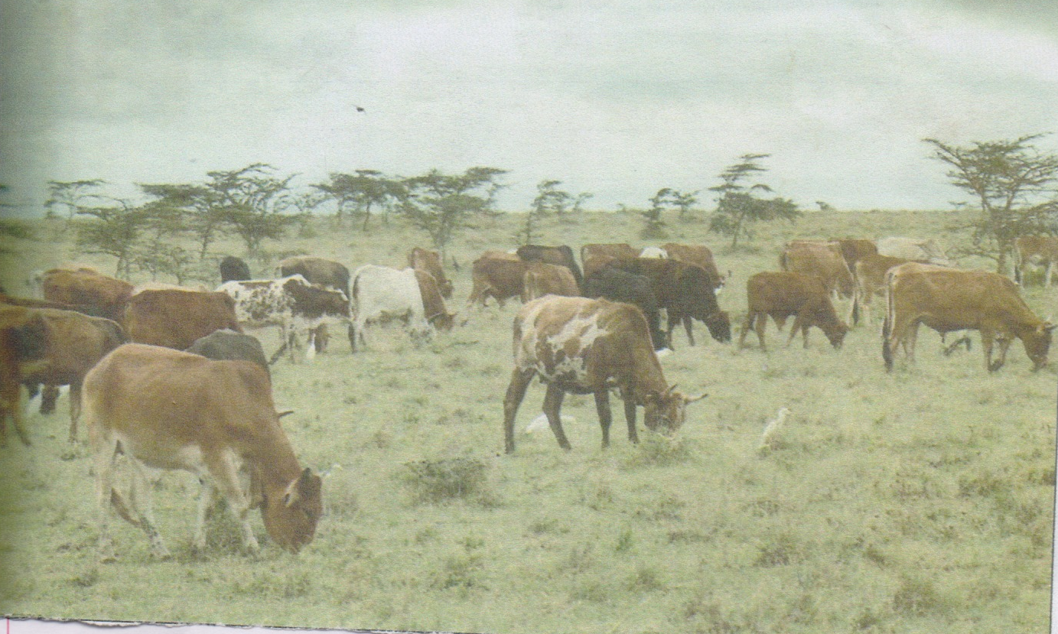
- i) Identify the type of photograph. (1mark)
ii) Describe the features shown in the photograph (4marks)
- i) Draw a rectangle measuring 14cm by 10cm to represent the area covered by the photograph
(1mark)
ii) On the rectangle, sketch and label four features shown on the photograph (5marks)
iii) Using evidence from the photograph, show two indicators which show that the area is dry
(2marks)
- i) Name two areas in Kenya where the photograph could have been taken (2marks)
ii) Explain how the following factors would improve livestock rearing in Kenya:
- Ranching schemes (2marks)
- Cross breeding (2marks)
- Destocking the animals (2marks)
- State four physical problems facing livestock farmers in Kenya (4marks)
- (a). (i) Name two provinces in Canada where wheat is grown on a large scale. (2marks)
(ii) State three physical conditions that favour wheat farming in Canada. (3marks)
(b) (i) Compare wheat farming in Kenya and Canada under the following sub-headings
- Research (2marks)
- government policy (2marks)
- transport (2marks)
c) Explain four problems that affect wheat farming in Canada. (8marks) (d) Your geography class intends to carry out a field study on wheat harvesting in a farm
(i) State two reasons for preparing a working schedule (2marks)
(ii) Outline two problems that face wheat harvesting you are likely to find out. (2marks) (iii) Suppose during the field study you used the interview method to collect data. State two limitations of the method. (2marks)
- a) i) Identify four types of fishing (4marks)
ii) Apart from drifting, name three other modern methods of fishing. (3marks)
b) Describe how drifting method of fishing is carried out. (6marks)
c) Explain four factors favoring fishing in the North East Atlantic fishing ground. (8marks)
d) Give four reasons why fish farming is encouraged in Kenya (4marks)
- (a)(i) List three Jua Kali Industries which are located in rural areas of Kenya. (3marks)
  - Suggest three ways in which the Kenya government can promote the development of the Jua Kali Industries. (3 marks)
(b)Explain three problems arising from industrialization. (6 marks)
(c) Explain four factors which influenced the location of iron and steel industry in the Ruhr region of Germany in the 19th century. (8 marks)
(d) Students of a school in Mombasa County went for a field study at the oil refinery in Mombasa.
(i) List two methods that they used to record data. (2 marks)
(ii) Give three problems that they might have faced during the study. (3 marks)
- (a) (i) Distinguish between management and Conservation of Environment. (2marks)
(ii) Apart from flooding, give two other forms of environmental hazards experienced in Kenya. (2marks)
(b) (i) Identify three districts that are prone to frequent flooding. (3marks)
(ii) Explain four measures that are taken to control flooding in Kenya. (8marks)
(iii) State four problems resulting from flooding. (4marks)
(c) Explain three reasons why it is necessary to manage and conserve the environment. (6marks)

