312/2
GEOPGRAPHY
Paper 1
NOV/DEC
Index Time: 2³/₄ Hours

NAME---------------------------------------Index No--------------------------------------
DATE-------------------------------signature---------------------------

GEOGRAPHY PAPER 312/1
EXAMINATION – 2021.
END OF TERM II NOV- DEC.
FORM IV
Kenya Certificate of Secondary Education (K.C.S.E)

INSTRUCTIONS TO CANDIDATES
- This paper contains sections A and B.
- Answer all questions in Section A.
- In section B, answer questions 6 and any other two.
- All answers must be written in the spaces in the question paper.

SECTION A
Answer all questions in this section (25 marks)
1) The diagram below represents structure of the earth.
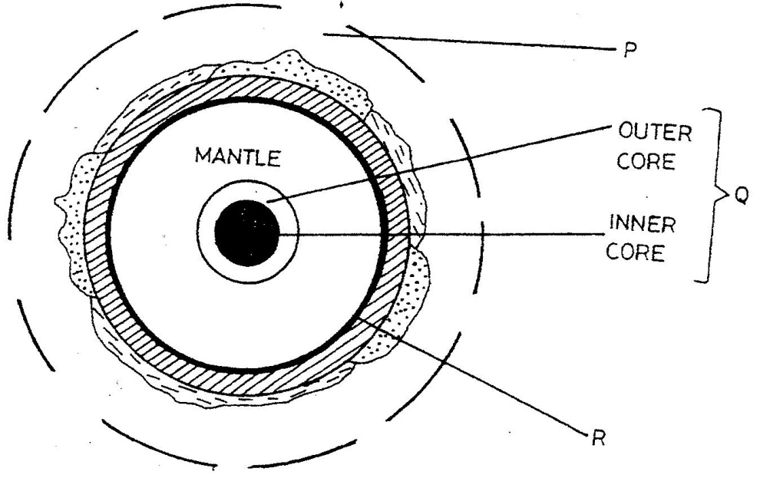
a) Use it to answer questions that follow.

H
E

F

i) Name the boundaries marked E and F. (2 marks)
E----------------------------------------------------------F------------------------------------------------
ii) Identify two minerals that make up the layer marked H. (2 marks)
------------------------------------------------------------------------------------------------------------------------------------------------------------------------------------------------------------------------------------------------------------------------------------
b) Give two effects of the rotation of the earth on its axis. (2 marks)
-----------------------------------------------------------------------------------------------------------------------------------------------------------------------------------------------------------------------------------------------------------------------------------
2)a) Define the term magmatic water (2 marks)
-----------------------------------------------------------------------------------------------------------------------------------------------------------------------------------------------------------------------------------------------------------------------------------

b) List three surface features on Karst landscape (3 marks)
----------------------------------------------------------------------------------------------------------------------------------------------------------------------------------------------------------------------------------------------------------------------------------------------------------------------------------------------------------------------------------------------------------------------------------------------------------------------------------------------------------------------------------------------------------------------
3).a) Define the term vegetation (2 marks)
-----------------------------------------------------------------------------------------------------------------------------------------------------------------------------------------------------------------------------------------------------------------------------------
b) Explain how the following factors influence the distribution of vegetation
i) Relief (2 marks)
-----------------------------------------------------------------------------------------------------------------------------------------------------------------------------------------------------------------------------------------------------------------------------------
ii) Soils (2 marks)
-----------------------------------------------------------------------------------------------------------------------------------------------------------------------------------------------------------------------------------------------------------------------------------
4) State four indicator of occurrence of sol creep in an area (4 marks)
-----------------------------------------------------------------------------------------------------------------------------------------------------------------------------------------------------------------------------------------------------------------------------------------------------------------------------------------------------------------------------------------------------------------------------------------------------------------------------------------------------------------------------------------------------------------------------------------------------------------------------------------------------------------------------------------------------------------------------------------------------------------------------------------------------------------------------------------------------------
5) a) Name two types of submerged highland coasts (2 marks)
-----------------------------------------------------------------------------------------------------------------------------------------------------------------------------------------------------------------------------------------------------------------------------------

b) Identify two resultant features of the emerged highland coasts (2 marks).
-----------------------------------------------------------------------------------------------------------------------------------------------------------------------------------------------------------------------------------------------------------------------------------
Section B. Answer question 6 and any other two. 75 marks
Q.6 Study the map of Kijabe provided to answer the questions that follow.
(a) (i). Identify the tittle of the map provided. (1 mark).
-----------------------------------------------------------------------------------------------------------------------------------
(ii). Give the latitudinal extent of the map given. (2marks)
----------------------------------------------------------------------------------------------------------------------------------
(ii). Identify any two methods used to represent relief in the map provided. (2 marks)
------------------------------------------------------------------------------------------------------------------------------------------------------------------------------------------------------------------------------------------------------------------------------------------------------------------------------------------------------------------------------------------------------------------------------(ii). Identify the feature in grid reference 402003. ( 1 mark)
-----------------------------------------------------------------------------------------------------
b)(i). Determine the length of all-weather road bound surface from grid reference 2589 to the junction at petrol station in kilometers. (2 marks)
---------------------------------------------------------------------------------------------------------------------------
(ii). Identify three natural vegetation in the area covered by the map. (3marks)
-----------------------------------------------------------------------------------------------------------------------------------------------------------------------------------------------------------------------------------------------------------------------------------------------------------------------------------------------------------------------------------------------------------------------------
(ii). Describe the drainage of the area covered by the map. ( 6 marks)
----------------------------------------------------------------------------------------------------------------------------------------------------------------------------------------------------------------------------------------------------------------------------------------------------------------------------------------------------------------------------------------------------------------------------------------------------------------------------------------------------------------------------------------------------------------------------------------------------------------------------------------------------------------------------------------------------------------------------------------------------------------------------------------------------------------------------------------------------------
(c )(i). Explain three social activities found in the area covered by the map. (6 marks)
------------------------------------------------------------------------------------------------------------------------------------------------------------------------------------------------------------------------------------------------------------------------------------------------------------------------------------------------------------------------------------------------------------------------------------------------------------------------------------------------------------------------------------------------------------------------------------------------------------------------------------------------------------------------------------------------------------------------------------------------------------------------------------------------------------------------------------------------------------------------------------------------------------------------------------------------------------------------------------------------------------------------------------------------------------------------------------------------------------------------------------------------
(ii). Give two proofs that suggests lumbering is taking place in the area covered by the map. ( 2 marks)
------------------------------------------------------------------------------------------------------------------------------------------------------------------------------------------------------------------------------------------------------------------------------------
7. a) i) Give three reasons why weather forecasting is important (3 marks)
------------------------------------------------------------------------------------------------------------------------------------------------------------------------------------------------------------------------------------------------------------------------------------------------------------------------------------------------------------------------------------------------------------------------------
ii) State three conditions that lead to fog formation. (3 marks)
------------------------------------------------------------------------------------------------------------------------------------------------------------------------------------------------------------------------------------------------------------------------------------------------------------------------------------------------------------------------------------------------------------------------------
b) Explain how the following factors influence climate.
i) Aspect ( 2 marks)
------------------------------------------------------------------------------------------------------------------------------------------------------------------------------------------------------------------------------------------------------------------------------------------------------------------------------------------------------------------------------------------------------------------------------
ii) Altitude ( 2 marks)
------------------------------------------------------------------------------------------------------------------------------------------------------------------------------------------------------------------------------------------------------------------------------------------------------------------------------------------------------------------------------------------------------------------------------
iii) Distance from the sea. (2 marks)
------------------------------------------------------------------------------------------------------------------------------------------------------------------------------------------------------------------------------------------------------------------------------------------------------------------------------------------------------------------------------------------------------------------------------
c) Using a well labeled diagram, describe the formation of orographic rainfall. (6 marks)
------------------------------------------------------------------------------------------------------------------------------------------------------------------------------------------------------------------------------------------------------------------------------------------------------------------------------------------------------------------------------------------------------------------------------------------------------------------------------------------------------------------------------------------------------------------------------------------------------------------------------------------------------------------------------------------------------------------------------------------------------------------------------------------------------------------------------------------------------------------------------------------------------------------------------------------------------------------------------------------------------------------------------------------------------------------------------------------------------------------------------------------------------------------------------------------------------------------------------------------------------------------------------------------
d) i) State two advantages of studying weather through fieldwork. (2 marks).
------------------------------------------------------------------------------------------------------------------------------------------------------------------------------------------------------------------------------------------------------------------------------------------------------------------------------------------------------------------------------------------------------------------------------
Students from Turuturu Secondary conducted a field study on weather in a weather station. ii) Formulate a suitable hypothesis they could have used for the study. (2 marks)
------------------------------------------------------------------------------------------------------------------------------------------------------------------------------------------------------------------------------------------------------------------------------------------------------------------------------------------------------------------------------------------------------------------------------

iii) State three follow-up activities they would carry out after the study. (3 marks)
------------------------------------------------------------------------------------------------------------------------------------------------------------------------------------------------------------------------------------------------------------------------------------------------------------------------------------------------------------------------------------------------------------------------------

8 a) Identify three ways in which ice moves. (3marks)
-----------------------------------------------------------------------------------------------------------------------------------------------------------------------------------------------------------------------------------------------------------------------------------------------------------------------------------------------------------------------------------------------------------------------------
b) Describe plucking as a process in glacial erosion. (4marks)
-----------------------------------------------------------------------------------------------------------------------------------------------------------------------------------------------------------------------------------------------------------------------------------------------------------------------------------------------------------------------------------------------------------------------------------------------------------------------------------------------------------------------------------------------------------------------------------------------------------------------------------------------------------------------------------------------------------------------------------------------------------------------------------------------------------------------------------------------------------------------------------------------------------------------------------------------------------------------------------------------------
c) i) Using a well labeled diagram, describe the formation of a pyramidal peak. (6marks)
----------------------------------------------------------------------------------------------------------------------------------------------------------------------------------------------------------------------------------------------------------------------------------------------------------------------------------------------------------------------------------------------------------------------------------------------------------------------------------------------------------------------------------------------------------------------------------------------------------------------------------------------------------------------------------------------------------------------------------------------------------------------------------------------------------------------------------------------------------------------------------------------------------------------------------------------------------------------------------------------------------------------------------------------------------------------------------------------------------------------------------------------------------------------------------------------------------------------------------------------------------------------------------------------------------------------------------------------------------------------------------------------------------------------------------------------------------------------------------------------------------------------------------------------------------------------------------------------------------------------------------------------------------------------------------------------------------------------------------------------------------------------------------------------------------------------------------------------------------------------------------------------------------------------------------------------------------------------------------------------------------
ii) Explain three factors that lead to glacial deposition. (6marks)
----------------------------------------------------------------------------------------------------------------------------------------------------------------------------------------------------------------------------------------------------------------------------------------------------------------------------------------------------------------------------------------------------------------------------------------------------------------------------------------------------------------------------------------------------------------------------------------------------------------------------------------------------------------------------------------------------------------------------------------------------------------------------------------------------------------------------------------------------------------------------------------------------------------------------------------------------------------------------------------------------------------------------------------------------------------------------------------------------------------------------------------------------------------------------------------------------------------------------------------------------------------------------------------------------------------------------------------------------------------------------------------------------------------------------------------------------------------------------------------------------------------------------------------------------------------------------------------------------------------------------------------------------------------------------------------------------------------------------------------------------------------------------------------------------------------------------------------------------------------------------------------------------------------------------------------------------------------------------------------------------------
d) You are required to carry out a field study on erosional features in glaciated lowland area
i) Give three reasons why you would require a working schedule (3marks)
------------------------------------------------------------------------------------------------------------------------------------------------------------------------------------------------------------------------------------------------------------------------------------------------------------------------------------------------------------------------------------------------------------------------------------------------------------------------------------------------------------------------------------------------------------------------------------------------------------------------------------------------------------------------------------------------------------------ ii) Give three erosional features in the lowland areas they would have identified. (3marks
------------------------------------------------------------------------------------------------------------------------------------------------------------------------------------------------------------------------------------------------------------------------------------------------------------------------------------------------------------------------------------------------------------------------------------------------------------------------------------------------------------------------------------------------------------------------9.a)i) A part from the Rift Valley name two other relief features that are formed as result of faulting. (2marks)
-------------------------------------------------------------------------------------------------------------------------------------------------------------------------------------------------------------------------------------------------------------------------------------------------------------------------------------------------------------------------------------------------------------------------
ii) With the aid of a well labeled diagram, describe how a Rift Valley is formed by tensional forces. (8marks)
-----------------------------------------------------------------------------------------------------------------------------------------------------------------------------------------------------------------------------------------------------------------------------------------------------------------------------------------------------------------------------------------------------------------------------------------------------------------------------------------------------------------------------------------------------------------------------------------------------------------------------------------------------------------------------------------------------------------------------------------------------------------------------------------------------------------------------------------------------------------------------------------------------------------------------------------------------------------------------------------------------------------------------------------------------------------------------------------------------------------------------------------------------------------------------------------------------------------------------------------------------------------------------------------------------------------------------------------------------------------------------------------------------------------------------------------------------------------------------------------------------------------------------------------------------------------------------------------------------------------------------------------------------------------------------------------------------------------------------------------------------------------------------------------------------------------------------------------------------------------------------------------------------------------------------------------------------------------------------------------------------------------------------------------------------------------------------------------------------------------------------------------------------

b) Explain four effects of faulting (8marks)
------------------------------------------------------------------------------------------------------------------------------------------------------------------------------------------------------------------------------------------------------------------------------------------------------------------------------------------------------------------------------------------------------------------------------------------------------------------------------------------------------------------------------------------------------------------------------------------------------------------------------------------------------------------------------------------------------------------------------------------------------------------------------------------------------------------------------------------------------------------------------------------------------------------------------------------------------------------------------------------------------------------------------------------------------------------------------------------------------------------------------------------------------------------------------------------------------------------------------------------------------------------------------------------------------------------------------------------------------------------------------------------------------------------------------------------------------------------------------------------------------------------------------------------------------------------------------------------------------------------------------------------------------------------------------------------------------------------------------------------------------------------------------------------------------------------------------------------------------------------------------------------------------------------------------------------------------------------------------------------------------------------------------------------------------------------------------------------------------------------------------------------------------
c) Students are planning to carry out a field study of an area affected by faulting
i)State four reasons why it is important for the students to have a pre-visit of the area. (4marks)
-----------------------------------------------------------------------------------------------------------------------------------------------------------------------------------------------------------------------------------------------------------------------------------------------------------------------------------------------------------------------------------------------------------------------------------------------------------------------------------------------------------------------------------------------------------------------------------------------------------------------------------------------------------------------------------------------------------------------------------------------------------------------------------------------------------------------------------------------------------------------------------------------------------------------------------------------------------------------------------------------------------------------------------------------------------------------------------------------------------------------------------------------------------------------------------------------------------------------------------------------------------------------------------------
ii)One of the ways they would use to collect data is through direct observation. Give three disadvantages of direct observation in the study of such an area. (3marks)
------------------------------------------------------------------------------------------------------------------------------------------------------------------------------------------------------------------------------------------------------------------------------------------------------------------------------------------------------------------------------------------------------------------------------------------------------------------------------------------------------------------------------------------------------------------------------------------------------------------------------------------------------------------------------------------------------------------

10. a) (i) Name three major deserts found in Africa (3 marks)
------------------------------------------------------------------------------------------------------------------------------------------------------------------------------------------------------------------------------------------------------------------------------------------------------------------------------------------------------------------------------------------------------------------------------
(ii) Give two processes in which wind erodes the earth’s surface. (2 marks)
-----------------------------------------------------------------------------------------------------------------------------------------------------------------------------------------------------------------------------------------------------------------------------------------------------------------------------------------------------------------------------------------------------------------------------
(iii) Explain three ways in which wind transports its load. (6 marks).
-----------------------------------------------------------------------------------------------------------------------------------------------------------------------------------------------------------------------------------------------------------------------------------------------------------------------------------------------------------------------------------------------------------------------------------------------------------------------------------------------------------------------------------------------------------------------------------------------------------------------------------------------------------------------------------------------------------------------------------------------------------------------------------------------------------------------------------------------------------------------------------------------------------------------------------------------------------------------------------------------------------------------------------------------------------------------------------------------------------------------------------------------------------------------------------------------------------------------------------------------------------------------------------------------------------------------------------------------------------------------------------------------------------------------------------------------------------------------------------------------------------------------------------------------------------------------------------------------------------------------------------------------------------------------------------------------------------------------
b) Using well labeled diagrams, explain how the following desert features are formed;
(i) Yardangs. (5 marks)
------------------------------------------------------------------------------------------------------------------------------------------------------------------------------------------------------------------------------------------------------------------------------------------------------------------------------------------------------------------------------------------------------------------------------------------------------------------------------------------------------------------------------------------------------------------------------------------------------------------------------------------------------------------------------------------------------------------------------------------------------------------------------------------------------------------------------------------------------------------------------------------------------------------------------------------------------------------------------------------------------
(ii) Mushroom blocks. (6 marks)
------------------------------------------------------------------------------------------------------------------------------------------------------------------------------------------------------------------------------------------------------------------------------------------------------------------------------------------------------------------------------------------------------------------------------------------------------------------------------------------------------------------------------------------------------------------------------------------------------------------------------------------------------------------------------------------------------------------------------------------------------------------------------------------------------------------------------------------------------------------------------------------------------------------------------------------------------------------------------------------------------------------------------------------------------------------------------------------------------------------------------------------------------------------------------------------------------------------------------------------------------------------------------------------------------------------------------------------------------------------------------------------------------------------------------------------------------------------------------------------------------------------------------------------------------------------------------
c) The diagram below represents features resulting from wind deposition in a desert
Use it to answer questions that follow.
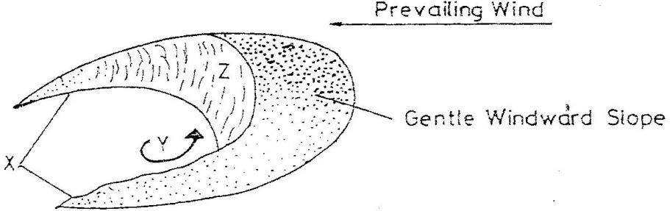

(i) Name the above feature (1 mark)
--------------------------------------------------------------------------------------------------------
(ii) Name parts marked X and Y
X------------------------------------
Y------------------------------------- (2 marks)

@ 2021 Nov/Dec. This is the last printed page.

