END OF TERM 3 EXAMINATIONS 2022
FORM THREE GEOGRAPHY
312/1 (GEOGRAPHY PAPER 1) TIME: 2 HOURS 45 MINUTES

NAME:………………………………………………………….CLASS:…….ADM NO:…….

INSTRUCTIONS TO CANDIDATES
- This paper has two sections: A and B
- Answer ALL the questions in section A.
- In section B, answer questions 6 and any other TWO questions.
- All the answers must be written in English on the foolscaps provided.

SECTION A
(Answer all the questions from this section)
1. (a) Define the term mineral. (2 marks)

(b) Give three examples of metamorphic rocks. (3 marks)

2. (a) Differentiate between rotation and revolution of the earth. (2 marks)

(b) State three reasons why the interior of the earth is very hot. (3 marks)

3. (a) Name two areas in Kenya where heath and moorland vegetation is found.(2 marks)
(b) State three characteristics of mangrove forests. (3 marks)
4. The diagram below shows a vertical section through the zones of underground water.

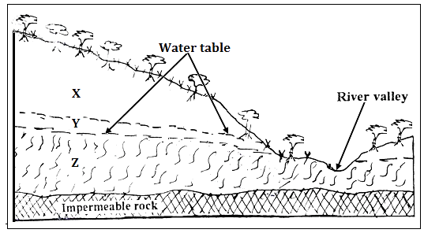

(a) Name the zones marked X, Y and Z (3 marks)

(b) State three ideal conditions necessary for the formation of an artesian well. (3 marks)

5. Outline four ways through which lakes in Kenya were formed. (4 marks)

SECTION B
(Answer question 6 and any other two questions from this section)
6. Study the map of Yimbo provided and use it to answer questions that follow.
(a) (i) Give two methods used to present relief on the map extract. (2 mark)
(ii) What is the latitudinal extent of the area covered by the map? (2mark)
(iii) Determine the six figure grid reference of a waterhole North of Port Southby. (2 marks)
(b) (i) Identify four types of natural vegetation in the area covered by the map. (4 marks)
(ii) Citing evidence from the map, give two social services offered in the area covered by the map. (4 marks)
(iii) Describe the relief of the area covered by the map (5 marks
(c) Draw a square 10 cm by 10 cm to represent the region west of easting 21 and North of Northing 90. On the square, mark and name:
- Lake Sare
-A thicket
-Busia District
-All weather road loose surface. (6 marks)
7. (a) (i) Differentiate between weather and weather forecasting. (2 marks)
(ii) Give three examples of low clouds. (3 marks)
(b) Explain how the following factors affect the temperature of a place:
(i) Cloud cover. (3 marks)
(ii) Aspect. (3 marks)
(c) With the aid of a well labelled diagram, describe how convectional rainfall is formed. (8 marks)
(d) Suppose you were to carry out a field study at a weather station:
(i) State three objectives that you would set for the study. (3 marks)
(ii) Give three follow up activities for the field study. (3 marks)
8. The diagram below represents types of faults and some fault features.
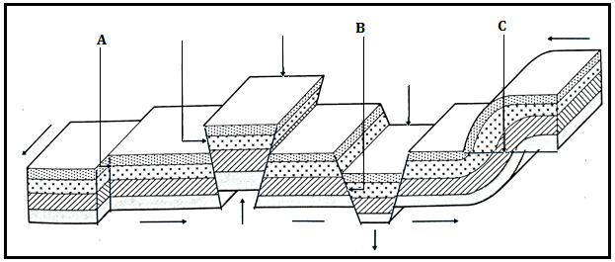
(a) Name the type of faults marked A, B and C. (3 marks)
(b) Explain how Isostatic adjustment causes earth movements (3 marks)

(c) (i) Apart from rift valleys and fault blocks, list three other features formed due to faulting. (3 marks)

(ii) Using well labelled diagrams, describe how a rift valley is formed due to compression forces. (8 marks)

(d) Explain four ways through which features resulting from faulting affects human activities. (8 marks)

9. (a) Define the term desertification. (2marks)

(b) Explain three ways in which wind transports its load (6marks)

(c) With the aid of a well labeled diagram, describe how yardangs are formed. (7 marks)

(d) A group of form four students went out for a field study on action of water in an arid area.
(i) Name three erosional features that they are likely to have observed. (3 marks)
(ii) State three problems they have encountered during the field study. (3marks)
(iii) What activities would they recommend to the residents in the area as an effort to control desertification? (4 marks)
10. (a) List three types of glacier. (3marks)
(b) Explain how glacier erodes through the following processes.
(i) Plucking (3 marks)
(ii) Abrasion (3 marks)
(c) The diagram below shows some features formed due to glacial deposition in lowlands.
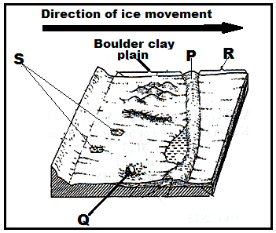
(i) Name the parts marked P, Q, R and S. (4marks)
(ii) Describe how a glacial trough is formed. (6marks)
(d) Explain three negative effects of glaciated landscapes. (6 marks)

