FORM FOUR. 312/1 GEOGRAPHY Paper 1
End of term 1, 2022
Marking scheme.

SECTION A
1. The diagram below shows a type of an eclipse.
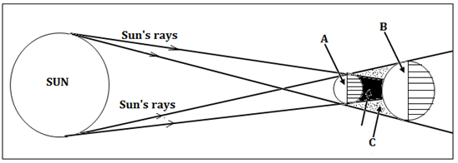
(a) Name the parts marked A, B, and C. (3 marks)
- A – The moon
- B – Earth
- C – Penumbra
(b) Apart from the occurrence of eclipses, state three other effects of the movement of the earth round the sun. (3 marks)
- Varying lengths of day and night at different time of the year.
- Occurrence of the four seasons in mid and higher latitudes.
- Changes in the position of the midday sun at different times of the year.

2. (a) What are metamorphic rocks? (2 marks)
These are rocks formed when original igneous or sedimentary rocks have been altered by intense heat, pressure or both.
(b) Give two examples of organically formed sedimentary rocks. (2 marks)

- Limestone,
- Chalk
- Coral reefs
- Coal
- Diatomite
- Iron stone

3. (a) List three landmasses that formed from Gondwanaland according to continental drift theory. (3 marks)

- Africa
- Arabia
- India
- South America
- Australia
- Antarctica

(b) Give two types of tectonic plate boundaries. (2 marks)
- Extensional plate boundary.
- Compressional plate boundary.
- Transform plate boundary

4. (a) What is an earthquake? (2 marks)
An earthquake is a sudden and rapid movement/vibrations of the earth’s crust
OR
An earthquake refers to the shaking of the ground due to release of energy within the crust.
(b) State three natural causes of earthquakes. (3 marks)
- Movements/collision of tectonic plates.
- Major volcanic eruptions/movements of magma within crustal rocks.
- Isostatic adjustments of the crustal rocks
- Collapsing inwards of rocks due to gravitative pressure.
- Energy release from the mantle.

5. The diagram below shows some features that form ocean relief.
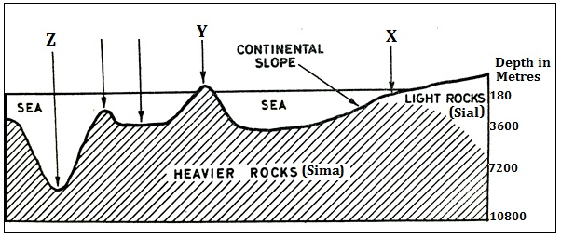
(a) Identify the features marked X, Y and Z. (3 marks)
- X – Continental Shelf
- Y – Oceanic Island
- Z – Ocean trench/ocean deep
(b) List two main forms of horizontal movements of ocean water. (2 marks)
- Waves
- Ocean currents
SECTION B
6. Study the map of Kijabe (1:50,000 sheet 134/3) provided and use it to answer the following questions.
(a) (i) Determine the six figure grid reference of an air photo principal point near the South Western corner of the map. (2 marks)
245903
(ii) Give two types of scale on the map extract (2 marks)
- Linear scale
- Representative ratio scale.
(iii) Give the position of the South Eastern corner of the area covered by the map by latitude and longitude. (2 marks)
(1⁰00’ South, 36⁰45’East) OR
Latitude 1⁰00’ South
Longitude 36⁰45’East

(b) (i) Citing evidence from the map, give three settlement patterns in the area covered by the map. (3 marks)
- Nucleated settlement pattern is evident at Maai Mahiu, Kimende and Kinari
- Linear settlement pattern along main trucks around Bathi and Kenton.
- Dispersed settlement pattern at Kagwe at the South East part.
(ii) Identify two relief features at grid square 3099. (2 marks)
- River valleys
- Spur
(iii) Explain how relief has influenced the distribution of settlements in the area covered by the map. (4 marks)
- Kijabe hill has steep slopes on the western side thus no settlements.
- Eastern slopes of Kijabe hill have few settlements due to gentle slopes.
- The escarpment has no settlements due to steep slopes. At the foot of the escarpment, there are many settlements due to gently sloping land
- Regions within river valleys have very few or no settlements due to ruggedness.
(c) Citing evidence from the map, give five economic activities carried out in the area covered by the map. (5 marks)
- Trade due to the presence of shops, petrol stations
- Livestock rearing due to the presence of a water trough, cattle dips and a dairy.
- Quarrying due to the presence of quarries and murram pits.
- Transport services due to the presence of all-weather roads – bound surface such as A104 and a railway line/Kijabe railway station
- Lumbering due to the presence of forest guard posts, saw mills and a forest station.
- Mining of Carbon (IV) oxide gas due to presence of Kagwe Carbacid plant.
- Tourism due to presence of hot springs and an escarpment.
- Communication due to presence of a post office.
(d) Describe the distribution of natural vegetation in the area covered by the map. (5 marks)
- There is a forest called Wakagwe forest on eastern parts.
- A bamboo forest occurs on near Kinari.
- There is a thicket near Maai Mahiu.
- The central parts of the area have woodland vegetation
- Scrub vegetation covers most of the western parts
- Some scattered trees occur around Kinari.
- A small part of Nyamweru forest occurs to the south of Wakagwe forest.
7. (a) (i) Differentiate between weather and climate. (2 marks)
Weather is the state of the atmosphere of a given place over a short period of time whereas climate refers to the average weather conditions of a place which have been observed over a long period of time such as 30 years.
(ii) Give three types of rainfall. (3 marks)
- Relief/orographic rainfall
- Convectional rainfall
- Frontal rainfall
(b) Explain how the following factors affect the climate of a place:
(i) Cold ocean currents. (4 marks)
- Onshore winds blowing over a cold ocean current are cooled from below. This brings a cooling effect which lowers the temperature of adjacent coastlands.
- Onshore winds blowing over a cold ocean current are cooled prematurely by the cold ocean surface thus loosing/dropping the moisture. Such winds reach the adjacent regions very dry thus very little or no rainfall to adjacent coastlands.
(ii) Inter Tropical Convergence Zone. (2 marks)
- Regions around the equator experience the passage of I.T.C.Z twice a year. This causes high rainfall/double maxima rainfall in some areas when trade winds converge.
- Some places in the Northern hemisphere experience one season of high rainfall when the sun is overhead at the Tropic of Cancer
(c) With the aid of a well labelled diagram, describe how sea breeze occurs. (8 marks)
- Sea breeze occurs during the day.
- The land is heated faster than the sea through insolation.
- Heated warm air over the land rises thus creating low pressure.
- Over the sea, the air is relatively cooler thus develops high pressure.
- As the warm air over the land rises, cool air from the sea blows towards the low pressure zone over the land as sea breeze.
- This brings a cooling effect over the hot land

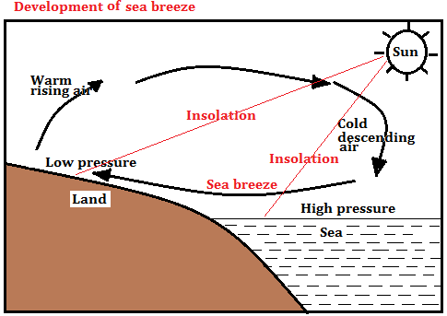
(d) Suppose you were to carry out a field study at a weather station:
(i) Give three methods that they would use to collect data (3 marks)
- Observation
- Interviewing
- Photographing
- Content analysis
(ii) State three follow up activities for the field study. (3 marks)
- Writing a report on data collected.
- Drawing of graphs to present numerical data.
- Analyzing and classifying the data collected
- Displaying processed photographs taken during the study.
- Conducting group discussions based on data collected.
- Giving a lecture to other students.

8. (a) (i) Define the term folding. (2 marks)
Folding is the process through which crustal rocks bend upwards or downwards due to compression force.
Crumpling of young sedimentary rocks due to compressional forces
(ii) Name three types of folds. (3 marks)
- Symmetrical
- Asymmetrical
- Overfold
- Overthrust/Nappe
- Recumbent
- Isoclinal
- Anticlinorium – Synclinorium complex
(b) The world map below shows the distribution of some fold mountains. Use it to answer question (i)
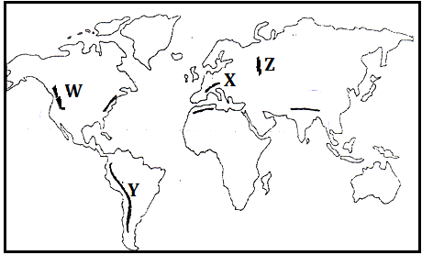
(i) Identify the fold mountains marked W, X, Y and Z (4 marks)
- W – Rockies
- X – Alps
- Y – Andes
- Z - Urals
- With the aid of well labelled diagrams, how Fold Mountains were formed. (10 marks)
- Initially, earth movements led to the formation of an extensive depression called a geosyncline.
- The geosyncline was filled with water to form an extensive ocean.
- The surrounding continental land masses were intensely eroded.
- Sediments were transported by rivers and glacier and deposited into the geosyncline in layers.
- Over many years of deposition, thick layers developed whose weight caused the geosyncline to sink inwards.
- Sinking of the geosyncline triggered compressional forces that drew the surrounding continental land masses towards each other. Compression forces could have also been caused by convection currents in the mantle.
- The intense compressional forces squeezed the layers of sediments bending upwards to form Fold Mountains.
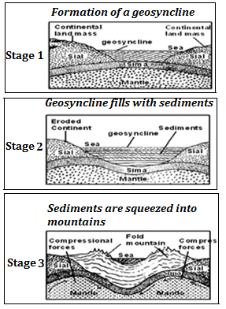
Diagrams – 4 marks
Description – 6 marks
Total - 10 marks

(c) Explain three negative effects of Fold Mountains (6 marks)
- The topography of some fold mountains discourages human settlement and agriculture due to ruggedness.
- Fold mountain ranges act as barriers to easy construction of transport lines/routes such as roads, railways and pipelines thus difficulties in accessing some regions,
- Leeward slopes of most fold mountains receive dry winds leading to arid conditions that hinders crop farming
9. (a) (i) What is a karst scenery? (2 marks)
A karst scenery is a rugged landscape made of limestone, chalk or dolomite rocks that have greatly been acted upon by carbonation to form many features.
(ii) State five characteristics of karst landscapes. (5 marks)
- The rock on the surface and underground is limestone or chalk.
- Absence of surface runoff due to swallow holes.
- Many surface depressions due to solution and carbonation.
- Underground network of caves and caverns with features.
- Scanty vegetation due to thin poor soils.
- The surface is rugged due to several residual hills

(b) Give four sources of ground water. (4 marks)
- Rain water which infiltrates the ground to lower parts.
- Melt water from ice or snow which also infiltrates through rocks.
- Water from rivers, lakes, swamps and ponds which seeps into the ground.
- Magmatic/plutonic water that is trapped deep in rocks during volcanism
(c) Explain how the following factors influence the occurrence of ground water:
(i) Nature of rocks. (2 marks)
The more permeable surface rocks are, the higher the infiltration rate. Impermeable rocks on or near the surface blocks infiltration resulting in high surface runoff.
(ii) Slope of land. (2 marks)
Infiltration is greater on flat areas since water remains in one place over a long period of time while areas with steep slopes have greater surface runoff.
(iii) Vegetation cover. (2 marks)
Where there is plenty of vegetation cover the surface runoff is obstructed. Its speed is showed and most of the water has time to sink into the ground.
Absence of vegetation cover leads to very little infiltration.
(d) Explain four conditions that favour the development of an artesian well. (8 marks)
- The aquifer must lie in between two impermeable rocks so that it can retain water.
- The aquifer must bend downwards from the intake area and form a broad shallow basin/syncline.
- The sides of the aquifer must be exposed in a high rainfall area or lake which is the source of water.
- The mouth of the artesian well must be at a lower level than the intake area to allow water to be forced to the surface under its own pressure.
- The aquifer must be made of the same material to allow water to pass through it.
10. (a) (i) What is glaciation? (2 marks)
Glaciation is the process through which moving ice erodes, transports and deposits materials on the earth’s surface OR
Glaciation refers to past occupation of ice in an area
(ii) Outline four factors which determine the rate at which ice moves. (4 marks)
- Temperature/season.
- The thickness and weight of the ice.
- The width of a glacial cannel
- The gradient of the land.
- The degree of friction with the surface rock
(b) Apart from a cirque, name four other glacial erosional features. (4 marks)

- Arete
- Pyramidal peak.
- Glacial trough
- Hanging valley.
- Fiord/Fjord
- Rock basin.
- Ice eroded plains
- Crag and tail
- Roche Moutonnee
- Depressions
(c) Using well-labelled diagrams, describe how a cirque is formed. (8 marks)
- Initially, a shallow pre-existing hollow/depression occur on a high mountain side.
- Snow accumulated in the shallow depression during the period of glaciation.
- The snow compacted into ice forming a cirque glacier followed by frost action/alternating freeze thaw action
- The shallow depression was eroded through plucking and abrasion
- Abrasion action at the bottom of the glacier deepened the hollow while plucking process widened the hollow
- Plucking action steepened the back wall of the hollow.
- When ice melted, melt water washed out some plucked materials.
Eventually a deep arm chair shaped depression known as a cirque was formed.
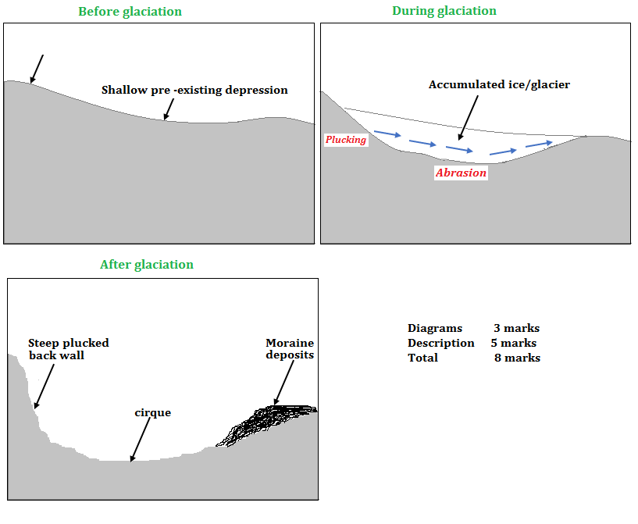
(d) Students of Nanyuki High School carried out a field study on glaciation on Mt. Kenya
(i) Give three reasons why they conducted a reconnaissance. (3 marks)
- In order to prepare a budget for the study.
- To enable them choose suitable methods of data collection and recording.
- To introduce oneself to guides/resource persons
- In order to formulate the objectives / hypotheses for the study
- In order to prepare a route map
- In order to assess the suitability of the area for the study
- In order to identify possible challenges and seek ways to deal with them.
- In order to be able to prepare a good work schedule.
(ii) State two factors they must have considered when selecting the data collection methods. (2 marks)
- The effectiveness of the method
- The method must be cheap to use/ budget – friendly
- One must consider the availability of the respondents and their willingness to co-operate
- One must consider the literacy level of the respondent
(iii) State two challenges they may have faced during the study. (2 marks)
- Rains may lead to muddy routes thus difficulties in walking.
- Some steep slopes may be difficult to climb, hindering data collection
- The low temperatures as one ascends the mountain may cause sickness hindering data collection
- Likelihood of being attached by wild animals as the make their way through dense vegetation.
- Poor visibility of some parts due to sudden fog.

