312/1
GEOGRAPHY
PAPER 1
2020/02021
TIME: 2¾ HOURS

PAVEMENT FORM 4 TRIAL 2 EXAMINATION 2021/2022
Kenya certificate of secondary education (K.C.S.E)

GEOGRAPHY
PAPER 1
TIME: 2¾ HOURS

INSTRUCTIONS TO CANDIDATES:

- This paper consists of two sections A and B.
- Answer ALL questions in Section A.
- In section B answer question 6 (compulsory) and any other two questions.
- All answers must be written in the answer booklet provided.

SECTION A: COMPULSORY
Answer ALL Questions.

- (a) What is dew point? (1mark)
(b) Describe how convectional rainfall is formed (4marks)
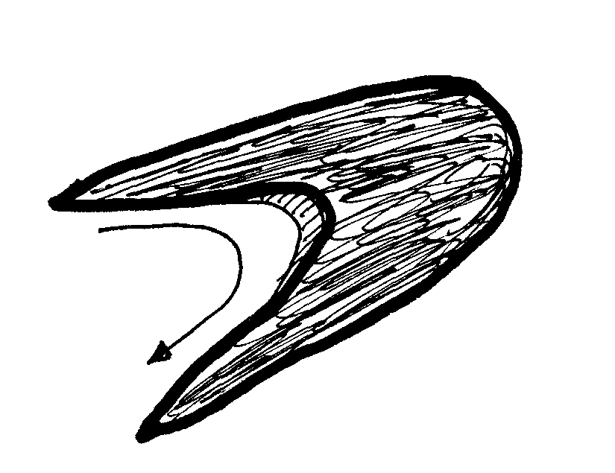
- (a)The diagram below shows a barchan.
L
K
L
K

- Name the air current marked L (1mark)
- Name the part labeled K (1mark)
(b) How is an Oasis formed? (3marks
- The diagram below shows a glaciated upland area. Study it and answer the questions that follow.
R
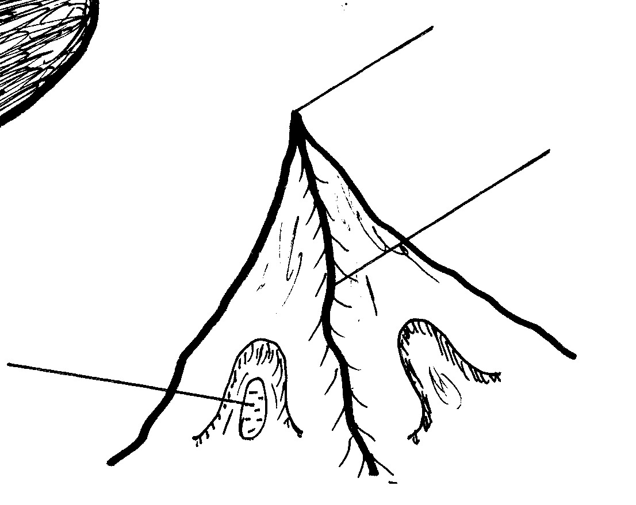
T

S

- Name the features marked R, S and T (3marks)
- Describe two distinct features of a fiord (2marks)
- Use the diagram below to answer question 5 (a) and (b)
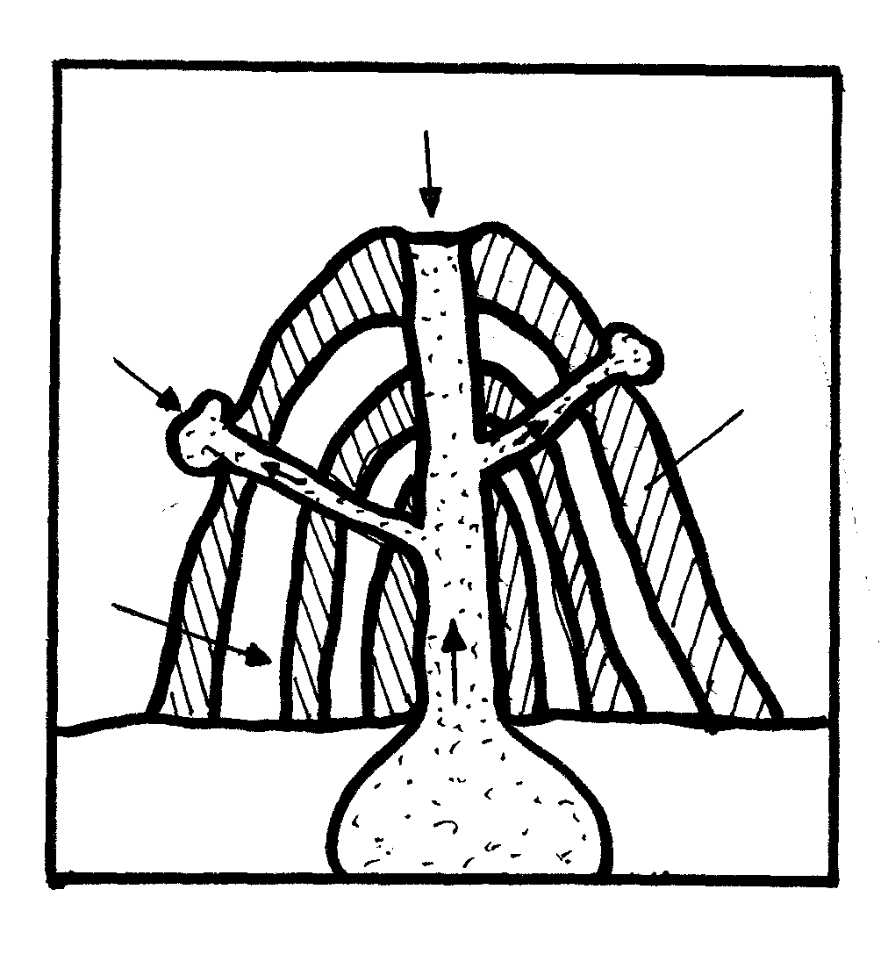
A
B
PYROCLAST

C

(a) Label the parts marked A, B and C (3marks) (b) Identify two characteristics of the feature drawn above (2marks)

SECTION B:
Answer question 6 and any other two questions from this section.
- Study the map of Busia 1: 50,000 (sheet 101/1) provided and answer the following questions.
- i) Name two types of vegetation found in the area covered by the map (2marks)
ii) What is the six – figure grid reference Nambobote School? (1mark)
- i) Identify two types of scales used to draw the map. (2marks)
ii) Calculate the area of the land to the west of the international boundary in the N.Western corner of the map (Give your answer in square kilometers) (2marks
- Measure the distance of the weathered surface road C 523 from grid reference 200299 and grid reference 276317 ( give your answer in kilometers) (2marks)
- Explain three factors which influenced the distribution of settlements in the area covered by themap. (6marks)
- Describe the drainage of the area covered by the map. (4marks)
- Citing evidence from the map explain three factors that favour business in Busia area. (6marks)
- a) i) Name two types of desert landscape (2marks) ii) State three physical factors contributing to the development of deserts (3marks)
b) With the aid of a well labelled diagram describe the formation of the following features
i) Rock pedestal (3marks)
ii)Barchan (3marks)
- Suppose you are to conduct a field study on the features formed by water action in the desert.
- List any three land forms you are likely to study (3marks)
- Outline two methods you would use to collect information (2marks)
- State three reasons why it is important for them to divide themselves into groups (3marks)
- Explain three significance of desert land forms to man (6marks)
- a) i)Define the term soil (2marks)
ii) Name three components of soil apart from water. (3marks)
b) i) Explain how the following factors influence soil formation.
- Plant and animals
- Topography
- Climate (6marks)
ii) State four characteristic of desert soils (4marks)
c) Use the diagram of a soil catena below to answer question (c) (i).
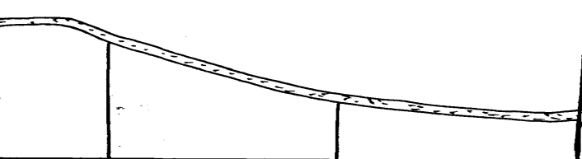
X

- Give a reason why the area marked x is rich for agriculture. (1mark)
- Explain three significance of soils to human activities (6marks)
d) Form four students intended to carry out afield study of soil in the school vicinity. State the
follow –up activities they would conduct after the study (3marks)
- (a)(i) Distinguish between a river divide and interfluves. (2marks)
(ii) The diagram below shows the processes of hydrological cycle. Name the processes marked P,Q,R and S (4marks)

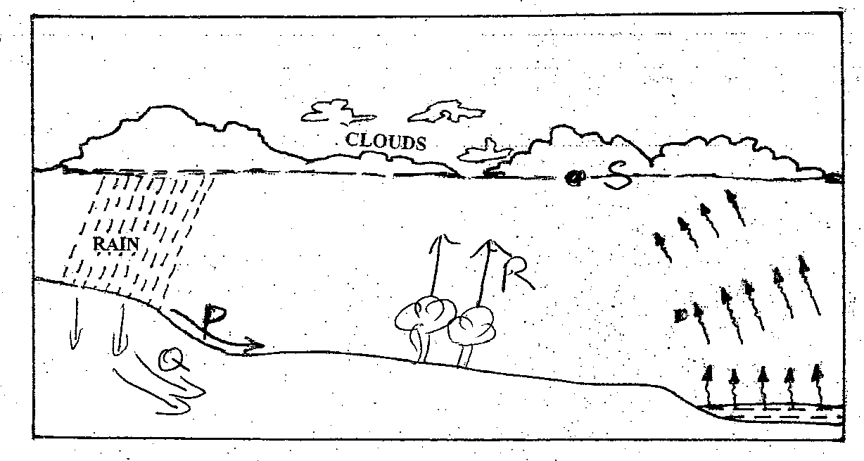

(iii)Explain two significance of the hydrological cycle. (4marks)
(b) Describe two processes by which a river transports its load. (4marks)
(c) Describe the following drainage patterns:
(i) Superimposed (3marks)
(ii) Dendritic (2marks)
(d)Your class is planning to carry out a field study on a river in its old stage.
(i) Apart from flood plain, name two other features you are likely to identify (2marks)
(ii) State three activities students would engage in during the field study. (3marks)
(iii)Describe three characteristics of the flood plain they would identify. (3marks)
- a) i) Give two examples of human-made lakes in Kenya. (2 Marks)
ii) A part from human activities, name other three external land forming processes that can lead to the formation of lakes. (3 Marks)
b) Describe how the following lakes are formed.
i) Crate lake. (4 Marks)
ii) Moraine dammed lake. (3 Marks)
iii) An oasis. (3 Marks)
c) i) State two ways in which a lake modifies the climate of the surrounding area. (2 Marks)
ii) Apart from modifying the climate, explain four other benefits of lakes. (8 Marks)

