GEOGRAPHY PAPER 1 MARKING GUIDE
PAVEMENT FORM 4 TRIAL 2 2021/22
SECTION 1

1 a) Two characteristics of planets
- They are spherical
- Some have satellites/ moon
- Earth is the only one with life.
- They all revolve around the sun on their own orbits.
- They all rotate on their own axes.
b) Three effects of the revolution of the earth round the sun.
- Causes changes in the position of the midday sun at different times of the year.
- Varying length of day and night at different times of the year.
- Causes four seasons i.e winter, summer, autumn and spring.
- Causes lunar eclipse (1 x 3 = 3mks)
2a) What is dew point?
Is the temperature at which air becomes saturated with water vapour.
b) Describe how conventional rainfall is formed (4marks)
- Intense heat from the sun heats the water body
- Evaporation takes place from the water body.
- On reaching condensation level, the water vapour cools and condenses forming clouds, which comes down as convectional rainfall. (4 x1 = 4mks)
3 a) Air current marked L
- Eddy current
- Part labeled K – the horn 1mark
b) How an oasis is formed
- A pre-existing depression / localized fault is deepened by eddy action / deflation.
- Gradually the depression is excavated through the removal of the unconsolidated materials / wind abrasion.
- The surface is lowered until if reaches the water bearing rock / aquifer.
- Water oozes out of the ground and collects in the depression to form an oasis.
4 a. Features marked R, S and T. (3marks)
R – Pyramidal peak
S – Arete
T – Tarn/ Corrie Lake.
b. Two distinctive features of a fiord.
- It has steep walls.
- It has a narrow / constricted sea intet
- It is shallower seawards and deeper inland.
- It is u-shaped.
- It has a hanging valley (2x 1 = 2mks)
5 a) Parts marked A, B and C (3marks)
A – conelet / parasitic cone
B – Crater
C- Lava layer
b) Two characteristics of the feature drawn.
- Some have a crater at the top
- Has steep slopes
- Has alternating layers of lava and pyroclast
- Has side vent /vent (2x1= 2mks)

SECTION B
Map work
6. (a) (i) - Scrub
- Thicket
- papyrus swamp vegetation
- Riverrine trees
(ii) 213336
(b) (i) - Linear scale
- R.F /ratio scale
(ii) - full squares = 21
½ squares = 18
½ x 18 = 9
Total full squares = 30
Areas of 1 square = 3/km²
Area off 30 squares = 30 x 1km²
= 30km km²
(iii) 8.3 km (1x 2= 2mks)
(c) – transport - most people settle a long line of communication for easy transfer of goods and people e.g
C 256
- Arrange – discourage settlement because the soils are poorly drained
- Relief - Hilly areas are steep and discourage settlement while gentle slope encourage settlement e.g Odiado Hill which has few settlement.
- There are no settlement along the river e.g R. Soi; because of floods and has swampy flood plans which discourage agriculture ( any 2x3 = 6mks)
(d) - The drainage features are rivers and swamps particularly in the northern part of the map
- Some rivers are disappearing underground
- The main river is R. Soi which is flowing towards the W.S.W directions
- The river has formed few tributarities and several meanders
- The area has deltas
- The rivers have dendric drainage pattern e.g R. Wakungu ( any 1x4 = 4mks)
(e) - Transport – e.g C 253 transfer goods
- Dense population which provide ready market e.g Funyala market
- Security which makes investments safe e,g chief’s camp ( 2531)
- Proximity to other large market –centre e.g Luanda, Sio port, Malaba, Ukwala provide ready market ( any 3x2 = 6mks)
7. a) Types of desert surfaces (2marks)
    - sandy /erg dessert
    - Stony /Reg desert
    - Rocky /Itamada desert.
ii) physical factors contributing to formation of deserts (3marks)
- high temperature
- unrealiability of rainfall
- Rain shadow effect.
- Long period of drought.
b) i) Rock pedestal (3marks)
This feature is formed by wind abrasion which attack the rock outcrop wearing the soft rock layers faster than the hard rock layers .
It’s base is eroded much more due to the strength of the wind at the base than at the top .this finally lead to formation of a rock pillar which is relatively. With narrow and noges slenderat the base known rock pedestal or mushroom rock.
Resistant rock
Soft rock
Wind abrasion

ii) Barchans (2marks)
This is an isolated crescent sand dune with horn of the crescent projecting downwards.
It is formed when wind accumulate sand on an obstacles such as rock or vegetation the windward slope is generally steep and slightly care due to eddy current.
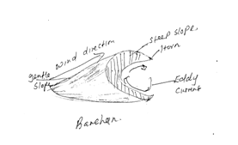

d) landforms likely to be studied in desert(water action)

- Playas
- Pediplains
- Buttes
- wadi
- Bajada
- Pediment
- Mesas
ii) Methods used to collect information (2marks)
- Observation
- Photographing
- Sampling.
iii) Reasons for grouping (3marks)
- To ensure many features are studied within a short time.
- To improve individual participation as all of the students will at least be involved in a direct way in the activities such observation of features.
- To simplify the work of supe ruising prudent progress.
iv) Significance of desert landforms to man (6marks)
- They provide good areas for military training.
- Desert features provide good sceneries which attract tourist thus earning foreign income.
- Loss deposits from fertile soils for high yield crop production e.g. rice production in having region in china.
- Solar energy has been tapped from high sun intensity in the dessert to provide power for both domestic and industrial uses.
- Sand which has accumulated in the desert can be used in construction of houses.(any 3 x 1 = 6)
8. a) Define the term soil
Is the loose top layer of the earth’s surface, consisting of rock and mineral particles mixed with decayed organic matter, water and air and is capable of plant life. (2 x 1=2mks)
ii) Name three components of soil apart from water.
- Organic matter / humus
- Soil air
- Inorganic matter/ minerals (3 x 1 = 3mks)
b) i) Explain how the following factors influence soil formation.
- Plant and animals
Living organisms assist in breaking down of rock through barrowing, ploughing and root penetration of plants.
Living organisms influence the chemical composition of soil by adding or removing organic acids and minerals.
Burrowing of animals or ploughing by people improves soil aeration.
When plant or animal matter decays it adds fertility to soil.
- Topography
- Relief has influence on drainage surface runoff and erosion/ steep slopes have thin soils due to erosion/ gentle slopes have thick soils.
- Relief determines the exposure of slopes to the sun/ exposure or non-exposure of sun causes differences in soil temperature and therefore soil types.
- Windward slopes are usually wetter and have different soil characteristics.
- Drainage is poor on level grounds / fairly flat lands forming swampy soils. ( 2 x 1=2mks)
- Climate
- Rainfall provides the moisture required for rocks to weather chemically and eventually forms soil.
- High temperature increases the rate of weathering / accelerate rate of bacterial activities which generate some of the organic matter in the soil. (2 x 1= 2mks)

(ii) Characteristics of desert soil.
- They are thin and shallow
- Are sandy or stony
- They lack humus
- Have low organic matter
- Are general saline
- Coarse texture
- Are porous
- Are alkaline
- Have low moisture content ( any 4x1 = 4mks)
c) Use the diagram of a soil catena below to answer question (c) (i).
- Give a reason why the area marked x is rich for agriculture.
Has thick and fertile alluvial soils suitable for agriculture. (1 x 1=1mark)
- Explain three signifance of soils to human activities
- Some soil is used in building and construction e.g. clay for making bricks
- Some soil is used in ceramics e.g. making of pots.
- Some soils are used to decorative purposes e.g. ocre by Maasai
- Some soils are sources of minerals that can be sold to earn income that improve living standards e.g alluvial gold. (any 3 x 2 =6mks)
d) State three follow –up activities they would conduct after the field study.
- Discussing the findings from the field.
- Writing a report about the types of soils and their uses.
- Laboratory testing and analyzing of samples carried from the field/ library readings.
- Displaying soil samples
- Displaying photographs taken from the field.
- (a)(i) Distinguish between a river divide and interfluves. (2marks)
- River divide is a ridge high ground that separates two or more river while interfluves is a high area in between the tributaries.
(ii) The diagram below shows the processes of hydrological cycle. Name the processes marked P, Q,R and S (4marks)
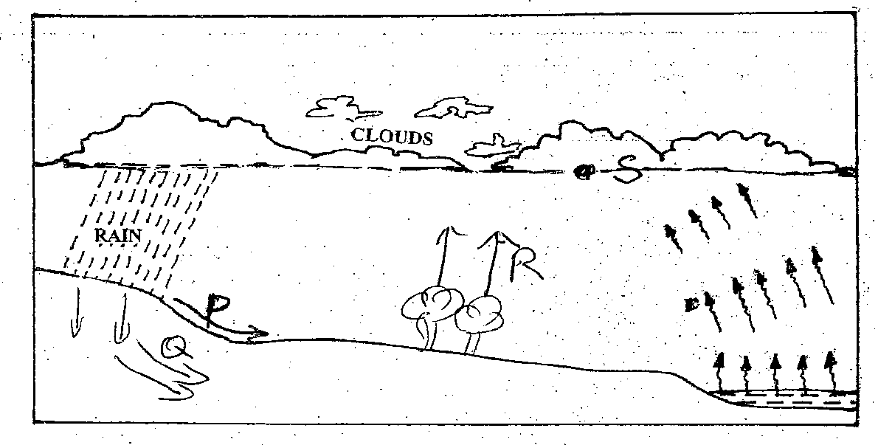
- P= Runoff R= Evapotranspiration
- Q= Peculation S= condensation level
(iii)Explain two significance of the hydrological cycle. (4marks)
- The cycle creates an ecolognal balance in water supply between the atmosphere and the ground.
- It leads to formation of rainfall which assists in agricultural production and vegetation growth.
- It leads to formation of clouds in the atmosphere.
- It clues the atmosphere, hydrosphere and the earth.
- It assists in the oxygen and carbon cycles in the atmosphere.
(b) Describe two processes by which a river transports its load. (4marks)
- Solution process: - the soluble minerals / materials are dissolved in river water and carried away.
- Suspension: - Light and insoluble materials such as sand and silt are carried and maintained within the water by river turbulence and transportation downstream.
- Traction:- the large and heavy loads of the rive are rolled/ dragged along the river bed by the force of the moving water and gravity.
- Saltation:-Some medium sized particles which cannot be suspended are momentarily lifted and dropped by water turbulences.
(c) Describe the following drainage patterns:
(i) Superimposed (3marks)
- The drainage system developing on a rock structure that overlies a totally different one.
- The river cuts through the surface rock layer onto the underlying rocks.
- Gradually the surface rocks are removed and the underlying rocks now become exposed.
- The river maintains the original direction of flow despite the new rock structure.
- The superimposed drainage bears no relationship to the existing rock structure.
(ii) Dendritic (2marks)
- It develops in areas where rocks have uniform structure.
- The direction of flow is influenced by the slope of the land.
- The tributaries coverage on the main river forming a shape like that of tree and its branches.
(d)Your class is planning to carry out a field study on a river in its old stage.
- Apart from flood plain, name two other features you are likely to identify. (2marks)
- Alluvial fans
- Meanders
- Ox-bow lakes
- River braids
- Natural levees
- Deltas.
(ii) State three activities students would engage in during the field study. (3marks)
- Taking photographs
- Observing features
- Drawing sketches
- Measuring the width of river.
(iii)Describe three characteristics of the flood plain they would identify. (3marks)
- The slope is almost flat in some areas
- Surface covered by thick alluvial deposits
- Lavas are common along the river bank
- Marshers/swamps are common on it.
- There are meanders and ox-bow
- River braids may be seen along the river bank.
- Distributaries and deltas may be found on the seaward/lake ward end.
- Different tributaries may be found where trees have formed. (max 3marks)
- a) i) Human – made lakes in Kenya
- Lake masinga√
- Lake Kindaruma√
- Lake Gitaru√
- Lake kaburu √ (max 2marks)
ii) External landforming processes
- Weathering by solution in limestone areas√
- Erosion by wind/ice√
- Deposition by water/ice√
- Meteorite falling on the earth’s surface√
- Mass movement√ (3marks)
b) i) Formation of Crater Lake.Two ways
- Formation of a crate lake during the formation of a volcano√
- Outpouring of lava forms a volcanic cone√
- As the lava cools, the magma in the vent cools and contracts√
- This causes it to withdraw into the vent leaving a funnel-shaped depression at the volcano√
- The depression later fills with rain water/ground water√
- Formation of a crater lake due to a volcanic explosion
- Gaseous explosions blow away the surface rocks√
- This results in the formation of a depression crater at the ground level√
- The rock materials later fall back to earth and accumulate round the rim of the hole√
- Water from the rivers/rain/underground may fill the crater to form a crater√ (1 x 4 = 4)
ii) Moraine dammed lake
- The glacier deposits terminal moraine at some point across the widened valley√
- As the glacier melts and retreats , the melt water accumulates behind the terminal moraine to form a moraine dammed lake√
- Ice erosion erodes and widens valleys to form glacial troughs√ (3marks)
iii) Formation of an oasis
- A pre-existing depression/localized fault is deepened by eddy action√
- Overtime the depression is further deepened through the removal of the unconsolidated materials and wind abrasion until it reaches the aquifer√
- Water oozes out of the ground and grounds and collects at the bottom of the depression hollow, to form an oasis√
c) i) Effects of lakes on climate of surrounding areas
- The resultant breezes may strengthen divert/revert the prevailing winds
- Lake breezes lower the temperatures of surrounding areas during the hot season
- In the cool season, the lake breezes bring a warming effect onto the land
- High rate of evaporation from lakes results to the formation of convectional rainfall (any 2 = 2mks)
ii) Benefits of lakes
- Fresh water lakes provide water for irrigation e.g. Naivasha√√
- Some lakes e.g. Magandi contain valuable minerals which are economically exploited by people√√
- Sand and smoothened pebbles found along the shores of many lakes are used in construction industry√√
- Water in lakes are harnessed for generation of hydro-electric power e.g. masinga√√
- Some lakes are habitats for wildlife hence act as tourist attraction sites√√ e.g. Lake Nakuru which is an habitat for flamingoes
- Some lakes provide waterways which are the cheapest means of transporting people and goods e.g. the Great lakes√√ (4 x 2 = 8marks)

