312/1
Name……………………………………………………………………
Class………………………………
Admission no……………………………………………
Date………………………………………………………
Sign……………………………………………………………
GEOGRAPHY
PAPER 1
TIME: 2³/₄ HOURS

CHOGORIA MURUGI PRE MOCK
312/1
Paper 1
GEOGRAPHY
INSTRUCTIONS TO CANDIDATES
- This paper consists of two sections.
- Answer all questions in section A .
- In section B answer question 6 and other two questions..

FOR EXAMINERS USE ONLY
SECTION | QUESTION | MARKS | SCORE
A | 1-5 | 25
B | 6 | 25
 | 7 | 25
 | 8 | 25
 | 9 | 25
 | 10 | 25
TOTAL MARKS |  | 100
TOTAL SCORE

SECTION A: Answer all questions in this section
- a) State two sub- branches of physical geography. (2 mks)
b) Give three reasons as to why it is important to study Geography. (3 mks)
- a) Differentiate between seismic focus and epicenter. (2 mks)
b) Give three causes of earthquakes. (3 mks)
- a) Name two major types of vegetation zones in the world. (2 mks)
b) State three characteristics of coniferous forest. (3 mks)
- a) The diagram below shows a water cycle. Use it to answer the question that follow.

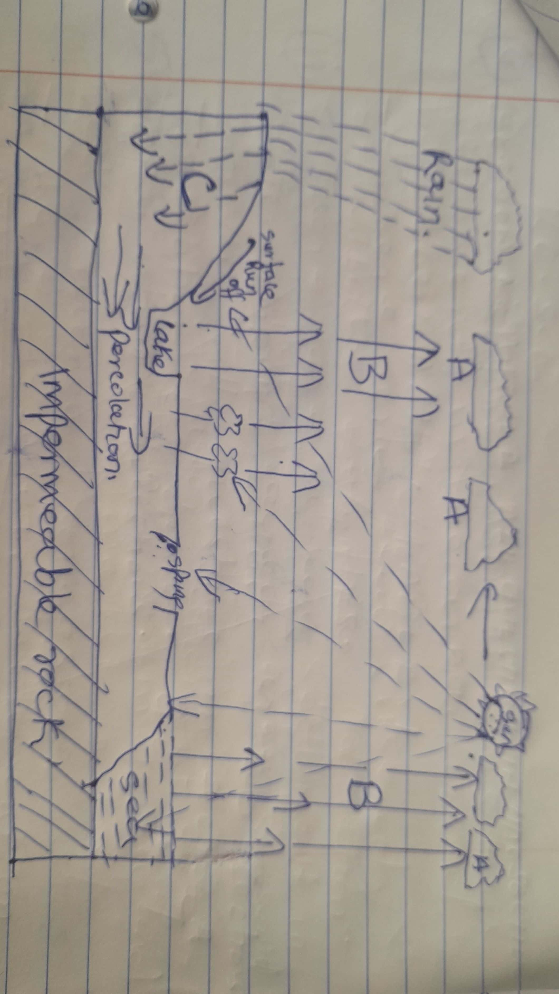

- Name the processes labelled. (3 mks)
A_________________________
B_________________________
C_________________________

- State two factors influencing the amount of surface run-off. (2 mks)
- a) What is a lake? (2 mks)
b) Give three reasons why some lakes in the Kenyan Rift valley are salty. (3 mks)

SECTION B
Answer question 6 and any other two questions in this section
- Study the map of Kisumu 1:50,000 (sheet 116/2) provided and answer the following questions.

- i) Give the longitudinal extent of the area covered by the map? (1 mk)
ii) Name the three human-made features in the grid square 0193. (3 mks)
iii) Identify two methods used to show relief on the map. (2 mks)
iv) Calculate the area of Kisumu town. Give your answer in square kilometres.(2 mks)
v) Name two types of natural vegetation. (2 mks)
- Draw a square 10cm by 10cm to represent the area enclosed by easting 00 and 10, and Northings 80 and 90. (1 mk)
On it mark and name the following
- Air photo principal point (04) (1 mk)
- Chinga market (1 mk)
- All weather road bound surface. (1 mk)
- River Ombeyi. (1 mk)
- Describe the distribution of settlement in the area covered by the map. (4 mks)
- Citing evidence from the map, give three economic activities carried out in the area by the map. (6 mks)
- a)i) Differentiate between a rock and a mineral. (2 mks)
ii) Describe the following characteristics of minerals.
- Colour (1 mk)
- Hardness (2 mks)
b)i) What are igneous rocks. (2 mks)
ii) State three notable differences between plutonic and volcanic rocks. (3 mks)
c)Describe the formation of the following rocks.
- Mechanically formed sedimentary rocks. (3 mks)
- Chemically formed sedimentary rocks. (3 mks)
d(i) Identify the missing type of rocks. (3 mks)
Original rock | Metamorphic rock
Limestone | (i)
(ii) | Graphite
Granite | (iii)

ii) Supposing you were to carry out a field study on rocks at the Kenyan Coast.
- State two reasons as to why you would ask for permission from the school administration. (2 mks)
- What reasons would you give for the widespread at sedimentary rocks at the Coastal plain. (3 mks)

- a)i) Differentiate between orogeny and orogenesis. (2 mks)
ii) State three factors that influence folding. (3 mks)
b)i) Apart from Recumbent fold name three types of folds. (3 mks)
ii) With the aid of a well labeled diagrams describe how a recumbent fold is formed. (6 mks)
c)Name three features formed by folding. (3 mks)
d) Explain four positive effects of folding to human activities. (8 mks)
- a) i) State three sources of ocean salts. (3 mks)
ii) Name two types of tides. (2 mks)
b)With the aid of a well labeled diagrams describe how a stack is formed. (8 mks)
c)i) Name two types of submerged highland coasts. (2 mks)
ii) State two factors influencing deposition by ocean waves. (2 mks)
d)Explain four significance of oceans to human activities. (8 mks)

- a)i) Differentiate between soil profile and soil catena. (2 mks)
ii) Draw a well labeled diagram of a mature soil profile. (5 mks)
b)i) Other than topography name three factors that influence formation of soil. (3 mks)
ii) Explain how topography influence formation of soil. (3 mks)
iii) List three characteristics of desert soils. (3 mks)
c(i) Give three types of soil erosion. (3 mks)
ii) Explain three effects of soil erosion on human activities. (6 mks)

