Name: …………………………..………………………….………………………… Class: ……….…………Adm.No………………….
Signature: ………………………………….

312/2
GEOGRAPHY
Paper 2
MOKASA I
JUNE/JULY 2021
Time: 2³/₄ Hours.

MOKASA I JOINT EXAMINATION.
Kenya Certificate of Secondary Education (KCSE)
Geography
Paper 2
Time: 2³/₄ Hours.

Instructions to candidates
- This paper has two sections A and B.
- Answer ALL the questions in section A. In section B answer questions 6 and any other TWO questions.
- All answers to be written on the answer booklet provided.
- Candidates should check the question papers to ascertain that all the pages are printed as indicated and that no questions are missing.

For Examiners use only:

Section | Candidate Score
A
6
7
8
9
10
Total

SECTION A
Answer ALL the questions in this section.

1. a) Give the relationship between Geography and Economics. (2 marks)
b) State reasons for studying Geography in secondary schools. (3 marks)
2. a) Identify three characteristics of bar graphs (3 marks)
b) State advantages of using bar graphs (3 marks)
3. a) The diagram below represents the occurrence of petroleum in the earth’s crust.
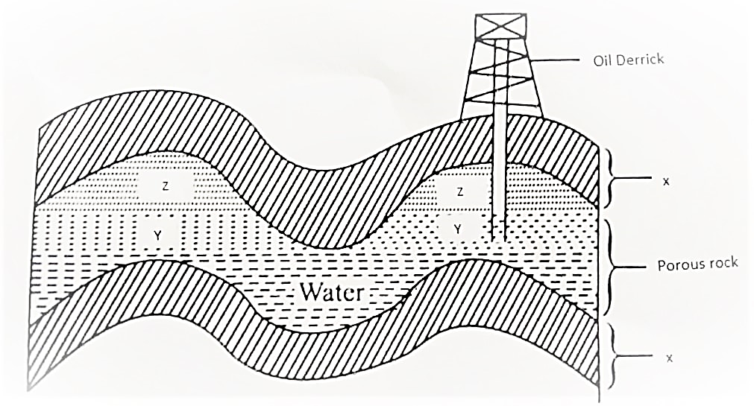
Name the parts marked X, Y and Z (3 marks)
b) Give the by-products obtained when refining crude oil (3 marks)
4. a) Define re-afforestation (2 marks)
b) Identify the importance of agro-forestry (3 marks)
5. a) State three characteristics of beef cattle ranching (3 marks)

SECTION B:
Answer question 6 and any other TWO questions from this section.

6. Study the photograph below and use it to answer question (a).
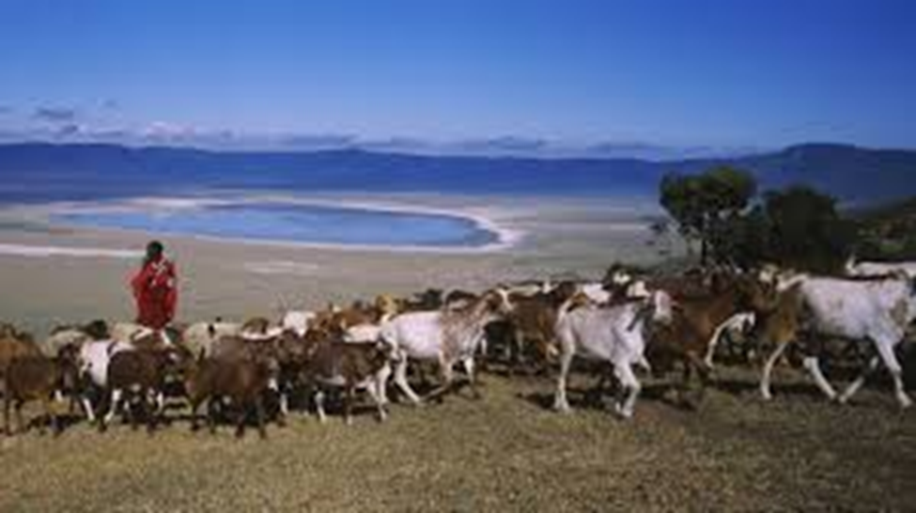
(a) (i) Identify the type of photograph shown above. (1 mark)
(ii) Using evidence from the photograph, give two indicators to show that the area is experiencing semi-arid conditions. (2 marks)
(iii) Describe the features shown on the photograph. (3 marks)
(iv) Draw a rectangle measuring 15 cm by 10 cm to represent the area covered by the photograph. (1 mark)
- On the rectangle, sketch and label four main features shown on the photograph. (4 marks)
(b) (i) Name two pastoral communities in East Africa. (2 marks)
(ii) Outline three physical factors that favour pastoral farming in Kenya.
(3 marks)
(c) State three problems facing pastoralists in Kenya. (3 marks)
(d.) Explain three ways in which the government of Kenya assists nomadic pastoralists to improve the quality of their livestock. (6 marks)
7.) a.) i.) Define mining (2 marks)
ii.) Explain how the following factors influence mining
      - Quality of the mineral ore (2 marks)
      - Capital (2 marks)

b.) Describe how the deep shaft method of mining is carried out (6 marks)
c.) i.) Give two uses of soda ash (2 marks)
ii.) State the contributions of soda ash mining to the economy of Kenya (5 marks)
d.) Explain three problems facing mining (6 marks)
8. a)i) Name three exotic softwood tree species planted in Kenya (3 marks)
ii) State four factors favouring the development of softwood forests in Kenya
(4 marks)
b) Explain four measures that the government of Kenya is taking to conserve forests in the country (8 marks)
c)i) Give reasons why forests are more wide spread in Canada than Kenya.
(4 marks)
ii) Compare forestry in Canada and Kenya under the following sub-headings;
- Tree species (2 marks)
- Harvesting (2 marks)
- Transportation (2 marks)
9. a) Name three counties in Western highlands where tea is grown.
(3 marks)
b) State four physical conditions that favour tea growing in the Kenya highlands. (4 marks)
c)i) Describe the stages involved in the processing of tea from harvesting to marketing. (7 marks)
ii) State the ways in which the Kenya Tea Development Agency (KTDA) assist small scale farms in Kenya (5 marks)
d) Explain three problems experienced by small scale tea farmers in Kenya.
(6 marks)
10.) a.) i.) Differentiate between land reclamation and land rehabilitation (2 marks)
b.) Identify three methods of land reclamation in Kenya (3 marks)
c.) i.) State four physical factors that influenced the location of Mwea Tabere irrigation scheme (4 marks)
ii.) Explain four problems facing Mwea Tabere irrigation scheme (8 marks)
d.) i.) Outline the stages that were involved in the reclamation of land from the sea in Netherlands (5 marks)
ii.) State three benefits of the of irrigation farming in Kenya (3 marks)

