MID TERM SERIES –TERM 1 -2023
GEOGRAPHY (312/1)
FORM 4
MARKING SCHEME

SECTION A
- (a) | What is a weather station?  - a place that is set aside for the purpose of observing, measuring and recording weather elements. | 1×2=2 marks
(b) | Give three factors that influence wind direction.  - the pressure gradient  - coriolis force  - centrifugal force  - friction with the earth’s surface | 3×1=3 marks
- (a) | Name two types of tectonic plate boundaries.  - divergence/extension/constructive  - convergence/compressional/destructive  - transform/conservative | 2×1=2 marks
(b) | Give three effects of the movement of tectonic plates.  - they cause earthquakes  - can lead to formation of fold mountains  - can lead to formation of new oceanic crust  - can lead to formation of submarine islands/volcanic islands | 3×1=3 marks
 | State four causes of the decline of the areas under forests in Kenya.  - forests are destroyed by accidental or intended fires  - pests attack planted forests making them to dry up  - human activities/settlement/charcoal burning/logging have destroyed many forests  - overexploitation depletes some tree species  - prolonged droughts lead to degeneration of forests  - government policy of degazetting some forests | 4×1=4 marks
- (a) | The diagram below shows a section of a river. Use it to answer the questions that follow.  Identify the stage of development of the section of the river.  - old/lower stage | 1×1= 1 mark
(b) | A part from feature marked R, give two other features formed at this stage.  - meanders  - braided channel  - flood plain  - deltas  - bluffs  - deferred tributaries | 2×1=2 marks
(c) | State three conditions necessary for the formation of the feature marked R.  - presence of pronounced meanders in the flood plain  - heavy load being carried by the river  - a reduction in the river gradient/energy/low velocity  - presence of obstacles in the river channel  - lateral erosion on the outer side of the river banks  - deposition on the inner side of the river banks
- (a) | Differentiate between an aquifer and a water table.  - an aquifer is a mass of permeable rock which can hold water in its air spaces and can allow it pass through while a water table is the level of ground water below which all available air spaces are saturated with water. | 1×2=2 marks
(b) | Give three problems associated with artesian wells.  - saline water in the wells  - overexploitation of the wells  - pollution of ground water  - prolonged drought leading to the wells drying up | 3×1=3 marks

SECTION B
- (a) | (i) Give the longitudinal extent of the area covered by the map.  - 36⁰45’E to 37⁰00’E | 1×2=2 marks
 | (ii) Give the six figure grid reference of the trigonometric station at Nyeri Hill forest.  - 665548 | 1×2=2 marks
 | (iii) Calculate the area of Nyeri forest. Give your answer in square kilometres.  - 2 + = 11.5 km² | 1×2=2 marks
(b) | (i) What is the bearing of The Ark Lodge from the trigonometric station 120 UT 16.  - 317⁰±1⁰ or N43⁰W | 1×2=2 marks
 | (ii) Identify three man-made features in grid square 7263.  - road D449  - other track/footpath  - settlement/houses  - Nderitu farm | 3×1=3 marks
 | (iii) Give three drainage features found in the area covered by the map.  - rivers  - dams/reservoirs  - water holes  - water tank  - ditch | 3×1=3 marks
(c) | Describe the relief of the area covered by the map.  - there are several river valleys  - there is a hill in grid square 6963  - north eastern and western area has gentle slopes  - there are steep slopes in the north western and southern parts  - there are ridges in the south western part  - the highest point is 2820m and lowest point is 1680m  - the area generally slopes downwards from west to east | 5×1=5 marks
(d) | Citing evidence from the map, identify three social services offered in Nyeri Township.  - administration services – PC/DC/Admin offices  - religion – church  - recreation – golf course/club/show ground/hotel  - rehabilitation – prison  - education – school  - security – police station | 3×2=6 marks
- (a) | (i) What is a mineral?  - a mineral is an inorganic substance with a definite chemical composition found at or beneath the surface of the earth.  (ii) Describe the following characteristics of minerals:  - Lustre - minerals differ in their brightness depending on the nature of their reflective surfaces (dull/shiny).  - Colour – different minerals display different colours  - Cleavage – minerals have patterns in which they split/divide/break into thin layers or along layers or shapes | 1×2=2 marks  1×2=2 marks  1×2=2 marks  1×2=2 marks
(b) | Describe three ways in which igneous rocks are formed.  - mechanically formed sedimentary rocks; rock fragments are transported by wind/water/ice are deposited in layers. Over a long period they are compacted in hard rocks.  - organically formed sedimentary rocks; remains of plants or animals are deposited in layers. Over long period of time the remains are compacted into hard rocks  - chemically formed sedimentary rocks; dissolved minerals are transported into water bodies. They are then precipitated/evaporated over time. Precipitates or evaporates are compacted to form hard rocks. | 3×3=9 marks
(c) | Explain four significance of rocks to the economy of Kenya.  - some rocks form unique features that attract tourists earning the country foreign exchange/income  - some sedimentary rocks contains fossil fuels which are sources of energy for domestic/industrial use e.g. coal  - some rocks act as storage for ground water which can exploited for domestic/industrial/agriculture  - some rocks e.g. phonolites are exploited for building ad construction  - rocks weather to form fertile soils that support crop farming  - some rocks are ores with valuable minerals that are exploited and sold to generate income | 4×2=8 marks
- (a) | (i) State three causes of faulting.  - earth movements causing tension within rocks  - earth movements causing compression within rocks  - faulting can occur when rocks shear  - vertical movement in the rocks cause rocks to fracture | 3×1=3 marks
 | (ii) Differentiate between a normal fault and a reverse fault.  - a normal fault is caused by tensional forces while reverse fault is caused by compressional forces  - in a normal fault, the upthrow moves away from the downthrow while in a reverse fault, the upthrow rides over the downthrow. | 2×2=4 marks
(b) | (i) A part from rift valley, give three other relief features formed due to faulting.  - tilt block  - escarpment/scarp slope  - block mountain/horst  - fault steps | 3×1=3 marks
(ii) With the aid of diagrams, describe how compressional forces can lead to formation of a rift valley.
- When layers of crustal rocks are subjected to compressional forces, lines of weakness occur and forms adjacent reverse faults
- Continued compression pushes out/thrusts the outer blocks over the central/middle block to form the floor of the rift valley.
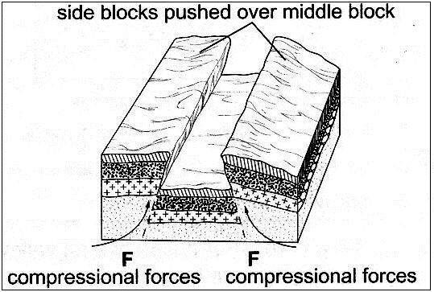
- The steep fault scarps on either sides of the outer blocks are further worn out by denudation (erosion, mass wasting, and transportation) to form gentle slopes.
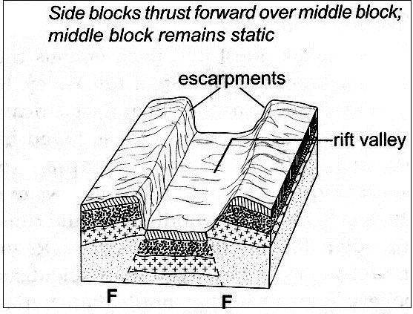
Text – 5 marks Diagrams – 3 marks
(c) | Students from your class are planning to carry out a field study on an area affected by faulting.  (i) State four reasons why it is important to have a pre-visit to the area.  - to draw route map  - prepare a working schedule  - identify relevant tools/equipment for the study  - identify suitable methods of collecting data  - seek permission from the authorities at the area of study  - prepare budget for the study | 4×1=4 marks
 | (ii) Give three reasons why it would be inappropriate to use observation to collect data during the field study.  - expensive to travel long distances  - time consuming  - limited to primary sources  - only suitable to the sighted people | 3×1=3 marks
- (a) | (i) What are ocean tides?  - ocean tides are periodic rise and fall in the level of ocean waters as a result of the gravitational attraction of the sun and the moon. | 1×2=2 marks
 | (ii) Name two ocean currents along the western coast of Africa.  - Benguela  - Guinea  - Cannary | 2×1=2 marks
(b) | State three factors that determine the rate of coastal erosion.  - duration of exposure of coast to wave erosion  - degree of exposure of the coast to wave erosion  - nature of materials transported by waves  - structure/nature of the coastal rocks  - nature/strength of the waves | 3×1=3 marks
(c) | With the aid of labeled diagrams, describe the formation of the following coastal features:  (i) Fringing reef  - This is a platform of coral which forms when coral polyps start building a reef near the shore.  - The reef extends seawards where the building is faster because of more food and the water is clearer.  - As the reef builds seawards, it encloses a shallow lagoon with the coast.  Text – 3 marks Diagram – 2 marks
(ii) Spit
- The movement of materials by the longshore drift is halted by a headland and the materials piled up/deposited in the sea/ocean water.
- This continues until they bulge out with the accumulation growing towards the sea

Text – 3 marks Diagram – 2 marks
(d) | Explain the significance of oceans to human activities.  - Presence of oceans modifies climatic conditions of an area through land and sea breezes.  - Oceans provide rich grounds for subsistence and commercial fishing.  - Ocean tides and waves can be harnessed to produce tidal power.  - Oceans are natural habit for marine life/ Biodiversity conservation.  - Provides cheap free water ways to transport goods and services across continents.  - Oceans provide sites for a variety of recreational activities e.g. water skiing, cruising sport fishing and tourism.  - Oceans provide grounds for navy/ military activities  - Ocean water can be distilled to provide fresh water  - Ocean water provide grounds for scientific/ educational research | 4×2=8 marks
- (a) | Name three components of soil.  - soil air  - soil water/moisture  - soil organic matter/humus  - soil inorganic matter/minerals | 3×1=3 marks
(b) | Explain how the following factors influence the formation of soil:  (i) Climate  - Areas with heavy precipitation (rainfall) are heavily leached and weathered compared to drier areas, they therefore have deep soils  - High temperatures promote rapid faster weathering and chemical changes in the soil/cold temperatures slow these processes  - Winds act as agents of soil erosion, blowing fine sand and dust and depositing them far away forming rich fertile soils | 2×2=4 marks
 | (ii) Topography  - valley bottoms/gentle slopes encourage formation of deep and fertile soils due to deposition/accumulation of materials  - steep slopes encourages erosion of top layer of soil slowing down formation of soil/have thin soils  - flat areas/flood plains are saturated with water slowing down soil formation  - slope influence the arrangement of soil. | 2×2=4 marks
(c) | Describe how laterization occurs.  - during wet season, mineral salts in the top layer of the soil dissolve in the rain water  - dissolved minerals percolate or seep downwards from the top soil to the sub-soil  - the dissolved minerals are further moved downwards to lower layer  - Insoluble minerals such as iron and aluminium accumulate on the top layer to form a crust of laterites hence laterization. | 6×1=6 marks
(d) | Explain four ways in which human activities contribute to soil erosion.  - cultivation on steep slopes increases the rate of soil erosion  - shifting cultivation/bush fallowing may leave land unprotected against agents of erosion  - cutting down trees exposes the soil to agents of erosion  - continuous ploughing weakens the soil structure, making it easy for the agents of erosion to carry it away.  - overgrazing leads to the removal of the protective cover of grass exposing the soil to agents of erosion  - overstocking leads to many animals trampling on the topsoil, loosening the particles and making it easy for them to be carried away. | 4×2=8 marks

