MARKING SCHEME
GEOGRAPHY FORM 2
END OF TERM 3 - 2022
TIME: 1 HR

1a. Name two branches of Geography. (2 mks)
- physical geography
- Human and economic Geography
- Practical Geography
b. What is the relationship between Geography and the following disciplines. (2 mks)
- mathematics (2 mks)
• Mathematics principles or formulae are used in Geography to calculate distances, area or population density, mean annual rainfall and temperature.
- chemistry (2 mks)
- The knowledge of chemistry is used in the study of chemical composition of rocks and soils chemical changes that take place in soils and rocks.
2a.(i) what is the solar system. (2 mks)
- The solar system is the sun, heavenly bodies and the planets orbiting around it.
(ii) Name three components of the solar system. (3mks)

- The sun
- planet
- asteroids
- meteors
- comets

b. (i) Distinguish between revolution and rotation of the earth. (2 mks)
- Rotation is the spinning of the earth on its axis while revolution is the movement of the earth around the sun.
(ii). State four effects of the rotation of the earth. (4mks)
- causes occurrence of day and night
- causes rising and facing of ocean or sea tides
- causes deflation of wind and ocean currents
- causes difference in time between places, longitude over the earth’s surface
- cause variations in atmospheric pressure on the earth’s surface.
3a.(i). State four elements of weather . (4 mks)

- Temperature
- rainfall
- atmospheric pressure
- sunshine
- humidity
- wind
- cloud cover

(ii). Describe four reasons why weather forecasting is important. (8mks)
- enables farmers to plan their activities
- helps to choose clothing of the day
- influence in designing of houses
- guides in taking off and leading of aircrafts
- weather forecasting helps in planning micutary activities
b. With the aid of a well labeled diagram explain the formation of relief rainfall. (9 mks)
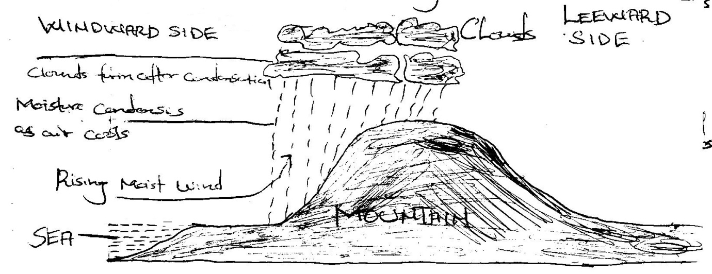
- This type of rainfall is formed when warm moist winds are moving or forced raise on hill on maintained or any raised surface.
- it’s the winds rise they experience lower pressure causing them to expand
- As they rise higher, they begin to cool until temperature drops to below the disappoint.
- condensation takes place resulting to the formatting of clouds and raindrops
- eventually rain falls on the wind side
- The resulting rain is relief cerographic or relief rainfall
- when the words go over the mountains, hill or raised surface and descend on the lower side, they warm up and pick any available moisture leaving the side dry.
4. a. Describe the formation of mechanically format sedimentary rocks. (6 mks)
- These are sedimentary rocks formed by compaction and fomentation of the pre-existing weathered rock particle
- The pre-existing weathered particles can be form igneous rocks, metamorphic or sedimentary rocks.
- the weathered materials are transported and deposited or in the sea by water wind or air
- several layers are deposited and over a period of the consolidate into hard rocks
b. State four uses of rocks. (4mks)

- Tourism
- Source of fossil feud
- building and construction
- storing ende
- Some weather down to form soil which support agriculture
- starting underground water
- making of ornaments
- source of income and employment when they are extracted and solid

5a with the aid of a well labeled diagram, explain the formation of the rift valley by tensional forces. (2 mks)
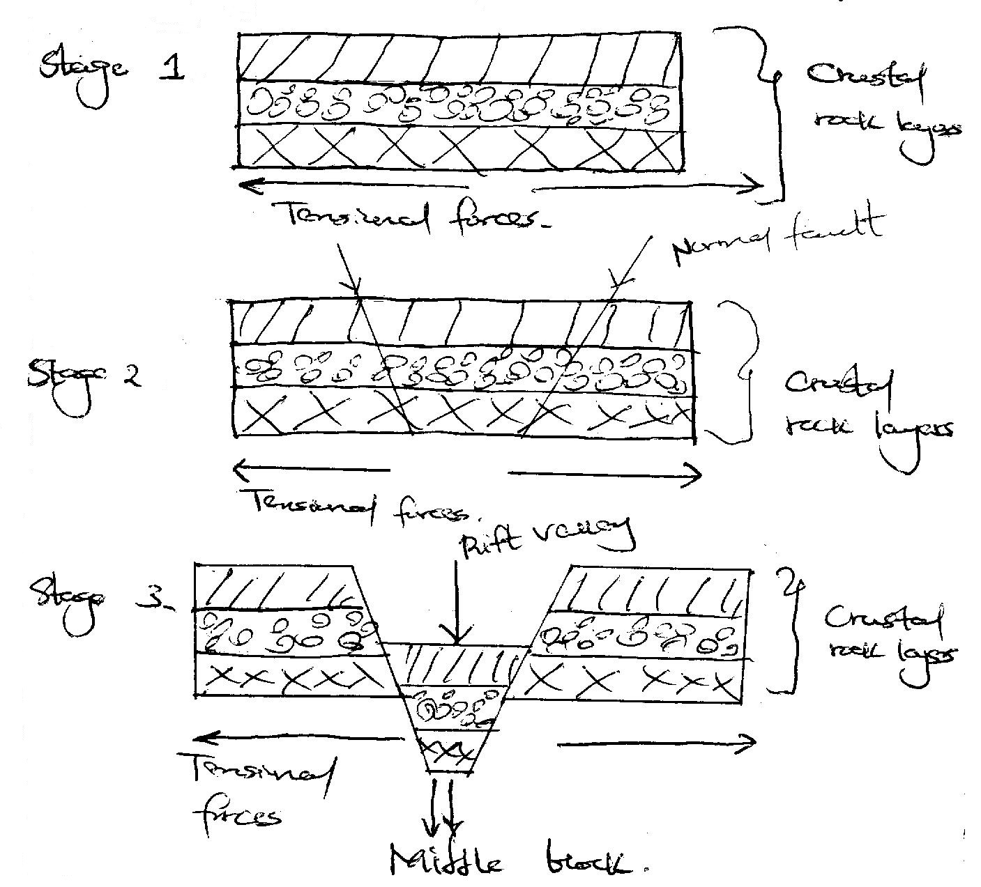
- The crusted rocks are subjected onto tensional forces due to instability within the earth’s crust
- Further tension leads to the development parallel normal faults
- The middle lock subside
- The depression created by the sunken lock middle forms the rift valley

b. Explain three positive effect of folding on human activities. (4 mks)
- Fold maintains experience heavy rainfall on the windward side which support agricultural activities, forestry and settlement eg Meru on the ward side of Mt. Kenya.
- Folding may bring valuable minerals into the surface for easy mining.
- Folding maintains create beautiful sceneries that which act as tourist attractions
- Fold maintains acts as protective barriers in time of war.
6 a. Distinguish between weather and climate. (2 mks)
- weather refers to the condition of atmosphere of a palce at a particular time over a period of time.
- Climate of the average of weather conditions of a place over a long period of time especially 30-35 3years

b. state three characteristics of modified equatorial climate in the coastal region. (4 mks)
- real dry month but rainfalls lows than the real equatorial climate.
- small mean unusual temperature of about 4c.
- Heavy convectional rainfall averaging 1600 mm/year
- Relative humidity is high due to the proximity to the ocean and high temperatures
- temperatures are high and averages between 20c to 27c
c. Explain four factors which influence climate. (8 mks)

- Cordinentality/distance from the sea
- Latitude
- altitude
- air masses
- aspect
- ITCZ
- Configuration of the coastline
- ocean currents
- human factors

(i). differentiate between desertification and aridity. (2mks)
- Desertification is the encroachment of large areas of barren land which are covered with sand.
- Aridity is a state of land being deficient in moisture leading to a scanty or lack of vegetates and deficiency in soil fertility.
(ii). Explain three natural causes of aridity ad desertification. (6 mks)

- rainfall
- Temperature
- Ocean currents and winds
- Confidentiality

- aspect/loxectun and leeward sides
- Pressure systems

7a. what is vegetation 2. (2 mks)
- Vegetation refers to all living plant cover growing in a particular area.
b. Name three types of vegetation. (3 mks)

- Natural vegetation
- semi-natural vegetation
- planted vegetation

c. Explain how the following factors influence the distribution of vegetables.
(i). Aspect (2 mks)
- Slops facing the sun have warmer and drier environment than the slopes facing away from the sun.
(ii). Precipitation. (2mks)
- Areas that receive heavy and reliable rainfall are mere vegetables than these that receive little and unreliable rainfall.
(iii). Temperature. (2mks)
- Temperature determines the rate act which plant process of germination growth photosynthesis transition flowering and fruit bearing take place.

