312/1
GEOGRAPHY P1
FORM IV
END OF TERM II EXAM (2021)
MARKING SCHEME

1)a) What is an inland delta?
Delta which form a long a rivers course before it reaches the sea/sea. ( 2MKS)
b) Name any three sources of rivers
- Lakes
- Melting ice / snow
- Springs
- Swamps
- Surface run off (Any 3 x 1 = 3mks)
2)a) Identify two sources of water found in a lake
- Rainwater
- Rivers
- Underground water
- Glacier melt water (Any 2 x 1 = 2mks)
b) State three causes of Salinity in lake Magadi
- The lake lacks an outlet to the sea thus mineral salts accumulate in its water
- Presence of salt bearing rocks on the lake bed leads to mineral salts dissolving in the water in the lake.
- The high temperature in the area lead to high evaporation from the lake resulting in high concentration of mineral salts in the water
- Mineral salts are deposited in the lake by surface run-off increasing the concentration of slats in the water
- Underground seepage of the water that is rich in mineral salts add to the salt in the late. (Any 3 x 1 = 3mks)
3)a) Name the two solstices
- Winter solstice
- Summer solstice ( 2mks)
b) Describe the solar system
- It is the sun, planets and other celestial bodies held together by the forces of gravity.
- The celestial bodies orbit the sun
- Most celestial bodies are spherical in shape ( 3 x 1 = 3mks)

4)a) List any two natural vegetation zones found on a mountain slope in Africa (2mks)
- Rain forest
- Bamboo forest
- Health and moorland
- Savannah vegetation (Any 2 x 1 = 2mks)
b) Give three economic uses of vegetation (3mks)
- Used as fodder
- Provides word fuel e.g charcoal
- Production of building / construction materials ( 3 x 1 = 3mks)
5)a) Apart from the Sahara, name two major deserts found in Africa (2mks)
- Kalahari
- Namib (2 X 1 = 2MKS)
b) Give three reasons why wind is the dominant agent of erosion in the Sahara desert. (3mks)
- The areas have scanty or no vegetation which exposes the land erosion
- The areas experiences strong tropical winds which erode the materials
- The areas have dry unconsolidated materials which are easily eroded.
(3 x 1 = 3mks)

SECTION B
- Study the map of Taita hills 1:50,000 (sheet 189/4) provided and answer the following questions.
a)i) Give the six figure grid reference of the dispensary in the Ronge forest (2mks)
367297 (2MKS)
ii) Calculate the bearing of the all-weather road loose surface D 535 from grid reference 393260 to the end at grid reference 421310 (2mks)
030⁰
b)i) Using a scale of 1cm to represent 20 meters draw a cross-section from the grid reference 400280 to 440280 (4mks)

ii) On the cross section, mark and name the following:
- All weather road, loose surface (1mk)
- River (1mk)
- Telephone line (1mk)
iii) Calculate the vertical exaggeration (V.E) of the cross-section (2mks)

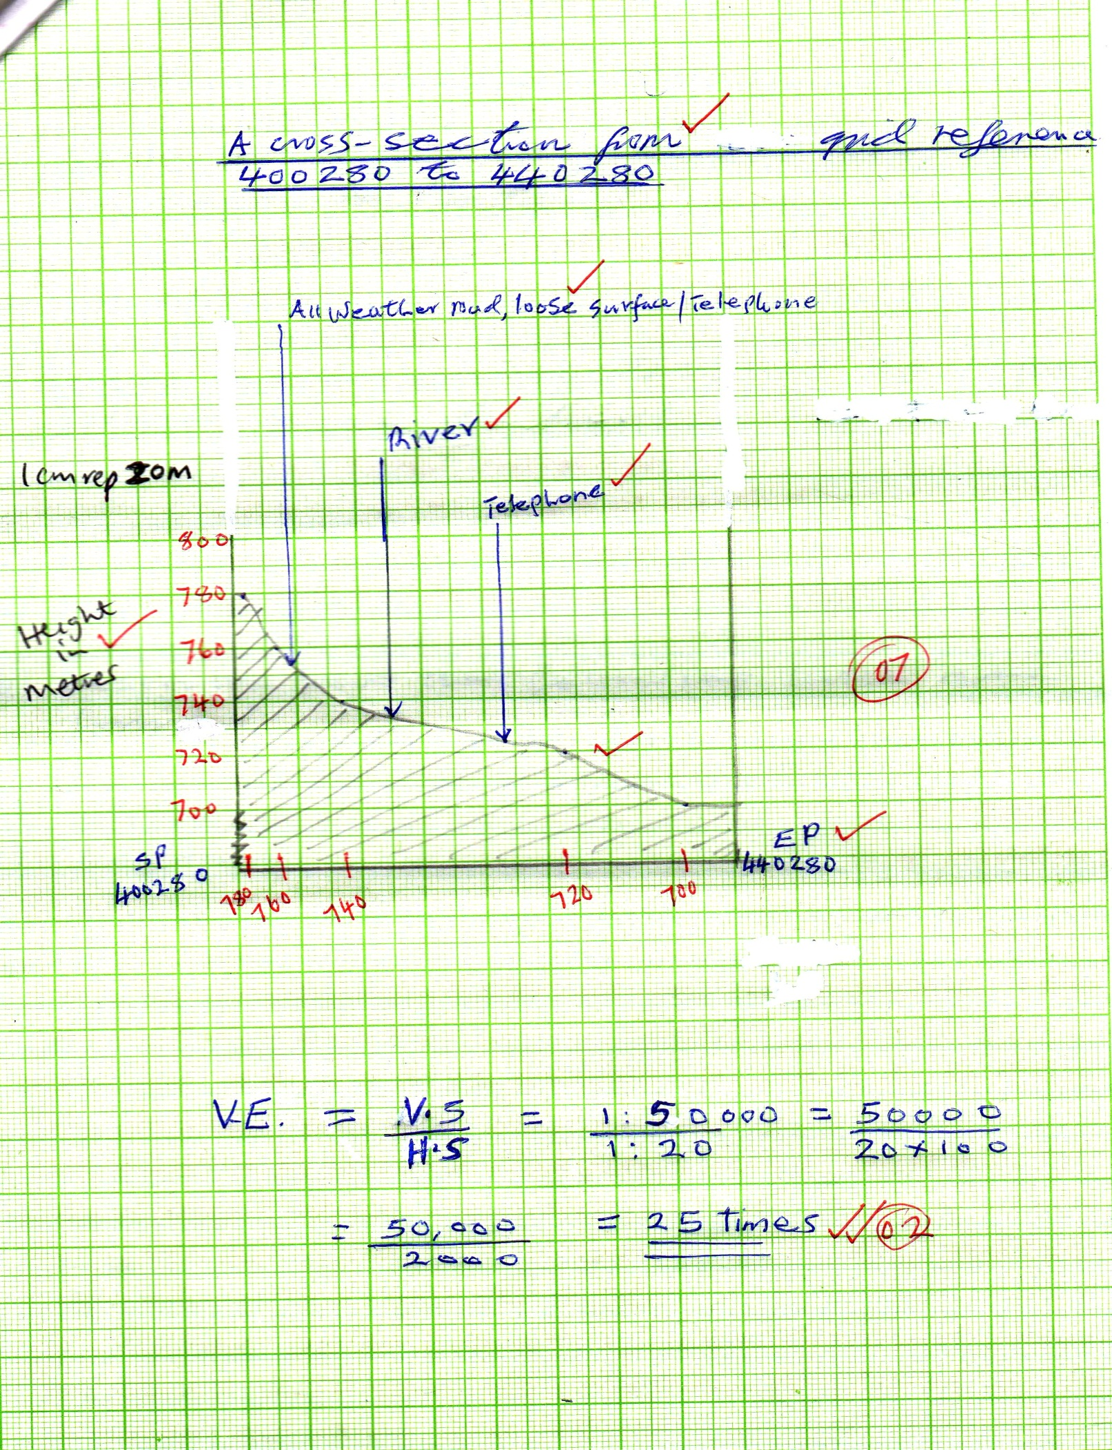

c)i) Identify three forms of transport found in the area covered by the map (3mks)
- All weather road / loose surfaces
- Dry weather road
- Motorable tracks
- Foot tracks
- Pipeline
(Any 3 x 1 = 3mks)

ii) Citing evidence from the map, explain three economic activities practiced in the area covered by the map (6mks)
- Transportation as evidenced by roads
- Livestock farming, there is a cattle dip at grid square 2424
- Trade as evidenced by shops
- Forestry – forest at 3629
- Crop growing / farming – Agricultural office
(Any Economic activity 1mk well matched evidence 1mk x 3 = 6mks)
iii) Identify three types of settlements found in the area covered by the map (3mks)
- Linear settlement (2325)
- Nucleated settlement (2918)
- Dispersed settlement (3924)
( 3 x 1 = 3mks)

7)a)i) Name two lakes that are due to volcanic activities (2mks)
- Crater / caldera lakes
- Lava dammed lakes ( 2 x 1 = 2mks)
iii) Give three characteristics of lakes formed due to faulting (3mks)
- They are narrow
- They are steep sided
- They are deep
- Most of them are salty
(Any 3 x 1 = 3mks)

b) Describe how the following lakes are formed
i) Oasis (4mks)
- A pre-existing depression is exposed to wind erosion
- Wind eddies remove unconsolidated material through deflation
- Wind abrasion deepens and widens / enlarges the depression
- Further abrasion leads to depression reaching the water table
- Water oozes out of the ground and collects into the depression to form a lake known as an oasis.
(Any 4 x 1 = 4mks)

ii) Lagoon (4mks)
- Single is moved by the long show drift and deposited at the entrance of the bay.
- The deposit accumulates forming a spit
- Further deposition elongates the spit and links the two headlands farming a bar bay.
- The bar separates part of the bay from the open sea. The enclosed water is the lagoon. (Any 4 x 1 = 4mks)
c)i) Explain three causes of salinity in lake Magadi (6mks)
- The lake lacks an outlet
- The presence of salt bearing rock on the lake floor which leads to dissolving of mineral salts in lake water.
- The high temperature in the area leads to high evaporation from the lake resulting to high concentration of mineral salts in the water.
- Surface run-off leads to deposition of mineral salts in the sea water.
- Underground seepage of the water that is rich in mineral salts.
(Any 3 x 2 = 6mks)

ii) Explain how a lake influences the climate of the surrounding areas. (6mks)
- Causes formation of lake breezes which have a cooling effect on the surrounding areas.
- Evaporation from the lake leads to high relative humidity in the area.
- Causes reversal of local winds in the surrounding area
- Moisture from the lake leads to increased rainfall received in the area.
- Regular lake breezes decrease the temperatures keeping the diurnal range low. (Any 3 x 2 = 6mks)

8)a)i) Name two substances that are suspended in the atmosphere (2mks)
- Dust particles
- Pollen grains
- Gases
- Salt particles
- Smoke
- Water vapour
(Any 2 x 1 = 2mks)

ii) State three factors that influence the amount of solar radiation that reaches the earth surface (3mks)
- The area and nature of the surface on which the rays fall
- The inclination / angle of the surface on which the sun’s rays fall.
- The position of the earth on its orbit which produce different seasons
- The transparency of the atmosphere that is transmission, absorption, scattering and reflection of the sun’s rays by particles found in the atmosphere.
(Any 3 x 1 = 3mks)

b)i) List any three elements of weather (3mks)
- Precipitation
- Claude cover
- Humidity
- Temperature
- Winds
- Atmospheric pressure e.t.c (Any 3 x 1 = 3mks)
ii) Describe how the rain gauge is used to measure rainfall (4mks)
- The instrument is placed in an open area and rain water collects in the jar.
- The metal collecting jar is removed from the metal holder
- The water is poured into a measuring indicated cylinder
- The reading is taken / recorded
- The water is emptied and the instrument is placed outside to collect more water for measuring the following day.
(Any 4 x 1 = 4mks)

c)i) Explain three different ways that air that condenses to form rainfall is made to rise (6mks)
- When winds blow over a mountainous region
- When hot air rises by conventional currents
- When warm air rises over cold air
(3 x 1 = 3mks)

ii) List three types of rainfall (3mks)
- Relief / orographic
- Convectional
- Cyclonic / frontal
( 3 x 1 = 3mks)

iii) Explain any two main features of a Stevenson screen (4mks)
- It is painted white to ensure that there is no absorption of heat as this would interfere with the temperature readings
- The louvered sides allow for free flow of air
- It is raised to a height of about 121 cm above the ground to prevent contact with direct radiation from the earth’s surface
- It has an insulated roof to provide shade from direct rays of the sun and rain.
(Any 2 x 1 = 2mks)

9)a) i) Name three parts of fault (3mks)
- Hade
- Heave
- Fault-line
- Fault plane (Any 3 x 1 = 3mks)
ii) Give three ways in which faults develop in the crust (3mks)
- When tension forces cause crustal rocks to over stretch they fracture
- When compression causes squeezing of crustal rocks and they fracture
- When vertical movements exert pressure on rocks they fracture
- When shear forces cause crustal rocks to tear.
(Any 3 x 1 = 3mks)
b)i) Name two types of faults (2mks)
- Normal
- Reverse
- Tear / Shear
- Thrust
- Anticlinal (Any 2 x 1 = 2mks)
ii) List four relief features that are associated with the Rift valley (4mks)
- Fault bocks
- Step faults
- Tilt blocks
- Volcanic cones (4 x 1 = 4mks)
c)i) Name four major faulted areas of the world (4mks)
- The Great Rift valley from Syria to Mozambique
- The central valley of Scotland
- The Cenozoic rift system of Europe
- The middle East Rift valley region ( 4 x 1 = 4mks)
ii) Identify any three parts of the great East African Rift Valley (3mks)
- Ethiopian Rift system
- Gregory Rift system
- Western rift valley
- Malawi Rift valley (Any 3x 1 = 3mks)
d) Explain three ways that faulting influences drained on the Earth surface (6mks)
- Fault scarps may expose underground water resulting in the formation of scarp springs
- Unequal subsidence caused by faulting may cause formation of depressions which may form cakes.
- Faulting may cause a river to disappear or change its course and flow along the fault line
- Uplift of some river channels may cause river rejuvenation
- Accept any other relevant point
- (Any 3 x 1 = 3mks)

10)a) Name two types of ice masses found on mountains in east Africa (2mks)
- Ice caps
- Cirque glaciers
- Valley gracier (Any 2 x 1 = 2mks)
b)i) Identify two ways in which ice moves (2mks)
- Plastic flowage
- Basal slip
- Extrusion flow
- Internal shearing
(Any 2 x 1 = 2mks)

ii) Name two mountains in east Africa which are ice capped (2mks)
- Mt. Kenya
- Mt. Kilimanjaro
- Mt. Ruwenzori (Any 2 x 1 = 2mks)
c) Explain three factors that lead to glacial deposition (6mks)
- Rising temperatures lead to melting of ice thereby causing the ice to deposit its load.
- Change of gradient to relatively flat surface will reduce the velocity of glaciers movement which will subsequently leads to deposition of fluvial glacial materials
- Alternating warm and cold periods load to seasonal melting of ice which allows materials embedded in the ice to be released and deposited
- Obstruction of glacier leads to pressure at the base of glacier which in turn leads to melting of ice at the base causing the embedded material to be released and deposited.
(Any 3 x 2 = 6mks)

d) You intend to carry out a field study on a glaciated landscape on Mt. Kenya.
i) Name three erosional features you are likely to observe during the field study (3mks)
- Depressions
- Crag and tail
- Ice eroded plain
- Roche montonee (Any 3 x 1 = 3mks)
ii) Explain three reasons why you would require a working schedule (6mks)
- It enables the planned activities to be carried out systematically
- It allows for proper use of available time
- It enables the assessment of the progress of the field study
- It enables the estimation of the total time required for the study
- To confine the research to the scope of the topic
- It ensures that all the relevant areas are adequately covered.
(Any 3 x 1 = 3mks)
iii) Give four follow-up activities you would undertake after the field study. (4mks)
- Displaying the photographs
- Discussing the findings
- Analyzing the data collected
- Drawing conclusions
- Comparing the notes
- Reading more about the topic
(Any 4 x 1 = 4mks)

