TERM TWO MID TERM EXAMS 2022
FORM TWO GEOGRAPHY
MARKING SCHEME
1.Distinguish between direction and bearing. (2mks)
Direction can be given as a distance from particular known point on the map or on surface of the earth while bearing is given as direction measured as an angle and given in degrees.
2.The diagram below is an illustration of the Grid reference system. Use it to answer questions that follow.
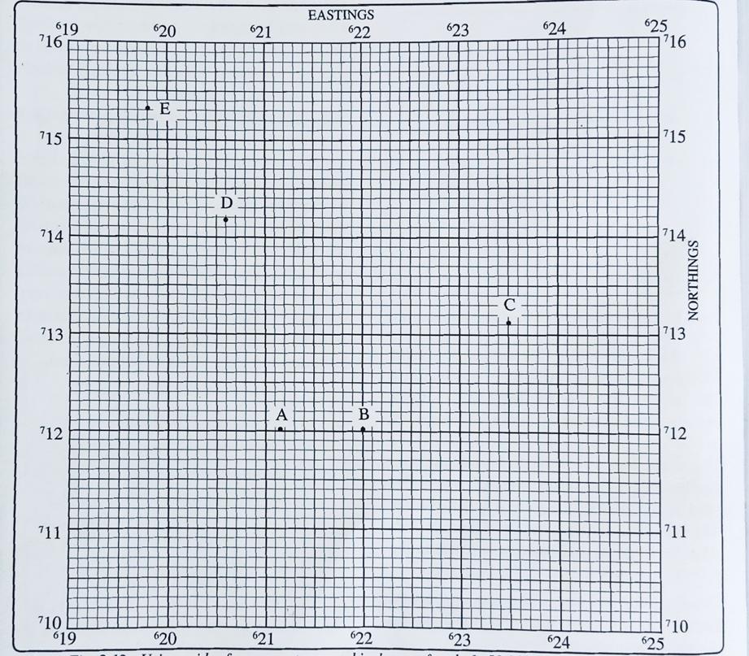

i. Give the FOUR figure grid reference of points B and D. (2mks)
B-2212
D-2014

ii. Give SIX figure grid reference of points C and E. (4mks)
C-235131
E-193153

iii. Give the direction and bearing of point D from point B. (3mks)

3.Identify two Traditional methods of indicating direction. (2mks)
Use of Landmarks
Use of Heavenly Bodies
4.Identify methods of representing Relief on Topographical maps. (5mks)
Contours
Hachures
Spot heights and Trigonometrical Stations
Hill shading
Colouring
Cliff and Rock drawing

5.Identify two types of Aerial Photographs. (2mks)
Vertical aerial photograph
Oblique aerial photograph
6.What is a photograph? (2mks)
An image of an object, person or scene in a form of a print or slide recorded by a camera on a film.
7.Identify three causes of Earthquakes. (3mks)
Tectonic movement
Vulcanicity
Isostatic adjustments
Human activities
8.Explain any three constructive consequences of Vulcanicity to Human Activities. (6mks)
The Volcanic rocks of the Kenya highlands have been weathered to produce fertile soil for agriculture.
Landforms resulting from activity are tourist attraction /scenic beauty e.g Mt Kenya.
Trachyte and phonolites/volcanic rocks are used for building
steams jets/gerious at Olkaria are used for generating geothermal power.
Gases associated with volcanic activities are mined in Kenya e.g CO2 at Kereita and at Esageri in Baringo
steep slopes formed through volcanic activity discourages settlement/farming/development of transport.
9.Identify two features that results from fissure eruption. (2mks)
Lava Plateau
Tuff plateau

10.Name two areas studied in Human and Economic Geography. (2mks)
Forestry
Wildlife and tourism
Mining and energy
Trade , transport and communication
Agriculture
Mgt and conservation of environment
11.Identify the marginal information found on a Topographical map. (5mks)
Map series
Sheet name and title
Sheet index number
Grid systems
Latitudes and longitudes
Compass direction
Magnetic variation
Scale, key, edition &publisher
12.State methods of Recording Statistical Data. (5mks)
Field sketching
Mapping
Tabulation
Tallying
Taking photographs
Tape recording
Note taking
Labelling of samples
Filling in questionnaires
13.Identify the instruments for measuring the following elements of weather. (5mks)
i. Temperature-Thermometer
ii. Humidity-Hygrometer
iii. Air Pressure-Barometer
iv. Wind speed- Anemometer
v. Sunshine-Sunshine Recorder

