FORM 1 GEOGRAPHY
TERM 2 2022 OPENER EXAM FORM 1
MARKING SCHEME.
1. (a) Apart from human and economic Geography, name the other two branches of Geography. (2mks)
Physical geography
Practical geography
(b) State four areas studied under Human and Economic Geography. (4mks)
- Mining
- Forestry
- Agriculture
- Fishing
- Wildlife and tourism
- Industry
- Energy etc.
2. State four importance of studying Geography. (4mks)
- Facilitates good relationship among nations by studying geography of other regions of the world.
- It’s a career subject in that it enables one to go for advanced studies in specialised fields e.g. geography teachers, meteorology, surveying etc.
- Enables us to appreciate other people’s way of life by learning economic activities of different communities within our country and other parts of the world.
- Enables us to conserve our environment when we learn negative and positive effects of human activities on the environment.
- Enables us to conserve our resources when we learn wise use of resources in conservation and management of resources e.g. wildlife, forests, energy, etc.
- Inculcates in us virtues of cooperation and patience as we work in groups.
- Makes us to appreciate manual work as we are involved in practical geography which may lead to self employment.
- Promotion of industry such as tourism by guiding tourists to places of interest by using maps, calculations of distances etc.
3. What is the relationship between geography and chemistry. (2mks)
geography applies chemistry in studying chemical composition and chemical changes which take place in soils and rocks
4. (a) State and explain four proofs supporting that the earth is spherical. (8mks)
- If one moves towards the east in a straight line he will end up where he started.
- Satellite photographs taken from space show that the earth is like a sphere.
- Places in the east see the sun earlier than those in the west.
- When a ship is approaching the smoke is seen first, then the mast and finally the whole ship.
- All the planets are spherical so the earth being one of them is also spherical.
- During the moon eclipse the earth casts a spherical shadow on the moon.
- The earth’s horizon appears curved when observed from a very high point like a tower.
(b) Name the three forces that are responsible for the shape of the earth. (3mks)
Centrifugal force
Gravitational force
Centripetal force
5. What is the time at town Y which is 60⁰E when it is 10:30 a.m at town X which is 30⁰E. (4mks).
60-30=30
30x4=120
120/60=2hrs
10:30+2:00=12:30 p.m
6. State three weaknesses of the passing star theory. (3mks)
- Doesn’t explain the origin of the sun and star.
- Minimal chance of a star approaching another
- Materials would disperse than condense
7. (a) What is the solar system? (2mks)
Solar system is the group of heavenly bodies comprising the sun and the planets
(b) From the solar system, identify;
(i) The planet that supports life earth
(ii) The hottest planet__mercury
(iii) The fifth planet from the sun__jupiter
(iv) The farthest planet_neptune
8. State four effects of rotation of the earth. (4mks)
- Creates day and night because at any one time one side of the earth faces the sun (day) and the other remains in darkness (night).
- Causes deflection of winds and ocean currents in the N hemisphere to the left and in the S hemisphere to the right.
- It causes rising and falling of ocean tides.
- Causes time difference between longitudes.
9. (a) Define the term equinoxes. (2mks)
Time of the year when the sun is vertically overhead at noon at the equator and the lenth of day and night is equal.
(b) Name The Four Seasons caused by the revolution of Earth. (4mks)
Summer
Autumn
Winter
spring
10. The diagram below represents the globe. Use it to answer the questions that follow.
OO
O
O
N
A
B
C
$$66\frac{1}{2} S$$
$$66\frac{1}{2} N$$
O
S

(a) Name the latitudes A,B & C (3mks)
A_tropic of cancer
B_equator
C_tropic of capricon
(b) Give the name of the latitude that runs from N to S (1mk)
Prime meridian
11. Using a well labeled diagram, describe how a lunar eclipse occurs. (7mks)
- The earth comes between the moon and the sun
- The earths shadow is cast on the moon
- The moon appears to be covered by darkness

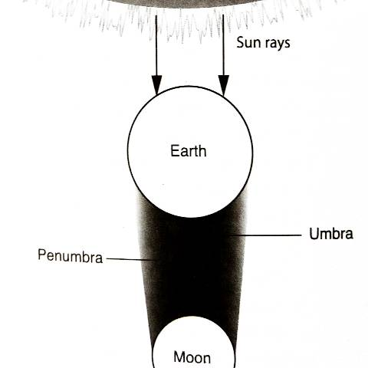
diagram=4mks
explanation=3mks
12. (a) state four characteristics of the earth crust. (4mks)
- Outermost layer of the earth
- Made of soils and other loose deposits of sand
- The dominant rocks are granites.
- Extends 0-50km
- Has 2 layers; SIAL and SIMA
- Crustal rocks are brittle
(b) Name the two layers of discontinuity in the internal structure of the earth. (2mks)
Gutenberg discontinuity
Mohovicic discontinuity
13. How long does the earth take to complete one rotation……24 hours(1mk)
14. (a) What is weather (2mks)
Daily atmospheric conditions of a place.
(b) give two examples of weather element (2mks)
Sunshine
Rainfall
Humidy
Atmospheric pressure
tempearature
(c) state two factors to consider when siting a weather station.(2mks)
The area should be free from flooding
The area should be free from tall buildings or tree
Should provide a clear view of the surrounding

